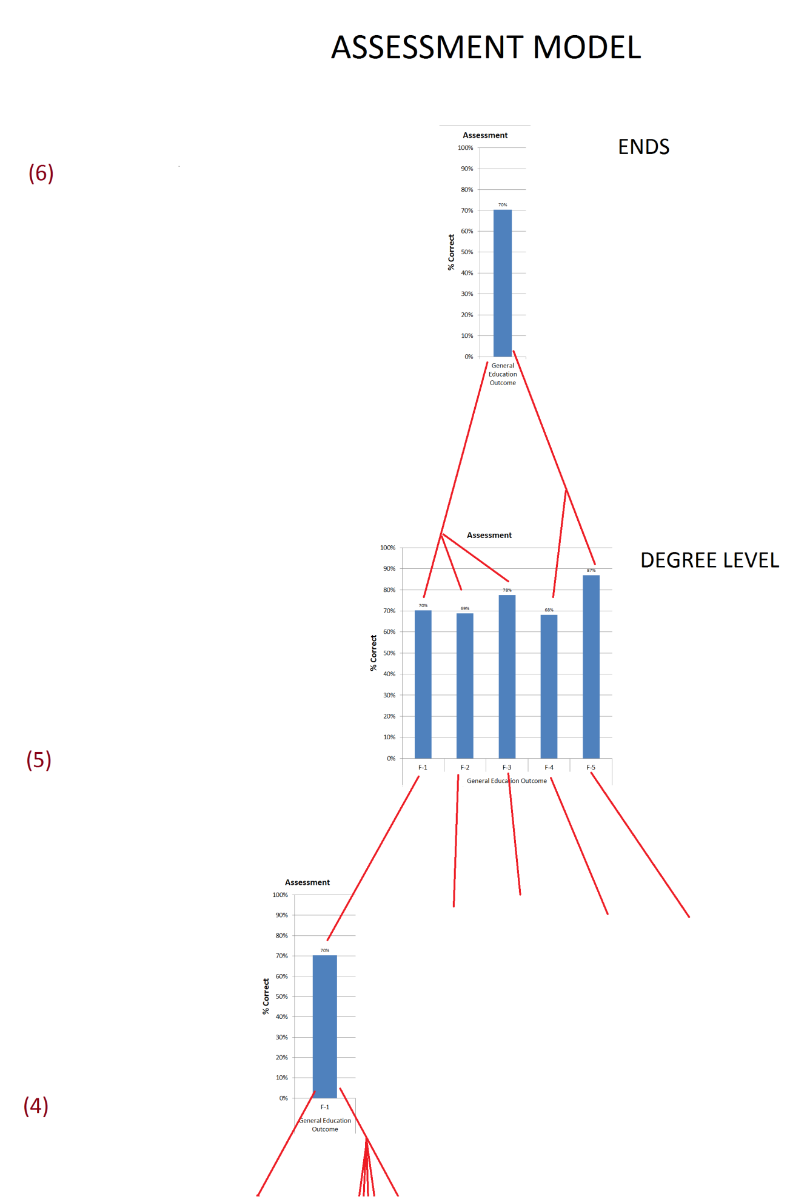
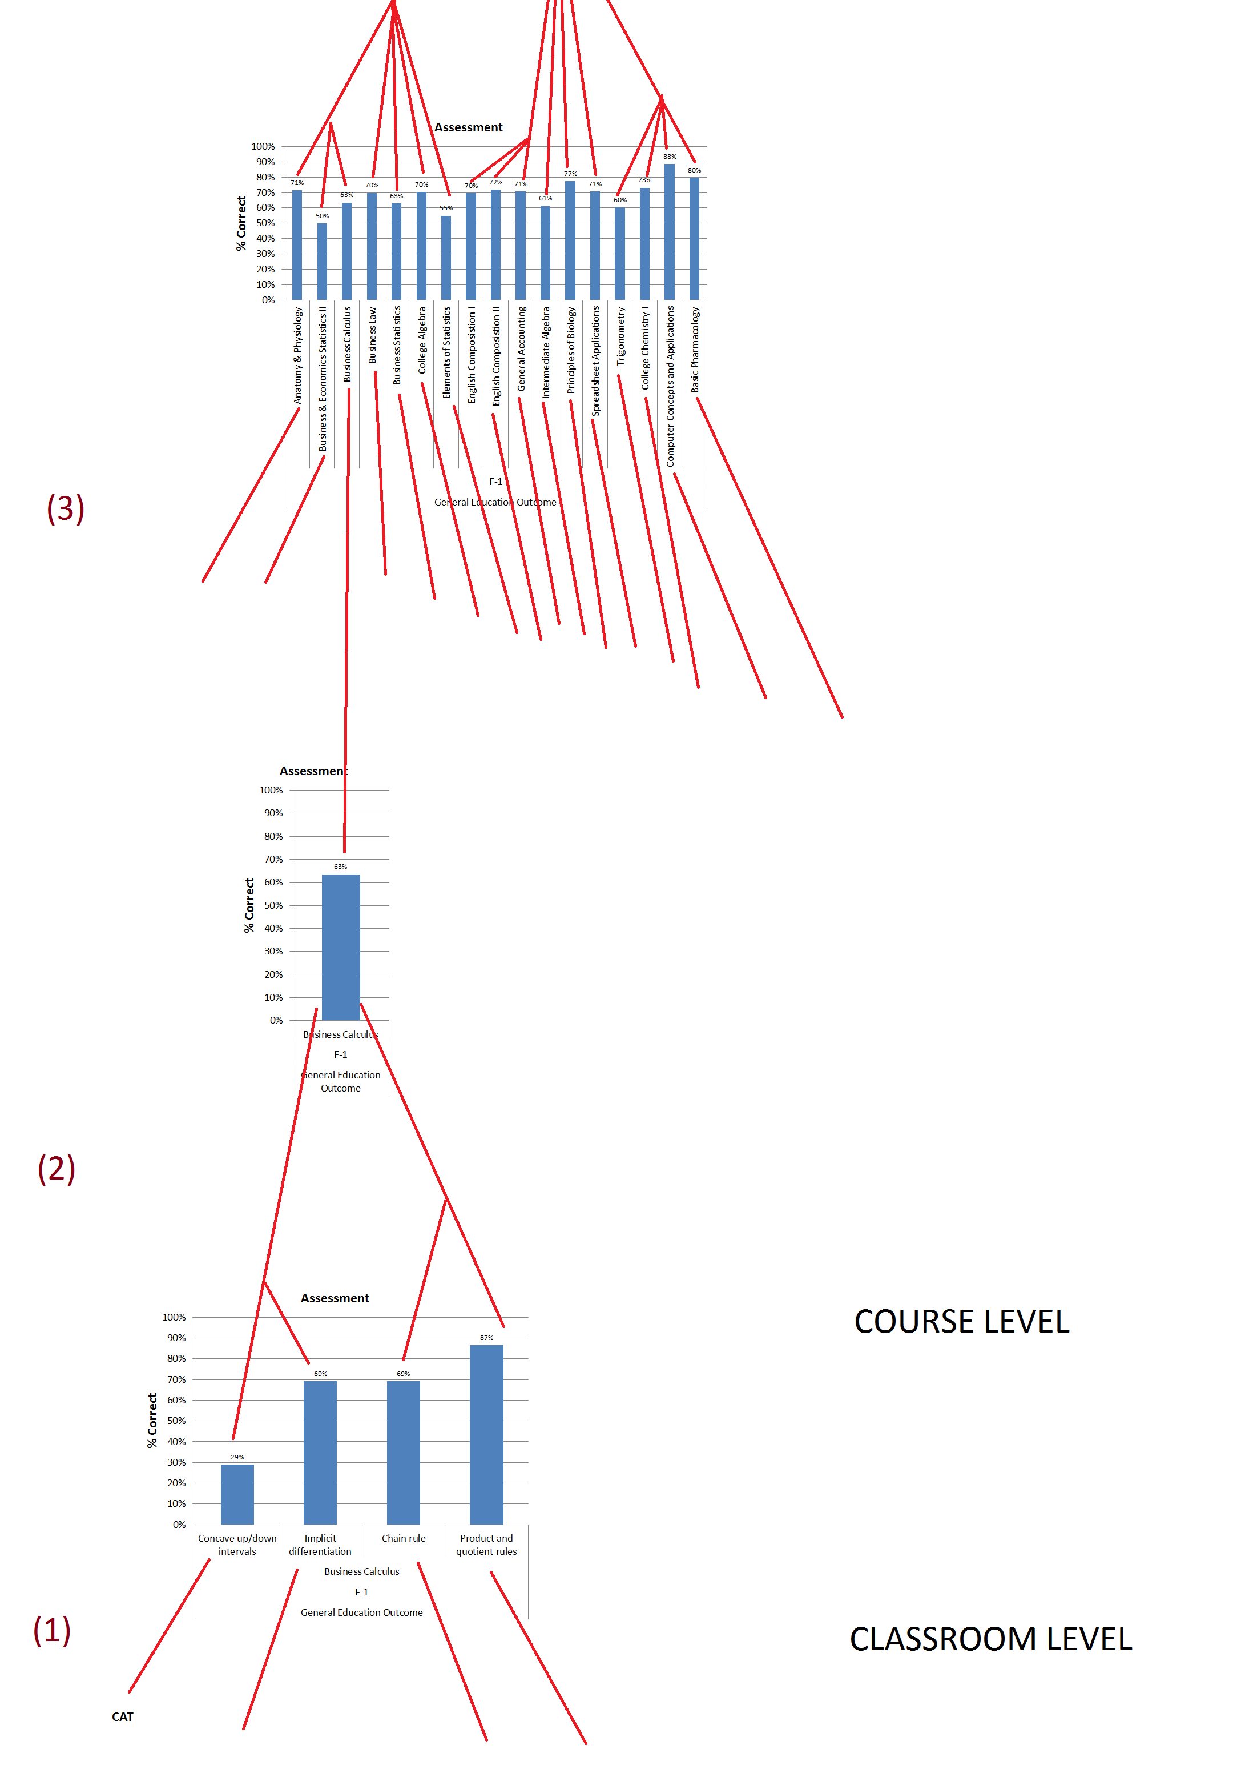
DESCRIPTION
(1) Beginning with the Classroom Level of assessment, Classroom Assessment Techniques (CATs) are used by Barton’s instructors to gauge student understanding and comprehension of a given topic or lesson. These in the moment assessments enable in the moment changes to take place with the purpose to improve student learning. To add additional direction and focus to CATs instructors involved with the Course Assessment Project (CAP) at the Course Level of assessment can identify which competencies are deficient in their classrooms. This will allow then to direct their CATs at specific parts of a given competency thereby shedding light on the possible causes for the lack of comprehension and hopefully improve student learning. This improvement should then be reinforced by feedback from the next round of the course assessment as to whether or not improvement within the competency itself is demonstrated.
(2) At the Course Level of assessment, the CAP asks instructors to determine a way to assess the course competencies. Most often this is done by identifying items on a Final or Post-Test within the course. This is done by corresponding questions within the exam to specific course competencies. Thus regardless of the percentage of students passing the exam, an instructor can look as specific questions and ask themselves, “how come only 29% of the class got number 5 correct?” The given visual uses Business Calculus as an example, which uses a Post-Test as its course assessment. Note the percentages do not represent pass rates, but rather how well the class did on specific questions within the exam itself. Since only 29% answered the question relating to competency regarding concavity, the instructor can now use CATs to further investigate the issue the next time the course is taught and perhaps try a new method for teaching the concept. As listed four such competencies are listed, although many more are included. These are specified because they directly relate to Barton’s general education outcome F-1, which may be found at: http://bartonccc.edu/administration/iss/documents/assessment/GenEdOutcomes.pdf. These four competencies are then pooled together to determine what percentage overall were answered correctly as it relates to F-1 (69%). This gives yet another layer of detail as it relates to their students ability to achieve the F-1 goals and abilities which can then be further investigated at the classroom level with CATs.
(3) The process of (1) and (2) is repeated for all CAPs each resulting in an overall score for F-1.
(4) All of these scores are then pooled together to create one overall score for F-1 drawing from the multiple course assessments where competencies assessed at the course level have been identified as also assessing the general education outcome F-1.
(5) The process of (1), (2), (3), and (4) are then repeated for all of the general education outcomes F-1 through F-5 giving us an overall assessment of the general education outcomes. This represents the Degree Level of Assessment at Barton, referenced as Degree Level Embedded Assessment which originated as an AQIP Action Project (#1586).
(6) All five of the general education outcomes are then combined into one overall score assessing the general education outcomes as a whole. This is then presented to the board as a direct measure of the ENDS statement directed at the Outcomes Assessment Committee (OAC): “Students will have the essential skills to lead productive lives. Assessment of the General Education Outcomes will serve as an indicator of the essential skills retained by our students and their ability to lead productive lives.”

