Copy of Tax Return or
Account Transcript
NOT ACCCEPTED
- By Federal Regulation, copies of Tax Returns or Account Transcripts cannot be accepted.
Tax Return Transcript
ACCEPTED
- Signature REQUIRED for one filer
- Will Delay Aid if Unsigned
- Sign at least One Page

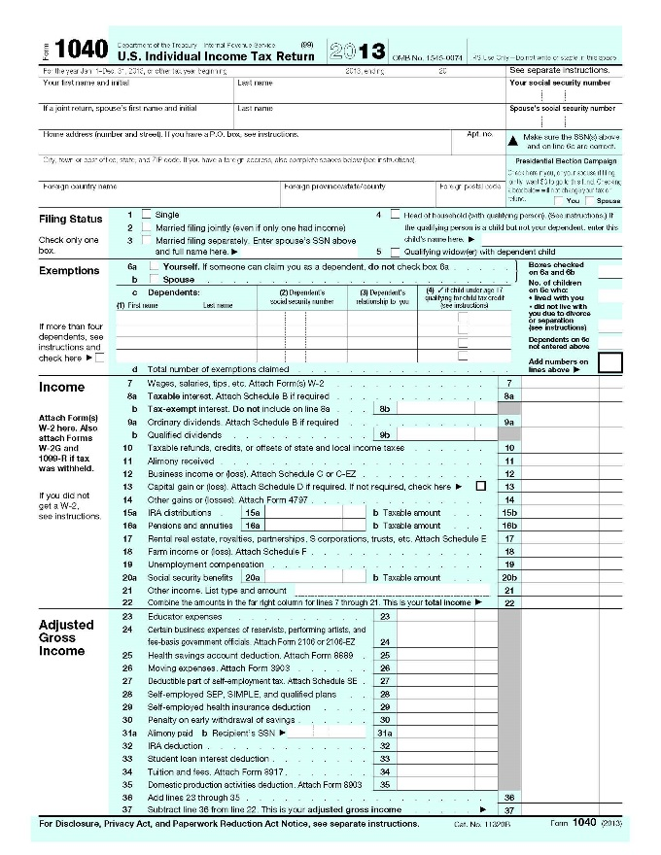
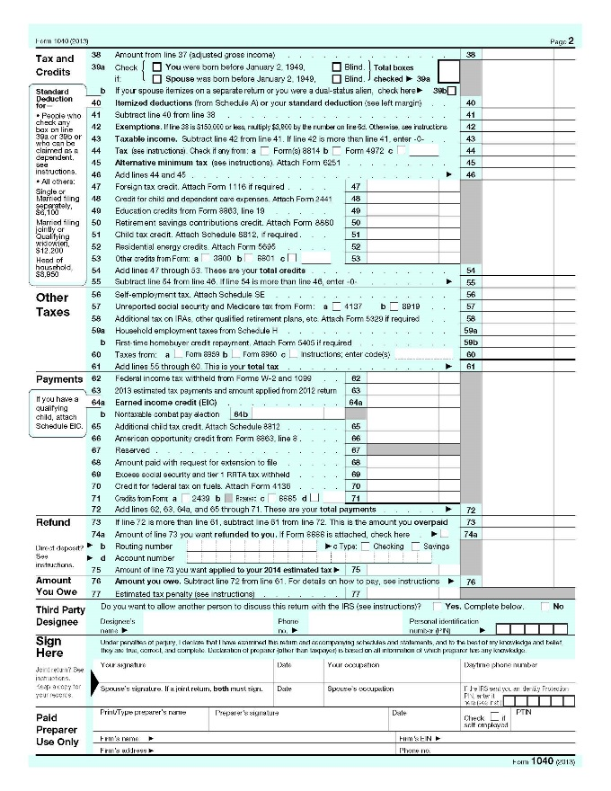
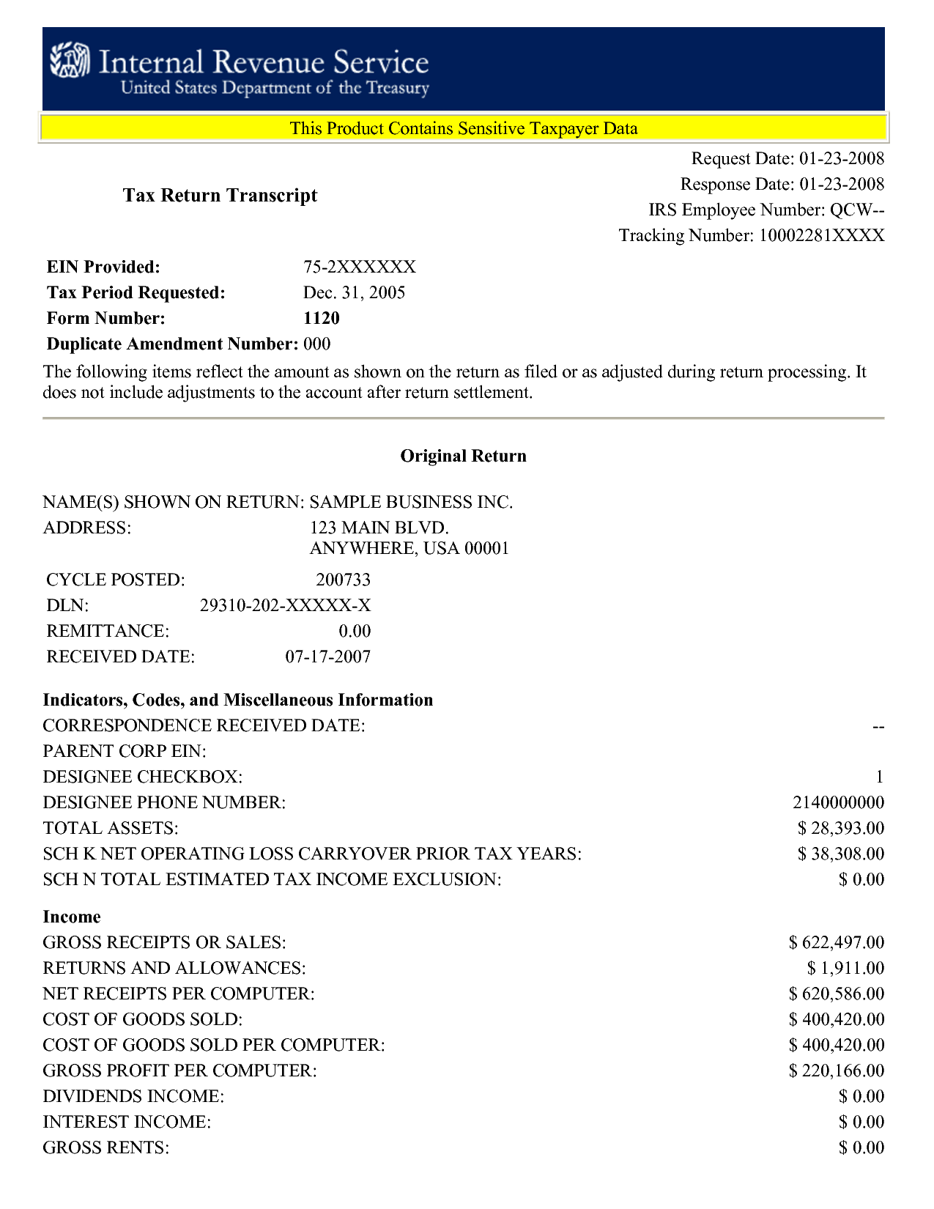
X _________
(Pen-to-Paper Signature)

IRS Tax Transcript Request
IMPORTANT INFORMATION BEFORE YOU REQUEST:
PEN-TO-PAPER SIGNATURE OF INDIVIDUAL
REQUIRED ON TAX-RELATED DOCUMENTS
Unsigned documents result in delay of federal aid awarding and may be returned by mail for signature.
- When requesting a tax return transcript, make sure that you request that exact item. There is another form called an Account Transcript, which is NOT the correct form. Please be very specific when requesting your documentation: IRS TAX RETURN TRANSCRIPT
- When requesting a tax return transcript by phone or online, you must use the primary filer’s social security number or your request will not be processed.
- You must use the address provided on the tax form that you are requesting.
- If you are requesting a verification of non-filing letter or W-2 transcripts and have never filed a tax return before, then you must make your request by paper form 4506-T. (see instructions below)
- Information on how to submit documents to our office can be found online: http://www.bartoncougars.com/financialaid/submitdocs
5 WAYS TO REQUEST:
1. VIEW AND PRINT ONLINE:
You may access the Tax Return transcript, Wage & Income transcript, or Verification of Non-filing Letter
http://www.irs.gov/Individuals/Get-Transcript
2. REQUEST BY PHONE:
You may only request by phone if you have filed a tax return this year or any previous year
Call 1-800-908-9946
3. REQUEST BY MOBILE APP
IRS2Go app can be downloaded for free to your mobile device
iTunes App store - https://itunes.apple.com/us/app/irs2go/id414113282?mt=8
Google Play store - https://play.google.com/store/apps/details?id=gov.irs&hl=en

For Request Options 2 & 3, transcripts should arrive to you by mail within 5-10 business days, free of charge.
4. REQUEST IN PERSON: The IRS has many offices throughout the U.S. You may visit an office and request these documents in person. To find a listing of your local offices visit www.irs.gov
5. REQUEST IN WRITING: Tax Return Transcripts, W-2 Transcripts and Verification of Non-Filing letters may be requested by paper form by submitting the IRS Form 4506-T. This form may be retrieved on the IRS website www.irs.gov or our office can supply one to you.

Tips for Success to setup IRS online account
- Use address on the most recently processed item to the IRS (Tax Return, W-2, 1099-T)
- Enter street address and city using ALL CAPITAL LETTERS
- Do not enter punctuation in street address
- Check standard address format with U.S. Postal Service - Look Up a Zip Code tool

How to Submit Signed Document to Barton Financial Aid Office
- Drop off in-person to Financial Aid office, Fort Riley, or Fort Leavenworth campus
- Mail
- Upload scan to Mapping Xpress

View details on how to submit documents:
http://www.bartoncougars.com/financialaid/submitdocs

