Entering Earned Leave Through Web Leave Reporting
Please refer to the Salaried Employee Calendar published by the Office of Human Resources for Web Leave Reporting turn-in dates and times. At the conclusion of the pay period, time sheets must be submitted for approval either in accordance with the applicable payroll deadline or as directed by your supervisor—whichever is sooner.
- Go to MyBarton Portal Login
- After logging in, click on Barton PAWS Account
- Click on the Employee tab
- Click on Hourly Time Sheet and Salaried Leave Reporting
- Click on Salaried Employee Leave Reporting. Make sure the radio button is set to “Access my Leave Report” and then click on Select.
- On the next page, (1) make sure the radio button is set on position number 444400-99; 444401-99; 444402-99; 444403-99; or 444404-99; (2) the leave report period is for the correct reporting period (drop down can be used to change the leave report period); and (3) then click on Leave Report.
- On the time sheet that is brought up, you will enter your leave hours on the appropriate date and for the appropriate leave category.
- Leave is to be entered in quarter hour increments. For example, 3 hours and 15 minutes would be entered as 3.25; 3 hours and 30 minutes would be entered as 3.50; and 3 hours and 45 minutes would be entered as 3.75.
Let’s say you used 3 hours and 45 minutes of Personal Leave on February 2. You will click on Enter Hours underneath Thursday, Feb 02, 2017. Doing this will bring up the Hours box. You will then enter your leave time of 3.75 hours into the Hours box and click Save.
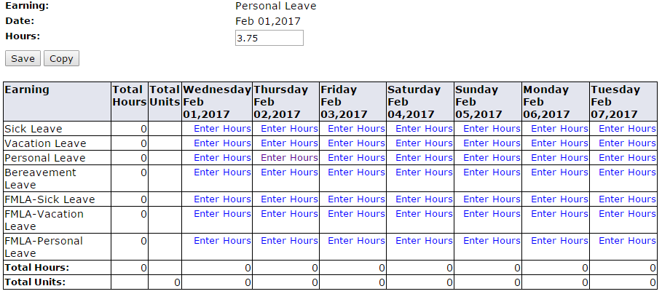

Your time sheet will then look similar to this:
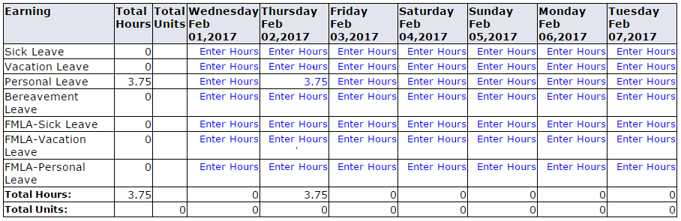
- You can navigate to other dates in the pay period by using the Previous or Next buttons.
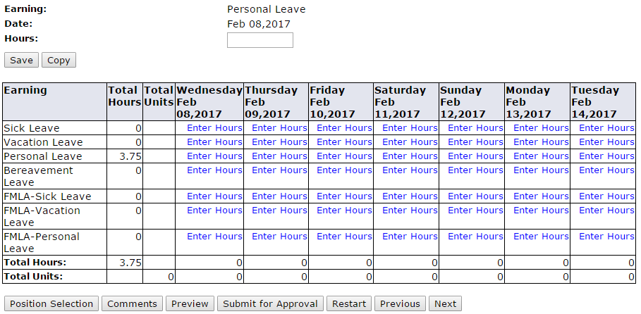

- At the conclusion of the pay period, click on the Submit for Approval button.
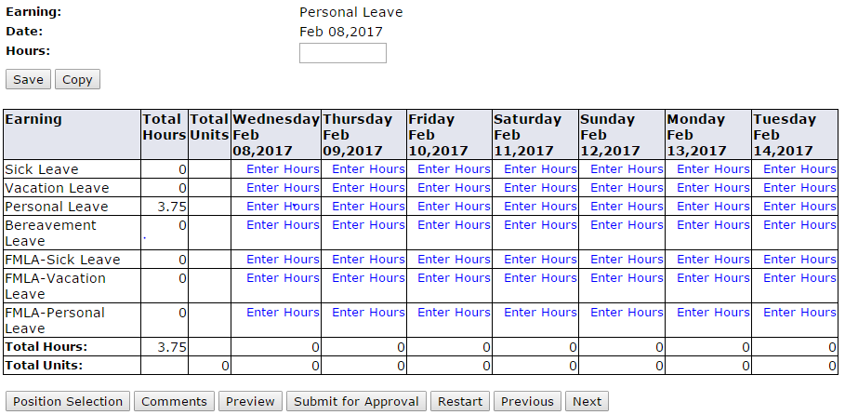
- This will bring up the Certification page where you will enter your PAWS PIN and click on Submit.
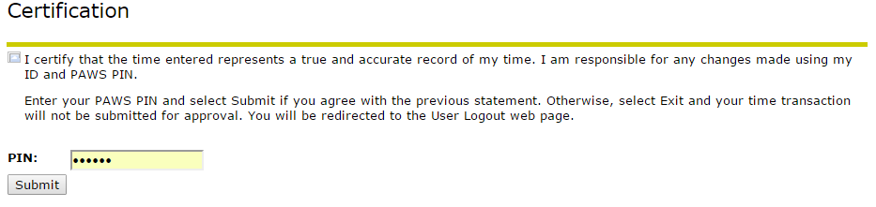
- By doing this, your leave report will be routed to your supervisor for review and approval. Once approved by your supervisor, the leave will be deducted from your earned leave time.

OHR 2/24/17

