ONE-X SETTINGS

There are 2 screens to set, the other you can leave as is. Launch the One-X application after installing and set the telephony screen and the Dialing rules screen, then save.

Under One-X select settings:
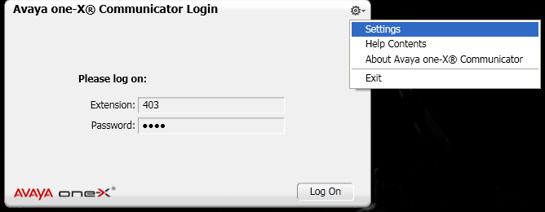

Select Telephony and set your extension and password of 1111
Add the server: 198.248.193.106.
(If it asks for a proxy, ignore this and move to the next screen, then save. After save, go back into

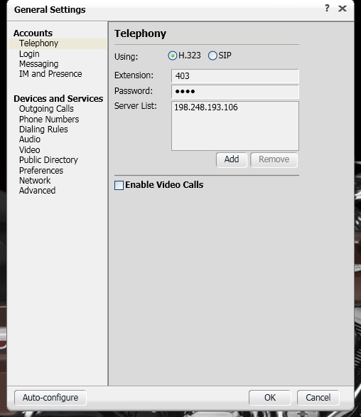

Next:
Select Dialing rules and set the rules as diplayed below.
