Avaya one-X® Communicator Release 6.2 SP1
(Product version – 6.2.1.06-SP1)

GA Release Notes

Issue 1.1
10th March 2014

© 2014 Avaya Inc. All Rights Reserved.
Notice
While reasonable efforts have been made to ensure that the information in this document is complete and accurate at the time of printing, Avaya assumes no liability for any errors. Avaya reserves the right to make changes and corrections to the information in this document without the obligation to notify any person or organization of such changes.

Documentation disclaimer

“Documentation” means information published by Avaya in varying mediums which may include product information, operating instructions and performance specifications that Avaya generally makes available to users of its products. Documentation does not include marketing materials. Avaya shall not be responsible for any modifications, additions, or deletions to the original published version of documentation unless such modifications, additions, or deletions were performed by Avaya. End User agrees to indemnify and hold harmless Avaya, Avaya's agents, servants and employees against all claims, lawsuits, demands and judgments arising out of, or in connection with, subsequent modifications, additions or deletions to this documentation, to the extent made by End User.

Link disclaimer
Avaya is not responsible for the contents or reliability of any linked Web sites referenced within this site or documentation provided by Avaya. Avaya is not responsible for the accuracy of any information, statement or content provided on these sites and does not necessarily endorse the products, services, or information described or offered within them. Avaya does not guarantee that these links will work all the time and has no control over the availability of the linked pages.

Warranty
Avaya provides a limited warranty on its Hardware and Software (“Product(s)”). Refer to your sales agreement to establish the terms of the limited warranty. In addition, Avaya’s standard warranty language, as well as information regarding support for this Product while under warranty is available to Avaya customers and other parties through the Avaya Support Web site: http://support.avaya.com. Please note that if you acquired the Product(s) from an authorized Avaya reseller outside of the United States and Canada, the warranty is provided to you by said Avaya reseller and not by Avaya.

License
THE SOFTWARE LICENSE TERMS AVAILABLE ON THE AVAYA WEBSITE, HTTP://SUPPORT.AVAYA.COM/LICENSEINFO/ ARE APPLICABLE TO ANYONE WHO DOWNLOADS, USES AND/OR INSTALLS AVAYA SOFTWARE, PURCHASED FROM AVAYA INC.,ANY AVAYA AFFILIATE, OR AN AUTHORIZED AVAYA RESELLER (AS APPLICABLE) UNDER A COMMERCIAL AGREEMENT WITH AVAYA OR AN AUTHORIZED AVAYA RESELLER. UNLESS OTHERWISE AGREED TO BY AVAYA IN WRITING, AVAYA DOES
NOT EXTEND THIS LICENSE IF THE SOFTWARE WAS OBTAINED FROM ANYONE OTHER THAN AVAYA, AN AVAYA AFFILIATE OR AN AVAYA AUTHORIZED RESELLER; AVAYA RESERVES THE RIGHT TO TAKE LEGAL ACTION AGAINST YOU AND ANYONE ELSE
USING OR SELLING THE SOFTWARE WITHOUT A LICENSE. BY INSTALLING, DOWNLOADING OR USING THE SOFTWARE, OR AUTHORIZING OTHERS TO DO SO, YOU, ON BEHALF OF YOURSELF AND THE ENTITY FOR WHOM YOU ARE INSTALLING,
DOWNLOADING OR USING THE SOFTWARE (HEREINAFTER REFERRED TO INTERCHANGEABLY AS “YOU” AND “END USER”), AGREE TO THESE TERMS AND CONDITIONS AND CREATE A BINDING CONTRACT BETWEEN YOU AND AVAYA INC. OR THE APPLICABLE AVAYA AFFILIATE (“AVAYA”).

Avaya grants End User a license within the scope of the license types described below. The applicable number of licenses and units of capacity for which the license is granted will be one (1), unless a different number of licenses or units of capacity is specified in the Documentation or other materials available to End User. “Designated Processor” means a single stand-alone computing device. “Server” means a Designated Processor that hosts a software application to be accessed by multiple users. “Software” means the computer programs in object code, originally licensed by Avaya and ultimately utilized by
End User, whether as stand-alone Products or pre-installed on Hardware. “Hardware” means the standard hardware originally sold by Avaya and ultimately utilized by End User.

License type(s)
Named User License (NU). End User may: (i) install and use the Software on a single Designated Processor or Server per authorized Named User (defined below); or (ii) install and use the Software on a
Server so long as only authorized Named Users access and use the Software. “Named User”, means a user or device that has been expressly authorized by Avaya to access and use the Software. At Avaya's sole discretion, a “Named User” may be, without limitation, designated by name, corporate function (e.g., webmaster or helpdesk), an e-mail or voice mail account in the name of a person or corporate
function, or a directory entry in the administrative database utilized by the Software that permits one user to interface with the Software.

Shrinkwrap License (SR). Customer may install and use the Software in accordance with the terms and conditions of the applicable license agreements, such as “shrinkwrap” or “clickthrough” license accompanying or applicable to the Software (“Shrinkwrap License”). (see “Third-party Components” for more information).

Copyright
Except where expressly stated otherwise, no use should be made of materials on this site, the Documentation, Software, or Hardware provided by Avaya. All content on this site, the documentation and the Product provided by Avaya including the selection, arrangement and design of the content is owned either by Avaya or its licensors and is protected by copyright and other intellectual property laws including the sui generis rights relating to the protection of databases. You may not modify, copy, reproduce, republish, upload, post, transmit or distribute in any way any content, in whole or in part, including any code and software unless expressly authorized by Avaya. Unauthorized reproduction, transmission, dissemination, storage, and or use without the express written consent of Avaya can be a criminal, as well as a civil offense under the applicable law.

Third-party components
Certain software programs or portions thereof included in the Product may contain software distributed under third party agreements (“Third Party Components”), which may contain terms that expand or limit
rights to use certain portions of the Product (“Third Party Terms”). Information regarding distributed Linux OS source code (for those Products that have distributed the Linux OS source code), and
identifying the copyright holders of the Third Party Components and the Third Party Terms that apply to them is available on the Avaya Support Web site: http://support.avaya.com/Copyright.
The open source license text file, OpenSourceLicense.txt, is available in the Licenses folder on the Avaya one-X® Client Enablement Services server: /Licenses/OpenSourceLicense.txt.

Preventing toll fraud
"Toll fraud" is the unauthorized use of your telecommunications system by an unauthorized party (for example, a person who is not a corporate employee, agent, subcontractor, or is not working on your company's behalf). Be aware that there can be a risk of toll fraud associated with your system and that, if toll fraud occurs, it can result in substantial additional charges for your telecommunications services.
Avaya fraud intervention
If you suspect that you are being victimized by toll fraud and you need technical assistance or support, call Technical Service Center Toll Fraud Intervention Hotline at +1-800-643-2353 for the United States and Canada. For additional support telephone numbers, see the Avaya Support Web site:
http://www.avaya.com/support
Trademarks
Avaya, the Avaya logo, Avaya one-X® Communicator, Communication Manager, Modular Messaging, and Conferencing are either registered trademarks or trademarks of Avaya Inc. in the United States of America and/or other jurisdictions. All non-Avaya trademarks are the property of their respective owners, and “Linux” is a registered trademark of Linus Torvalds.

Downloading documents
For the most current versions of documentation, see the Avaya Support Web site:
http://www.avaya.com/support
Contact Avaya support
Avaya provides a telephone number for you to use to report problems or to ask questions about your product. The support telephone number is 1-800-242-2121 in the United States. For additional support telephone numbers, see the Avaya Support Web site:
http://www.avaya.com/support

Contents
About Avaya one-X® Communicator 6
Getting Started 6
Downloading the Avaya one-X® Communicator Release 6.2 SP1 8
Avaya one-X® Communicator 6.2 SP1 client installation requirements 10
Upgrading or Installing Avaya one-X Communicator 6.2 SP1 client 11
Important Notes 12
Interoperability 13
Interoperability Issues 16
Caveats and Known issues with Avaya one-X Communicator 6.2 SP1 Release 16
Caveats 16
Known Issues 19
Fixed Issues – 27
Technical Support 33
Appendix A: Acronyms 34
Appendix B: Quick Notes for installing and configuring ACA on Windows XP 35
Appendix C: Reference Notes on XMPP Federation Configuration 46

About Avaya one-X® Communicator

Avaya one-X® Communicator is a rich Unified Communications client that provides enterprise users with simple, intuitive access to their everyday communications tools. Users can better manage communications tasks, making them more productive, responsive, and accessible regardless of where they are working on any given day.

Avaya one-X Communicator provides rich collaboration through:
- Unified communications with voice, video, instant-messaging, conferencing, voicemail, etc.
- Seamless integration of directory, contacts and presence allows instant access to contacts, tells you if a contact is available and lets you start a conversation with IM, email or call.
- Adapts to your work-flow and environment providing the best experience in the office, at-home or when travelling.
- Provide Flexibility – Selectable usage modes allow users to choose the best path for their audio: through their computer, to their desk phone, or to any mobile or landline phone.
- Simplify Deployment – Deploy Avaya one-X® Communicator pre-configured or utilize the enhanced auto-configure capability.
- Standalone or Server-based (1XCES) – one-X Communicator can be deployed in two different ways.
- Multi-Protocol – Support for both SIP and H.323 protocols. Shared presence between SIP and H.323 users enables appropriate interoperability.

Getting Started

Review these notes prior to installing the one-X Communicator 6.2 SP1 software.

What’s New in one-X Communicator 6.2 SP1 release
One-X Communicator 6.2 SP1 provides support for Internationalization and Localization. This release also have multiple fixes which are considered important for customers.
In Addition to this, we have the features listed from R6.2.
Following contents are delivered as part of 6.2 release -
- New installer (Install Shield)
one-X Communicator now comes with new installer integrated for better user experience and with built-in option to install Avaya Collaboration Applications (ACA) on Windows 7 and 8 operating systems. Pre-requisites are now installed automatically during the installation, if not available on the user’s machines when installing one-X Communicator client.

- Avaya Collaboration Applications
Built-in integration with ACA 6.3 to provide add-ons for Internet Explorer and Chrome bowsers, Outlook and Office for features like Click-to-Dial and Host / Join Conference.
- Windows 8 and 8.1 support
one-X Communicator can now be installed on Windows 8 and 8.1 operating system in addition to Windows XP and Windows 7 operating systems.

- Trusted Third Party Certificate Support
one-X Communicator now allows users to select identity certificate from the system certificate store. This certificate can be signed by any Trusted Third Party (TTP) Certification Authority (e.g. VeriSign) and will be used as a client certificate during SSL/TLS negotiations with servers such as Session Manager (using SIP) and one-X Client Enablement Services (using HTTP).

- New media engine (Google Media Engine)
one-X Communicator has new media engine - Google media engine replacing the GIPS engine.

- Video SRTP support
SRTP support for video in SIP mode when using This Computer login option.

- Interoperability with Session Border Controller (SBC)
one-X communicator now supports login through SBC in SIP modes. Use split horizon configuration for seamless login from inside or outside of the enterprise network.

- Open fire Interoperability / other XMPP federation with 1XC
This enables users using 3rd party clients to interop with one-X Communicator for Presence and IM functionalities.

- Presence ACL
ACL allows 1XC user to selectively allow or deny his or her Presence updates from being published on other user’s clients who have added him or her as a Favorite contact.

- Personal Call Feature
This feature is allows making personal calls with additional prefixes other than usual dialing rules such that these calls are recorded with account codes in CDR generated by Communication Manager.

- Grouping of Contacts
This feature allows the user to create custom groups and add contacts in these groups as required.

- DTMF support on call bar
DTMF digits passed from one-X Communicator UI (or from the keyboard) while on active call are displayed on the call bar.

- Hot keys to Answer / End calls
Users can now quickly answer calls, end calls, Show/Hide 1XC application or dial from clipboard using hot keys from keyboard.

- File Transfer on IM
Users can now send files through Instant Message window to other one-X Communicator users. Files can be transferred using drag-and-drop or attach using the options provided on the IM window.

- Failover support in Shared Control mode
Failover supported in Shared Control (SIP and H.323) modes.

Downloading the Avaya one-X® Communicator Release 6.2 SP1

one-X Communicator release 6.2 SP1 installer would be available on Avaya Support site for downloading. The zip package contains following files –
- Avaya one-X Communicator Suite.exe
- ForWindowsXP\ACA\ ACA-6.2.2.zip
- onexcuiadmin.exe
- one_X_Communicator_Client_6_2_SP1_Release_Notes.docx
- License.rtf
- README.txt

The one-X Communicator install suite contains following packages and allows users to choose application(s) they want to install on their machines -
- Avaya one-X® Communicator 6.2 SP1
- Avaya Collaboration Applications (ACA) 6.3*
*The ACA 6.3 client in the install suite supports only on Windows 7 and 8 operating systems.
If users are using Windows XP operating system, they have to extract the ACA 6.2.2 package from the above zip package - ForWindowsXP\ACA\ ACA-6.2.2.zip and install it separately on their systems post one-X Communicator installation.

Avaya one-X® Communicator 6.2 SP1 client installation requirements

Hardware requirements – Users must have the following minimum hardware configuration to be able to install and run one-X Communicator application properly -

- Computer hardware (for users not requiring video feature)
• Intel Pentium 1.2 GHz processor (minimum)
• 1-GB RAM. More for Windows 7, and Windows 8 as per Microsoft recommendations
• 1.5-GB free hard disk space (3-GB free hard disk space if .NET 4.0 is not already installed)
• Keyboard
• Mouse or some other compatible pointing device
• Monitor with 1024 x 768 or higher resolution
• Network interface card
• USB headset for This Computer mode
- Computer hardware (for users requiring video feature)
- For non-HD video support
• Intel Pentium 4 2.0 GHz or dual-core processor (minimum)
• 1-GB RAM. More for Windows 7, and Windows 8 as per Microsoft recommendations
• 100 MB dedicated video RAM
• 1.5-GB free hard disk space (3-GB free hard disk space if .NET 4.0 is not already installed)
• Keyboard
• Mouse or some other compatible pointing device
• Video adapter and Monitor with 1024 x 768 or higher resolution
• Network interface card
• USB headset for This Computer mode
• Recommended USB camera.

- For HD video support
• Intel Dual Core or Core 2 Duo or Core i3
• 2-GB RAM. More for Windows 7, and Windows 8 as per Microsoft recommendations
• 100 MB dedicated Video RAM. If this is shared with main RAM, main RAM needs to be
increased by 100 MB.
• 1.5-GB free hard disk space (3-GB free hard disk space if .NET 4.0 is not already installed)
• Keyboard
• Mouse or some other compatible pointing device
• Video adapter and Monitor with 1024 x 768 or higher resolution
• Network interface card
• USB headset for This Computer mode
• HD camera (up to 720p that supports 30fps video)
Installation pre-requisites
- It is recommended that users update their operating systems with the latest updates before installing one-X Communicator.
- It is recommended that users stay connected to the internet when installing one-X Communicator client, so that required software / pre-requisites can be downloaded and installed without interrupting the installation, if these are not available on the machines prior to installing one-X Communicator.
If you are using proxy server to access internet and use automatic proxy detection or automatic configuration script, installer would not be able to access the internet to download the pre-requisites. In this case, it is recommended that you download and install .NET 4 framework prior to one-X Communicator installation. This framework is available at - http://www.microsoft.com/en-us/download/details.aspx?id=17718
- Close applications like Microsoft Internet Explorer, Google Chrome, Microsoft Outlook or Lotus Notes before installing or upgrading to the one-X Communicator 6.2 SP1 client.
For further information please refer to the Avaya one-X Communicator 6.2 guides available on Support site.

Upgrading or Installing Avaya one-X Communicator 6.2 SP1 client

Existing installations of one-X Communicator on release 6.1 SP8 or 6.1 SP9 or 6.2 GA can be directly upgraded to 1XC 6.2 SP1 release using the one-X Communicator 6.2 SP1 install suite. Users running any previous installation of ACA must uninstall it before installing the new version.
New installations of one-X Communicator can be done on the operating systems listed in interoperability section in this document.
Windows XP users must install ACA package separately, as the Avaya one-X Communicator suite would not install ACA on Windows XP. Refer to the Appendix A section for notes on ACA installation.
For further information please refer to the Avaya one-X Communicator 6.2 guides available on Support site.

Important Notes

Video SRTP configuration on one-X Communicator client: By default 1XC 6.2 SP1 has Video SRTP enabled on Best Effort basis, so no need to update any configuration to support this feature. Video would be SRTP enabled only when TLS is selected for login over SIP – This Computer mode.

The following are the default settings:

ENFORCE_SIPS_URI = 1
SDPCAPNEG = 1
MEDIAENCRYPTION = 1,2,9

It is recommended to keep SRTP settings on Best Effort on the Aura components as well like Communication Manager, Session Border Controller, Avaya Aura Conferencing and also on other clients and endpoints.
It is also recommended to have the same settings as above on Avaya Aura Communication Manager.

Installation in Citrix environment: For deploying one-X Communicator in Citrix environment, it is MUST to install the 1XC client using command line interface. This will allow the administrator to explicitly select and install one-X Communicator for Citrix environment.

If you are using proxy server to access internet and use automatic proxy detection or automatic configuration script, installer would not be able to access the internet to download the pre-requisites. In this case, it is recommended that you download and install .NET 4 framework prior to one-X Communicator installation. This framework is available at - http://www.microsoft.com/en-us/download/details.aspx?id=17718
For further information please refer to the Avaya one-X Communicator 6.2 guides available on Support site.

Interoperability
Following is the list of systems supported by Avaya one-X Communicator release 6.2 SP1:
Avaya Components | Supported release
Avaya Aura® Communication Manager | 5.2.1, 6.2, 6.3 (AA 6.2 FP2), 6.3.2 (AA 6.2 FP3)
Avaya Aura® Session Manager | 6.3, 6.3.2 (AA 6.2 FP2), 6.3.4 (AA 6.2 FP3)
Avaya Aura® System Manager | 6.3, 6.3.2 (AA 6.2 FP2), 6.3.4 (AA 6.2 FP3)
Avaya Aura® Messaging | 6.1
Modular Messaging | 5.2
Avaya Aura® Communication Manager Messaging | 6.2
Avaya Aura® Conferencing | 6.0, 7.0, 7.2, 7.2.2 (7.2 FP2)
Meeting Exchange | 5.2, 6.2
Avaya Aura® Presence Services | 6.2 (AA 6.2 FP2), 6.2.2 (AA 6.2 FP3)
Avaya Aura Session Border Controller | 6.2, 6.2 FP1
Avaya Application Enablement Services | 5.2, 6.3, 6.3.1 (AA 6.2 FP3)
Avaya one-X® Client Enablement Services | 6.2, 6.2 SP2
Awareness Services | 2.0
Avaya one-X® Mobile SIP iOS | 6.2
Avaya Flare® iPAD / Windows | 1.2
Avaya Desktop Video Device | 1.2
Avaya VDI-C | 1.0 SP2
Avaya IP Desk phones | 46xx (H.323)  96x1 – release 6.2, 6.3 (SIP and H.323)
Avaya Digital phones | 14xx, 24xx, 94xx
Radvision Scopia Solution | 8.2 FP1
3rd Party Components | Supported release
Operating Systems (32 / 64 bits) | Microsoft Windows XP Professional  Microsoft Windows 7 Enterprise, Ultimate and Professional  Microsoft Windows 8 / 8.1 Enterprise and Pro
Citrix | XenApp 5.0, 6.0, 6.5  XenDesktop 5.5, 5.6
AMCE Packet SBC | Net-Net 3800, Net-Net 4500
Polycom | RMX 2000, HDX 4000, HDX 7000
LDAPs | Microsoft Active Directory 2003, 2008, 2010, 2012  Novell eDirectory 8.8  IBM Domino 8.5  SUN DSEE 7
Microsoft Lync | 2010
Microsoft Office Communicator | 2007, 2007 R2
Microsoft Office | 2007, 2010, 2013  365
Other Applications | Microsoft Outlook 2007, 2010, 2013  Lotus Notes 8.5
Browsers | Microsoft Internet Explorer (IE) 7,8,9,10 (32-bit only, 64-bit IE browser is not supported)  Google Chrome 31
Cameras | HD Cameras –  Creative Live! Cam Socialize HD Web Cam  LifeCam Webcam Cinema  Logitech Webcam C905  Non-HD Cameras-  Creative Live! Cam Notebook Pro Webcam  Logitech QuickCam Messenger, Webcam Pro 5000, Webcam Pro 9000

Notes –
- Avaya Collaboration Applications 6.3 when deployed with 1XC 6.2 SP1 would support interoperability with following 3rd party components –
3rd Party Components | Supported release
Operating Systems (32 / 64 bits) | Microsoft Windows 7 Enterprise, Ultimate and Professional  Microsoft Windows 8 / 8.1 Enterprise and Pro
Microsoft Outlook | 2007, 2010, 2013
Microsoft Office | 2007, 2010, 2013  365
Browsers | Microsoft Internet Explorer (IE) 8,9,10 (32-bit only, 64-bit IE browser is not supported)  Google Chrome 31

- Avaya Collaboration Applications 6.2.2 when deployed with 1XC 6.2 SP1 would support interoperability with following 3rd party components –
3rd Party Components | Supported release
Operating Systems | Microsoft Windows XP
Microsoft Outlook | 2007, 2010
Microsoft Office | 2007, 2010
Browsers | Microsoft Internet Explorer (IE) 7,8,9 (32-bit only, 64-bit IE browser is not supported)

Interoperability Issues
Below are some interoperability issues with resolution on the issue or workaround, if any.

Key | Summary | Resolution / Workaround
Avaya Aura Conferencing
ONEXC-9557 | 1XC-SIP MDA Enabled: AAC Dial-Out conference call drops from 1XC as soon as 1XC answer the call | None
ONEXC-8597 | 1XC SC mode (with DCP phone) and AAC video call: If 1XC H323 SC video mode is used with DCP phones, then AAC video call ends automatically even after joining into the call with proper voice path. | Use 96x1 H323 phones in SC mode for 1XC-H323
ONEXC-7323 | H323 users don't have video when they call into Adhoc Bridge
ONEXC-8660 | MoH hear at other participants in AAC conference, while 1XC-H.323 participant putting call on hold. | Do not Hold AAC conf call when join by H323 station
Avaya Aura Presence Services
ONEXC-8643 | 1XC SIP - Presence is NOT shown in search results (seen with user that is in My Contact) | Issue fixed on Presence Services 6.2.2 release and above.
Other Issues
ONEXC-8689 | Delayed in transmitting video and black/frozen video seen after resuming a held call with Polycom RMX MCU. | None.

Caveats and Known issues with Avaya one-X Communicator 6.2 SP1 Release

Caveats
Avaya one-X Communicator 6.2 SP1 release has following caveats –
ONEXC ID | Caveat | Resolution / Notes
NA | Using 1xc 6.2 with Presence Server 6.1SP5 or older release | 1xc 6.2 release requires PS 6.2 or 6.2.2 to support all of the new presence enhancements. PS 6.1 was not tested with 1xc 6.2 release and results are unknown.
NA | Using 1xc 6.2 with 1xCES 6.1.x or older release | 1xc 6.2 release requires 1xCES 6.2 or 6.2 SP2 to support all of the new 1xCES related enhancements. 1xCES 6.1 was not tested with 1xc 6.2 release and results are unknown.
ONEXC-9364 | [XenApp] 1XC crash when more than 4 Users login on Xenapp server | This is limitation and PSN will be published for this issue
ONEXC-7839 / ONEXC-7840 | 1XC 6.2 does not support Windows Vista operating system. | Current 1XC 6.1 users on Windows Vista operating system are advised not to upgrade to 1XC 6.2 release.
ADCE-1729 | Click-to-Dial does not work with Microsoft Internet Explorer 11 | Users are advised to stay on previous versions of Microsoft Internet Explorer until this support is available.
ONEXC-8612 | While launching 1XC application a user may observe Cryptographic error window “Encryption failed”. It will happen for read-only Windows user profiles (e.g. mandatory Windows profiles). | To avoid this error message customization can be done via Centralized Admin Tool.  Configure “Customize”->”Show Encryption error message” to “No” in Admin tool.
ADCE-1591 / ONEXC-7879 | Click-to-Dial support with Firefox browser is currently not available with 1XC 6.2. | None.
ONEXC-6281 | Integration with Microsoft Outlook for features like - incoming call toast (pop-up) with name lookup in Outlook, call log journaling and contact re-indexing is not available in 1XC 6.2 | None.
ONEXC-7756 | one-X Communicator supports only following Avaya SIP phones in Shared Control (Desk phone) – SIP mode:  Avaya 96x1 series – release 6.2 or above | None.
ONEXC-6611 | Video SRTP is supported only in SIP – This Computer mode in environment having Avaya Aura 6.2 FP3 or later.  With Avaya Aura 6.2 FP2, video would be supported on RTP only.  Table below shows audio and video support over SRTP or RTP for different user types and login modes -  Login Mode H.323 User SIP User  SRTP This Computer Audio Audio & Video  Desk Phone Audio Audio  Other Phone - -  RTP This Computer Audio & Video Audio & Video  Desk Phone Audio & Video Audio  Other Phone Audio Audio | None.
ONEXC-7400 / ONEXC-7404 | Video SRTP support is available with Avaya Aura 6.2 FP3 and AAC 7.2 FP2 onwards. | None.
ONEXC-5709 / ONEXC-5822 | - Avaya one-X® Communicator Supported Codecs –  - Audio Codecs –  - ISAC  - G.722-64k  - G.729A  - G.729AB  - G.711A  - G.711MU  Video Codecs –  - H.263  - H.263 – 1998 (H.263+)  - H.264 | None.
NA | one-X Communicator no longer supports integration with Microsoft for Call handling (Telephony tab) from Microsoft Office Communicator client. The interoperability is only limited to Presence and IM functionalities. | None.
NA | Presence and IM does not work if user set & character in email field on LDAP. This is not supported | Use Work Number instead of email handle for JID
ONEXC-7663 | AutoDial Feature button is not displayed and not supported with 1XC | None.
ONEXC-7756 / ONEXC-8426 | Shared Control mode is not supported with 96x0 desk phones in SIP mode. | None.
ONEXC-6553 | User must select different device in “Ring Additional Device” other than selected in “Microphone” and “Speaker”. If user select same device, “Test” button will be disabled | Select other device for “Ring Additional Device”
NA | Outlook 2010 contacts are not displayed in 1XC if the Message Class is not set correctly for those contacts in Outlook | Set correct Message Class for these contacts in outlook
ONEXC-7055 | IM in Contact Detail cannot be saved after logoff and re-login again on SIP mode. | IM handles of enterprise users are configured on SMGR. The same applies to e.164 handles that are displayed in the work number field. User cannot edit these values via 1XC/PPM interface.
ONEXC-6239 | With Microsoft LifeCam HD-6000, Video quality is not HD all the time. | This is LifeCam HD issue.
NA | one-X Communicator requires the most up-to-date video driver version for your system. If your video driver is not current, you may experience system blue screen freezes, or system lockups caused by interactions between outdated video drivers and recent installed operating system patches | Update the video driver to the latest available.
NA | Terminal Services and RDP (Remote Desktop) are not supported. When using Avaya one-X® Communicator over an RDP (Remote Desktop) connection, audio and video devices may not be available, listed with correct names or not working properly, depending on specific machine configuration | None
ONEXC-7240 | one-X Communicator does not handle docking and undocking of computer scenario gracefully – issues are seen with audio path and in some cases 1XC gets hung. | Quit 1XC before docking / undocking and re-launch 1XC once docked / undocked. No additional configuration, etc is required.
NA | Avaya one-X® Communicator does not support ad-hoc IM conference (Group chat/Multi-User chat) session with multiple OCS (Office Communications Server) users. Only point-to-point IM chat can be successful between Avaya one-X® Communicator and OCS (Office Communications Server) users. | None
ONEXC-8408 / ONEXC-8601 | Mobile account setup details like Country, Model, Manufacturer and SMS Address are no longer required to be filled during 1XC post-install Setup or from its Settings, as these are not supported by 1XCES 6.2. | None.
ONEXC-8967 / ONEXC-8276 | 1XC cannot re-start video on an active call once video is stopped by the user. | Re-initiate the call if you want to establish the video again on the call.
ONEXC-8977 | 1XC supports importing up to 250 Outlook or Lotus Notes contacts in SIP mode and up to 1000 Outlook or Lotus Notes contacts in H.323 mode. | None.
ONEXC-8834 | 1XC does not support secure LDAP connections. | Establish connection over non-secure port with LDAP.

Known Issues
Below are known issues with resolution on the issue or workaround, if any.
Key | Summary | Resolution / Workaround
Installation, Upgrade and Uninstallation
ONEXC-7873 / ONEXC-7733 | Cancellation of installation or uninstallation does not work while in progress | None
ONEXC-8817 | Failed to uninstall 1XC on Win-7 system from Add/Remove Program files of Control panel. | Use “Avaya one-X Communicator” suite to uninstall Application
ONEXC-8985 | In Citrix Xenapp, "This Computer" Mode and video window POP-UP should not be visible.
ONEXC-8955 | On fresh Windows OS, if 1XC Installation is in progress, Windows update may cause a System Reboot. Post system reboot installation will resume further | This happens when the user is installing 1XC for the first time and does not have all the pre-requisites / updates including that of .NET. It is recommended that users install .NET and its updates prior to installing 1XC.
ONEXC-9567 | Win-7, SIP: 1XC crashed on the system, after keeping the user on logged in idle state for longer duration of time (over week-end). | Exit and Relogin 1XC. This is observed specifically with Desk phone mode. With My Computer mode, frequency is very less.
Administration
NA | Not able to save configuration changes in XML file through Admin tool. | Make sure the XML file and/or folder has the write permission. Alternatively, this file can be saved in some other directory and then copied to the installation directory once changes are made.
Login and Registration
ONEXC-8529 | “Log on” button might get disabled post logoff | Restart 1XC to re-enabled the log on button and proceed with login.
ONEXC-9572 | Win-7, SIP: 1XC crashed on the system, after keeping the user on logged in idle state for more than 1 hour and after that try to make an outgoing call. | Exit and try re-login
ONEXC-9036 | Users might experience slight delay during login process if there are 250 or more contacts added as My Contacts. | Allow the client to load all contacts post login before using it.
ONEXC-6124 | Release Notes: 1XC shows Login Error message when laptop is resumed after standby/hibernation in CES mode operation. | None
ONEXC-8831 | 1XC SIP – Shared Control – application will logoff during administrator initiated failback to primary SM controller | Re-login from the 1XC client.
ONEXC-8644 / ONEXC-8381 | 1XC SIP – Shared Control mode – 1XC logs off during active call during SBC HA failover. Cannot re-login from 1XC.  1XC fails to download Presence, FAV, PPM details post login. | Following command must be executed on Session Manager to clear stale subscriptions -  runsmconsole –c “rm allsubscriptionslocal true”
ONEXC-8171 | 1XC SIP – Shared Control mode – Login is unsuccessful if “SET ENABLE_PPM_SOURCED_SIPPROXYSRVR” is set to 0 in 46xxsettings file. | Set the “SET ENABLE_PPM_SOURCED_SIPPROXYSRVR” is set to 1 in 46xxsettings file to allow successful login.
ONEXC-8785 | Post upgrade or install, 1XC in 1XCES Integration mode cannot login. Warning message is shown as - “The Security Certificate for HTTP Server is not trusted! Please contact your administrator” | Attempt to re-login from 1XC, if it does not login after few attempts – restart 1XC and try.
ONEXC-5270 | 1XC – SIP Shared Control mode – Login issues if 1XC and desk phone server IPs not listed in same order. | It is recommended to have the server IPs (primary and secondary) listed in same order on both 1XC and desk phone.
Call Handling
ONEXC-6770 | 1XC – SIP Other Phone mode – 1-way or no audio after hold-resume of call from 1XC UI. | Try to hold-resume the call again to establish voice path.
ONEXC-8961 | 1XC – H.323 Shared Control mode – Call pickup does not work from 1XC client’s Call Pickup button. | Use call pickup from the desk phone or dial Feature Access Code (FAC) to pick up the call from 1XC.
ONEXC-7362 | 1XC Shared Control mode with VDIC – Post network recovery, calls might fail / not work as expected | Re-login on 1XC.
ONEXC-8345 | "Priority" string is not appended to the calling party display name in call appearance when 1XC user receives a priority call. | None
ONEXC-8841 / ONEXC-8840 | 1XC SIP – Other Phone mode – Other phone does not receive call when a Priority call is initiated from 1XC or user tries to unpark a call using “Call Retrieve” from 1XC UI. | None.
ONEXC-8814 | 1XC SIP – Shared Control mode – Post Session Manager failover, 1XC won’t be able to carry out transfer / conference on the active call initiated before failover. | None.
ONEXC-8142 | 1XC H.323 – Other Phone mode – Number dialed using dial pad is not dialed completely resulting in call failure | Enter the number from text box provided on main 1XC UI.
ONEXC-8382 | 1XC SIP – Other Phone mode – Incoming call appearance shows call on hold when answered at other phone | None.
ONEXC-8663 | Call dropped when transferring SRTP call to a RTP endpoint | None.
ONEXC-8349 | 1XC H.323 modes: Unable to pick up a new call using directed pick-up when having an active call-appearance. | None.
ONEXC-8849 | 1XC SIP – Other Phone mode – Incoming call not received on other phone when call is answered on 1XC on bridge-call-appearance. | None.
ONEXC-8729 | 1XC H.323 modes: User cannot initiate 2nd call from 1XC dial pad or keyboard after placing 1st call on hold. | Initiate the 2nd call from by entering the number in the text box.
ONEXC-7110 | 1XC SIP modes: Intercom calls not working as expected. | None.
Video
ONEXC-8511 / ONEXC-8248 | Poor self-view video post 1XC login or after locking-unlocking computer with active P2P call. | Close and re-open the video window.
ONEXC-8023 / ONEXC-8787 / ONEXC-9059 | 1XC shows black Video window post login or after resuming from Sleep mode. | Close and re-open the video window or exit and re-login the 1XC application, if re-opening video window does not help.
ONEXC-9060 | 1XC H.323 modes – Black video window of far end user seen on active call. | This is seen on certain systems only. Check your system configuration and specification and make sure it meets the minimum requirements.
ONEXC-8549 | SRTP Video automatically fallback to RTP video, after resuming held peer-to-peer video call [Media Encryption : 2,9] | None.
ONEXC-8995 | Incorrect video Presence is shown (video icon with x mark) when far end is video enabled. | None.
ONEXC-5444 | Removing camera and re-attaching it to machine while on active video call does not resume video. | Hold and resume the call to re-establish the video.
Conferencing
ONEXC-8659 | 1XC Other Phone mode – Conference call terminates within a minute when joined from 1XC as a moderator. Seen with AAC 7.2. | None.
ONEXC-8567 | Audio mute/unmute button doesn't update properly while muting/unmuting audio via TUI (*61) in AAC Conference | Use UI to mute / unmute the call.
Presence and IM
ONEXC-8526 | Presence does not get reset to Available post network recovery during active call when 1XC is logged in Shared Control mode. | None.
ONEXC-8229 | Phone Presence Status available when user manually set Presence to offline | None
ONEXC-8261 | Cannot send Chinese, Japanese, Korean and Unicode characters through IM chat window | None.
ONEXC-8710 / ONEXC-8646 | 1XC SIP mode - Presence status not updated after failover, if user was on active call during failover. | Presence will be reset in an hour for that user automatically.
ONEXC-8631 | 1XC SIP mode – Presence of Contacts does not update properly after SBC HA failover | None.
ONEXC-9010 | Sending file to multiple parties through single window will show warning message that the transfer in progress even when it is completed. | Click on OK on the warning message to close the IM window, once the “File Sent” message is displayed for all users.
ONEXC-8131 | Presence is not updated properly in multi-party IM chat window | To know the accurate Presence of a user, see the same in the Contacts tab on 1XC main UI.
ONEXC-8996 | Drag and drop does not work for file transfer in Citrix environment | Attach the file through the options provided on the IM window to send.
ONEXC-8712 | 1XC H.323 mode - Presence is not recovered / updated post network recovery | Restart and re-login on 1XC to see the updated presence.
ONEXC-8930 | Presence in search results not seen when users are searched through Advanced search options | Use basic search option from 1XC UI to see presence in search results.
ONEXC-8055 | 1XC SIP – Shared Control mode – Presence resets to Available post re-login while on active call. | None.
ONEXC-7770 / ONEXC-8758 | Presence does not updated to Busy – on-Call when incoming call is answered at EC500 (mobile) endpoint | None.
ONEXC-8081 | When entering Sleep or Hibernation, Presence does not update to Offline. | Logoff or manually change the Presence to Offline before entering Sleep or Hibernation.
ONEXC-5564 | User cannot change presence state through 1XC (integrated with 1XCES) if the value is not set to Auto-Manage for the same user on 1XM. | Keep the Presence state to Auto-Manage on 1XM to allow user defined Presence state updates through 1XC.
ONEXC-6699 | ACL list gets populated on 1XC even if the Global ACL setting on SMGR / PS is set to ALLOW | Users must not modify this list when Global ACL is set to ALLOW on SMGR / PS.
ONEXC-8623 | Presence is not shown for users when searched through 1XCES server (enabled under Name Lookup settings) | None.
ONEXC-9081 | Presence is shown as unknown when same user is searched again through Public Directory name lookup for second time with a logoff-login initiated on 1XC in between two searches carried out within an hour. | Presence would update for this user automatically if searched again after an hour or add this user as Favorite to see Presence immediately.
ONEXC-8145 | IM messages sent in a multi-party chat to a user who is offline are not seen to that user post login. | None.
ONEXC-6670 | Multiparty IM conference does not work with 9641 SIP phone from 1XC. | None.
Contacts
ONEXC-5366 | Not able to add user as Favorite from search results > Show Details window. | Add the user as My Contact and then select to add as a Favorite.
ONEXC-8344 | Multiple work numbers are displayed when clicked on call icon against that user to open details. | Select the desired E.164 numbers from the list to call that person.
ONEXC-8184 | Search using Display Name on Novell LDAP does not work | Search using First Name or Last Name.
ONEXC-6383 | Unable to add a user from LDAP search results as Favorite, if user has been previously saved in My Contacts list. | Go to the select contact in My Contacts list and then mark that contact as Favorite.
ONEXC-8204 | Favorites and VIPs cannot be managed from tabs like Call logs and Messages | Manage these contacts from Contacts tab.
UI
ONEXC-8479 | 1XC – SIP Shared Control mode - Dial pad is not working properly in this mode | Use the number box on 1XC UI to enter the digits to call a number.
ONEXC-8196 | Not able to remove Hot Key combination from Settings page. | Change the Hot Key combination to different value if the assigned combination is causing problems.
ONEXC-8553 / ONEXC-8632 | 1XC application does not close on clicking "Close" on 1XC icon on Taskbar / Alt+F4 does not close it either. | Use the Exit option on 1XC UI to close the application.
ONEXC-8776 / ONEXC-8714 | Volume Control and Speaker list not populated on 1XC main UI / volume control is not in sync. | Go to Settings and test the Audio controls with the correct device options. Once done, these devices will be listed on the main 1XC UI under the Volume Control and Speaker list and would be in sync.
ONEXC-8935 | 1XC application is not able to shut down or exit without network connectivity | Make sure network connectivity is proper while shutting down or exiting the 1XC application.
ONEXC-7386 | Team button does not turn ON for active calls on extensions logged in with extended (long) format | None.
ONEXC-7157 | 1XC – Shared Control mode - Personalized feature labels configured on desk phones are not reflected on 1XC UI. | None.
ONEXC-4895 | 1XC does not show indication of forwarded calls on incoming call appearance. | None.
ONEXC-9095 | Team Button does not display correct status after re-login 1XC from Desk phone to This Computer mode | None.
1XCES Integration
ONEXC-8237 | Issues with sync of FAV / VIP contacts between 1XM and 1XC in 1XCES mode | Restart the 1XC client to refresh and sync the FAV / VIP contact details.
ONEXC-8053 | 1XC in 1XCES mode shows transferring party’s name and number in the call logs instead of transferred party’s. | None.
ONEXC-8326 | Bridge Conferencing (with MX) window of 1XC might show incorrect call duration at times. | See call duration value on the call – appearance display on main 1XC UI for actual duration.
Radvision Interoperability
ONEXC-8163 | 1XC H.323 mode - From 1XC call appearance , mute feature doesn't work when joining Radvision Virtual conference room or P2P Video call with Radvision endpoints. | None.
ONEXC-8783 | Call to Radvision Elite MCU with hold/resume leads to black video | None.
ONEXC-8850 | Call gets dropped if 1XC H323 endpoints make a call to Radvision XT5000 (SIP registered endpoint on Avaya Aura). | None.
Dialing Rules
ONEXC-8346 | Dialing Rules are not applied when transferring a call | To transfer the call, enter the correct routable number of the destination where the call is being transferred to.
ONEXC-7701 / ONEXC-8272 | Dialing Rules sometimes fail to convert long distance / international numbers properly. | It is recommended to enter the number in E.164 format such that dialing rules would be applied properly.
ONEXC-8994 | ARS code is not applied to numbers less than the length of Internal Extension | None
ONEXC-9017 | Dialing Rule setting modifications are not reflected immediately. | Restart 1XC application and update the Dialing Rule settings to bring these changes into effect.
ONEXC-6895 / SCAE-4069 | 1XC H.323 mode - With Dialing Rules disabled, calling numbers starting with ‘+’ from call logs or contacts fails on call server (Communication Manager) | Communication Manager 6.3.2 (AA 6.2 FP3) and above has the fix (via MR defsw130719) for this issue and is now capable of handling such calls by transforming the E.164 number to actual routable number using calltype analysis table.
DTMF
ONEXC-8094 | 1XC H.323 – This Computer or Deskphone modes – DTMF tone back not heard when pressed from 1XC dial pad or machine’s keyboard | DTMFs are passed properly, but are not heard back.
ONEXC-6720 | DTMFs from 1XC are not sent on active call in Other Phone mode. | Send the DTMFs from the Other Phone once the call is active.
Call Logs
ONEXC-8014 | Double call logs are generated on primary client when call is answered on secondary client on bridge call appearance of primary. | None.
ONEXC-7738 | 1XC H.323 mode – Phone icon is not displayed for incoming / missed calls in Call Logs entries when Dialing Rules are disabled (seen when caller is not in Contacts or Favorites list) | Enable Dialing Rules from 1XC Settings to show the phone icon for all call logs.
Click-To-Conference / Click-To-Call
ONEXC-8957/ONEXC-9368 | Conference PIN code is displayed twice on Confirmation Window using Click-To-Conference feature through Outlook or IE / Chrome browsers | Turn off the Confirmation Window display before dialing a number from Settings page.
ONEXC-9032 | E.164 number in Subject line of an email is not recognized for Click-To-Dial | None, Working as design
ADCE-1861 | Incorrect parsing Chrome browser pages. Meeting number is recognized as a normal call if participant code follows after ",," | Please dial the Moderator or Participant code manually
ADCE-1862 | Participant code is truncated by IE. | Provide 1 white space e.g  Bridge: +912030412680,, 361541"
Wipe-To-Dial
ONEXC-8793 | When dialing rules are not enabled, alpha-numeric characters are not fully converted to number for dialing out when using Wipe-To-Dial feature | Enable the dialing rules to use this functionality

Fixed Issues –
Below are the one-X Communicator issues fixed in 6.2 SP1 release –
Key | Summary | Component/s
ONEXC-8826 | Intermittently call drops occur on 1xc with call session error message | Call Control/Handling
ONEXC-8817 | Failed to uninstall 1XC on Win-7 system from Add/Remove Program files of Control panel. | Documentation, Installer
ONEXC-8828 | call pickup alerting issue (see ONEXC-6821) | Call Control/Handling
ONEXC-8821 | 1xc UI looses line appr when hold recall or priority tone is sent by CM
ONEXC-8819 | Propagation: UCaaS FP3: Invocation of "Transfer to Voicemail" for ringing call causes endless ringing at members of pickup group | Call Control/Handling
ONEXC-8799 | UCaaS FP3 one-X Communicator SIP Desk Phone mode does not recover after a failover to secondary Session Manager. | Failover-Failback, SBC, Shared Control - SIP
ONEXC-8726 | incorrect 1XC behavior while using ALT-F4 | General, UI
ONEXC-9171 | Manifest and Digital Signature to Admin Tool to Require Elevation for Win7 | Admin Tool
ONEXC-8720 | 1XC is registered with the previously used extension | UI
ONEXC-8673 | With multiple CM environment 1XC Never attempts to connect to primary CM-IP | Login/Registration
ONEXC-8612 | Cryptographic error: the password cannot be encrypted and hence not saved | Security
ONEXC-8611 | CPN blocking does not work in 1XC Desk Phone mode | Shared Control - SIP
ONEXC-8598 | When logging on and then off 1XC very quickly the https connection to 1XCES stays up. | General
ONEXC-8616 | OneX Communicator R6.1SP7 H.323 - error “Conference Error, Unable to add participant” when conference an outbound call that uses diod R2MFC trunk group | Conferencing
ONEXC-8664 | Caller’s number in the 1XC popup window during an incoming call is displayed twice | Call Control/Handling
ONEXC-8614 | 1xc saves “Anruf von” as name for external calls | Call Log
ONEXC-8301 | 1xc Win should handle dock/undock situation gracefully instead of the current behavior of Docking and un-docking breaks Audio path (one way audio), client gets hung, restart or reboot of PC required
ONEXC-8265 | Restore from system tray not working | UI
ONEXC-8211 | [BREAKAGE] from R6.1 SP8: User cannot log-in to 1XC using CES mode with valid credentials (Intermittent 50%) | 1XP/1XCES Integration, Login/Registration
ONEXC-8717 | One-x shows "on a conference" when bridged appearance is on a call | Call Control/Handling
ONEXC-9389 | Aftere pressing of the "Ring also" button,the 1XC displays a list of mobile numbers with delay. | UI
ONEXC-9375 | dialing rules fails to translate international numbers | Call Control/Handling
ONEXC-9215 | [SCAE-5020] - SIP96X0-8041/SIP96X1-8854: BLOCKING CI R6.1.6: CM is configured to Display TeamButton Names, 1xC is just showing Extension Numbers | Call Control/Handling
ONEXC-9206 | [SCAE-5021] - AD Search for "Lastname Firstname" doesn't give results | Contacts
ONEXC-9425 | [SCAE-5077] - Ldap search slow | LDAP
ONEXC-9428 | AD search shows Phone Number in IM Field if extensionAttribute14 is not set on AD for this user | LDAP, SIP
ONEXC-9187 | DSCP value not applied based on call precedence | QoS
ONEXC-9063 | Propagation: Presence always shows busy after login to 1XC | Presence
ONEXC-9057 | Propagation: Sometimes number is stored at the name | Call Log
ONEXC-9012 | Using dual monitor 1xc does not save window position correctly | Configuration, UI
ONEXC-9035 | [SCAE-4941] 1XC SIP CES mode cannot unhold a held MX conference using Bridge UI | 1XP/1XCES Integration
ONEXC-8979 | Update 1XC document for TC mode usage | Documentation
ONEXC-8953 | Propagation: 1xc UI issue with Ring also: Mobile button | UI
ONEXC-7536 | Login w/1XCES cannot be cancelled | 1XP/1XCES Integration
ONEXC-7512 | Group Chat issue | IM
ONEXC-7511 | Copy Smiley | IM
ONEXC-9441 | Wrong german translation in 1xc 6.2 Outlook Addin "Reminder Window" | CCE
ONEXC-9192 | One-X Communicator screen update on a bridge call with exclusion | Call Control/Handling
ONEXC-8635 | [SCAE-4839] (Observed 80%) Win-XP and Login Registration: 1XC CRASHES while trying to launch and login on Win-XP 32 bit system. | Login/Registration
ONEXC-8405 | Watcher Presence does not Update on 1xc client if 96x1 SIP phone lock or logout | Presence
ONEXC-9460 | Documentation: Federated IM | Documentation
ONEXC-9286 | [SCAE-5041]Call Pickup Button not working (h.323) | H.323, Shared Control - H.323
ONEXC-9183 | [SCAE-4992] 1xC (SIP) Transfer doesn't work | Call Control/Handling, SIP
ONEXC-8822 | After starting One-x Communicator 6.1 SP9 and press the Loudspeaker symbol the two entry will show "Loading..." | General
ONEXC-7513 | Picture in Chat | IM
ONEXC-9383 | Auto-Discovery not working on first run | DHCP
ONEXC-8719 | Partial transtlations of the installation wizard | Localization
ONEXC-9398 | Propagation: Unable to dial from the searched result | PPM
ONEXC-9553 | Upgrades Not Working for R6.2 Service Pack 1 | Installer
ONEXC-7523 | Fix Incorrect File Versioning on Avaya Executables and Libraries | Installer
ONEXC-9458 | 6.2 SP1: Installation is taking too much time(8-10 mins) | Installer
ONEXC-9385 | Help page is not present for Security page (German) | Help
ONEXC-9551 | R6.2 SP1 | Installer : Modify, Repair and Remove options are not coming when user tries to install Avaya one-X Communicator Suite again. | Installer
ONEXC-9561 | R6.2 SP1 : Avaya one-X Communicator icon is not showing in the Control Panel after installation of 1X Communicator
ONEXC-9559 | R6.2 SP1 : User Cannot uninstall 1X communicator from Program Maintenance window | Installer
ONEXC-9466 | [Breakage] Call button doesn’t display with the call logs, after adding it in contact list. | Call Log
ONEXC-9464 | [Breakage] Call button doesn't display with the contacts on 1XC-SIP users. [i.e. Unable to make contact from contacts] | Contacts
ONEXC-9135 | [1XC-R 6.2 Patch 1] Upgrade doesn’t work from 1XC 6.2 GA build to 1XC 6.2 Patch-1 | Installer
ONEXC-9437 | Add Digital Signatures to 1XC Libraries and Executables | Authenticode
ONEXC-8602 | ONEXC-8601 Update document on 1XC mentioning the removal of Mobile application download from 1XCES | 1XP/1XCES Integration, Documentation, UI
ONEXC-9601 | [Breakage] UI Uninstallation on Win-7 64 bit: Failed to uninstall 1XC from UI (sometimes on command prompt but non-silent mode). | Installer
ONEXC-9068 | [SCAE-4884] Auto login fails in 1XCSIP. | Login/Registration, SIP
ONEXC-9503 | Incorrect name for Collaboration Services in Installer
ONEXC-9465 | 6.2 release shows only 3 rows on ExpandedFeatures view without any scroll bar (breakage) | UI
ONEXC-9512 | ONEXC-8708 Update Online help files to V12
ONEXC-9605 | Add "NOQOS" Parameter to Installer | Installer
ONEXC-9470 | Dock/undock issues | Failover-Failback, General
ONEXC-9569 | 6.2SP1: Collaboration Services failed to upgrade/uninstall from 6.2.0.04-GA/R6.2 Patch1 to R6.2-SP1 | Installer, Upgrade
ONEXC-9556 | [SCAE-5194][Breakage- 1XC 6.2 SP1] User unregistered automatically after keeping 1XC client idle for long duration (1hr) | Call Control/Handling
ONEXC-9457 | 1X Communicator is not getting upgraded from 6.2.0.04-GA to R6.2-SP1 and R6.2 Patch1 | Upgrade
ONEXC-9021 | OneXC 6.2 doesn't show status note of XMPP Federation user | Presence
ONEXC-9426 | [SCAE-5078] 1xC Critical Error | Core, H.323, Reliability
ONEXC-9583 | 1XC crashes after upgrading from R6.1 SP9 GA | Installer
ONEXC-9606 | GenResTool fails with Parentheses in Path Names | Installer
ONEXC-9388 | update the year of the copyright to 2014 for R6.2 SP1 load
ONEXC-8601 | Update 1XC UI > Settings to support changes delivered in 1XCES 6.2 to remove the download of mobile applications from CES server. | 1XP/1XCES Integration, UI

Technical Support

Support for Avaya One-X® Communicator Client is available through the normal Avaya escalation process. If you encounter trouble with the clients:
- Retry the action. Follow the instructions in written or online documentation carefully.
- Check the documentation that came with your hardware for maintenance or hardware-related problems.
- Note the sequence of events that led to the problem and the exact messages displayed. Have the Avaya documentation available.
- If you continue to have a problem, submit a trouble ticket to Avaya.

When you request technical support, provide the following information:
- Configuration settings.
- Usage scenario, including all steps required to reproduce the issue.
- Screenshots.
- Copies of all logs related to the issue.
- All other information that you gathered when you attempted to resolve the issue.

Appendix A: Acronyms

1XC Avaya one-X® Communicator Client
1XM Avaya one-X® Mobile Client
1XCES Avaya one-X® Client Enablement Services
AAC Avaya Aura® Conferencing
ACA Avaya Collaboration Application
CM Avaya Aura® Communication Manager
LDAP Lightweight Directory Access Protocol
MM Modular Messaging
MX Meeting Exchange
PS Avaya Aura® Presence Services
TTP certificate Trusted Third Party Certificate
SM Avaya Aura® Session Manager
SBC Avaya Session Border Controller
SMGR Avaya Aura® System Manager

Appendix B: Quick Notes for installing and configuring ACA on Windows XP

Once you have installed the 1XC 6.2 on Windows XP, click on the DCE-6.2.2-Configurator.msi file package in the zip file available with ACA 6.2.2 package. Once completed, Avaya Configurator icon would be available on your desktop / start menu. Follow the screen shots below to install and configure the ACA functionalities.
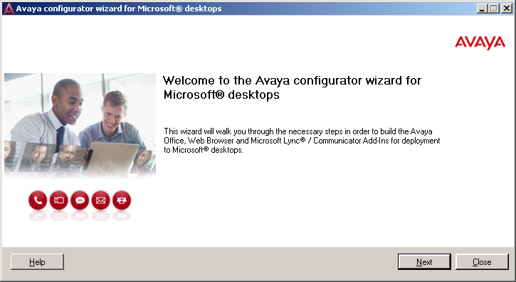

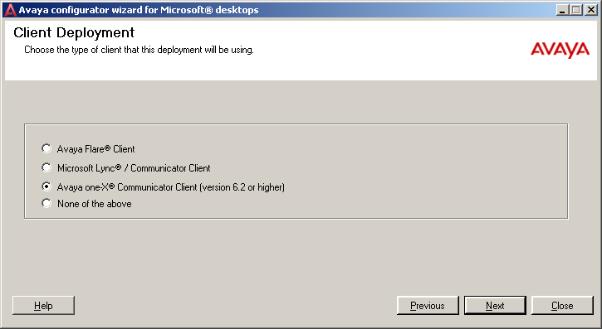
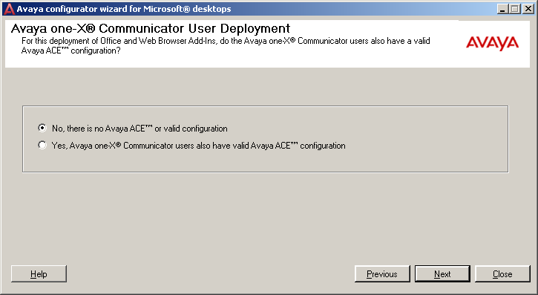

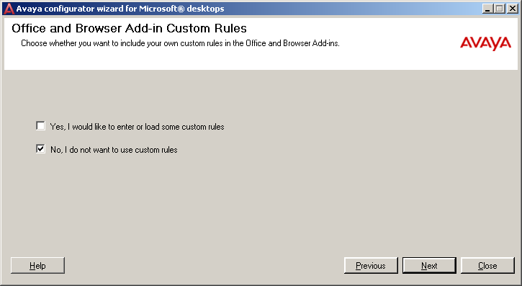

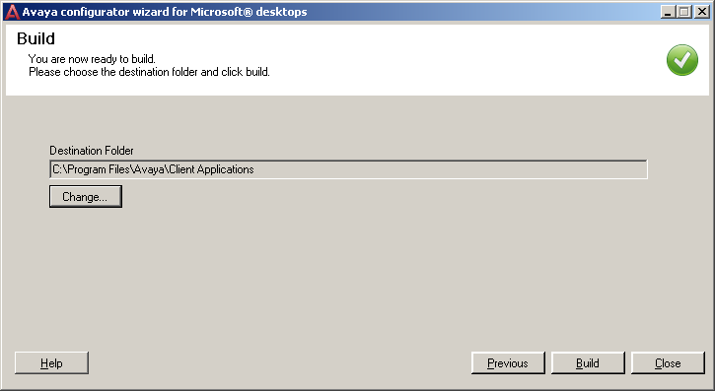

Build and Close the configurator wizard.

Go to the location provided above and click on setup.exe to install the add-ins for Browser and Office. Note – shutdown Internet Explorer and Office before proceeding.
For installing Browser add-in – go to the folder shown below and click on setup.exe and follow the steps as shown below -
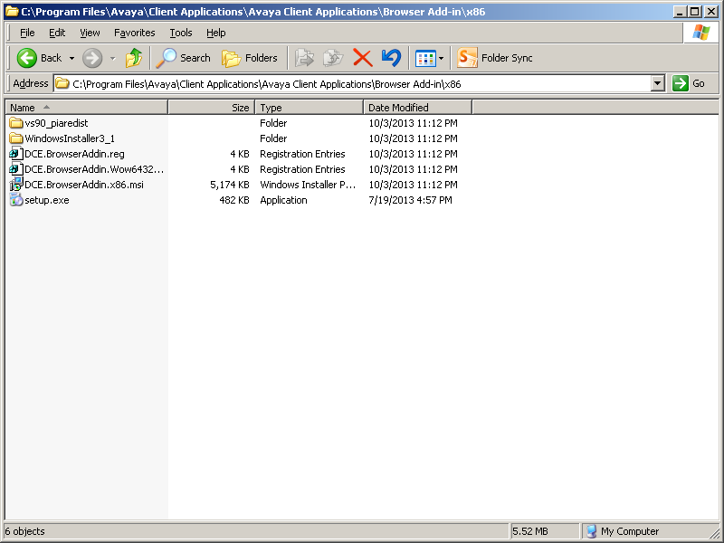

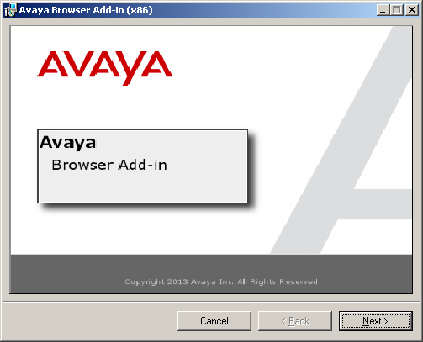
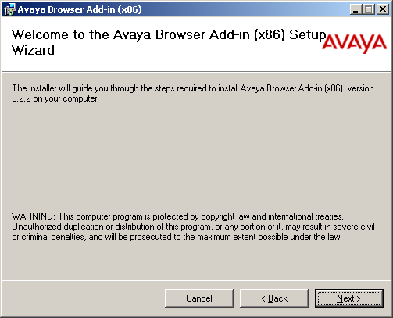
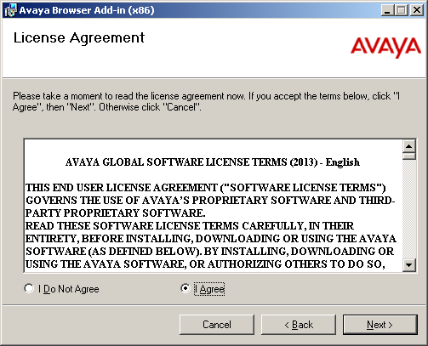
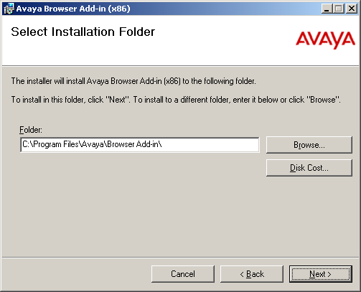
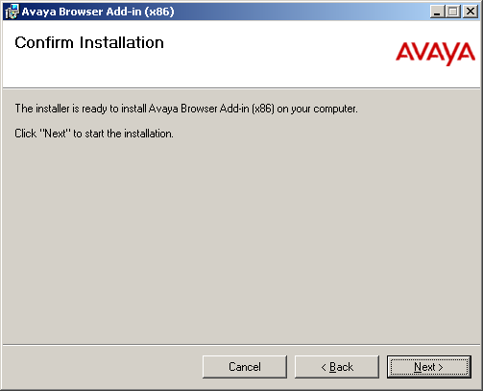
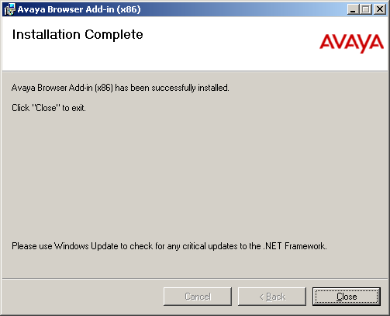
For installing Office add-in - – go to the folder shown below and click on setup.exe and follow the steps as shown below -

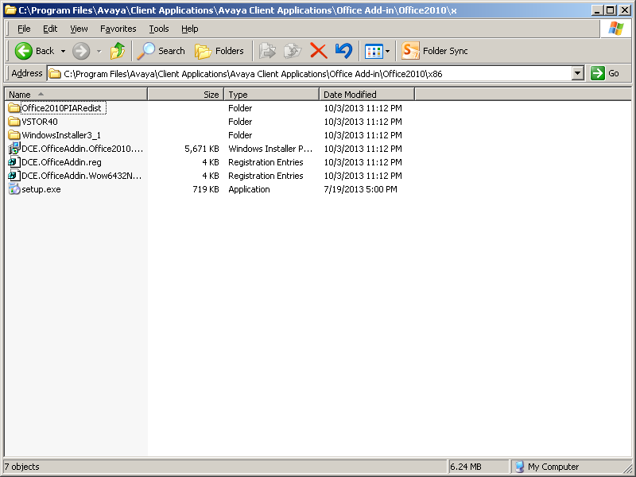

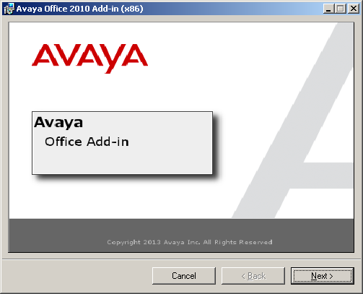

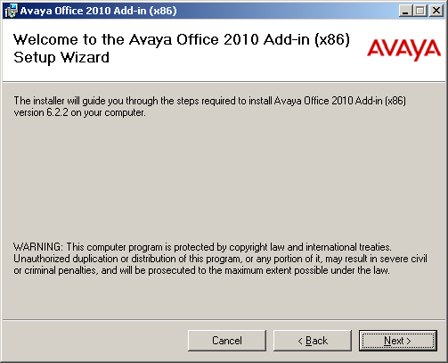

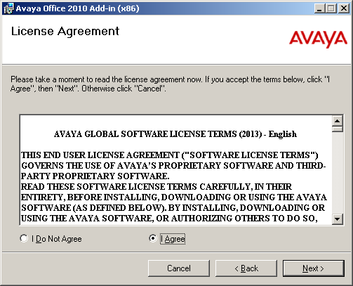

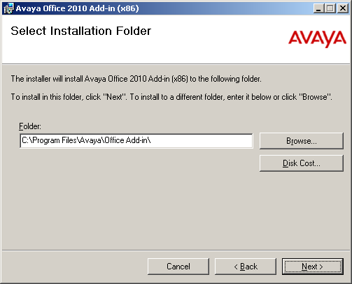
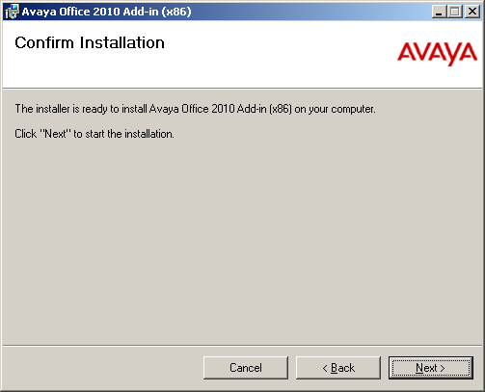

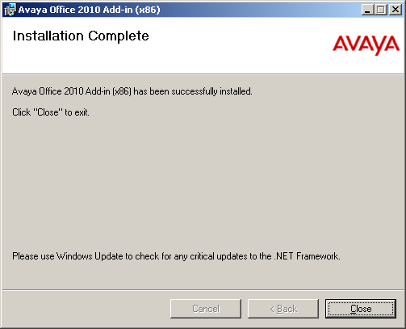

Appendix C: Reference Notes on XMPP Federation Configuration

Refer to the attached presentation for reference configuration notes on XMPP federation. For additional information on any specific products, refer to the Avaya documents on Support site.

