2022 Academic Integrity Quality Initiative Project

Project Title: Academic Integrity Quality Initiative Overview
Unit: Institutional
Project Facilitator: Vice President of Instruction – Elaine Simmons
Supervisor: Vice President of Instruction – Elaine Simmons
Project Team Members: Academic Integrity Council (see Participates)

  - Project Summary:

Issue or Challenge:
With an academic integrity (AI) policy that dates back to 2002, we found ourselves under siege in 2018 with academic integrity violations. The issue of how to address the increase of AI policy violations presented was multi-tiered and would take time, research, and testing to answer. The data table below provides a glimpse of where we have been and where we are going:

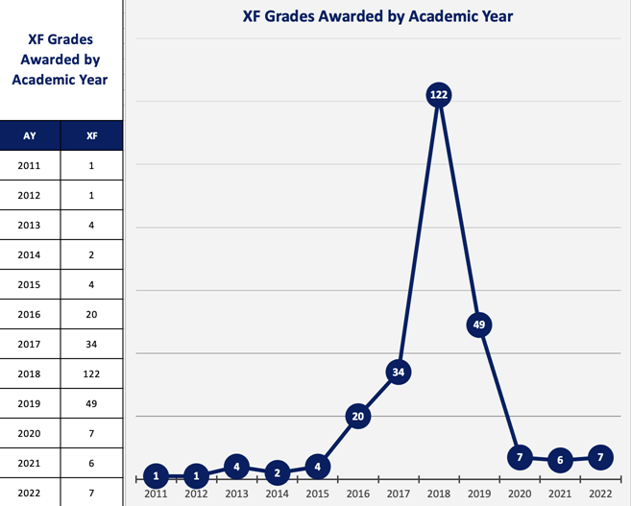
Figure 1: Created by Todd Mobray, Director of Institutional Effectiveness
Figure 1 charts academic integrity violations specifically sanctioned with an XF. An XF documents on students’ transcripts that they failed the course due to an academic integrity violation. This graph does not note all academic integrity violations; however, it implies a significant increase of violations across the institution.

Goals:
The initial challenge was to understand more clearly the problem that sat before us, determine how we could address it, and intentionally define what our proposed solutions would communicate to the stakeholders.

Initial goals to improve academic integrity were established with the creation of the Academic Integrity Council in 2018. Each of the goals listed below are discussed in greater detail in this report and referenced in the Academic Integrity Quality Initiative Timeline accompanying this report.
- Policy & Procedure
  - Update integrity procedure
  - Ensure institution’s positive reputation
- Professional Development & Student Outreach
  - Educate students on integrity expectations
  - Provide institutional professional development on academic integrity
  - Develop academic integrity materials for students
- Build a Culture of Integrity
  - Create a culture of integrity
  - Develop instructional strategies that deter cheating
- Collect Data & Measure Success
  - Conduct data inventory: Investigating what is happening in AI with metrics for measurement

Identifying these goals was the first step in an ongoing and iterative process. These goals support our primary purpose to create a culture of integrity across the institution where faculty and student engagement with integrity practices lead to improved teaching and learning and create opportunities for student success.

Brief Project Description:

Process:

2018
In 2018, the Academic Integrity Council was approved by the President to become an institutional team. With the opening of the Council, an institutional membership was acquired with the International Center for Academic Integrity (ICAI), and the beginning of an exploration and restructure of the Academic Integrity Procedure #2502 began. For the rest of the year, the Council developed its awareness of AI through its membership in ICAI and a subcommittee was formed to revise procedure #2502.

2019
In 2019, a new position was created – Director of Innovation & Excellence. Part of this position would further support academic integrity efforts and take on the primary investigator role for capital academic integrity violations. The college also attended the ICAI conference for the first time with four attendees. That summer, focus was directed to the #2502 procedure where the first and second review were presented and discussed. To support communication of the Council’s Academic Integrity initiative, initial discussions for the development of graphics and marketing materials began. By the end of the year, the #2502 procedure was presented to Faculty Council for an initial review.

2020
In 2020, the #2502 procedure was reviewed by Instructional Council and Dean’s Council and the AI Charter received an update. In March, President’s Staff approved the updated #2502 procedure. At this time, COVID was up front and center. Graphics and marketing materials were being developed, a new sub-team proposed and implemented an integrity campaign year-long plan that included the creation of Academic Integrity Student Ambassadors, and #2502 procedure continued review with an emphasis on process. These conversations resulted in another minor update to the #2502 procedure in October.

2021
In 2021, opening conversations began with expansion efforts around graphics and marketing, including the development of a website and the creation of faculty resources. For the rest of spring 2021, Academic Integrity Council members attended multiple conferences and prepared for the expansion of the Integrity Campaign. Summer proved productive with additional professional development around the AI process as well as the approval from LICC to add an Academic Integrity Statement in the institution’s Master Course Syllabi. Fall 2021, Student AI presentations provided opportunities to define ‘cheating’ and shared information and tips on maintaining integrity and resources available.

2022
As of the beginning of 2022, an AI orientation is being included in both a faculty bootcamp as well as being implemented in the “Course Binder Project.” Spring 2022 proved challenging with a spike in basic and capital violation cases. The capital investigation process was assessed and expanded to include more information around the data available and how it can be used. With the growing collection of AI data over the last four years, the Council is beginning to evaluate and gather insights into trends to identify options for further development. The launch of the AI website is scheduled for Fall 2022. The second class of the Student Academic Integrity Ambassadors will also be selected for Fall 2022.

Addressing Challenges:

Policy & Procedure:
With the creation of the Academic Integrity Council the procedure (#2502) was reviewed for needed updates for clarity of intent and application of process.

Challenge:
- Addressed an outdated policy that did not reflect current trends in cheating, institutional experiences, or academic integrity best practices

Changes Made:
- Clarified meaning and definitions
- Improved descriptions and applications
- Addressed process and implementation of Maxient and process flowchart
- Clarified process application to Problem-Resolution (#2615) and Student Code of Conduct (#2611)

Lesson Learned:
Institutional responsibility of integrity – Moving through reviewing and updating the academic integrity procedure highlighted the need for clear communication, clarification of academic integrity violations, and a fully outlined process.

Professional Development & Student Outreach
With the attention to and lessons learned from the review process of procedure #2502 and participation in regional and international organizations, the need to provide educational opportunities were more clearly identified.

Challenge:
- Provide opportunities to learn from other institutions’ best practices, trends, new ideas and approaches, etc.
- Provide professional development for faculty on identified best practices, available resources, and information about the new AI process and procedure #2502.
- Open conversations with students about what academic integrity is, types of cheating, what they can do to make good decisions.

Changes Made:
- Training based on procedure
- Awareness campaigns for students, employees, and community at large: Day against Contract Cheating, “I Choose” Campaign, Academic Integrity Week, and Academic Integrity Fair

Lesson Learned:
Communication and collaboration are key – Responding and adjusting to feedback from trainings is just as important as providing the opportunities for professional development. Working to make the process work for all stakeholders is a constant cycle of conversation and revision.

Build a Culture of Integrity
Implementing a cultural change requires consistency of message and opportunities to engage with that message. This plays a role in both the development of the procedure and the professional development goals.

Challenge:
- Develop a long-term strategy
- Review internal processes for communicating standards and expectations

Changes Made:
- Selected and promoted Integrity Ambassadors
- Developed Academic Integrity Fair
- Increased professional development and student engagement
- Implemented Academic Integrity best practices for instruction
- Developed marketing materials

Lesson Learned:
Consistency and reputation – With the consistency of message and action rooted in the procedure, we are able to follow our process and set standards laying the foundation to build a culture of integrity.

Collecting Data & Measuring Success
To not only determine the success of the changes made, but to also inform future decisions, data needed to be a point of conversation. Thus, we have begun initial research efforts.

Challenge:
- Identify data to be collected
- Identify method for collecting data
- Created process for reporting data

Changes Made:
- Maxient analytics investigated

Lesson Learned:
Importance of review and continuous learning – As an area of growth, we are beginning to look at initial data to identify trends and insights to further improve our process, professional development, and student outreach.

Timeline:
- See Timeline

Participants:
Academic Integrity Council Members:
- Carla Alford, Amanda Alliband, Paulia Bailey, Janet Balk, Angela Campbell, Deanna Heier, Darren Ivey, Erika Jenkins-Moss, Stephanie Joiner, Kathy Kottas, Karly Little, Angie Maddy, Claudia Mather, Lee Miller, Sarah Riegel, Elaine Simmons, and Andrea Thompson

Investigators:
- Stephanie Joiner and Lee Miller

Academic Integrity Campaign Sub-team:
- Janet Balk, Angela Campbell, Deanna Heier, Stephanie Joiner, Karly Little, Angie Maddy, and Lee Miller

Participating Employees:
- Faculty:
- Support:
- Administration:

Resources:
Resources that have been utilized or created over the course of this initiative include:
- Training and presentation videos
- Maxient
- “Interactive Integrity Wheel”
- “Faculty Best Practices”
- Marketing materials including logo, stickers, and notebooks
- Upcoming website
- ICAI membership resources

Measurable Objectives:
See “Collecting Data & Measuring Success” above (pg. 5) I don’t think that section answers what is needed for ‘Measurable Objectives.’ I think we need to create measurable objectives – Perhaps list our initial goals? Have we set standards or objectives that we can determine we have ‘met’? – Objectives measurable in terms of completion?

Data:
See “Collecting Data & Measuring Success” above (pg. 5) We could also consider listing the types of data we are beginning to review as well as the types of data (i.e. student feedback) we need to begin collecting.

Evaluation:
(Cathie – what else do you need here?) How will we know we have met our objectives? Do we have a timeline? Do we have a benchmark or threshold? We can’t evaluate if we don’t have specific objectives.

Quality Improvement:
(Cathie – what else do you need here?) We have evidence that we are doing a lot of great things, but we do not have evidence of impact or improvement other than our opinions at this stage… I may be being a bit harsh right here…

Everything below is discusses above under ‘Process’ and ‘Addressing Challenges’ – what else do you need here?

Successes:

Failures:

Lessons Learned:

Changes Made/Continuous Improvement:

Improved Learning:

