Classroom Assessment Techniques (CATs)

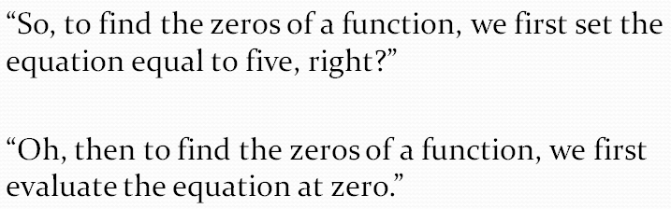
The four steps to completing a CAT:
- Choose a learning goal to assess
- Choose an assessment technique and apply it
- Analyze the data and respond to it
- Document the assessment
Examples:
- Nods/Audible*
- Documented Problem Solving/Walk-About
- Background Knowledge Probe (Pre-Test)
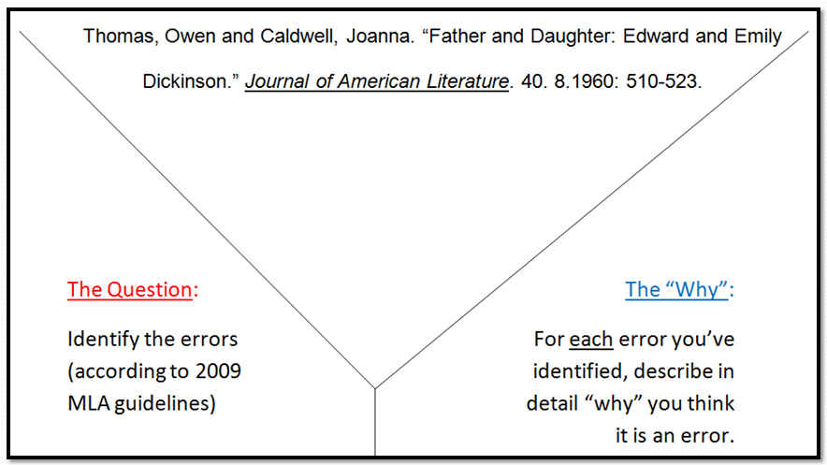
- “Y” Diagram*
- Muddiest Point*
Courses excluded from this analysis:
- Edukan courses
- 0, 0.5, 0 to #, credit hour courses
- ITV Receiving courses
- 0 enrollment courses
- Seminars
- Labs
- Field Experience
- Internship
- Practicums (CHLD 1506, 1508, 1509)
- Occupational Work Experience
- MSCT 1100, 1101, 1102, 1103, 1104
- Courses less than 2 calendar weeks in length
- PE Activities (ex. Fitness Thru Activities)
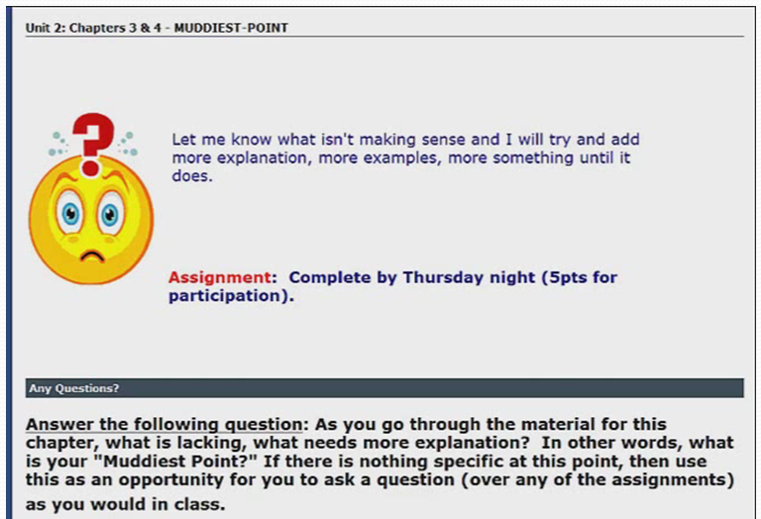
- PHED (by arrangement)
- Independent Study
- MLTC 1501, 1519, 1520
- MEAS 1102, 1103
- AUTO 1132, 1134
Total Title 3 Grant Award: $1,949,666

Goal #1
Increase the percentage of courses that incorporate classroom assessment techniques (CATs) to monitor day-to-day learning of their students to 90% by September 2014
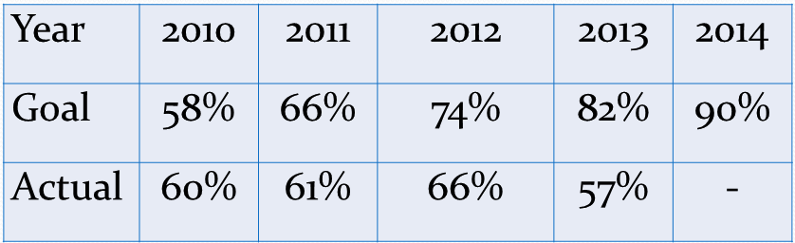
www.tinyurl.com/submitCAT
Goal #2
Increase the percentage of courses who demonstrate incorporation of improvement strategies resulting from assessment data to 90% by September 2014
