Barton’s Current Key Performance Indicators 05/02/2019

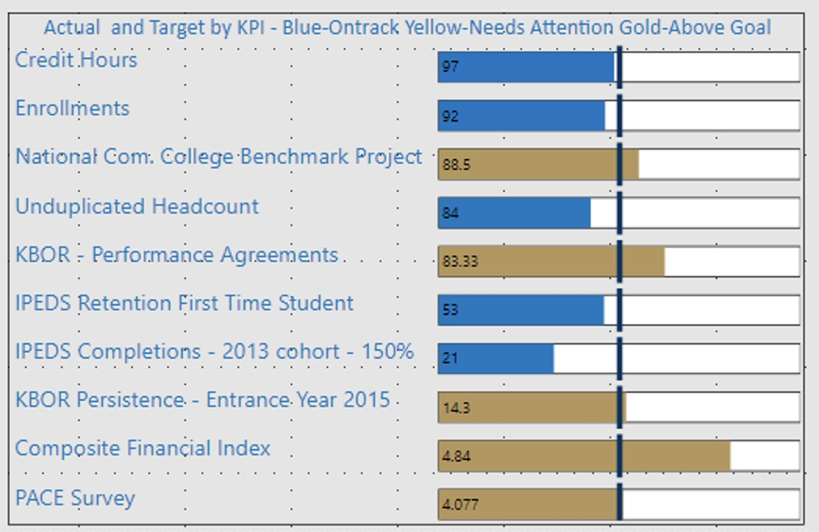

Credit Hours – flat to -3%.

Enrollments – flat to -3%.

National Com. College Benchmark Project (NCCBP) – goal to be in the Top National Ranking. Currently in Top National Ranking.

Unduplicated Headcount – flat to -3%.

KBOR Performance Agreements – meet 4 out of 6 goals.

IPEDS Retention First Time Student – meet or exceed the cohort target of 58%.

IPEDS Completions – 2013 cohort – 150% of time – meet or exceed the cohort target of 33%.

KBOR Persistence – Entrance Year 2015 – meet or exceed the cohort target of 13.8%

Composite Financial Index – meet or exceed 3.0.

PACE Survey – meet or exceed 3.0 target Currently exceeding that goal and the college administration is operating in the 4.0 collaborative system.

