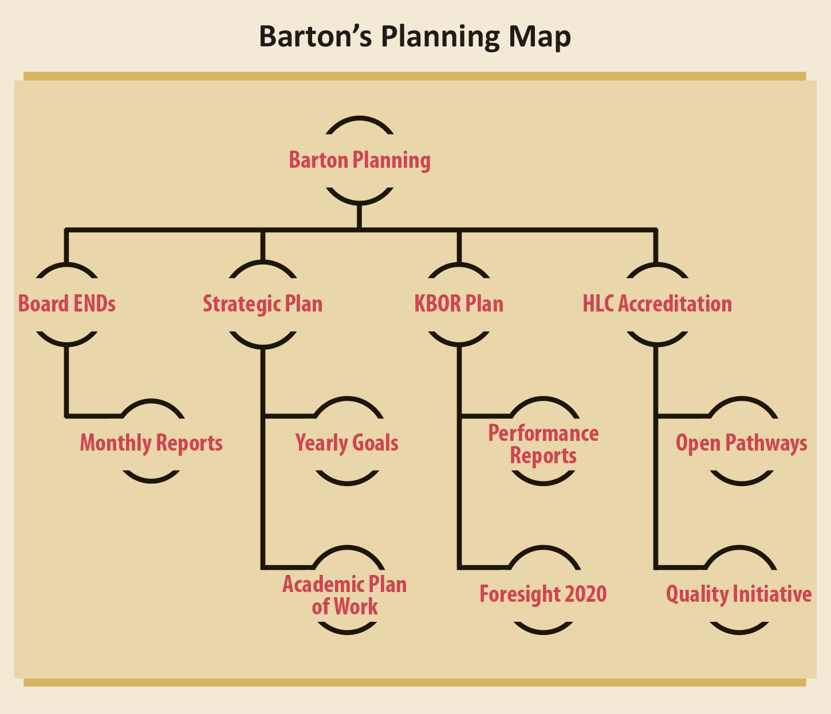

Barton Two Year Academic Plan of Work Model

Drive Student Success (Budgeted - Growth $???) (Instruction and Student Services $???)
- Prioritize retention and completion strategies
  - Identify systems and processes to improve retention and completion outcomes; implement and evaluate
  - Explore and implement intentional strategies for gathering student input, particularly related to student success, retention and completion outcomes.
- Enhance the Quality of Teaching and Learning
  - Foster student engagement through student interaction strategies
  - Strengthen Academic Integrity expectations and safeguards
Cultivate Community Engagement (Budgeted - Growth $???)
- Cultivate and Strengthen Partnerships
  - Maintain and develop partnerships with universities and school districts; identify ways to enhance post-secondary opportunities for students.
  - Identify new programs and services through existing and expanded workforce partnerships *
- Reinforce Public Recognition of Barton Community College
  - Enhance communication and marketing initiatives for BARTOnline, academic events & programs, and workforce/continuing technical educational programs
- Provide Cultural and Learning Experiences for the community
  - Offer short professional development and community centered courses online, on-campus and for our communities
  - Offer cultural events for our communities
Emphasize Institutional Effectiveness (Budgeted – Growth $???) (Institutional Support $???)
- Develop, enhance, and align business processes
  - Develop and demonstrate data-informed decision-making
  - Identify and implement strategies to reallocate and increase revenue, and maximize resources
- Cultivate a service-minded, welcoming and safe environment
  - Increase awareness and understanding of rights afforded to and responsibilities expected of stakeholders, employees and students
Optimize Employee Experience (Budgeted – Growth $??? raises, $??? professional development)
- Support a culture in which employees are engaged and productive
  - Identify and support professional development opportunities for faculty and staff
  - Create a work environment that prioritizes personal and team development.
- Develop, enhance, and align business human resource processes
  - Research alternate methods for employee evaluation and time keeping

* The 2-year Academic Plan must contain one paradigm shifting action item
Total Budgeted for Growth - $??? (Departments $???)

