Recently, Faculty and staff at Barton Community College gathered to discuss and evaluate the College’s ENDS at maturity scale planning meetings. Participants were asked to score where they felt Barton Community College was for each respective END and sub bullet. After assigning a score, comments were gathered regarding their determination as well as how to move to the next higher score. An analysis of the comments provided as feedback by faculty and staff at Barton Community College was conducted after the maturity scale planning meetings had occurred. The results are discussed below.

Analysis of Aggregated Comments
Respondents could comment on every score they assigned. However, many scores did not receive explanatory comments nor discussion for moving to the next higher score. The following comparison chart shows the number of comments regarding the assigned “where Barton is currently” score, the number of comments for “how to move to the next higher score” and the total number of scores recorded for each END.

The same information depicted in the chart is also recorded in the following table.
 | Where | Move | Possible
End 1 | 122 | 111 | 389
End 2 | 46 | 64 | 258
End 3 | 61 | 84 | 360
End 4 | 59 | 55 | 313
End 5 | 31 | 37 | 315
End 6 | 11 | 23 | 302
End 7 | 13 | 13 | 314
End 8 | 13 | 11 | 133

Both of these resources reveal that the faculty and staff did not have much feedback to provide. However, the feedback provided does contain valuable insight and themes.

Their feedback was broken down into individual words and stopwords were removed. Stopwords provide virtually no value and common examples include “the” and “an.” Word frequency analytics were conducted to identify the most commonly used words by respondents. “Student” was utilized more than any other word. “Skill”, “survey”, “essential”, and “work” made up the remaining five most utilized words. Other notable words include “advisor” and “needed.” The frequencies provide insight regarding the overall focus of the comments, which was a student orientation with a focus on essential skills, advisement, and measuring outcomes.

The 50 most commonly utilized words are shown in the following chart.
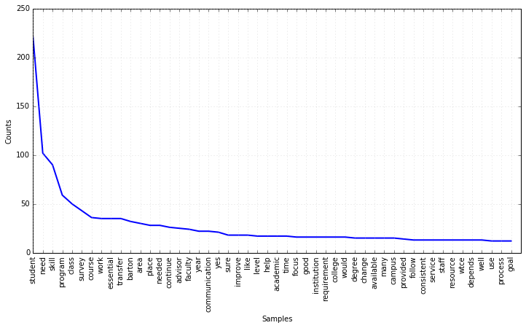
Word | Count
student | 221
need | 102
skill | 90
program | 59
survey | 43

Next the comments were evaluated based upon frequency of word pairings. The most frequently used words pairs add context to the most frequently used words. ‘Essential’ and ‘skill’ were paired together more than any other two words. The remaining top five most common pairings were 'student' and 'need', 'guided' and 'pathway', 'advisory' and 'board', and finally 'online' and 'student'. The student orientated with essential skills, advisement, and measuring outcomes focus suggested by the most frequently utilized words is further supported by the most common word pairings.

The 25 most common pairings are shown in the following chart.

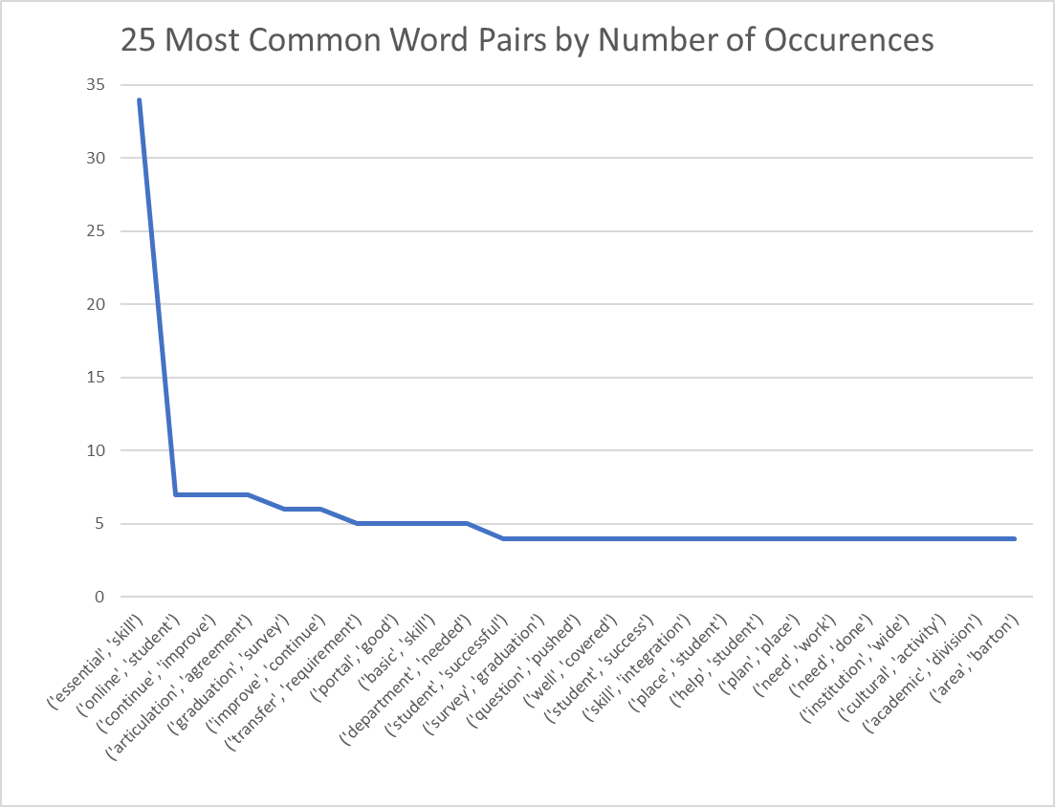

Analysis of END Specific Comments
Comments were then evaluated by the specific END and bullet item to which they were responding. Comment frequency by END and bullet are reported below.
End/Bullet | # Where we are Responses | % | # How to move Responses | % | # Possible Responses
1
1 | 31 | 29.81% | 30 | 28.85% | 104
2 | 30 | 30.61% | 29 | 29.59% | 98
3 | 29 | 31.18% | 29 | 31.18% | 93
4 | 32 | 34.04% | 23 | 24.47% | 94
2
1 | 20 | 22.73% | 25 | 28.41% | 88
2 | 18 | 21.69% | 21 | 25.30% | 83
3 | 8 | 9.20% | 18 | 20.69% | 87
3
1 | 21 | 22.11% | 26 | 27.37% | 95
2 | 14 | 15.56% | 23 | 25.56% | 90
3 | 14 | 15.56% | 19 | 21.11% | 90
4 | 12 | 14.12% | 16 | 18.82% | 85
4
1 | 16 | 19.51% | 17 | 20.73% | 82
2 | 15 | 18.75% | 13 | 16.25% | 80
3 | 10 | 14.49% | 7 | 10.14% | 69
4 | 18 | 21.95% | 18 | 21.95% | 82
5
1 | 10 | 12.66% | 9 | 11.39% | 79
2 | 4 | 5.33% | 7 | 9.33% | 75
3 | 13 | 14.77% | 12 | 13.64% | 88
4 | 4 | 5.48% | 9 | 12.33% | 73
6
1 | 5 | 7.69% | 5 | 7.69% | 65
2 | 0 | 0.00% | 2 | 3.39% | 59
3 | 3 | 5.45% | 5 | 9.09% | 55
4 | 1 | 1.64% | 3 | 4.92% | 61
5 | 2 | 3.23% | 8 | 12.90% | 62
7
1 | 4 | 4.60% | 6 | 6.90% | 87
2 | 4 | 5.00% | 3 | 3.75% | 80
3 | 1 | 1.43% | 1 | 1.43% | 70
4 | 4 | 5.19% | 3 | 3.90% | 77
8
1 | 8 | 10.81% | 8 | 10.81% | 74
2 | 5 | 8.47% | 3 | 5.08% | 59

Themes within the context of each END and bullet were identified. Comments were examined for similarities and topics most frequently discussed were consolidated into succinct themes. It is worth mentioning that the overall number of comments was low and that any themes identified should be carefully considered and likely not considered a significant representation of the population of faculty and staff at Barton Community College. However, that does not negate any insight gained, but rather serves as a warning against overstating any results or trends identified. The following table reports the overall theme for each END and bullet for the “where Barton is currently” and “what is needed to improve” categories of commentary.

 | Where | Move
End 1
Bullet one | Not uniform across college/programs | Need more consistency across entire college; required
Bullet two | Not uniform across college/programs | Need more consistency across entire college; Academic Divisions may be behind; More student training needed
Bullet three | Not uniform across college/programs | Need more consistency across entire college; Students could benefit from a basic life skills course requirement
Bullet four | Sufficient | Need more consistency across entire college; Mandatory/assessment implementation
End 2
Bullet one | Most are there | Make sure all venues and students have them; Gather feedback to assess readiness of former students
Bullet two | May be a problem for some areas | Make sure essential skills are emphasized
Bullet three | As expected | Depends on the individual student; Connect material and work environments
End 3
Bullet one | Do well but may improve through Degree Works and advisor training | Better articulation program and promotion
Bullet two | Good alignment with advisors | Tools and communication with students to eliminate confusion
Bullet three | Students are informed | Guided Pathways/more advisement
Bullet four | Have existing partnerships | More partnerships/Guided Pathways/advising
End 4
Bullet one | Difficult to get accurate responses from students | Increase student participation through efforts emphasizing importance
Bullet two | Some instructors take their evaluations seriously, but most students don't | More follow up with faculty
Bullet three | Not sure/students don't take survey's seriously | Gather more responses
Bullet four | "lacking an effective diverse cultural relationship between staff, faulty and foreign students" | Increase the number of cultural experiences
End 5
Bullet one | Proactive efforts exist at Barton | Continued use of advisory boards
Bullet two | Improving | More visibility and transparency; Better resource allocation across all locations
Bullet three | Have strong partnerships in place | Increased visibility in business community for all locations
Bullet four | Improving but unsure if BCC is viewed as a leader by community | Increase awareness and visibility in communities
End 6
Bullet one | May need nontraditional support hours for students | Work to standardize at all locations/campuses
Bullet two |  | More online tools like Admissions Portal
Bullet three
Bullet four
Bullet five |  | Improve communication with all locations to increase faculty/staff buy in and participation
End 7
Bullet one | Current plan meets this goal | Ongoing communication
Bullet two | Continued Ends Meetings/Planning
Bullet three
Bullet four |  | Add evaluation of previous decisions to process
End 8
Bullet one | Barton is mindful of its resources | Not all departments/areas as efficient as others; Increase communication among employees and locations before changes made
Bullet two | President communicates well with Trustees

Two major themes quickly emerged during comment evaluation. The first and most common theme centered on a need to improve uniformity across the entire college. The second theme indicated that increased efforts towards greater visibility and communication were needed. Additionally, a sub item of the second theme reflected a desire for greater usage of online tools to accomplish the second theme. The identified themes are discussed further in the next section.

Lessons Learned
Theme 1: Need to improve uniformity across entire college.
- 9 of the individual END and bullets summary themes echoed this message.
- Most often concern was communicated that not all parties are equal in terms of efficiency, student service, and academic standards.
  - Concern students were not equally served was also present.
The first theme centers on ensuring students have the same education, student services, and support regardless of how or where they attend Barton. Comments covered everything from using resources efficiently, to providing better tools for advisors and students to ensure success. Additionally, respondents advocated for increased attention be paid to student evaluations. Specifically, they wanted both the students to take evaluations seriously and faculty to carefully consider the feedback given. Further, comments also expressed concern over the perceived differences across departments and campuses. Most often the commenter felt others did not perform as well as their respective group did; so some bias is surely present in these opinions.

Theme 2: Need to increase efforts towards greater visibility and communication by the College.
- Greater usage of online tools to reach audiences.
  - Admissions Portal
  - Guided Pathways
- Increase awareness in the community.
  - Leader on business training.
  - Leader on economic development.
- Increase student awareness of programs, transfer options, student services, and various tools available to them.
- Expand business partnerships and enhance offerings to the various business needs that exist near Barton.
The second theme is less about internal visibility and communication and more about Barton self-advocating in the surrounding communities and internal audiences. Comments emphasized a need to make various businesses, community members, and students aware of the services, products, and solutions Barton produces. From 2+2 agreements to Barton’s ability to lead economic development, respondents felt there was much more that could be done to leverage these aspects into win/win scenarios for both the college and its partners.

Appendix

Word clouds of most common words.
