Barton Student Address Maps – 09/15/2020

Barton Institutional Research creates various enrollment reports to assist college employees in determining ways to grow enrollments.

One such report is titled: Live Student Address Profile located in the College Wide App.

Below are highlights from the above report.

- Barton is everywhere people are in the United States. (looking at the heatmap with only Enrolled slicers applied)

- People who enrolled with Barton often originate from major cities, such as Los Angeles, New York, Chicago, Dallas, and Miami. (looking at the heatmap with only Enrolled slicers applied, but zoomed in)

- Main Campus draws students from every corner of Kansas. (Looking at circles with only Main Campus, Enrolled, and KS selected)

- The largest clusters of students enrolled from Kansas originate in Kansas City, Wichita, Manhattan/Junction City, and Topeka. (Looking at circles with Enrolled selected and zoomed in)

- The top 5 states enrollments originate from are Kansas, California, Missouri, Texas, and Oklahoma. (USA student counts page, enrolled slicer only)

- In terms of geographic diversity, BARTOnline is most diverse followed by Edukan, Fort Riley, Main Campus, Grandview Plaza, and Fort Leavenworth. (heatmap, enrolled selected, and each campus only selected.
- BOL

- Barton County Campus

- Fort Leavenworth

- Each campus footprint by county in Kansas is very different and would represent different markets. (counts tab, KS selected, Enrolled selected and each campus selected).

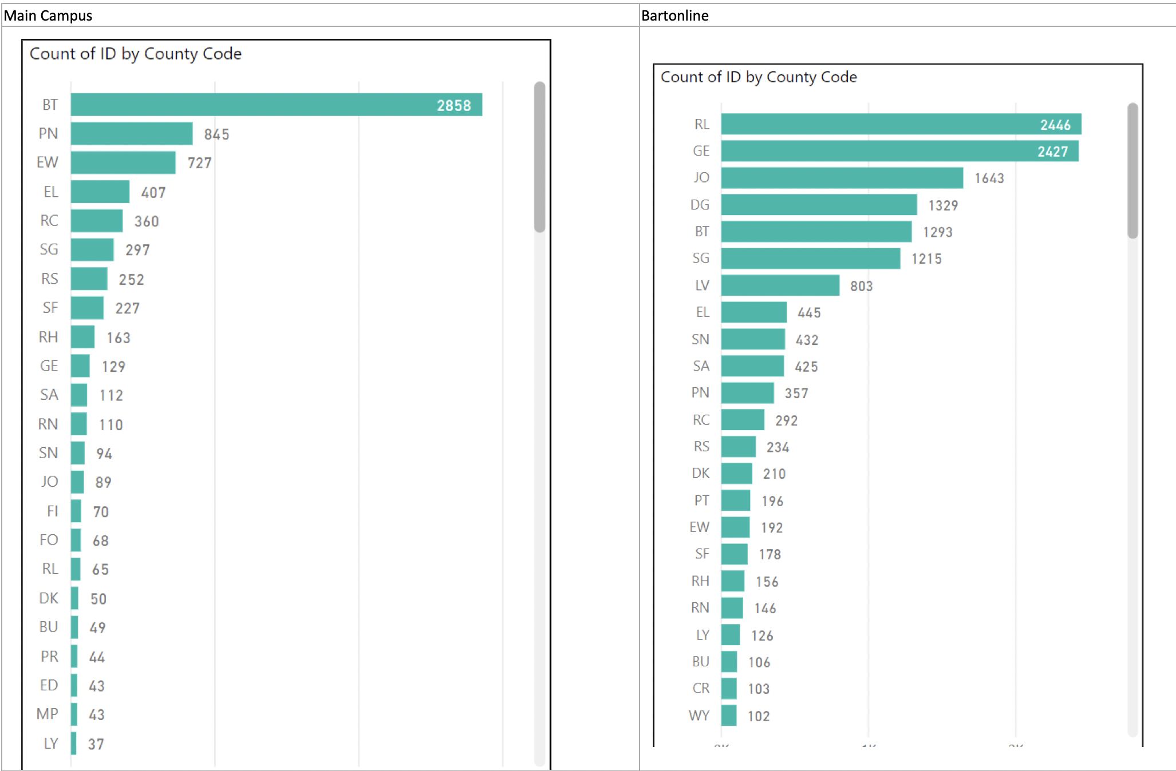

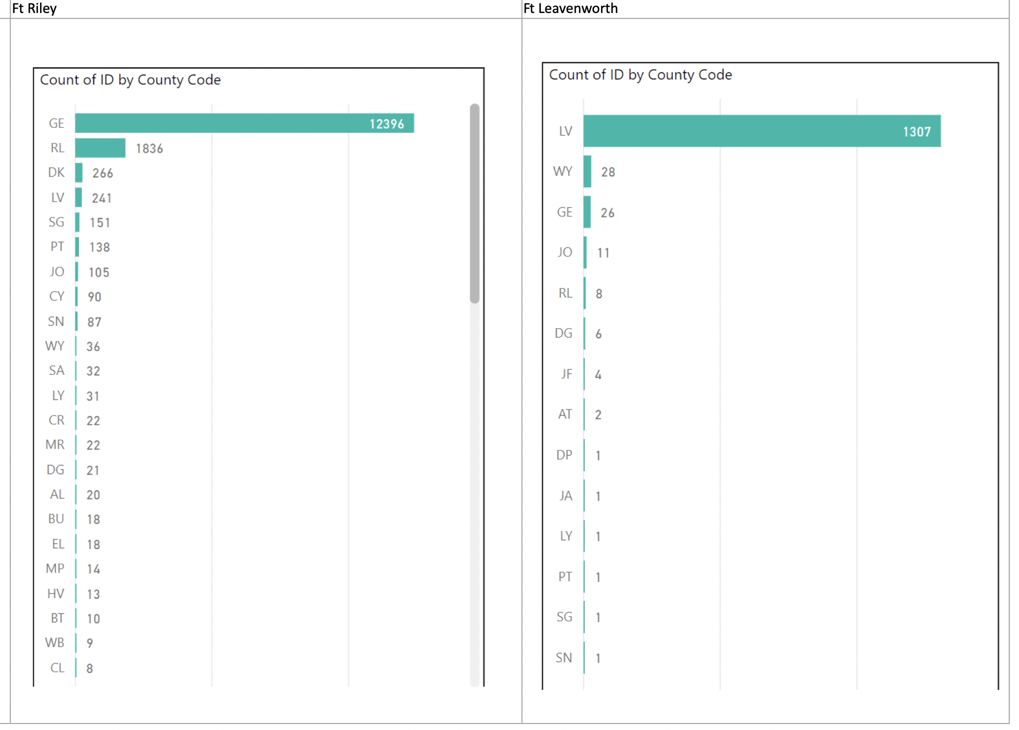

- Markets for BARTOnline should be thought of in terms of cities not states. (Heatmap, enrolled, BARTOnline selected).

