Board END: Service Regions

The College Mission will be supported by the strategic development of service regions.

- Service regions will be compatible to the institutional mission of the College.
- Service regions will be in accordance to available resources.
- Service regions will maximize revenues and minimize expenses.
- Service regions will minimize local tax reliance.
- Service regions will compliment growth of student learning services.

On a regular basis the college reports to the board and various initiatives which are being undertaken. Also the Board just approved the Strategic and Yearly Barton Success Plans. The reports and plans are how we communicate to the Board the various service regions. At all levels of the college great care is taken to insure that any new service region is carefully analyzed to ensure compatibility with the mission of the College. After due diligence in this area then plans are produced and new areas of service are explored.

Service plans are developed with the expectation that revenues will exceed or at minimum meet expenses. This was reinforced this past month with the Bartonline report to Trustees. The Fort Riley service area does help lower local taxes. Barton’s current mill levy for Y2011 is 32.659 without the Fort Riley operations Barton’s mil levy would have been 36.276.
The college makes extensive use of advisory boards giving us the most up to date information on needed classes and also helps us find instructors. By having advisory boards assist in the development of education and training programs that ensure our students have the skills necessary to compete and succeed in the workplace. Along with the necessary skills is also the component of job opportunities after graduation. We continue to be appreciative and encouraged by the resourcefulness of college employees to find ways to lower the cost of delivering education.

Over the past several years the college has worked diligently in moving to a funding model of 1/3 local tax payer, 1/3 state funded and 1/3 student funded. Below is a chart showing where the college is currently.

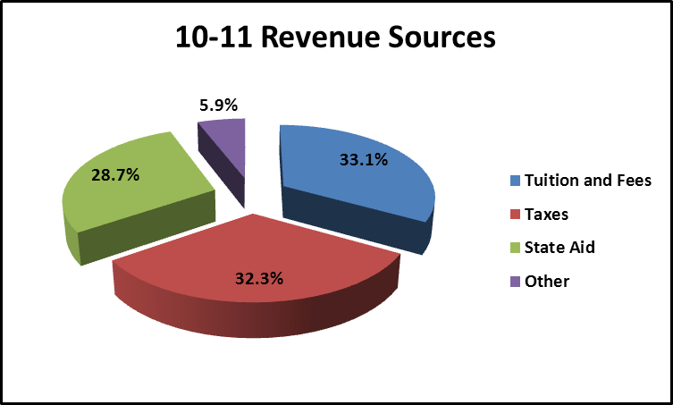

As the college has moved from face to face to hybrid and online solutions Dean for Student Services, Angie Maddy, is reviewing different models to constantly improve student services.

Through the current Title III grant, the college established some objectives related to the distance education services. While access to services can be essential to the online only student, the enhancement of services for distance students will, in the long run, pay dividends for all students.

Included in projects related to distance education services has been work to align the information available on the Barton website and on the Bartonline website to ensure that the information is consistent in both places. From these efforts came the development of the One Stop for Students webpage. (http://www.bartonccc.edu/current/collegesvcs/oncampus/) This page brings together a variety of information on services that can be useful to all students and can be contained in one place. It’s essentially a directory of services, so to speak.

Related to the task of aligning messages for better consistency has been a project to consolidate the registration confirmation information that students receive for enrolling in fully online, hybrid, or ecompanion classes. In the past, these confirmations came from different places, had slightly different formats, and contained some information that might have been construed by students as contradictory. Thus, aligning the information may reduce students’ confusion and reinforces consistency in terms of student service.

Another project that has been piloted with the distance education students has been an enhanced Early Alert process, designed to identify students who may become at risk of falling behind in their classes. Students who have not “attended,” (i.e. logged in) very often, very long, or for a certain period of time and/or students who have low grades are contacted with this information and with information about services that may be of help to them. Additionally, advisors for these students are contacted so that they might also reach out to offer assistance to the students. While Barton has long had an Early Alert procedure for Barton campus face to face classes, the process requires additional effort from the faculty, whereas the enhanced process can pull information readily available in the ecollege system.

A fourth project in the very beginning of implementation is a Constituent Relationship Management (CRM) system. This system should allow Barton to collect better data and better track students throughout their relationship with the institution, from inquiry to completion. The idea is that Barton will better understand who is inquiring, who our students are, how we are communicating with them, etc. The CRM system will begin its implementation at Barton in mid-November.

Numerous other projects are in various stages of review/development/implementation including projects on placement testing, academic advising, retention, enhanced technology, etc.

