Volunteers In Action Website Enhancements

Landing Page

Logo (attached)
Volunteers In Action Logo
RSVP Logo Under55
Contact Us
Volunteers In Action
1025 Main #D114
Great Bend, KS 67530
620.792.1614
volunteersinaction@bartonccc.edu
Executive Director
Linn Hogg
620.786.7558
hoggl@bartonccc.edu
Volunteer Coordinator
Megan Barfield
620.786.7559
barfieldm@bartonccc.edu
Meals On Wheels
Yvonne Strecker
620.786.7557
streckery@bartonccc.edu
Medical Transportation
Victoria Garza-Reyes
620.786.7556
garzav@bartonccc.edu
Announcement Block
Don’t forget to RSVP for the annual RSVP Volunteer Appreciation Banquet
August 14th, 2014
6:00p.m.
Call our office today.
620.792.1614
New Volunteers (link to form)
Report Hours (link to form)
Nonprofit Organization (link to separate page)
Fillers/Whitespace/Visual
TED Video to embed:
<iframe src="http://embed.ted.com/talks/mark_bezos_a_life_lesson_from_a_volunteer_firefighter.html" width="640" height="360" frameborder="0" scrolling="no" webkitAllowFullScreen mozallowfullscreen allowFullScreen></iframe>
vol·un·teer [vol-uhn-teer] noun
1. a person who voluntarily offers himself or herself for a service or undertaking.
2. a person who performs a service willingly and without pay.

Volunteer graphic from Volunteer Handbook
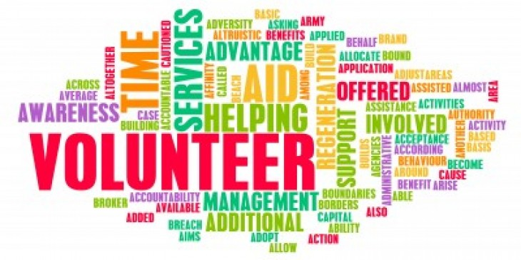

Content
Volunteers In Action: Your local one-stop volunteer center serving all of Barton and Pawnee counties. We strive to match both retired seniors and working professionals who want to volunteer their skills with nonprofits who need their help.
Our Mission
Through the recruitment of skills-based volunteers of all ages we will leverage the specialized skills and talents of individuals to strengthen the infrastructure of our local nonprofits. Connecting volunteers with the agencies will empower each group and create an environment of sustainability enabling the agencies to better fulfill their missions.
Our Story
For over 35 years Retired and Senior Volunteer Program, R.S.V.P., has been in the community giving our retired seniors a way to give back and share lifelong learned skills and experiences. This program is growing and thriving and will continue to do so! Along with our local senior volunteers, we are actively growing our volunteer center to include all ages. Men. Women. Children. Everyone has something to share and we want to encourage you to share your skills, passions and talents with the many nonprofit organizations throughout Barton and Pawnee counties.

What is SKILLS-BASED VOLUNTEERING?
Skills-based volunteerism is service by individuals or groups that capitalizes on personal talents or core business skills, experience or education. More and more, agencies are struggling to meet their bottom line. In fact, a 2006 Deloitte/Points of Light IMPACT study indicated that:
- Nine out of 10 nonprofits realize that volunteer skills are extremely valuable
- Seventy-seven percent of nonprofit organizations believe they would benefit from corporate volunteers
- Sixty-two percent work with corporate volunteers and only 12 percent of agencies align roles with skill
This gap means that many agencies are missing out on a precious resource — the talent of individual volunteer leaders and corporate teams who can use their skills and products to increase the capacity and effectiveness of nonprofits. Skill-based volunteerism or SBV comes in all shapes and sizes and can include:
- Individual volunteers, corporate paid or non-paid volunteers, groups, loaned executive, or interns
- Projects completed in one day, short, medium or long-term projects
- Activities performed during working hours or on individual time
- Planned in advance or spontaneous (such as disaster response) projects
- Application of all types of skills and talents from business professional experience to hobbies
- Content from nonprofit infrastructure efficiency effort to direct “in the field” projects
- Local impact to national and international
Volunteers In Action believes that more agencies must seize the opportunity to leverage talent and that more businesses are eager to activate around their brand and core business. We believe SBV is meant to do more — more for volunteers, agencies and communities. We are committed to helping companies activate SBV through information, research and easy-to-implement tools.

Other Services
Meals On Wheels (logo attached)
Meals on Wheels is a non-profit organization founded in 1972 to provide a hot, well balanced meal to persons age 60 and over who are unable, due to age, physical, or mental condition or infirmity to shop, or prepare meals for themselves.
Meals are served five days a week in the city limits of Great Bend, Hoisington and Ellinwood, and are prepared by the Great Bend Senior Center.
The cost of a meal is $5.25 for those that do not meet the over 60 and housebound criteria. If those criteria are met, we ask for a suggested donation of $3.35 per meal.
Interested in receiving a meal?
Know someone who would like to receive a meal?
Interested in being a volunteer Meals On Wheel driver to deliver meals?
Call our office at 620-786-7557 today!
Your support greatly benefits our community, and helps to maintain this vital program.

Medical Transportation (logo attached)
Medical Transportation is a service we offer to anyone needing a ride to any medical related appointment, including the pick-up of your prescriptions. There are no age or income requirements to meet.
Our volunteers pick up and drive individuals to many of the surrounding communities and cities, including Hays, Salina, Hutchinson and Wichita.
Volunteers are essential in keeping this much needed service in place. If you’re interested in being a medical transportation driver, please call our office for more information.
To request a ride or become a volunteer driver, call Victoria at 620-786-7556.

