CMA Textbooks

[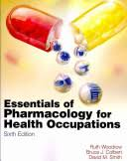](https://www.google.com/shopping/product/8068495036658720637?safe=off&biw=1920&bih=963&sclient=psy-ab&q=essentials+of+pharmacology+for+health+occupations+6th+edition&oq=essentials+of+pharmacology+for&pbx=1&bav=on.2,or.r_cp.r_qf.&bvm=bv.78597519,d.eXY&tch=1&ech=1&psi=cmhSVNzYOcyfNuTngPgK.1414686835475.15&ei=3mtSVOfrC4OfyAS5o4DYAQ&ved=0CGgQqSswAA)[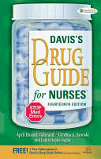](https://www.google.com/shopping/product/13960957025646517381?q=davis+drug+guide+14th+edition&safe=off&biw=1920&bih=963&sqi=2&bav=on.2,or.r_cp.r_qf.&bvm=bv.78597519,d.eXY&tch=1&ech=1&psi=cmhSVNzYOcyfNuTngPgK.1414686835475.7&ei=aWpSVIqBIY_4yQTkyoKgAg&ved=0CGcQqSswAA)

Davis’s Drug Guide for Nurses

14th Edition

ISBN: 9780803639768

**Essentials of Pharmacology for Health Occupations**

6th Edition

ISBN: 9781435480339