#1 - How Do I Access and Fill Out My Time Sheet?

Introduction
Self-service Web Time Entry is a web-based time entry system designed to improve accuracy and eliminate loss or delays in paper processing of physical time sheets. The Web Time Entry system will allow you to log into a secure website and enter your hours worked and leave taken online from any computer with access to the Internet. Your time is then approved online by your supervisor and sent electronically to Payroll for processing.
In order to be paid each month, it is critical that you submit your time sheet by the deadline noted in the hourly employee pay calendar. You are responsible for submitting your electronic time sheet to your supervisor. Without a time sheet, the supervisor is unable to approve your time, and you will not be paid.
Accessing Time sheet
After accessing PAWS, click on the Employee tab, which will bring up the employee menu page. Click on Hourly Time sheet and Salaried Leave Reporting. Next click on Hourly Employee Time Sheet. If you have multiple positions, they will be listed separately and you will need to record your pay period hours separately for each position. If a position is not listed, please notify Human Resources.
Some words of caution. Because of functionality problems, do not click on the back browser nor double click on any of the fields while using Web Time Entry.
If the pay period for which you wish to enter time is not shown underneath the Pay Period and Status column, you will need to click on the down arrow to select a different pay period. Once you have selected the correct position and pay period, click on Time Sheet. Once you click on the Time Sheet the time sheet status will change from Not Started to In Progress.
Once you have opened your time sheet to enter time, click on the Enter Hours link underneath the day you worked and on the row for the appropriate earnings type such as regular pay, holiday/closure/jury duty, vacation leave, sick leave, etc. for which you are reporting hours. For example, if wanted to enter regular pay for hours worked on Oct 28, 2016, you will click Enter Hours.
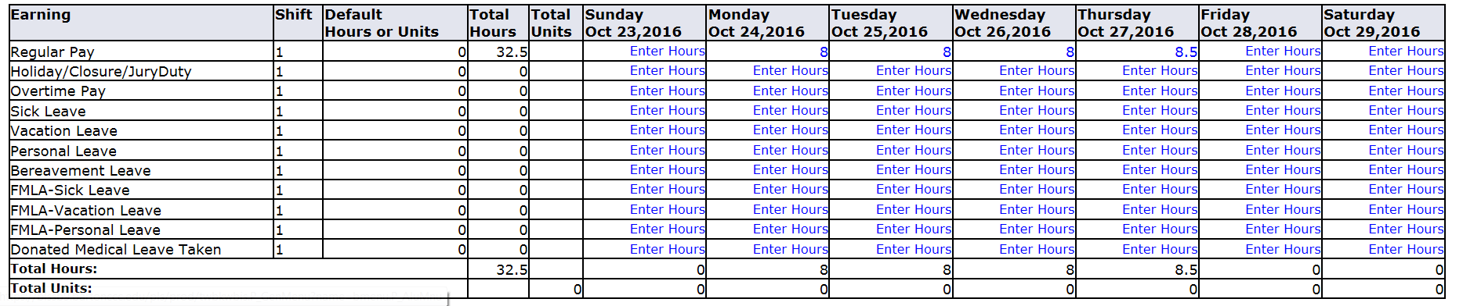
Insert the number of hours worked in the box that appears. You will then click Save.
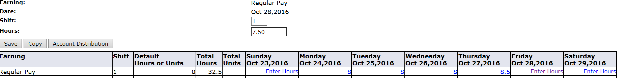
Hours must be entered for each day worked or each paid holiday or leave period for which you are claiming time within the pay period. Remember, hours recorded for the day are to be rounded to the nearest 15 minutes as shown on the Quarter Hours Increment Chart located on the Barton web site.
Employees must receive prior permission from their supervisor before working any overtime. Paid holidays, vacation leave, sick leave, personal leave, bereavement leave, official college closure, jury duty, and any other paid leave shall not accrue towards the working hour’s overtime clause of the Fair Labor Standards Act. Overtime is not computed on an 8 hour day.

In this example, overtime would not apply.
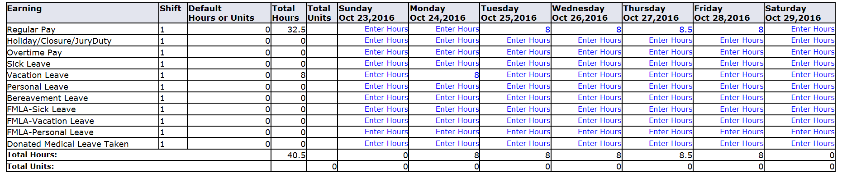
In this example, overtime would apply. Overtime isn’t calculated until you have physically worked 40 Regular Hours.
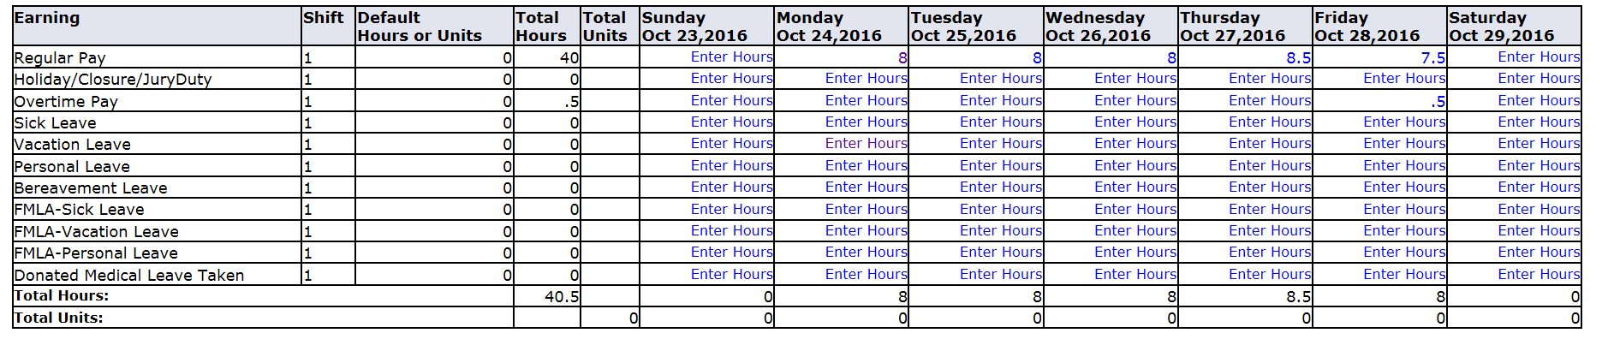
To remove incorrectly entered hours, highlight hours and use the delete key found on your key board to remove them. Do not enter “0”. Next you will need to click Save.
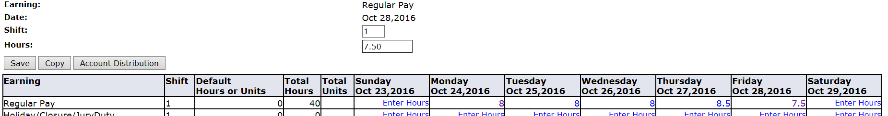
Hours should be entered on a daily basis so they can be checked by your supervisor and should not be entered before they are worked.
Each pay period is either a 4-week or 5-week period but not all of the days can fit on the width of one screen. Click on Previous or Next at the bottom of the screen to toggle back and forth between each week.
Do not click Submit for Approval until you have finished entering all of your hours for the entire pay period.
If you are finished entering hours worked and leave taken, and reviewed your time sheet for the entire pay period and are ready to submit for approval, click the “Submit for Approval” tab.

You will then be asked to enter a Password/Portal Pin. This will be the same password you used to log into the Portal.
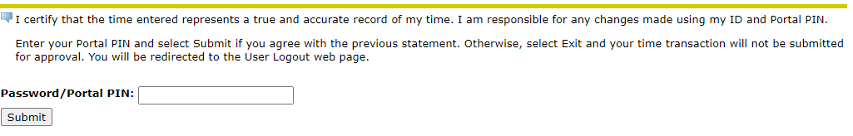

You will then see, Your time sheet was submitted succesfully.

Should this message appear, contact Shelly Schmidt in IT at 620-792-9383.
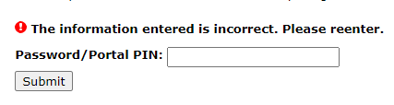
Log Out
To exit PAWS, click the Exit button in the upper right hand corner of the screen.
