**#7 - How Do I Access and Fill Out My Web Leave Report?**

Introduction

Self-Service Web Leave Reporting is a web‐based leave entry system designed to improve accuracy and eliminate loss or delays in paper processing of physical leave reports. The Web Leave Reporting system will allow you to log into a secure website and enter your leave hours taken online from any computer with access to the Internet. Your leave report is then approved online by your supervisor and sent electronically to Payroll for processing.

It is critical that you submit your web leave report by the deadline noted in the salaried employee pay calendar. You are responsible for submitting your electronic leave report to your supervisor.

Accessing Leave Report

After accessing PAWS, click on the **Employee tab**, which will bring up the employee menu page. Click on **Hourly Time Sheet and Salaried Leave Reporting.** Next click on **Salaried Employee Leave Reporting.** Next click on **Access my Leave Report** and then click on **Select**. If you have multiple positions, they will be listed separately. If a position is not listed, please notify Human Resources.

*Some words of caution. Because of functionality problems, do not click on the back browser nor double click on any of the fields while using Web Leave Reporting.*

If the pay period for which you wish to enter leave is not shown underneath the **Leave Report Period and Status** column, you will need to click on the down arrow to select a different pay period. Once you have selected the correct position and pay period, click on **Leave Report**. Once you click on the **Leave Report,** the leave report status will change from **Not Started** to **In Progress.**

Once you have opened your leave report to enter leave, click on the **Enter Hours** link underneath the day you took leave and on the row for the appropriate earnings type such as sick leave, vacation leave, personal leave, etc. for which you are reporting hours. For example, if wanted to enter Sick leave hours for Tuesday, March 2, you will click **Enter Hours**.

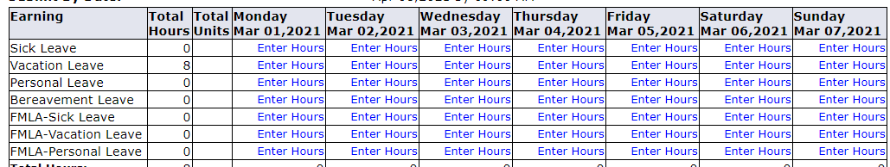

Insert the number of hours of leave taken in the box that appears. You will then click **Save**.

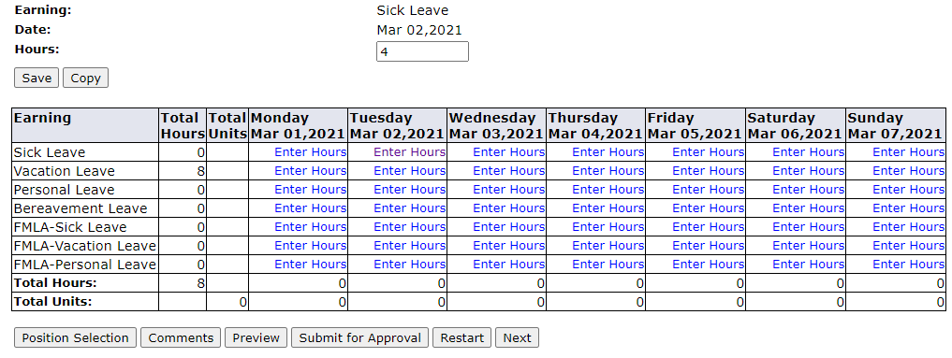

To remove incorrectly entered hours, click on hours and use the delete key found on your key board to remove them from the box. **Do not enter “0”.** Next you will need to click **Save**.

Leave taken should be entered daily so that hours can be checked by your supervisor. Leave taken can also be entered ahead of time for an extended period of time if necessary.

Each pay period is from the first of the month to the end of the month. Click on Previous or Next at the bottom of the screen to toggle back and forth between each week.

Do not click **Submit for Approval** until you have finished entering all leave taken for the entire pay period. Wait to **Submit for Approval** until the end of the month or until your supervisor asks you to do so.

If you are finished entering leave hours taken, and reviewed your leave taken for the entire pay period and are ready to submit for approval, click the **Submit for Approval** tab.



You will then be asked to enter a **Password/Portal Pin**. This will be the same password you used to log into the Portal.

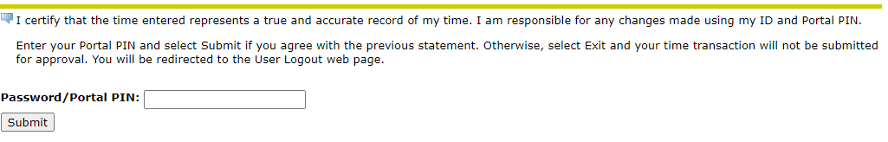

You will then see, **Your Leave Report was submitted succesfully**.

cid:image001.png@01D7209E.BD859990

Should this message appear, contact Shelly Schmidt in IT at 620-792-9383.

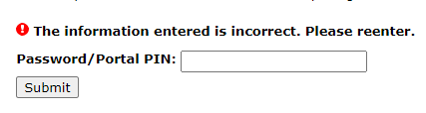

Log Out

To exit PAWS, click the **Exit** button in the upper right hand corner of the screen.

