FPV Disassembly & Quality Control SOP
Author: CPT Alexander H. King

POC | Notes | Date
CPT Alexander H. King | Initial Release | XX NOV 2025

Table of Contents
1. Drone/Part Inspection 5
1.1 Whole Build 5
1.2 Critically Damaged FPV Build 5
1.3 Individual Component 6
2. Disassembly of FPV Drones 7
2.1 Disassembly Station Layout 7
2.2 Component Cleaning 9
3. FPV Part Quality Control 10
3.1 Frame Components 10
3.2 Fasteners 10
3.3 Motors 10
3.4 FC and ESC 11
3.5 VTX/RX 11
3.6 Props 11
3.7 Antennas 11
4. FPV Component Marking SOP 11
4.1 Frame Components 11
4.2 Fasteners 12
4.3 Motors 12
4.4 FC and ESC 12
4.5 VTX/RX 13
4.6 Props 14
4.7 Antennas 14
5. Damaged Component Storage/Disposal 14
5.1 Frame Components 14
5.2 Fasteners 14
5.3 Motors 14
5.4 FC and ESC 15
5.5 VTX/RX 15
5.6 Props 15
5.7 Antennas 15
6. Build Kit Quality Control 15
6.1 Gummies 15

Figure 1: Station 1 Layout 7
Figure 2: Station 2 Layout 8
Figure 3: Station 3 Layout 9
Figure 4: Motor Disassembly 10
Figure 5: Frame Component Marking 12
Figure 6: Motor Marking 12
Figure 7: FC Marking 13
Figure 8: ESC Marking 13
Figure 9: VTX/RX Marking 14
Figure 10: Antenna Marking 14
Figure 11: QTY 4 Short Gummies & QTY 4 Standoff Gummies 16
Figure 12: QTY 8 Short Gummies & QTY 4 3D Printed Spacers 16

1. Drone/Part Inspection

1.1 Whole Build
Testing procedure for complete FPV drone builds whose mission capable status is unknown. This will be conducted for every FPV drone post-course to identify damage done to components after multiple strikes and free flight.
QC Steps
- Visually inspect the FPV per the preflight checklist to identify issues.
  - Identify immediate issues and mark for additional troubleshooting in accordance with section 4.
- Conduct test flights in the hanger and on the flight line in accordance with the build POI check flight standards.
- Identify any issues with major components (FC, ESC, VTX and Motor) and mark items for additional troubleshooting in accordance with marking SOP located in section 4.

1.2 Critically Damaged FPV Build
Testing procedure for FPV drones that have endured a significant crash event. This test will be utilized to isolate the issue at the component level.
QC Steps
- Visually inspect the FPV per the preflight checklist to identify issues.
  - Identify immediate issues and mark for additional troubleshooting in accordance with section 4.
- Use smoke stopper to attempt to power up the FPV and attempt to arm.
  - Identify immediate issues such as motor stutter and mark for additional component in accordance with section 4.
- Connect to BetaFlight.
  - Test Motors individually in the motors tab.
  - View Accelerometer and Gyroscope data.
- Connect to escconfigurator.com and perform ESC check and diagnostic.
- Conduct test flights in the hanger and on the flight line in accordance with the build POI check flight standards.
- Identify any issues with major components (FC, ESC, VTX and Motor) and mark items for additional troubleshooting in accordance with marking SOP located in section 4.

1.3 Individual Component
Testing procedure for FPV drone components whose mission capable status is unknown. These components consist of those pulled from storage bins and not components that are installed on actively flying drones. However, this methodology can be used to identify/isolate issues with individual components. This test will be utilized to determine serviceability of the component for reuse in the FPV build course when the component’s status is unknown or suspected to be NMC.

1.3.1 Motor Testing
QC Steps
- Assemble known working/new FC and ESC pair with capacitor and XT60 pigtail as a test bed.
- Solder motor to ESC
- Conduct motor testing in BetaFlight motors tab.
- Identify any issues with motor and mark items for additional troubleshooting in accordance with marking SOP located in section 4.3.

1.3.2 ESC Testing
QC Steps
- Connect ESC to known working/new flight controller.
- Connect to escconfigurator.com and perform ESC check and diagnostic.
- Solder motor to ESC.
- Conduct motor testing in BetaFlight motors tab.
- Move motor to each ESC module and repeat step 4.
- Identify any issues with ESC and mark items for additional troubleshooting in accordance with marking SOP located in section 4.4.

1.3.3 FC Testing
QC Steps
- Install FC on known working full FPV build.
- Connect to BetaFlight and ensure FC has been properly programmed.
- Conduct test flights in the hanger and on the flight line in accordance with the build POI check flight standards.
- Identify any issues with FC and mark items for additional troubleshooting in accordance with marking SOP located in section 4.4.

1.3.4 VTX/RX Testing
QC Steps
- Install VTX/RX on known working full FPV build.
- Attempt to bind controller to VTX/RX.
- Connect to BetaFlight.
- Verify receiver inputs within the receiver tab.
- Verify VTX is transmitting, and the channel/band can be successfully changed.
- Conduct test flight at range to validate VTX transmission power.
- Identify any issues with VTX/RX and mark items for additional troubleshooting in accordance with marking SOP located in section 4.5.

2. Disassembly of FPV Drones
Due to the resource constrained environment in which the JMTG-U FPV Course operates, the disassembly and reuse of all FPV drone components is required. To maximize efficiency in this process the following station-based approach is recommended.

2.1 Disassembly Station Layout
Station 1: Hardware removal (All fasteners and standoffs)
Responsibilities:
- Remove props and prop nuts and place into collection bins
- Place all fasteners and standoffs into collection bin
- Place all carbon fiber components into collection bin
- Place all cameras, flight controllers, antennas, and VTX's into collection bins
- Place all 3D prints into collection bin
- Place all wiring harnesses into collection bin
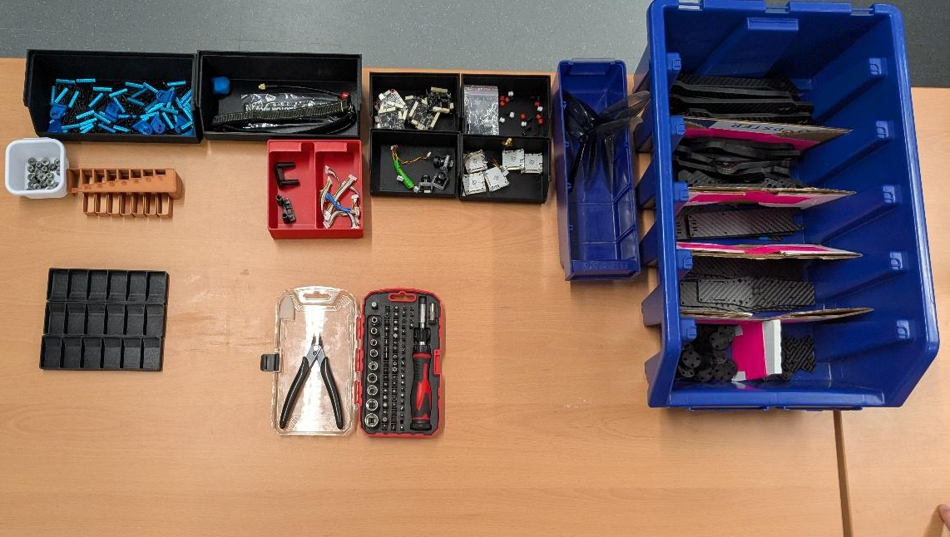
Figure 1: Station 1 Layout

Station 2: Motor De-Soldering
Responsibilities:
- Remove all motors from the ESC and place motors into collection bins
- Remove Battery cable and capacitor and place into collection bin
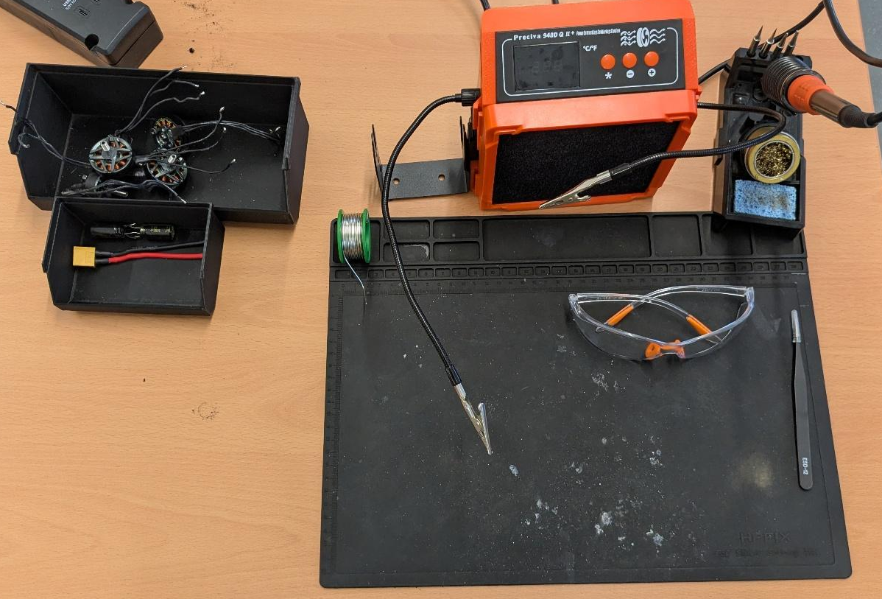
Figure 2: Station 2 Layout
Station 3: Solder Removal
Responsibilities:
- Remove solder from ESC and place ESC into collection bin
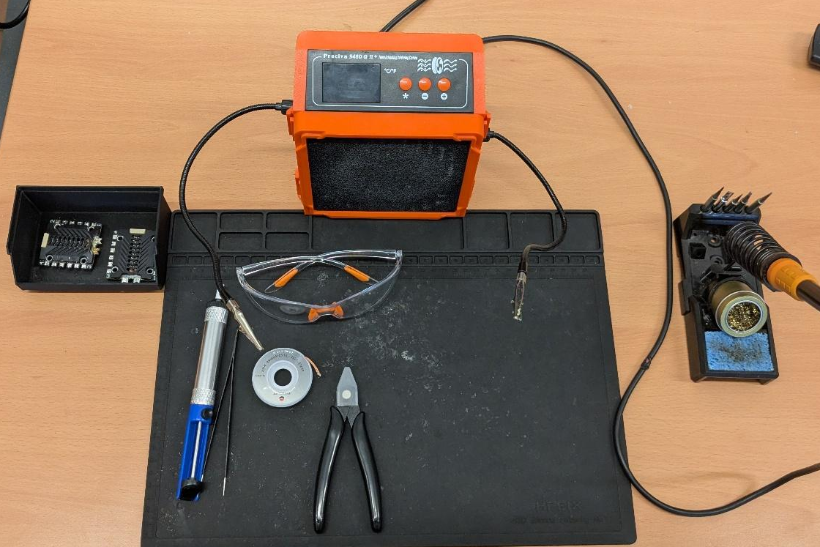
Figure 3: Station 3 Layout
NOTE: Stations 1 and 3 are the bottlenecks for disassembly. It is critical to task all additional personnel to these two stations.

2.2 Component Cleaning
All components must be cleaned upon disassembly to prevent corrosion and to make them presentable for a professional course.

2.2.1 Carbon Fiber, Cameras, Props, and Fasteners
All carbon fiber components, cameras, and fasteners will be wiped down with sanitization wipes to remove any dirt and debris.

2.2.2 Flight Controller, ESC, and VTX/RX
Flight Controller, ESC, and VTX/RX will be cleaned with isopropyl alcohol and a soft-bristled toothbrush to remove any dirt and debris. Antennas attached to the VTX/RX will be wiped down with sanitization wipes to remove any dirt and debris.

2.2.3 Motors
Motors will be wiped down with sanitization wipes to remove any dirt and debris. The fastener located at the bottom of the motor mount can be removed in order to separate the motor bell from the stator. Once separated, components can be cleaned with isopropyl alcohol and a soft-bristled toothbrush to remove any dirt and debris.
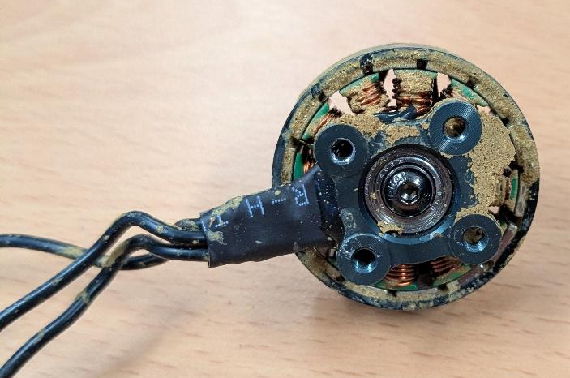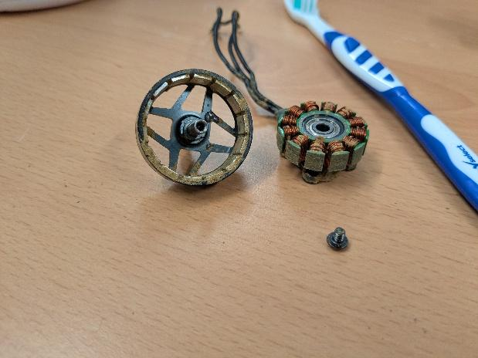
Figure 4: Motor Disassembly

3. FPV Part Quality Control
This section serves as a guide for visual inspection of all FPV components and wiring harnesses. All components must be serviceable prior to being added to student build kits. Failure to do so will result in the degradation of training and more importantly waste time and resources. Damage that occurs during the course, during normal execution of tasks is to be expected and provides students with training on troubleshooting and repairing their equipment. This quality control is to be conducted as part of the visual inspections required in section 1 as well as repeated when components are placed in build kits as a method of redundancy.
An excel checklist must be provided to individuals building the FPV kits for use in the course. Process all damaged components in accordance with section 5.

3.1 Frame Components
Points of Inspection
- Inspect for any signs of delamination or cracking in the carbon fiber.
- Inspect bottom plate for all rivet nuts to ensure they are still installed.

3.2 Fasteners
Points of Inspection
- Ensure that screw heads are not stripped and dispose of any non-serviceable fasteners after ensuring a replacement is available.

3.3 Motors
Points of Inspection
- Inspect motor wires to ensure they are not damaged in any way.
- Inspect that the motor bell is free of debris and spins freely.
- Inspect that the motor shaft is not bent.
- Ensure that the motor wires are the minimum length required to reach the ESC.

3.4 FC and ESC
Points of Inspection
- Inspect the FC and ESC for any signs of burnt components/soot or solder splatter.
- Inspect the FC and ESC connectors and solder pads ensuring all are present on the board.
- Inspect Wiring Harnesses for damage.

3.5 VTX/RX
Points of Inspection
- Inspect the UFL connectors on the board ensuring they are not broken off.
- Inspect Wiring Harnesses for damage.

3.6 Props
Points of Inspection
- Inspect props for major chips missing from blades.
- Inspect props for major bending below or above the prop centerline.

3.7 Antennas
Points of Inspection
- Inspect shielded portion of antennas for tears and cuts.
- Inspect Antenna tips for cuts/damage and broken shielding on omni antennas.

4. FPV Component Marking SOP
This section outlines the standard markings to be applied to any components found to be damaged via visual inspection, suspected of damage, or found to be damaged through testing outlined in sections 1 and 4.

4.1 Frame Components
Mark with high-vis tape forming a flag on the arms and applied to the top surface of the top and bottom carbon plate. Write the issue identified and either Non-Mission Capable (NMC) or Testing Required (TR).
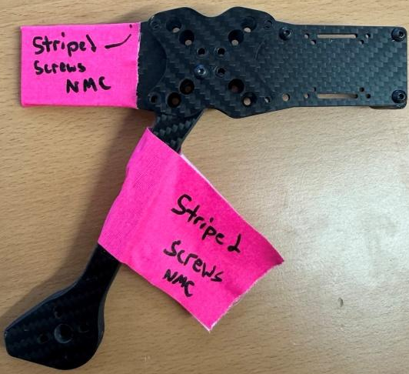
Figure : Frame Component Marking

4.2 Fasteners
No marking required. Identify replacement fastener and discard.

4.3 Motors
Mark with high-vis tape forming a flag motor shaft. Write the issue identified and either Non-Mission Capable (NMC) or Testing Required (TR).
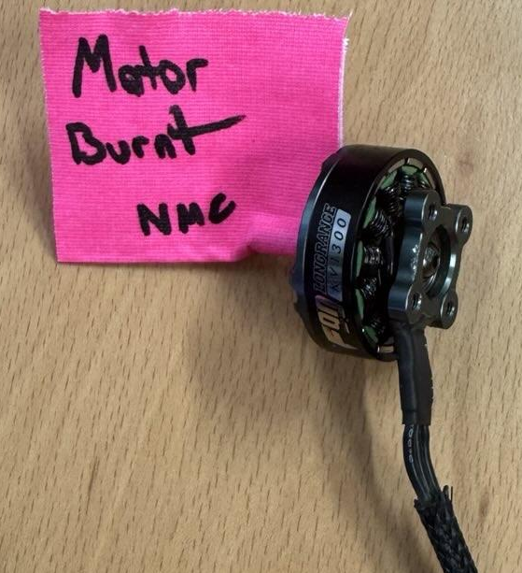
Figure : Motor Marking

4.4 FC and ESC
Mark with high-vis tape forming a flag across the board width. Write the issue identified and either Non-Mission Capable (NMC) or Testing Required (TR).
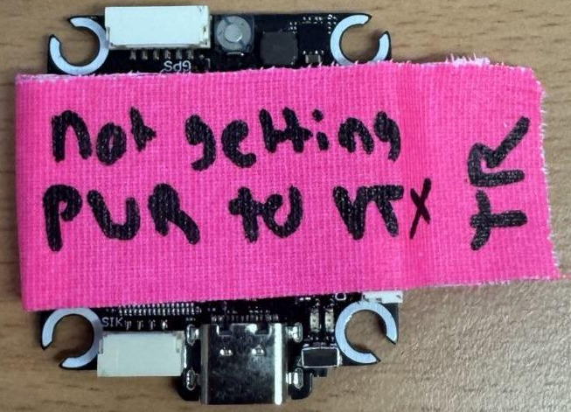
Figure : FC Marking
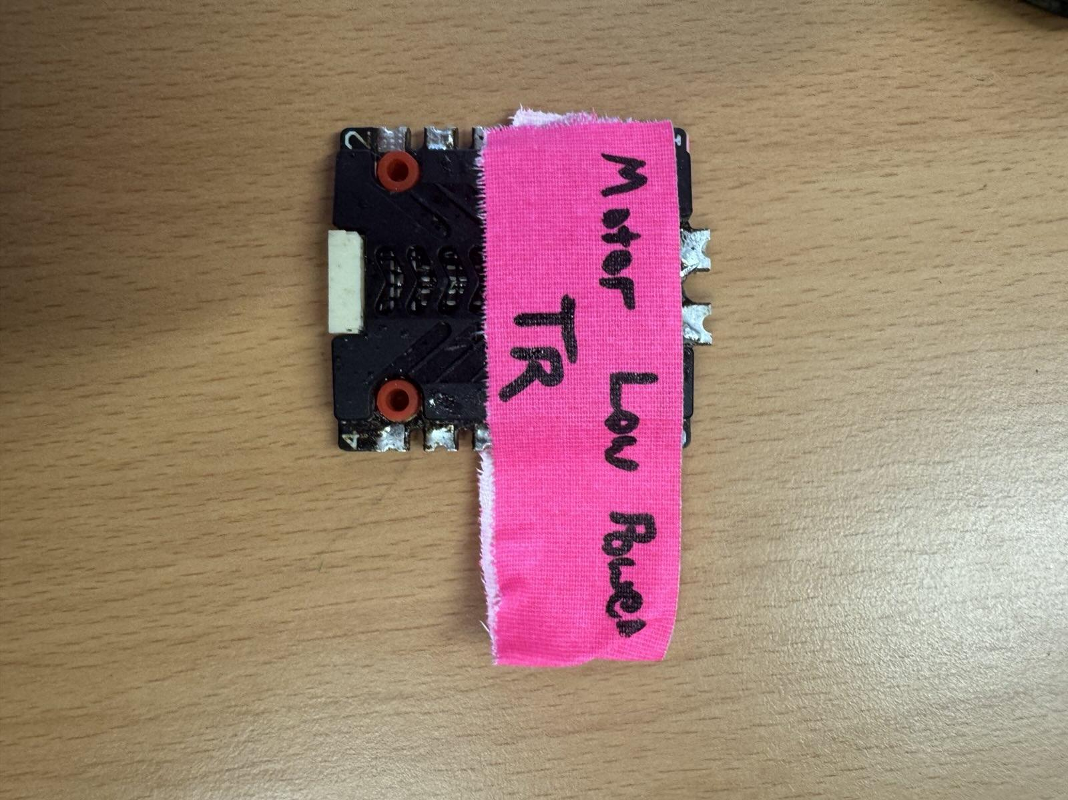
Figure : ESC Marking

4.5 VTX/RX
Mark with high-vis tape forming a flag across the board width. Write the issue identified and either Non-Mission Capable (NMC) or Testing Required (TR).
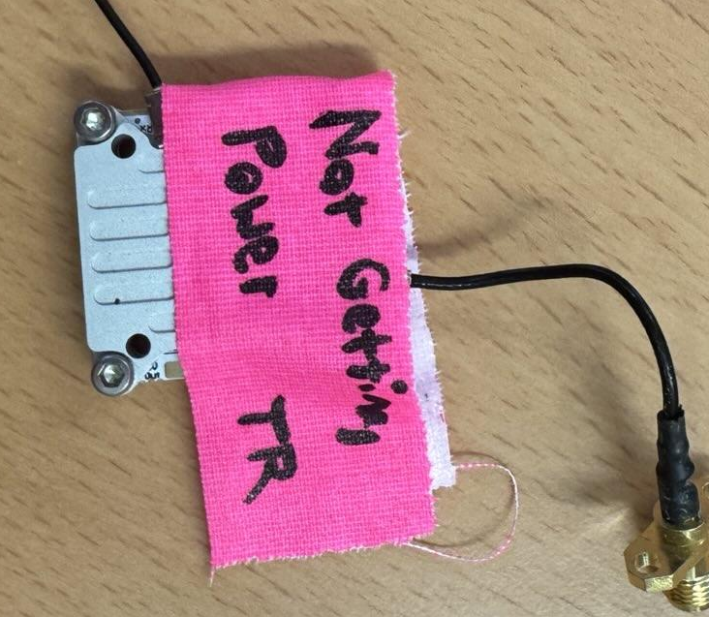
Figure : VTX/RX Marking

4.6 Props
No marking required. Discard.

4.7 Antennas
Mark with high-vis tape forming a flag across the shielded portion of the antenna. Write the issue identified and either Non-Mission Capable (NMC) or Testing Required (TR).
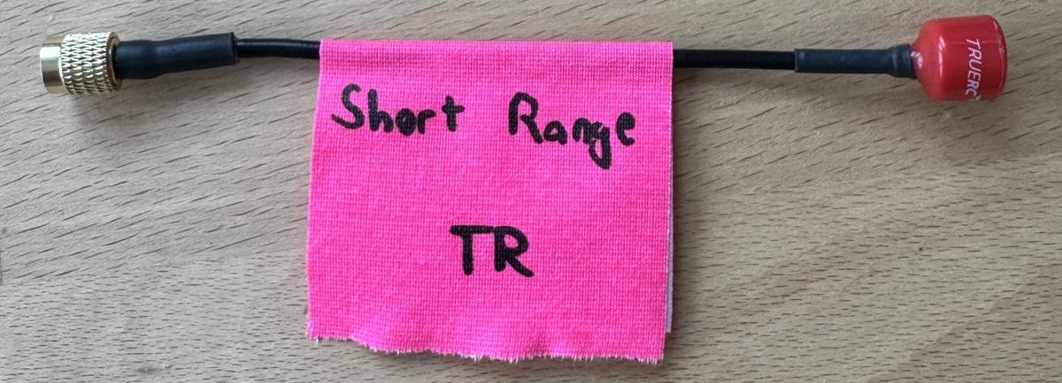
Figure 10: Antenna Marking

5. Damaged Component Storage/Disposal

5.1 Frame Components
Discard.

5.2 Fasteners
Discard.

5.3 Motors
Retain markings and store in dedicated collection bin for innovations related activities.
- Harvest magnets for use in innovation-related activities.

5.4 FC and ESC
Discard.

5.5 VTX/RX
Retain markings and harvest all antennas/connectors from the VTX/RX. Store in dedicated collection bin for use as standalone RX.

5.6 Props
Discard.

5.7 Antennas
Retain markings and store in dedicated collection bin for innovation-related activities.
- Custom antenna builds
- Repeater systems
- Attempt repair

6. Build Kit Quality Control
Components forming a complete kit will be organized in a standard layout prior to being placed into a kit. Inspections completed in accordance with section 3 will be conducted for all components in addition to a gross quantity check to ensure serviceable components are being provided to the student body. Soldiers will use the FPV Build Kit QC Checklist to ensure all components are present and serviceable.
Assembly of these kits will be conducted in an assembly line in which stations are established for frame components and hardware, electronics, and miscellaneous items.

6.1 Gummies
Due to inconsistent part selection during the procurement process, the correct vibration isolators or “gummies” are not available to all kits. 3D printed spacers are currently used as a solution to this problem, but it serves as the major complication when building out the FPV kits. Below are the two configurations of gummies and spacers. This corresponds to the QTY 8 Gummies listed on the FPV Build Kit QC checklist.
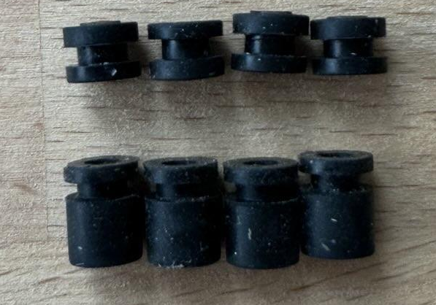
Figure 11: QTY 4 Short Gummies & QTY 4 Standoff Gummies
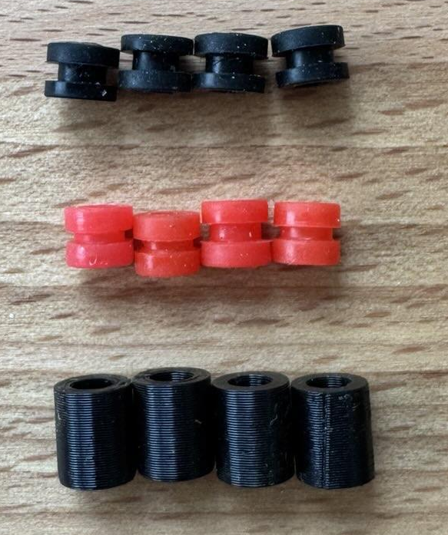
Figure 12: QTY 8 Short Gummies & QTY 4 3D Printed Spacers

