BetaFlight Overview Brief
Purpose: Instructor Notes to walk students through BetaFlight prior to programming their FPV Drones.
Author: CPT Alexander H. King
Date: 14 September 2025

Installing BetaFlight
Go to https://betaflight.com/ to download the most current version of BetaFlight for offline use.
Alternative 1: Use winget package manager to install from Command Prompt
Paste the following:
winget install Betaflight.Betaflight-Configurator
This will automatically install BetaFlight onto your system.
Alternative 2: Use the online BetaFlight Web App

Install Driver Fix
Often times, computers will not recognize your flight controller when you attempt to connect to Betaflight 9/10 times this is a driver issue. Install the following to correct this issue.
https://impulserc.com/pages/downloads

Firmware Tab
- How to access firmware updates
- Options walkthrough
  - Target Board
  - Firmware versions
  - Full erase
  - Local Firmware
  - Online Firmware
- How to fix a “Bricked FC”
  - https://oscarliang.com/backup-fc-stm32cubeprogrammer/

Connect FC to BetaFlight
- Flight controller populates in com port menu
- Hit connect
- If it does not display see driver issue section

Setup Tab
The setup tab is the main screen for BetaFlight. It shows drone status and allows you to calibrate the accelerometer.
Components
- Setup/Calibration menu
- Drone Status
  - Battery
  - Gyro
  - Accelerometer
  - GPS
  - Barometer
  - Compass
  - Sonar/Sensor
- Live View of drone
- MISC Data

Ports Tab
This tab enables you to tell BetaFlight what hardware you have connected to the drone.
What is a UART? UART stands for Universal Asynchronous Receiver Transmitter. You can think of these like USB cables, sending data back and forth between the FC and the additional hardware.
- MSP – MultiWii Serial Protocal
  - This is the USB connection from the FC to your computer
  - Serial RX – Used to denote which port contains you receiver module
  - Telemetry Output – Sends data back to your controller or other devices
  - Sensor Input – used to configure things like GPS and compass modules
  - Peripherals – Used to denote what type of hardware is connected when the other columns are not applicable. Usually used for VTX

Configuration Tab
The configuration tab is used to give permission to the Flight controller to use the hardware specified in the ports tab.
- Gyro Update Frequency – number of times per second that they FC updates the gyro data. This is set to the same frequency as the gyro installed on the FC. The ORQAF405 is 8K
- PID Loop Frequency – Tied to the DSHOT protocol used on the ESC. Our ESC supports DSHOT600 so we utilize 8K
- Sensor Toggles – enables use of sensors by the FC
- Board and Sensor Alignment – Used to manually input the orientation of the FC if not used in the default configuration (i.e. upside down, or rotated 90 degrees)
- DSHOT Beacon Tone – Uses the motors to act as a “beeper”
- Other Features - A list of various features that can be enabled or disabled, and may or may not be present on your flight controller
- Beeper Configuration – When you FPV Drone beeps

Power Tab
Set up all your power and battery related settings. Set the voltage and current sensor sources and calibration so that the FC can read the values and warn you accordingly. You can also check the current power measurements.

Failsafe Tab
Failsafe is the action your craft takes when it loses connection to the transmitter. This tab allows you to configure what your craft does in an event of a failsafe.

Presets Tab
Presets offer an easy way to configure your settings. They are short snippets of CLI commands that can be applied to your configuration. Everything from tune presets to product-specific settings. You can also create your own presets and share them with the community.

PID Tuning Tab
Configure the PID controller settings, Filter settings, as well as the rates.
Give quick PID tuning lesson
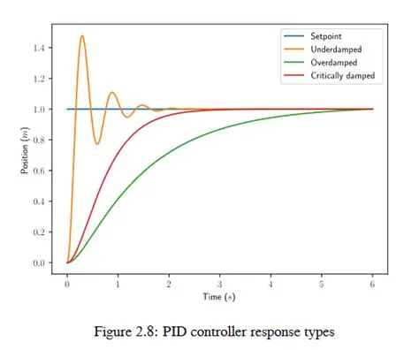

Receiver Tab
A receiver is a device that (as its name suggests) receives data from a transmitter, usually your radio controller. The receiver tab is used to configure the FC such that it can read the receiver data. The receiver tab is divided into two sections: the receiver output preview and the receiver configuration.
- Output Preview – allows you to test your controllers input against a virtual FPV Drone
- Receiver – select the receiver that matches the hardware installed on your FPV done. Most modern receivers use Serial connections.
- Channel Mapping – Allows the FC to read the standard stick inputs correctly.
- Stick Settings – Allows manual input of stick min, center, and max values

Modes Tab
Modes are used to enable or disable features and trigger FC actions using AUX channels switches. Modes are enabled when Ranges or Links are active.

Adjustments Tab
Used for ad hoc inflight changes. Mostly a legacy tab, but still has some uses, such as switching OSD profiles.

Motors Tab
Configure motor and ESC settings. Change motor direction and mixing, and set up advanced telemetry and flight features.

OSD Tab
BetaFlight OSD allows the pilot to view in-flight information and telemetry data overlaid onto their FPV camera feed. This is where you can configure the OSD elements and their layout, as well as the alarms and warnings which will be displayed.

Video Transmitter Tab
Configure the video transmitter (VTX) using this tab. It allows setting of power, band, channels, etc. Note that this tab is not applicable to Digital Video systems or to our all-in-one VTX/RX module.

CLI Tab
BetaFlight Command Line Interface (CLI) gives complete control of all BetaFlight settings through a terminal like structure. This can be used to input a complete system’s settings through only a copy and paste of text into the CLI.
Demo “dump”
Demo Student OSD
Display presets CLI files

