JMTG-U FPV IQT Syllabus

Course Description
This course will provide initial qualification training (IQT) for First Person View (FPV) operators. The course is broken down into 3 weeks (15 training days) with the following emphasis areas:

Week 1 – Simulator & Academics
Week 1 introduces operators to fundamental FPV maneuvers using the Liftoff FPV simulator, both with and without FPV goggles. Complementing simulator training, students receive 15 hours of classroom instruction covering essential topics such as FPV components, tactical employment strategies, and electronic warfare principles.

Week 2 – Build & Repair
Week 2 is dedicated to FPV construction. Students learn soldering and programming techniques, aiming to complete their individual FPV build by Day 10. In addition to the build, 20 hours of simulator practice are allocated to further refine basic flight skills. A mandatory simulator evaluation is conducted on Day 8 to qualify students for Week 3's live flight phase as FPV pilots.

Week 3 – Live Flights
Week 3 concentrates on live flight training, utilizing the FPV systems constructed by students during Week 2. Students who did not pass the simulator evaluation will operate the stabilized DJI FPV system and short-range reconnaissance (SSR) aircraft, providing support for FPV maneuver and strike training.

Prerequisites
- For US Service Members
  - Register for SUASMAN Account
  - Complete Basic Unmanned Qualification (BUQ) I/II
- Complete and submit pre-screening

Objectives
As a result of this course, you will be able to:
- Analyze the role of in-flight forces and the three primary axes of rotation to maneuver an FPV aircraft.
- Identify the individual components of an FPV aircraft and explain their integration into an unmanned system.
- Apply the basic principles of electronic warfare to FPV aircraft operations.
- Explain the fundamentals of the electromagnetic spectrum and antenna theory.
- Operate as a member of an FPV team.
- Employ an FPV aircraft tactically to enable maneuver forces.
- Build, program, and repair a functioning FPV aircraft.

Course Schedule
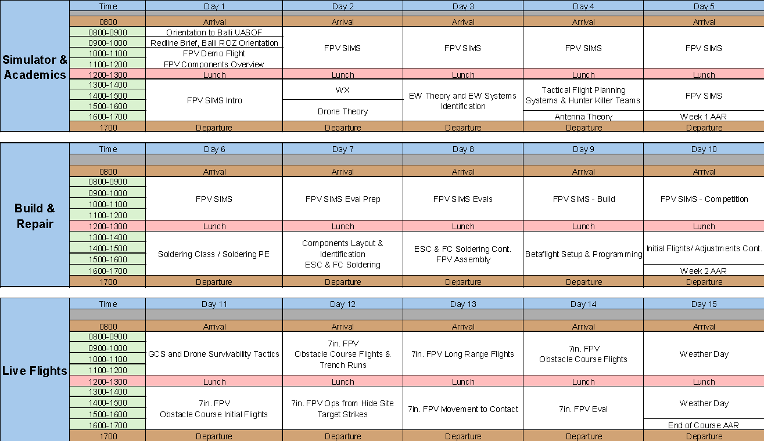

Evaluations and Graduation Requirements

Simulator Evaluation (Gate to Live Flight)
The simulator evaluation, held on Day 8, is a mandatory requirement to ensure all students possess the fundamental skills needed for safe live-flight operations in Week 3. This gate prevents personnel injury, equipment loss, and breaches of the Restricted Operating Zone (ROZ).
Eligibility for this evaluation is not automatic. To qualify, students must first complete tasks 1 through 16 as outlined in their Student Performance Checklist.
Warning: Failure to complete these prerequisite tasks will result in the student being barred from the evaluation. This policy is strictly enforced with no exceptions.

Simulator Evaluation Standards
The simulator evaluation measures piloting proficiency through four distinct races. The passing standards are divided into two categories:
- Students will be evaluated on two aircraft survivability races. The standard for these untimed events requires the operator to navigate the entire course on a single attempt. A NO-GO is defined by the following:

  - Crashing the drone beyond a flyable state
  - Landing at any time
  - Impacting the ground
  - Using the repair station

- Students will be evaluated on two Time-on-Target races. To meet the standard, operators must complete these courses within a specified time window. A maximum of ten (10) attempts are permitted for each race. The required time parameters for each race will be provided immediately prior to the evaluation. A NO-GO is defined by the following:

  - Crashing the drone beyond a flyable state
  - Landing at any time
  - Impacting the ground
  - Failure to meet the time standard
  - Using the repair station

Students must pass all four evaluation races to be considered a GO. Failing one event will automatically result in the student being re-evaluated the following training day (Day 9).
Students who do not receive a GO during the simulator eval will operate stabilized platforms for the remainder of the course to provide additional training and familiarization with SRR platforms.

FPV Build Evaluation
The FPV Build Evaluation assesses the student's technical proficiency. Passing this evaluation requires meeting two distinct performance standards:
- Successful Construction: The student must build and program a fully functional FPV drone according to course specifications.

- Successful Test Flight: The completed aircraft must demonstrate full functionality and airworthiness during a supervised test flight.

Live Flight Evaluation
Students, operating in battle buddy teams, launch one FPV at a time, navigate to target area, and strike a target (net).

Graduation Requirements
Upon completion of the course, students will be awarded a certification based on the specific evaluations they have successfully passed. There are two tiers of qualification:

FPV Operator
To receive full certification as a qualified FPV Operator, a student must pass all three of the course's primary evaluations:
- Simulator Evaluation
- FPV Build Evaluation
- Live Flight Evaluation

FPV Build and Repair Specialist
In the event that a student passes the FPV Build Evaluation but does not pass the required flight evaluations, they will receive a certificate as a qualified FPV Build and Repair Specialist. The sole requirement for this certification is to:
- Pass the FPV Build Evaluation

Attendance Policy
This course is conducted in a high-tempo training environment. Due to the accelerated pace, all scheduled training is mandatory. Any time missed will result in the student falling behind, as missed material or flight time cannot be made up.
A maximum of 4 hours of authorized absence may be granted for the entire course. All requests for absence must be coordinated with and approved by the course cadre at least 24 hours in advance. The cadre reserves the right to deny any absence that is not for a documented medical reason.

