SPECIAL INSTRUCTIONS

- This is a hands-on practical exercise. You will use only the reference publications shown. You may use notes. Do not talk to other students at any time. Speak only to the instructor.

- Be sure to read the “SITUATION”. If you have any questions, ask the instructor now.

- The soldier will score a GO (G) if all steps are passed. The soldier will score a NO-GO (NG) if any steps are failed. If the soldier scores a NG on any step, the soldier will be shown what was done incorrectly, how to do it properly, and then will be re-tested.

- During this practical exercise you will need:

  - Safety Goggles
  - M249 Machine Gun
  - M199A1 Linked dummy Rounds
  - Magazine
  - Tool Kit Small Arms Repairman
  - AR 25-400-2
  - TM 9-1005-201-10
  - TM 9-1005-201-23&P
  - DA Pam 750-8
  - Computer with forms program or blank forms.
  - Pencil or Pen

GENERAL INFORMATION

Your unit of assignment | D Co, 13th MP BN  Fort Lee, VA 23801
Unit DODAAC | WK4C30
Unit UIC | WBAKD0
Company Commander | Paul J. Sfransky  CPT, MP
Armorer/Supply Clerk | You are the Armorer/Supply Clerk
Unit Phone Number | 765-9185
Maintenance Supervisor | SFC Mike McGuire
Direct Support Unit (DSU) | 581st Maintenance Company
M249 National Stock Number | 1005-01-127-7510
M249 Serial Number | Student will use the SN from actual weapon
M249 EIC | 4BG

GENERAL SITUATION
You are the unit armorer for D Co 13th MP BN. The Supply Sergeant has informed you that the M249 Machine Guns are scheduled for their quarterly service. You have been tasked with performing organizational maintenance on the Machine Gun 5.56mm, M249.

Requirement 1
Using TM 9-1005-201-10, TM 9-1005-201-23&P, and the performance sheet listed below, unload and clear the M249 Machine Gun.

UNLOAD AND CLEAR THE WEAPON | GO | NO GO
- Pull the cocking handle rearward.
- Lock the bolt in the rear position.
- Push charging handle forward until you hear it click.
- If belt feed is used squeeze latches to open cover.
- Remove ammunition belt and loose links.
- If magazine is used push down on the magazine release tab and pull out magazine. Raise cover assembly.
- Raise feed tray assembly.
- Look in chamber.
- Lower feed tray assembly.
- Close, shut and lock cover assembly.
- Push safety to left (RED BAND visible)
- Hold cocking handle to the rear, pull trigger and ride bolt forward to close and lock.

Requirement 2
Using TM 9-1005-201-10, TM 9-1005-201-23&P and performance sheet listed below, disassemble the M249 Machine Gun.

DISASSEMBLY OF THE WEAPON | GO | NO GO
- Begin disassembly with the bolt forward and the cover closed.
- Raise the cover assembly.
- Pull the upper retaining pin at the rear of the receiver to the left.
- Let the buttstock pivot downward so that the rear opening of the receiver is clear.
- Hold the weapon with one hand on the buttstock. At the same time, push in and upward on the rear end of the operating rod assembly with the thumb of the other hand. Release and withdraw the operating rod assembly.
- While steadying the weapon with the left hand, pull the cocking handle to the rear.
- Slide the moving parts out the rear of the receiver.
- Grasp the slide assembly and pull the moving parts from the rear of the receiver.
- Rotate the bolt to disengage the driving lug.
- Remove the bolt from the slide assembly.
- Separate the piston from the slide assembly, press the rear retaining pin to the left. Lift the piston off the slide assembly.
Barrel removal
- Close the cover and depress the barrel locking lever with the left hand.
- Hold the carrying handle with the right hand. Lift up on the carrying handle and push the barrel forward.
GAS REGULATOR REMOVAL
- Position the gas collar to allow the scraper assembly to be installed.
- Place the tip (guide) of the scraper assembly into the notch in the front left of gas block and hold guide firmly in notch.
- Holding the scraper assembly in position, turn the collar counterclockwise until the collar can be removed.
- Remove the gas regulator from the gas block.
HANDGUARD REMOVAL
- Push the handguard retaining pin to the left using the spring guide rod.
- Then pull down and remove the handguard.
BUTTSTOCK AND SHOULDER ASSEMBLY REMOVAL
- Using the spring guide rod, push the lower retaining pin to the left.
- Remove the buttstock and shoulder assembly by pulling it rearward, while supporting the trigger mechanism.
TRIGGER MECHANISM REMOVAL
- Remove the trigger mechanism by pulling downward.
GAS CYLINDER REMOVAL
- Turn the gas cylinder to the left or right to release the locking spring.
- Pull forward to remove the gas cylinder.
BIPOD REMOVAL
- Slip off the receiver easily. If not, turn the bipod to the left or right to loosen dirt or corrosion.

STUDENT: You must stop at this time and have an instructor verify that you have correctly completed requirements 1 and 2.

Requirement 3
Using TM 9-1005-201-23&P, DA Pam 750-8, and a computer with an Army form program or blank DA Form 2404 (Figure 1), and DA Form 2407 (Figure 2). Complete the DA Form 2404 for the quarterly inspection and prepare the DA Form 2407 on the M249 Machine Gun. Annotate all corrective actions as required. Today’s date is 20 February 20XX. The following deficiencies were found on the rifle.

DEFICIENCY
Drive spring has broken strands in 3 spots (Not on hand)
Cover does not remain open under spring tension

Requirement 4
Using TM 9-1005-201-10, TM 9-1005-201-23&P, and the performance sheet listed below, student will reassemble the M249 Machine Gun.

REASSEMBLY OF THE WEAPON | GO | NO GO
- Place the bipod on the receiver.
- Push the gas cylinder through the bipod yoke into the receiver. When the gas cylinder is fully inserted, rotate the cylinder until it locks into place. Because the length of the gas cylinder may make it hard to position correctly, guide it with the other hand.
NOTE: Before beginning this step, be sure that the cleaning equipment is properly placed in the handguard.
- Place the handguard onto the receiver and slide it backward until it stops.
- Use the spring guide rod; push the handguard retaining pin to the right. This will lock the handguard into position.
- Pull downward on the handguard to ensure it is locked into position.
- Insert the gas regulator into the gas block and align the notch on the gas regulator with the notch in the gas block.
- Insert the gas regulator collar. Push downward and rotate the gas regulator collar lever clockwise into the (N) position.
- Depress the barrel locking lever. Insert the barrel into the receiver. Using the carrying handle, rotate the barrel clockwise.
- Release the barrel locking lever.
- Place the spring on the firing pin.
- Put the bolt into the bolt carrier. Apply pressure to compress the firing pin spring.
- Rotate the bolt and hook the driving lug into the bolt carrier.
- With the feed cover open; press the trigger and place the bolt lugs onto the receiver rails. At the same time, ensure that the piston enters the rear of the gas cylinder. Push the moving parts all the way forward.
- Place the operating rod and spring into housing in rear of the piston.
- Press in and down on the rear of the operating rod assembly until its two lugs are positioned in the receiver grooves.
- Pivot the butt upward into position and push the retaining pin to the right. Close the cover assembly.

Requirement 5
Using TM 9-1005-201-10, TM 9-1005-201-23&P, and the performance sheet listed below, perform a functions check on the M249 Machine Gun.

FUNCTION CHECK | GO | NO GO
WARNING: Ensure that the machine gun is clear before performing a function check.
- Pull the cocking handle to the rear. Return it forward to the locking position.
- Move the selector lever to the SAFE position.
- Pull the trigger. The weapon should not fire.
- Place the selector lever on FIRE. Pull and hold the cocking handle to the rear.
- Pull the trigger and allow the bolt to ease forward

STUDENT: You must stop at this time and have an instructor verify that you have correctly completed requirements 4 and 5.

PERFORMANCE MEASURE | RESULTS
- Clear the SAW before disassembly | P | F
- Disassemble the SAW. | P | F
- Prepare DA Form 2404 and DA Form 2407 | P | F
- Assemble the SAW. | P | F
- Performs a function check | P | F
- Weapon functions as mission-ready | P | F
Verified By Signature:
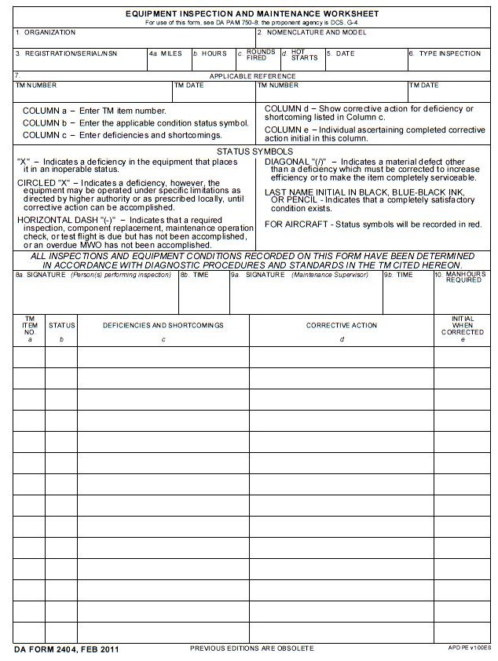
Figure 1

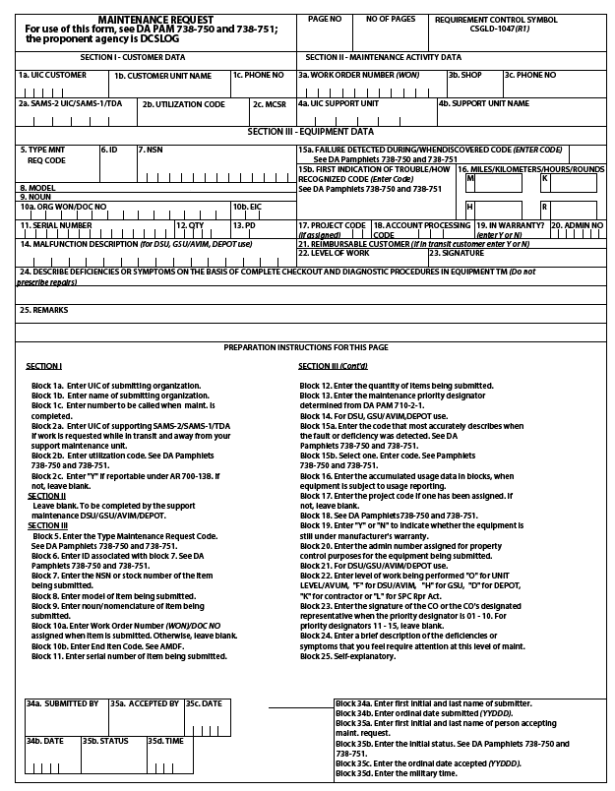
Figure 2

