GENERAL INFORMATION

You are assigned to | D Co. 13th Military Police Battalion  Fort Lee, VA 23801
Office Symbol | ASTM-MP-D0
Your Units DODAAC/UIC | WK4C30/WBAKD0
Company Commander | Paul J. Sfransky  CPT, MP
Executive Officer (XO) | Michael T. Braddock  1LT, MP
Supply Sergeant | SSG Brian A. Flanders
Supply Clerk/Assistant Armorer | PFC Dollie Wood
Armorer | You are the Armorer
Staff Duty | SSG Rex Dillard
Maintenance NCO | SSG Mike McGuire
DSU | 581st Maintenance Company  Fort Lee, VA 23801
Arms Room Keys Serial Numbers | (1) 17653, (2) 27624, (3) 28655, (4) 35342,  (5) 36134, (6) 37798, (7) 39923, (8) 40721,  (9) 78645, (10) 81112

GENERAL SITUATION
You are assigned as the unit armorer for D Co, 13th Military Police Battalion.

SITUATION 1
You are preparing to get the arms room keys to open the arms room for the day when the Staff Duty NCO informs you that the key control register is completely filled out. You must prepare a new DA Form 5513 before you can receive the arms room keys. Today’s date is 23 Oct 20XX. Answer the following requirements pertaining to key control and opening the arms room.

Requirement 1
What is the official title of the person appointed on orders, to issue and receive keys from individuals on the key access roster?

- Armorer
- Lock manager.
- Key custodian.
- Supply sergeant.

Requirement 2
What method is used to secure the Key Control Register?

- In approved locked container.
- In a temporary file.
- In a desk drawer.
- In a commercial container.

Requirement 3
Using the provided DA Form 5513 (Figure 1), and the general information provided, prepare a new DA Form 5513.

Requirement 4
Using the DA Form 5513 prepared in Requirement 3 above, have the staff duty NCO issue you the keys to open the arms room. The time is 0830

SITUATION 2
You have opened the arms room, but need to complete the physical inventory of the contents of the arms room. The following weapons and ammunition are in the arms room:

NSN | ITEM | QTY
1005-01-118-2640 | Pistol 9mm, M9 | 4
1005-01-128-9936 | Rifle 5.56mm M16A2 | 10
1005-01-127-7510 | Machine Gun 5.56mm M249 | 3
 | Cartridge 9mm | 20
 | Container of 1000 rounds of 5.56mm ammunition Seal # 225487 | 1

Requirement 5
Using the DA Form 2062 provided (Figure 3); complete the opening physical inventory of the weapons and ammunition found in the arms room.

SITUATION 3
A new soldier, PFC Derek Jeter has reported to your unit. The soldier is now in processing the arms room. PFC Jeter has been assigned to the Commo Section.

Requirement 6
You need to add PFC Jeter to the MAL (Figure 4) and issue him a DA Form 3749 (Figure 5). After reviewing the MAL, you decide to assign him the available unassigned M16A2. Place all required signatures on the DA Form 3749

SITUATION 4
1LT Braddock, SFC McGuire, SPC Mauer, and PFC Martin have been tasked to guard the Ammunition Holding Area for 48 hours. All four soldiers are at the arms room preparing to receive their weapons. 1LT Braddock, SPC Mauer, and PFC Martin have their Equipment Receipt Card and will be receiving their own weapons. The commander has authorized SFC McGuire to be issued a M9 Pistol instead of his assigned M16A2. 1LT Braddock will also be receiving 10 rounds of 9mm ammunition, Lot Number LT-877. Today’s date is 23 Oct 20XX.

Requirement 7
Based on the information provided in Situation 4, enter the required information into the Weapons and Ammunition Control Log (Figure 6). 1LT Braddock weapon draw time is 1000, SPC Mauer weapon draw time is 1005, and PFC Martin weapon draw time is 1010. Initial and Sign all blocks as needed.

Requirement 8
Issue SFC McGuire a weapon based on the information provided in Situation 4. Remember he is NOT receiving his assigned weapon. SFC McGuire is issued his weapon at 1015. Use Figure 6 and Figure 7 to complete this requirement. Initial and Sign all blocks as needed.

SITUATION 5
You have received one M16A2 SN 10012548 and one M9 SN 4590093 from the SSA.

Requirement 9
Using the information provided and the MAL (Figure 4), add the weapons to the MAL.

SITUATION 6
The commander and SFC Strong have come to you to ask questions about the required inventories of the sensitive items. You are to answer their questions about the inventory.

Requirement 10
How often should weapons and ammunition be inventoried?

- Daily
- Weekly
- Monthly
- Annually

Requirement 11
When differences are found during the serial number inventory and are not resolved, the completed copy of the results of the DA Form 2062 is kept as an exhibit to what adjustment document?

- Administrative Adjustment Report
- Statement of Charges
- Cash Collection Voucher
- Financial Liability Investigations of Property Loss

Requirement 12
What person in a unit is NOT authorized to conduct the weapons and ammunition inventory?

- First Sergeant
- Platoon Sergeant
- Squad Leader
- Unit Armorer

Requirement 13
Who conducts the inventory when a change of custody of the arms storage facility is transferred?

- Outgoing Custodian and First Sergeant
- Incoming Custodian and Outgoing Custodian
- Outgoing Custodian and Commander
- Incoming Custodian and Commander

Requirement 14
What document is used to record the results of the change of custody inventory?

- DA Form 2062.
- DA Form 2064.
- DA Form 3749.
- DA Form 4949.

Requirement 15
What action should the person conducting the ammunition inventory take when the ammunition is stored in sealed containers?

- Open each container to do a physical count.
- Randomly check several containers by physical count.
- List the quantities shown on banded or sealed containers.
- Have a Quality Assurance Specialist inventory the contents.

Requirement 16
What filing action is taken to the change of custody inventory record when the next monthly serial number inventory of weapons and ammunition is completed?

- Destroyed.
- Maintained in the unit arms room files.
- Placed in the unit supply files.
- Sent with the monthly serial number inventory.

SITUATION 7
SFC Strong has completed the required weapons and ammunition inventory. During the inventory SFC Strong discovered several discrepancies; annotated as follows:

ITEM DESCRIPTION | RECORDED INFORMATION | INVENTORIED INFORMATION
M16A2 Rifle | SN 9195285 | SN 9195258
Pistol | Pistol 9mm M9A1 | Pistol 9mm M9

Requirement 17
What action should be taken when there is a difference with the recorded serial number and the inventoried serial number?

- File the document because it has been that way since you got there.
- Make a pen and ink change.
- Process Financial Liability Investigations of Property Loss.
- Process an Administrative Adjustment Report.

Requirement 18
What action should be taken to correct the make and model item description of the 9mm Pistol?

- Prepare and process an Administrative Adjustment Report.
- Make a pen and ink change.
- Prepare and process a Financial Liability Investigations of Property Loss.
- File the document because it has been that way since you got there.

SITUATION 8
You have completed your tasks for the arms room and are preparing to secure the arms room for the night.

Requirement 19
You are to conduct the closing physical count of weapons inside the arms room before locking and securing the arms room. Using the DA Form 2062 (Figure 3) complete the physical count.

Requirement 20
Using the DA Form 5513 (Figure 1), turn the arms room keys into the staff duty NCO. The staff duty NCO is SFC David Roberts. The time is 1630.

SITUATION 9
The soldiers have returned from the guard duty tasking. They are at the arms room to turn in the weapons and ammunition they have. Today’s date is 25 Oct 20XX and the time is 1330.

Requirement 21
Complete the turn in of the weapons using the Weapons and Ammunition Control Log (Figure 6). Make all required entries to complete the form. All quantities of weapons and ammunition are being turned in.

SITUATION 10
1LT Braddock has come to the arms room to help prepare for an upcoming inspection. He is asking questions about some of the paperwork, signs and the IDS system. You are to answer his questions.

Requirement 22
What paragraph in AR 190-13 covers posting of the restricted area signs?

- Para 6-6.
- Para 6-4.
- Para 4-6.
- Para 3-8.

Requirement 23
According to AR 190-11, what form is used to approve construction of facilities?

- DA Form 5513.
- DA Form 7281.
- DA Form 4604.
- DA Form 3749.

Requirement 24
What form is used to screen and evaluate personnel involved in control and accountability of AA&E according to AR 190-11?

- DA Form 7281.
- DA Form 3056.
- DA Form 5513.
- DA Form 4608

Requirement 25
What appendix in AR 190-11 explains specifications for an Intrusion Detection System Sign?

- Appendix G.
- Appendix E.
- Appendix F.
- Appendix A.

Requirement 26
Using AR 190-11 what form is required to conduct a semiannual inventory of keys and locks?

- DA Form 2062.
- DA Form 3161.
- DA Form 7281.
- DA Form 5513.

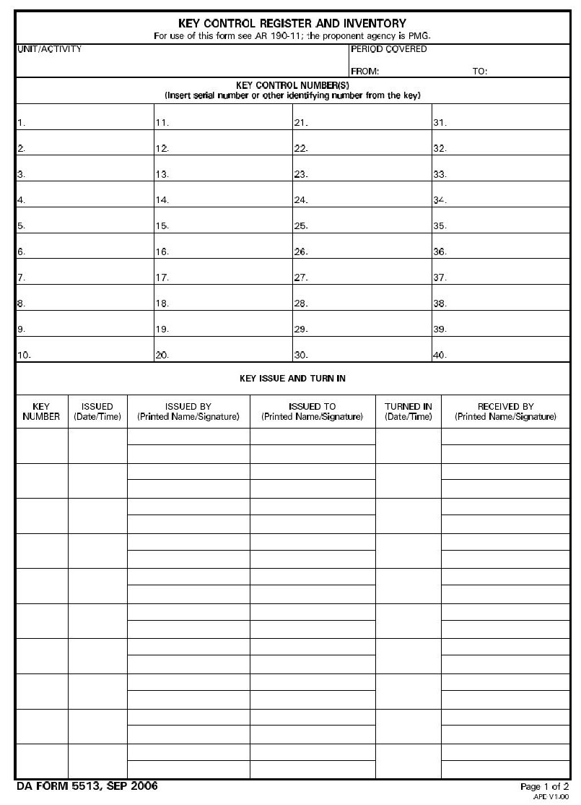
Figure 1
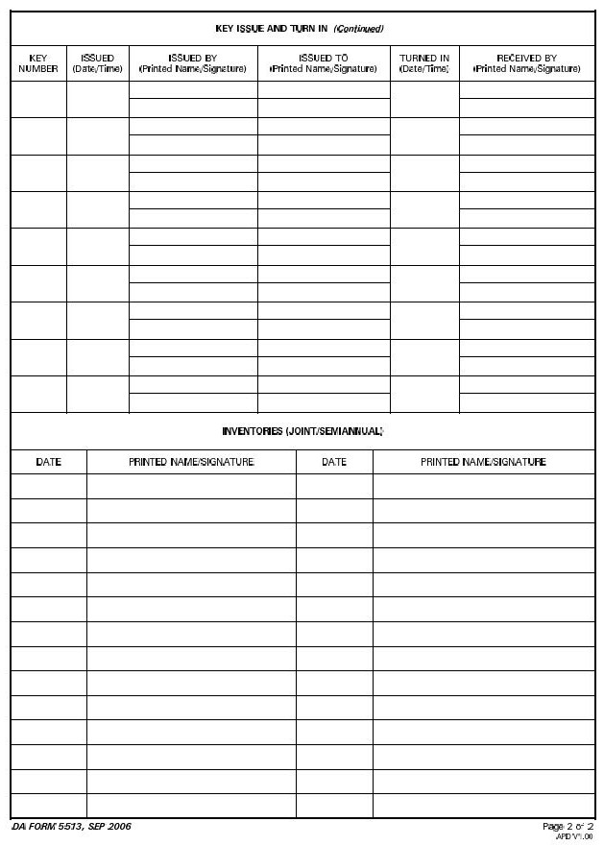
Figure 2
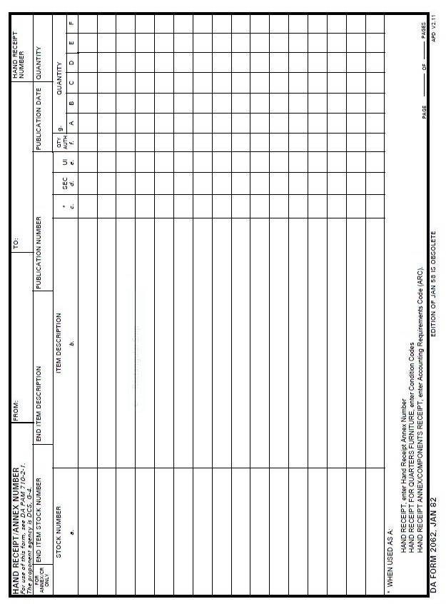
Figure 3
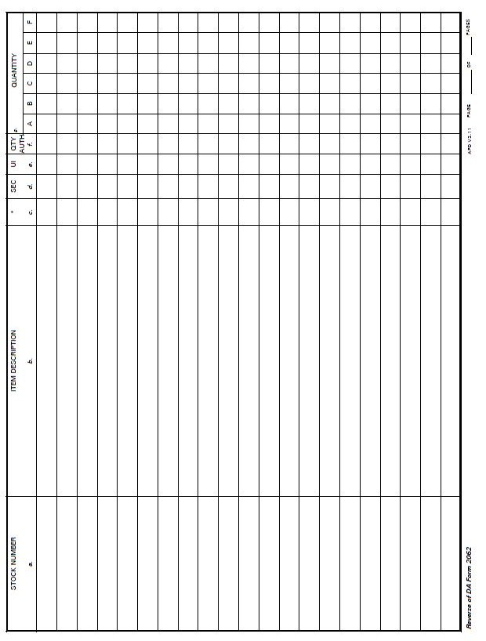
Figure 3
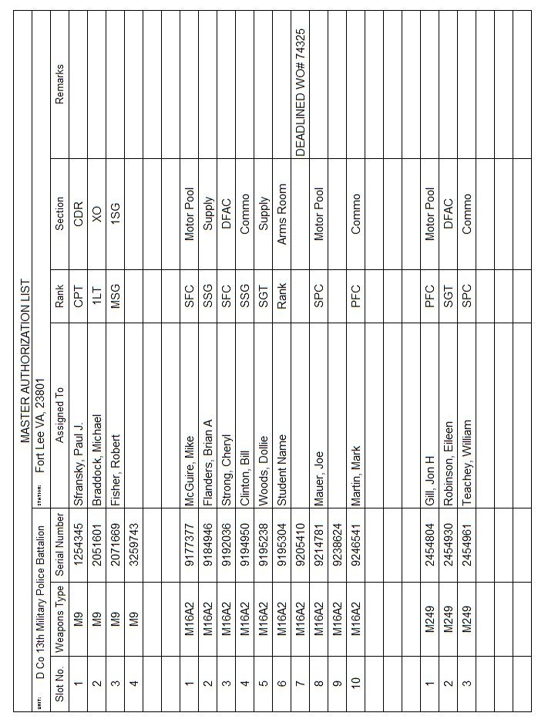
Figure 4
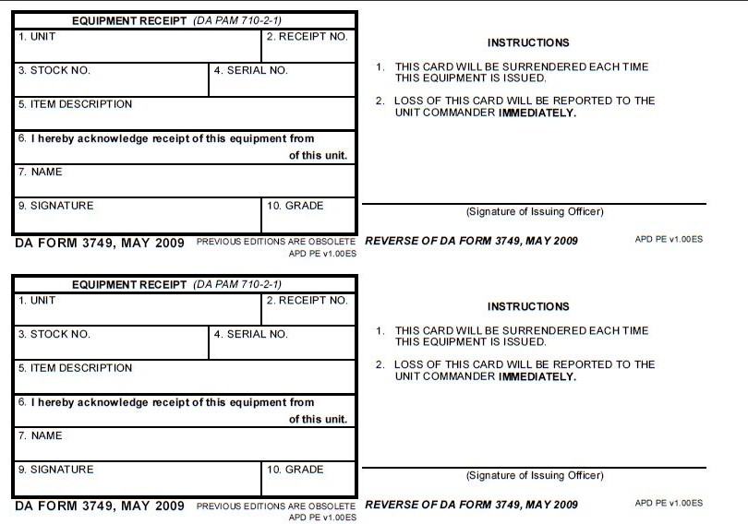
Figure 5
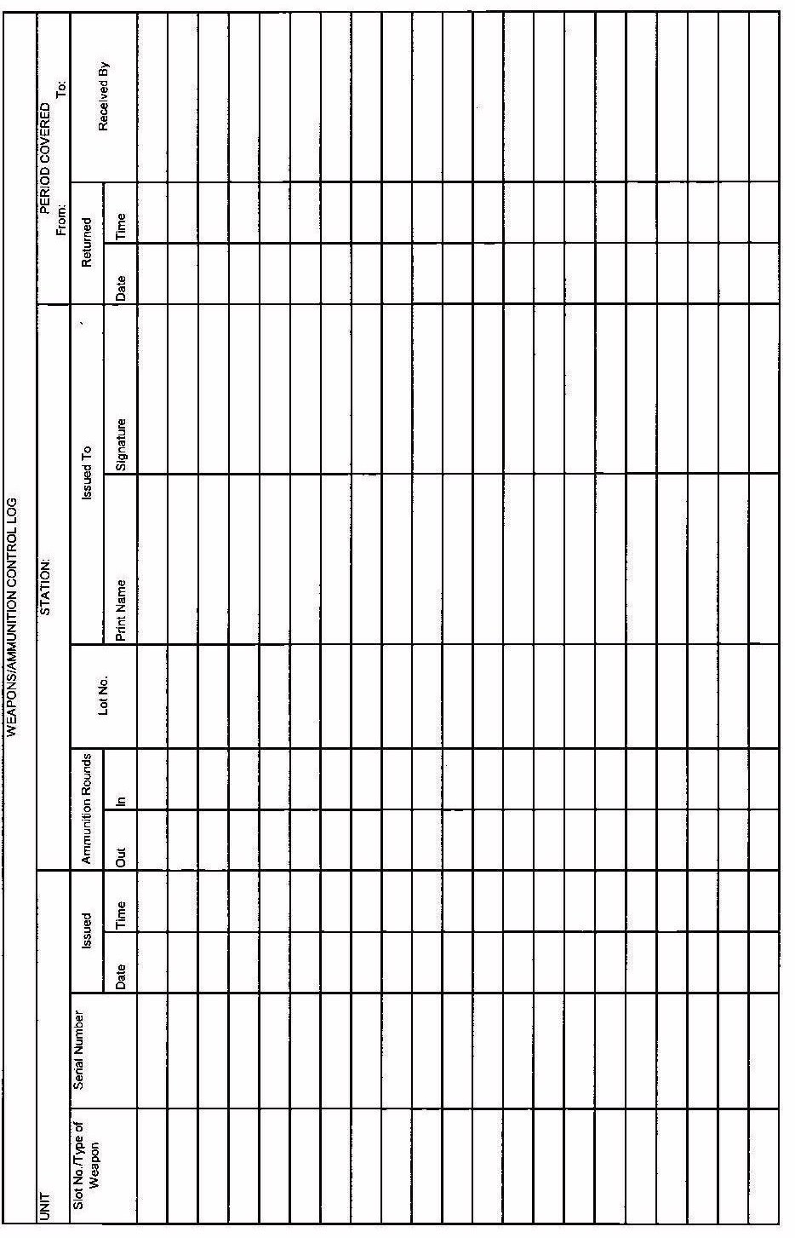
Figure 6
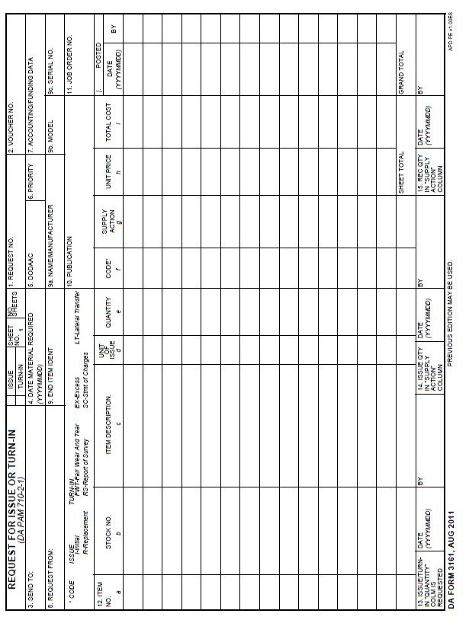
Figure 7

