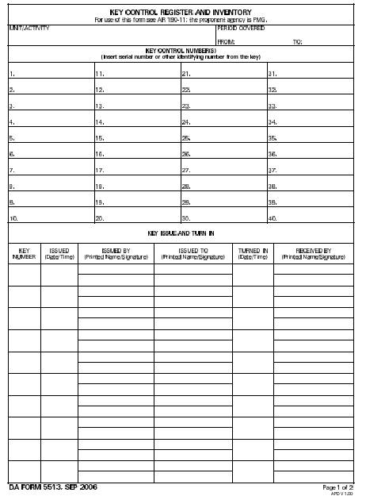
Figure 1

Figure 2

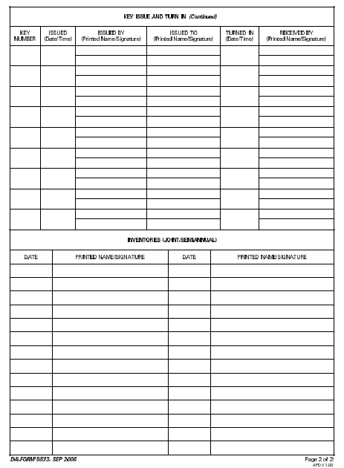
Figure 3

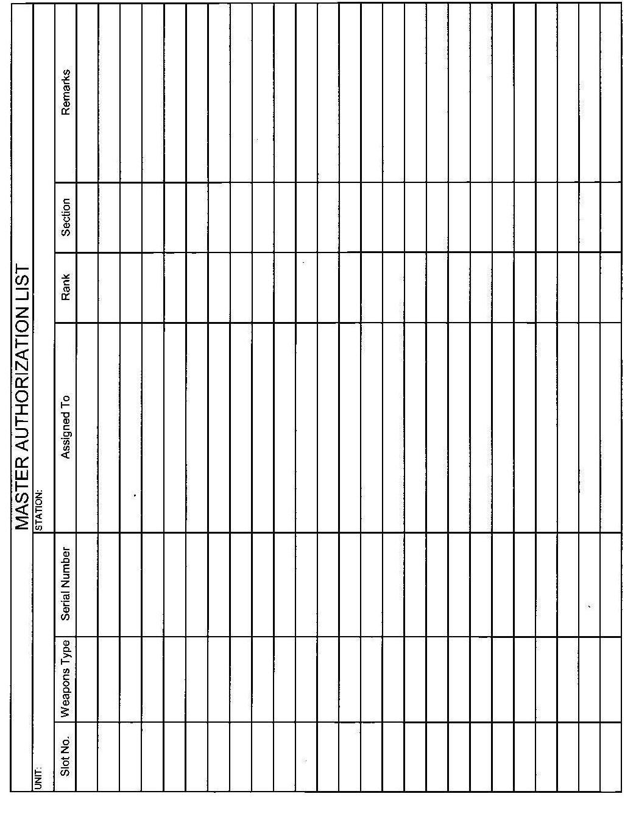
Figure 4

Additional information required to complete the MAL:

Weapon Type | M9 | M16A2 | M16A2
Slot Number | 2 | 3 | 4
Serial Number | 1251776 | 9190221 | 9190286
Assigned To | Knepper, Dave | Waltrip, Darryl
Rank | 1SG | PFC
Section | 1SG | Commo
Remarks |  |  | In Maintenance

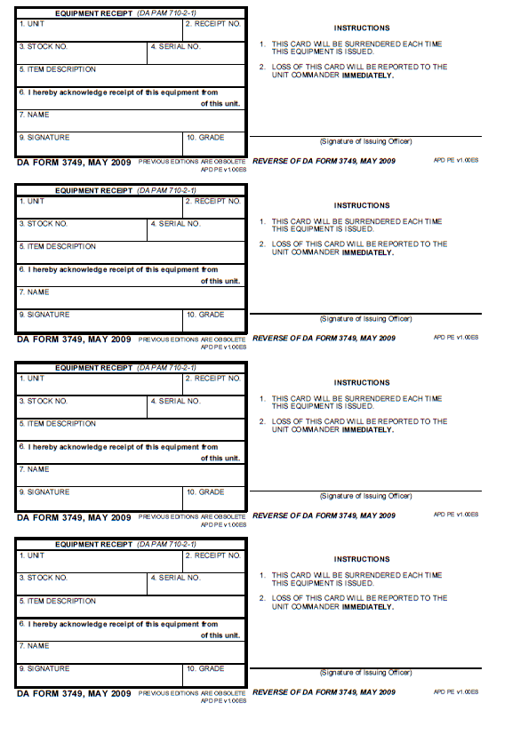
Figure 5

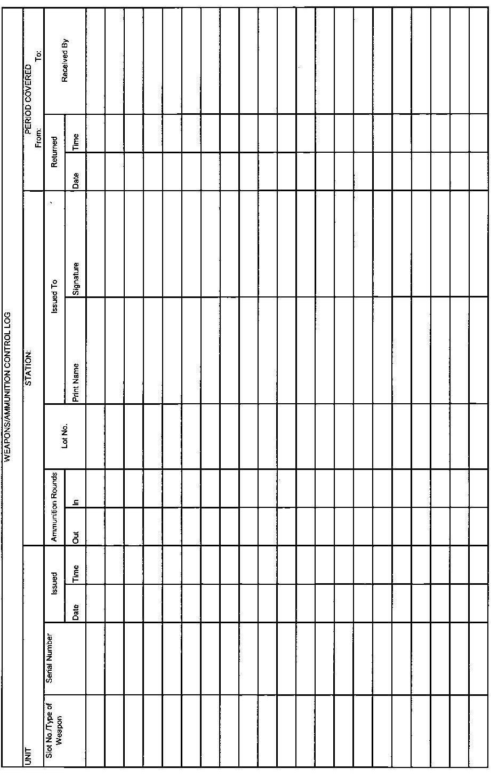
Figure 6

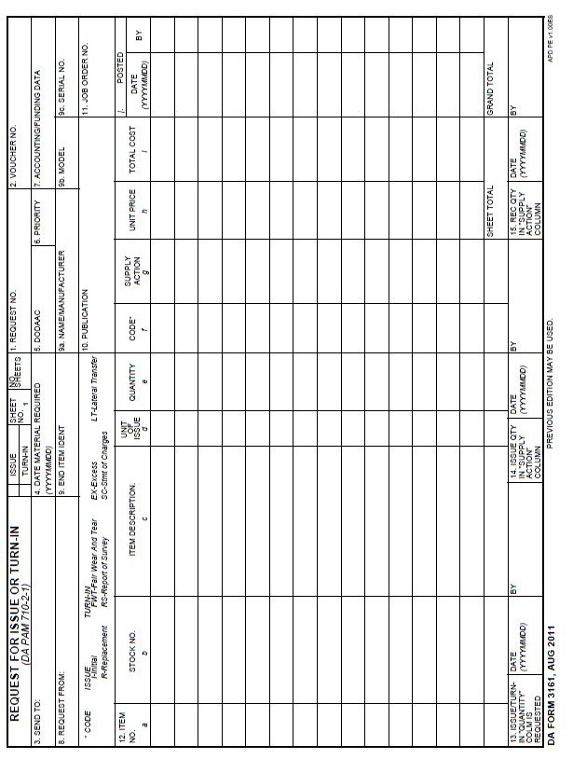
Figure 7

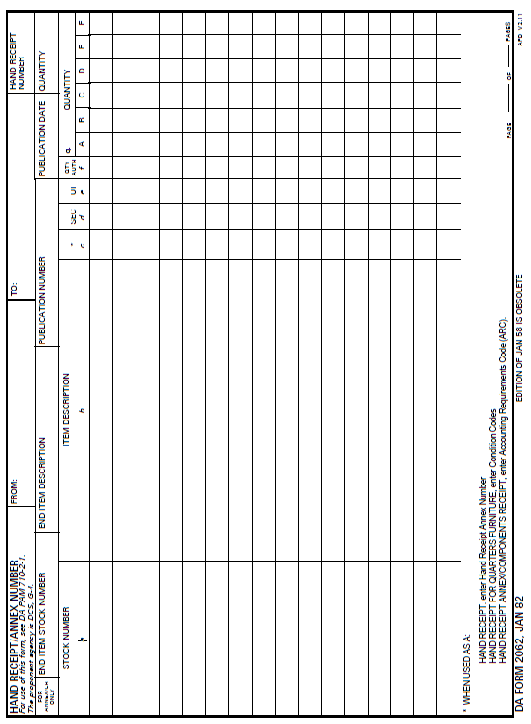
Figure 8

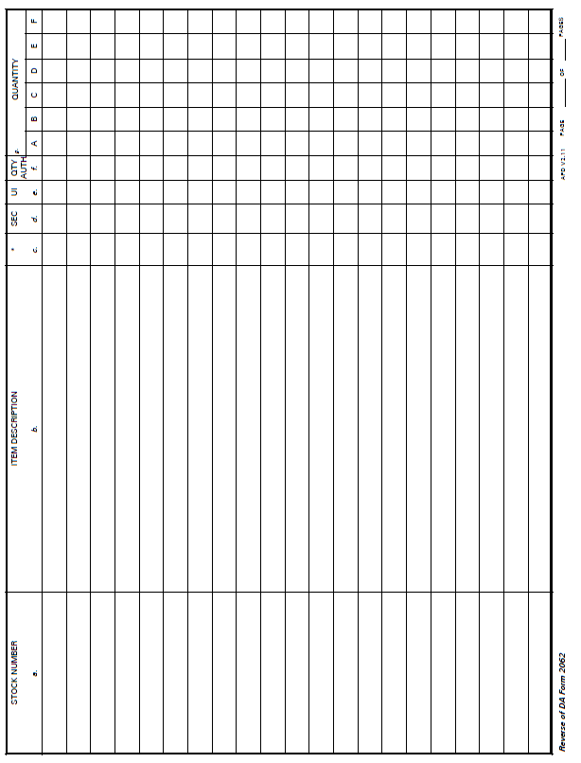
Figure 8

Figure 9

Figure 9

Additional information for completing the Change of Custody Inventory:

QTY ITEM DESCRIPTION

4 Machine Gun Cal .50, M2

4 Machine Gun 7.62mm, M240B

15 Pistol 9mm, M9

100 Cartridge 5.56mm ball - DODIC: A071

40 Cartridge 9mm

1500 Cartridge 5.56mm ball – DODIC: A071 in a sealed container. Seal Number 224689

1000 Cartridge 5.56mm ball – DODIC: A071 in a sealed container. Seal number 112461

