GENERAL INFORMATION
You are assigned to | D Co. 13th Military Police Battalion  Fort Lee, VA 23801
Unit DODAAC | WK4C30
Unit UIC | WBAKD0
Company Commander | Paul J. Sfransky  CPT, MP
Executive Officer (XO) | Michael T. Braddock  1LT, MP
Supply Sergeant | SSG Brian A. Flanders
Unit Phone Number | (804) 765-9185
Armorer | You are the Armorer
Maintenance NCO | SSG Mike McGuire
DSU | 581st Maintenance Company  Fort Lee, VA 23801
Priority | 05
M9 National stock Number | 1005-01-118-2640
M9 Admin and Serial Numbers | 1. 1046090  2. 1047740  3. 1052031  4. 1088595  5. 1327611
Deficiencies found | SN: 1047740 – Locking Block Lug is cracked  SN : 1327611 – Left Pistol Grip is cracked

SITUATION 1
The Company XO has some questions about the M9 Pistol. You are required to answer his questions using TM 9-1005-317-23&P

REQUIREMENT 1: The proper useable on code to use when referencing information on the M9 Pistol is
a. BP9
b. J96 (WP 0021 00-7)

REQUIREMENT 2: The Maintenance Code can be found in what two (2) positions of the SMR Code?
  - 1 and 2
  - 2 and 3
  - 3 and 4 (WP 0021 00-2)
  - 4 and 5

REQUIREMENT 3: Identify the NSN for the following Part Numbers:
PART NUMBER | NATIONAL STOCK NUMBER
9346428 | 5360-01-206-8592 WP 0029 00-1
9346472 | 1005-01-204-4362 WP 0029 00-2
9346451 | 1005-01-204-4374 WP 0029 00-1
12556375 | 5315-01-236-0340 WP 0029 00-2

REQUIREMENT 4: Identify the Part Number for the following NSNs:
NATIONAL STOCK NUMBER | PART NUMBER
1005-01-204-4337 | 9346422 WP 0030 00-1
5360-01-206-0937 | 9346441 WP 0030 00-2
5340-01-204-4361 | 9346471 WP 0030-00-1
5315-01-249-4351 | D63477/8-37P WP 0030 00-2

REQUIEMENT 5: Identify the SMR Code for the following NSNs
National Stock Number | SMR CODE
5360-01-206-0934 | PAOZZ WP 0023 00-1/2, Figure 2
5340-01-204-4343 | PAFZZ WP 0025 00-3/4, Figure 4
5360-01-204-4370 | PAFZZ WP 0027 00-3, Figure 6
1005-01-204-4340 | PAFZZ WP 0024 00-1/2, Figure 3

SITUATION 2:
Your unit has recently implemented the automated maintenance forms. To ensure accuracy the SAMS-E operator has provided you the AWCMF 452 with instructions to verify the information and return it with any required corrections.

REQUIREMENT 6: Using the prepared DD 314, verify that the information on the AWCMF 452 (Figure 1 through Figure 5) is accurate. Annotate any needed corrections by lining through the inaccurate information and placing the correct information beside the inaccurate information.

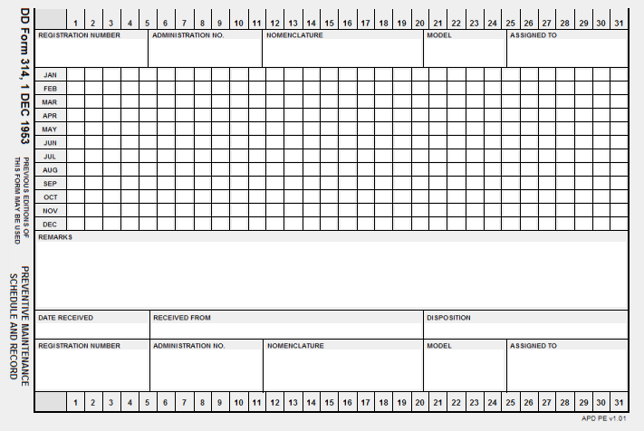
Q Pen Entry
Q Pencil Entry
Q Pen Entry
XX
See Remarks M9 # 1 – 5 Pistol Semi-Automatic 9mm M9 D Co 13th MP BN
Equip End Item: EJ P98152
1. 1046090
2. 1047740
3. 1052031
4. 1088595
5. 1327611

SITUATION 3:
You are the unit armorer for D Company, 13th Military Police Battalion, Fort Lee, VA 23801. A quarterly inspection is being performed on your 9mm Pistols. Use the general information and the information below to complete the requirements. Today’s Date is 16 Aug 20XX.

REQUIREMENT 7: You have completed the Quarterly maintenance on the M9 Pistols. Using DA Pam 750-8, the General Information and the DA Form 5988-E (Figure 6 through Figure 9); annotate the DA Form 5988-E.
NOTE: Place the appropriate signature on each form and give it to the instructor.

REQUIREMENT 8: One of the weapons was missing its DA Form 5988-E; you decide to use a DA Form 2404 to show the completion of the Quarterly maintenance. Using DA Pam 750-8, prepare a DA Form 2404 (Figure 10) for the weapon that was missing the DA Form 5988-E. (Use the attached form or a computer with a forms program.)

REQUIREMENT 9: Using DA Pam 750-8, prepare a DA Form 2407 (Figure 11) for the weapon that needs to go to maintenance. (Use the attached form or use the forms program to print a copy)

DATE: 20XX0716 | SERVICE SCHEDULE | AWCMF 452
DODAAC: WK4C30 | D Co, 13TH MP BN

 | ADMIN NUM: D01 | READING:
NSN: 1005011182640 | MODEL: M9 | NOUN: PISTOL SEMI-AUTO, 9MM
PUB DATA: TM 9-1005-317-10 | 01 02/07 | LAST SERVICE: Q 20XX0515
TM 9-1005-317-23&P | 02 04/08

SERVICE DATA
DATE TYPE | SERVICE DUE | INTERVAL DAYS | READING | DUE
20XX0816 | Q | 90
------------- |  | 0
-------------
Figure 1

DATE: 20XX0716 | SERVICE SCHEDULE | AWCMF 452
DODAAC: WK4C30 | D Co, 13TH MP BN

 | ADMIN NUM: D02 | READING:
NSN: 1005011182640 | MODEL: M9 | NOUN: PISTOL SEMI-AUTO, 9MM
PUB DATA: TM 9-1005-317-10 | 01 02/07 | LAST SERVICE: Q 20XX0615
TM 9-1005-317-23&P | 02 04/08 | 20XX0515

SERVICE DATA
DATE TYPE | SERVICE DUE | INTERVAL DAYS | READING | DUE
20XX0816 | Q | 90
------------- |  | 0
-------------
Figure 2

DATE: 20XX0716 | SERVICE SCHEDULE | AWCMF 452
DODAAC: WK4C30 | D Co, 13TH MP BN

1005011372640 | ADMIN NUM: D03 | READING:
NSN: 1005011372640 | MODEL: M9 | NOUN: PISTOL SEMI-AUTO, 9MM
PUB DATA: TM 9-1005-317-10 | 01 02/07 | LAST SERVICE: Q 20XX0515
TM 9-1005-317-23&P | 02 04/08

SERVICE DATA
DATE TYPE | SERVICE DUE | INTERVAL DAYS | READING | DUE
20XX0816 | Q | 90
------------- |  | 0
-------------
Figure 3

DATE: 20XX0716 | SERVICE SCHEDULE | AWCMF 452
DODAAC: WK4C30 | D Co, 13TH MP BN

 | ADMIN NUM: D04 | READING:
NSN: 1005011182640 | MODEL: M9 | NOUN: PISTOL SEMI-AUTO, 9MM
PUB DATA: TM 9-1005-317-10 | 01 02/07 | LAST SERVICE: Q 20XX0515
TM 9-1005-317-23&P | 02 04/08

SERVICE DATA
DATE TYPE | SERVICE DUE | INTERVAL DAYS | READING | DUE
20XX0816 | Q | 90
------------- |  | 0
-------------
-------------
Figure 4

DATE: 20XX0716 | SERVICE SCHEDULE | AWCMF 452
DODAAC: WK4C30 | D Co, 13TH MP BN

 | ADMIN NUM: D05 | READING:
NSN: 1005011182640 | MODEL: M9 | NOUN: PISTOL SEMI-AUTO, 9MM
PUB DATA: TM 9-1005-317-10 | 01 02/07 | LAST SERVICE: Q 20XX0515
TM 9-1005-317-23&P | 02 04/08

SERVICE DATA
DATE TYPE | SERVICE DUE | INTERVAL DAYS | READING | DUE
20XX0816 | Q | 90
------------- |  | 0
-------------
-------------
Figure 5

DATE: 20XX0801 | EQUIPMENT MAINTENANCE AND | DA FORM 5988-E
 | INSPECTION WORKSHEET
WBAKD0 | D Co, 13th MP Bn
-------------------------------------------------------------- EQUIPMENT DATA ---------------------------------------------------------------
ADMIN NUM: D01 | EQUIP SERIAL NUMBER: 1046090
EQUIP MODEL: M9 | REGISTRATION NUMBER:
EQUIP NOUN: PISTOL, SEMIAUTOMATIC, 9MM | TYPE INSPECTION: QUARTERLY
EQUIP NSN: 1005011182640 | CURRENT READING:

NUMBER | DATE | CHANGE NUMBER
PUBLICATION: TM 9-1005-317-10 | 02/07 | 1
PUBLICATION: TM 9-1005-317-23&P | 04/08 | 2
INSPECTORS LIC#: _______________ TIME: _________ | SIGNATURE: ___________________ TIME: ______

-------------------------------------------------------------- PARTS REQUESTED --------------------------------------------------------------

FAULT | DOC | NUM | NIIN | NOUN | QTY  DUE/REC | STATUS DATE | DATE COMP | P D  R L  I C

------------------------------------------------------------ MAINTENANCE FAULTS ------------------------------------------------------------

ITEM  NUM | FAULT  DATE | FAULT  STATUS | FAULT  DESCRIPTION | CORRECTIVE  ACTION | OPER  HRS LIC#
____ | _________ | _____ | __16 Aug 20XX______________ | ___________________________ | Stud  __ Info
____ | _________ | _____ | ___________________________ | ___________________________ | __ _____
____ | _________ | _____ | ___________________________ | ___________________________ | __ _____
____ | _________ | _____ | ___________________________ | ___________________________ | __ _____
____ | _________ | _____ | ___________________________ | ___________________________ | __ _____
____ | _________ | _____ | ___________________________ | ___________________________ | __ _____
____ | _________ | _____ | ___________________________ | ___________________________ | __ _____
____ | _________ | _____ | ___________________________ | ___________________________ | __ _____
____ | _________ | _____ | ___________________________ | ___________________________ | __ _____
____ | _________ | _____ | ___________________________ | ___________________________ | __ _____
____ | _________ | _____ | ___________________________ | ___________________________ | __ _____
____ | _________ | _____ | ___________________________ | ___________________________ | __ _____
____ | _________ | _____ | ___________________________ | ___________________________ | __ _____
____ | _________ | _____ | ___________________________ | ___________________________ | __ _____
____ | _________ | _____ | ___________________________ | ___________________________ | __ _____
____ | _________ | _____ | ___________________________ | ___________________________ | __ _____
____ | _________ | _____ | ___________________________ | ___________________________ | __ _____
____ | _________ | _____ | ___________________________ | ___________________________ | __ _____
Figure 6

DATE: 20XX0801 | EQUIPMENT MAINTENANCE AND | DA FORM 5988-E
 | INSPECTION WORKSHEET
WBAKD0 | D Co, 13th MP Bn
-------------------------------------------------------------- EQUIPMENT DATA ---------------------------------------------------------------
ADMIN NUM: D02 | EQUIP SERIAL NUMBER: 1047740
EQUIP MODEL: M9 | REGISTRATION NUMBER:
EQUIP NOUN: PISTOL, SEMIAUTOMATIC, 9MM | TYPE INSPECTION: QUARTERLY
EQUIP NSN: 1005011182640 | CURRENT READING:

NUMBER | DATE | CHANGE NUMBER
PUBLICATION: TM 9-1005-317-10 | 02/07 | 1
PUBLICATION: TM 9-1005-317-23&P | 04/08 | 2
INSPECTORS LIC#: Student Info___ TIME: _________ | SIGNATURE: ___________________ TIME: ______

-------------------------------------------------------------- PARTS REQUESTED --------------------------------------------------------------

FAULT | DOC | NUM | NIIN | NOUN | QTY  DUE/REC | STATUS DATE | DATE COMP | P D  R L  I C

------------------------------------------------------------ MAINTENANCE FAULTS ------------------------------------------------------------

ITEM  NUM | FAULT  DATE | FAULT  STATUS | FAULT  DESCRIPTION | CORRECTIVE  ACTION | OPER  HRS LIC#
_3__ | 16 Aug XX | __X__ | Locking Block Lug is Cracked___ | DA Form 2407/5590-E________ | __ _____
____ | _________ | _____ | ___________________________ | ___________________________ | __ _____
____ | _________ | _____ | ___________________________ | ___________________________ | __ _____
____ | _________ | _____ | ___________________________ | ___________________________ | __ _____
____ | _________ | _____ | ___________________________ | ___________________________ | __ _____
____ | _________ | _____ | ___________________________ | ___________________________ | __ _____
____ | _________ | _____ | ___________________________ | ___________________________ | __ _____
____ | _________ | _____ | ___________________________ | ___________________________ | __ _____
____ | _________ | _____ | ___________________________ | ___________________________ | __ _____
____ | _________ | _____ | ___________________________ | ___________________________ | __ _____
____ | _________ | _____ | ___________________________ | ___________________________ | __ _____
____ | _________ | _____ | ___________________________ | ___________________________ | __ _____
____ | _________ | _____ | ___________________________ | ___________________________ | __ _____
____ | _________ | _____ | ___________________________ | ___________________________ | __ _____
____ | _________ | _____ | ___________________________ | ___________________________ | __ _____
____ | _________ | _____ | ___________________________ | ___________________________ | __ _____
____ | _________ | _____ | ___________________________ | ___________________________ | __ _____
____ | _________ | _____ | ___________________________ | ___________________________ | __ _____
Figure 7

DATE: 20XX0801 | EQUIPMENT MAINTENANCE AND | DA FORM 5988-E
 | INSPECTION WORKSHEET
WBAKD0 | D Co, 13th MP Bn
-------------------------------------------------------------- EQUIPMENT DATA ---------------------------------------------------------------
ADMIN NUM: D03 | EQUIP SERIAL NUMBER: 10452031
EQUIP MODEL: M9 | REGISTRATION NUMBER:
EQUIP NOUN: PISTOL, SEMIAUTOMATIC, 9MM | TYPE INSPECTION: QUARTERLY
EQUIP NSN: 1005011182640 | CURRENT READING:

NUMBER | DATE | CHANGE NUMBER
PUBLICATION: TM 9-1005-317-10 | 02/07 | 1
PUBLICATION: TM 9-1005-317-23&P | 04/08 | 2
INSPECTORS LIC#: _______________ TIME: _________ | SIGNATURE: ___________________ TIME: ______

-------------------------------------------------------------- PARTS REQUESTED --------------------------------------------------------------

FAULT | DOC | NUM | NIIN | NOUN | QTY  DUE/REC | STATUS DATE | DATE COMP | P D  R L  I C

------------------------------------------------------------ MAINTENANCE FAULTS ------------------------------------------------------------

ITEM  NUM | FAULT  DATE | FAULT  STATUS | FAULT  DESCRIPTION | CORRECTIVE  ACTION | OPER  HRS LIC#
____ | _________ | _____ | __16 Aug 20XX______________ | ___________________________ | Stud  __ Info
____ | _________ | _____ | ___________________________ | ___________________________ | __ _____
____ | _________ | _____ | ___________________________ | ___________________________ | __ _____
____ | _________ | _____ | ___________________________ | ___________________________ | __ _____
____ | _________ | _____ | ___________________________ | ___________________________ | __ _____
____ | _________ | _____ | ___________________________ | ___________________________ | __ _____
____ | _________ | _____ | ___________________________ | ___________________________ | __ _____
____ | _________ | _____ | ___________________________ | ___________________________ | __ _____
____ | _________ | _____ | ___________________________ | ___________________________ | __ _____
____ | _________ | _____ | ___________________________ | ___________________________ | __ _____
____ | _________ | _____ | ___________________________ | ___________________________ | __ _____
____ | _________ | _____ | ___________________________ | ___________________________ | __ _____
____ | _________ | _____ | ___________________________ | ___________________________ | __ _____
____ | _________ | _____ | ___________________________ | ___________________________ | __ _____
____ | _________ | _____ | ___________________________ | ___________________________ | __ _____
____ | _________ | _____ | ___________________________ | ___________________________ | __ _____
____ | _________ | _____ | ___________________________ | ___________________________ | __ _____
____ | _________ | _____ | ___________________________ | ___________________________ | __ _____
Figure 8

DATE: 20XX0801 | EQUIPMENT MAINTENANCE AND | DA FORM 5988-E
 | INSPECTION WORKSHEET
WBAKD0 | D Co, 13th MP Bn
-------------------------------------------------------------- EQUIPMENT DATA ---------------------------------------------------------------
ADMIN NUM: D05 | EQUIP SERIAL NUMBER: 1327611
EQUIP MODEL: M9 | REGISTRATION NUMBER:
EQUIP NOUN: PISTOL, SEMIAUTOMATIC, 9MM | TYPE INSPECTION: QUARTERLY
EQUIP NSN: 1005011182640 | CURRENT READING:

NUMBER | DATE | CHANGE NUMBER
PUBLICATION: TM 9-1005-317-10 | 02/07 | 1
PUBLICATION: TM 9-1005-317-23&P | 04/08 | 2
INSPECTORS LIC#: Student Info_____ TIME: _________ | SIGNATURE: ___________________ TIME: ______

-------------------------------------------------------------- PARTS REQUESTED --------------------------------------------------------------

FAULT | DOC | NUM | NIIN | NOUN | QTY  DUE/REC | STATUS DATE | DATE COMP | P D  R L  I C

------------------------------------------------------------ MAINTENANCE FAULTS ------------------------------------------------------------

ITEM  NUM | FAULT  DATE | FAULT  STATUS | FAULT  DESCRIPTION | CORRECTIVE  ACTION | OPER  HRS LIC#
_5__ | 16 Aug XX | __X__ | Left Pistol Grip Cracked___ | 1005-01-287-2606____________ | __ _____
____ | _________ | _____ | ___________________________ | ___________________________ | __ _____
____ | _________ | _____ | ___________________________ | ___________________________ | __ _____
____ | _________ | _____ | ___________________________ | ___________________________ | __ _____
____ | _________ | _____ | ___________________________ | ___________________________ | __ _____
____ | _________ | _____ | ___________________________ | ___________________________ | __ _____
____ | _________ | _____ | ___________________________ | ___________________________ | __ _____
____ | _________ | _____ | ___________________________ | ___________________________ | __ _____
____ | _________ | _____ | ___________________________ | ___________________________ | __ _____
____ | _________ | _____ | ___________________________ | ___________________________ | __ _____
____ | _________ | _____ | ___________________________ | ___________________________ | __ _____
____ | _________ | _____ | ___________________________ | ___________________________ | __ _____
____ | _________ | _____ | ___________________________ | ___________________________ | __ _____
____ | _________ | _____ | ___________________________ | ___________________________ | __ _____
____ | _________ | _____ | ___________________________ | ___________________________ | __ _____
____ | _________ | _____ | ___________________________ | ___________________________ | __ _____
____ | _________ | _____ | ___________________________ | ___________________________ | __ _____
____ | _________ | _____ | ___________________________ | ___________________________ | __ _____
Figure 9

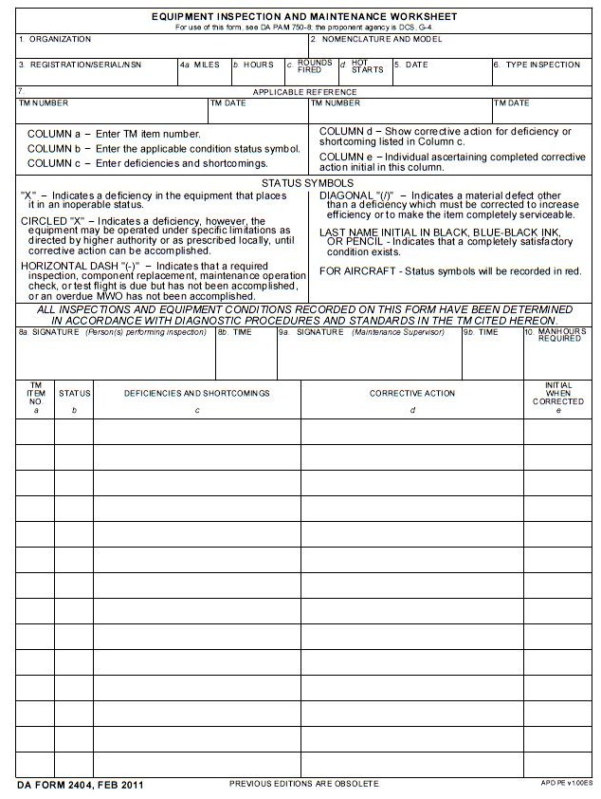
16 August 20XX Initials
TM 9-1005-317-23&P W/Ch 2 4 Apr08
1005-01-118-2640 / 1088595 16 Aug 20XX Quarterly
D Co, 13th MP BN Pistol Semiautomatic, 9mm; M9
Figure 10
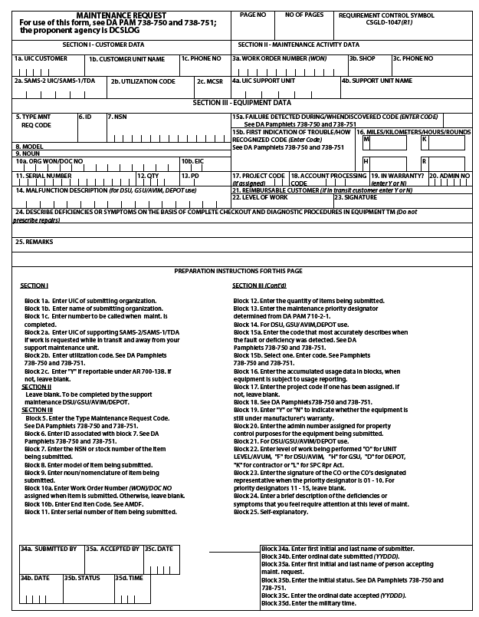
4 M N
F
WBAKD0 D Co 13th MP BN 765-9185
1 0 4 7 7 4 0 0 0 0 0 1 05 N D 0 1
Pistol Semi-Automatic, 9mm
M9
1 A 1005-01-118-2640
Locking Block Lug is Cracked
0
1 1
Figure 11

