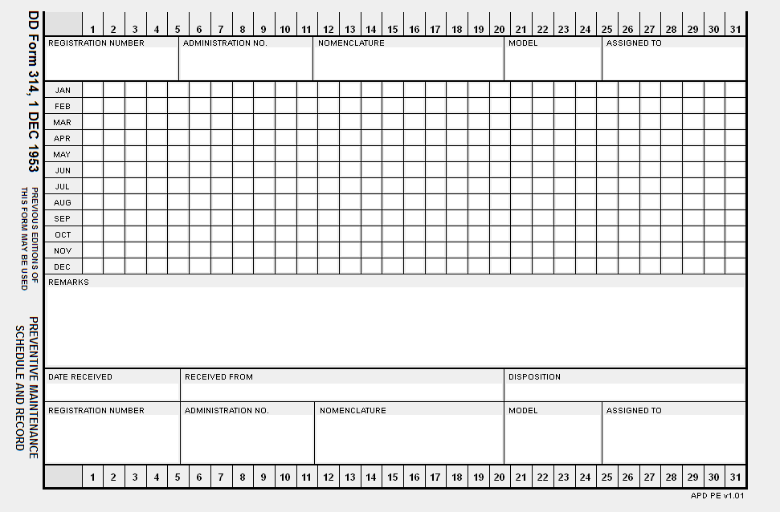
Figure 1

DATE: 20XX0616 | SERVICE SCHEDULE | AWCMF 452
DODAAC: WK4C26 | HHC 13TH MP BN

-----------------------------------------------------------------------------------------------------------------------------------------------------------------------------------
 | ADMIN NUM: M9 HHC 3 | READING:
NSN: 1005011182640 | MODEL: M9 | NOUN: PISTOL SEMI-AUTO, 9MM
PUB DATA: TM 9-1005-317-10 | 01 02/07 | LAST SERVICE: Q 20XX0411
TM 9-1005-317-23&P | 02 02/07

SERVICE DATA
DATE TYPE | SERVICE DUE | INTERVAL DAYS | READING | DUE
20XX0711 | Q | 90
------------- |  | 0
-------------
-------------
Figure 2

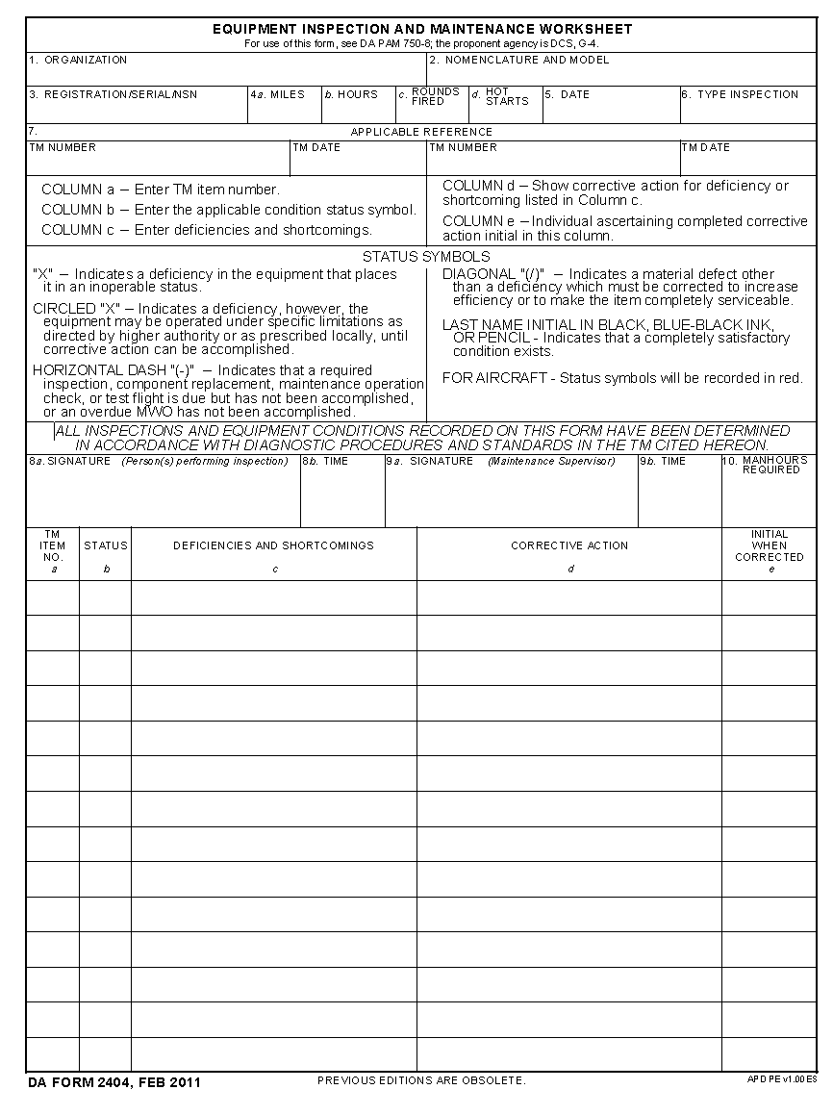
Figure 3

DATE: 11 July 20XX | EQUIPMENT MAINTENANCE AND | DA FORM 5988-E
 | INSPECTION WORKSHEET
WBAKT0 | HHC 13TH MP BN

--------------------------------------------------------------------------- EQUIPMENT DATA ---------------------------------------------------------------------------
ADMIN NUM: M9 HHC 3 | EQUIP SERIAL NUMBER: 9204924
EQUIP MODEL: M9 | REGISTRATION NUMBER:
EQUIP NOUN: PISTOL SEMI-AUTOMATIC 9MM | TYPE INSPECTION: Q
EQUIP NSN: 1005011182640 | CURRENT READING:

NUMBER | DATE | CHANGE NUMBER
PUBLICATION: TM 9-1005-317-10 | 02 / 07 | 01
PUBLICATION: TM 9-1005-317-23&P | 02 / 07 | 02
INSPECTORS LIC#: _______________ TIME: __________ | SIGNATURE: _________________________ TIME: ______

-------------------------------------------------------------------------- PARTS REQUESTED --------------------------------------------------------------------------

FAULT | DOC | NUM | NIIN | NOUN | QTY  DUE/REC | STATUS DATE | DATE COMP | P D  R L  I C

------------------------------------------------------------------------ MAINTENANCE FAULTS ------------------------------------------------------------------------

ITEM  NUM | FAULT  DATE | FAULT  STATUS | FAULT  DESCRIPTION | CORRECTIVE  ACTION | OPER  HRS LIC#
_____ | _________ | _____ | ______________________________ | ______________________________ | ___ ________
_____ | _________ | _____ | ______________________________ | ______________________________ | ___ ________
_____ | _________ | _____ | ______________________________ | ______________________________ | ___ ________
_____ | _________ | _____ | ______________________________ | ______________________________ | ___ ________
_____ | _________ | _____ | ______________________________ | ______________________________ | ___ ________
_____ | _________ | _____ | ______________________________ | ______________________________ | ___ ________
_____ | _________ | _____ | ______________________________ | ______________________________ | ___ ________
_____ | _________ | _____ | ______________________________ | ______________________________ | ___ ________
_____ | _________ | _____ | ______________________________ | ______________________________ | ___ ________
_____ | _________ | _____ | ______________________________ | ______________________________ | ___ ________
_____ | _________ | _____ | ______________________________ | ______________________________ | ___ ________
_____ | _________ | _____ | ______________________________ | ______________________________ | ___ ________
_____ | _________ | _____ | ______________________________ | ______________________________ | ___ ________
_____ | _________ | _____ | ______________________________ | ______________________________ | ___ ________
_____ | _________ | _____ | ______________________________ | ______________________________ | ___ ________
_____ | _________ | _____ | ______________________________ | ______________________________ | ___ ________
Figure 4

DATE: 11 July 20XX | EQUIPMENT MAINTENANCE AND | DA FORM 5988-E
 | INSPECTION WORKSHEET
WBAKT0 | HHC 13TH MP BN

--------------------------------------------------------------------------- EQUIPMENT DATA ---------------------------------------------------------------------------
ADMIN NUM: M9 HHC 4 | EQUIP SERIAL NUMBER: 9204925
EQUIP MODEL: M9 | REGISTRATION NUMBER:
EQUIP NOUN: PISTOL SEMI-AUTOMATIC 9MM | TYPE INSPECTION: Q
EQUIP NSN: 1005011182640 | CURRENT READING:

NUMBER | DATE | CHANGE NUMBER
PUBLICATION: TM 9-1005-317-10 | 02 / 07 | 01
PUBLICATION: TM 9-1005-317-23&P | 02 / 07 | 02
INSPECTORS LIC#: _______________ TIME: __________ | SIGNATURE: _________________________ TIME: ______

-------------------------------------------------------------------------- PARTS REQUESTED --------------------------------------------------------------------------

FAULT | DOC | NUM | NIIN | NOUN | QTY  DUE/REC | STATUS DATE | DATE COMP | P D  R L  I C

------------------------------------------------------------------------ MAINTENANCE FAULTS ------------------------------------------------------------------------

ITEM  NUM | FAULT  DATE | FAULT  STATUS | FAULT  DESCRIPTION | CORRECTIVE  ACTION | OPER  HRS LIC#
_____ | _________ | _____ | ______________________________ | ______________________________ | ___ ________
_____ | _________ | _____ | ______________________________ | ______________________________ | ___ ________
_____ | _________ | _____ | ______________________________ | ______________________________ | ___ ________
_____ | _________ | _____ | ______________________________ | ______________________________ | ___ ________
_____ | _________ | _____ | ______________________________ | ______________________________ | ___ ________
_____ | _________ | _____ | ______________________________ | ______________________________ | ___ ________
_____ | _________ | _____ | ______________________________ | ______________________________ | ___ ________
_____ | _________ | _____ | ______________________________ | ______________________________ | ___ ________
_____ | _________ | _____ | ______________________________ | ______________________________ | ___ ________
_____ | _________ | _____ | ______________________________ | ______________________________ | ___ ________
_____ | _________ | _____ | ______________________________ | ______________________________ | ___ ________
_____ | _________ | _____ | ______________________________ | ______________________________ | ___ ________
_____ | _________ | _____ | ______________________________ | ______________________________ | ___ ________
_____ | _________ | _____ | ______________________________ | ______________________________ | ___ ________
_____ | _________ | _____ | ______________________________ | ______________________________ | ___ ________
_____ | _________ | _____ | ______________________________ | ______________________________ | ___ ________
Figure 5

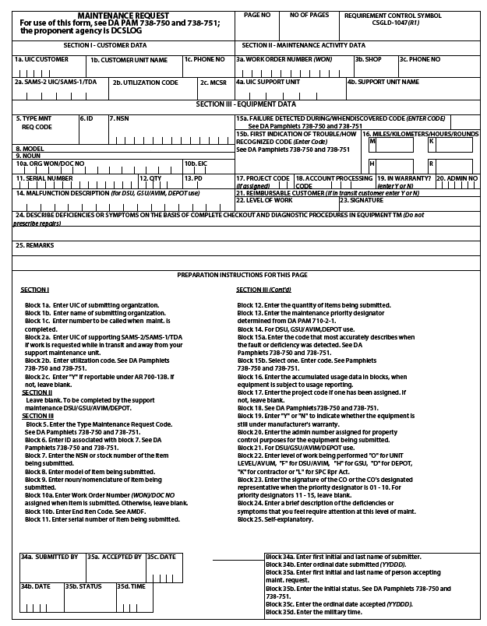
Figure 6

DATE: 20XX0717 | MAINTENANCE REQUEST | DA FORM 5990-E

--------------------------------------------------------------------------- CUSTOMER DATA ---------------------------------------------------------------------------
UIC: WBAKT0 | HHC, 13TH MP BN | PHONE: 765-9185
UTIL CODE: 0

--------------------------------------------------------------------------- ACTIVITY DATA ---------------------------------------------------------------------------
SUP WON: | 581ST MAINTENANCE CO | PHONE: 734-7235
SUP UIC: WBBDXF |  | SHOP SEC: .

-------------------------------------------------------------------------- EQUIPMENT DATA --------------------------------------------------------------------------

TYPE MNT REQ: 1 | ID: A NSN: 1005011182640 | MODEL: M9 .
NOUN: PISTOL SEMI-AUTOMATIC, 9MM | SER NUM: 9204925 | QTY: 00001 .
ORG WON : | PRIORITY: 12 . | FAILURE DETECTED: D .
MI/KM: ------------ | HOURS: ----- | ROUNDS: .
IN WARRANTY: | LEVEL OF WORK: F . | ADMIN NUM: M9 HHC 4 .
DEFICIENCY: Safety lever does not rotate freely
PD AUTHENTICATING SIGNATURE: _________________________________________________________________________

------------------------------------------------------------------------ SIGNATURE DATA ------------------------------------------------------------------------

SUBMITTED BY: ___________________________________ |  | ORD DATE: ______________ | MIL TIME: ___________
ACCEPTED BY: ______________________ | STATUS: ___ | ORD DATE: ______________ | MIL TIME: ___________

------------------------------------------------------------------------ ACTION DATA ------------------------------------------------------------------------

WORK STARTED BY: ____________________ | STATUS: ___ | ORD DATE: ______________ | MIL TIME: ___________
INSPECTED BY: ____________________ | STATUS: ___ | ORD DATE: ______________ | MIL TIME: ___________
PICKED UP BY: ____________________ | STATUS: ___ | ORD DATE: ______________ | MIL TIME: ___________

------------------------------------------------------------------------ COMPLETION DATA ------------------------------------------------------------------------

QTY RPR: ________________ | QTY CONDEMNED: ______________ |  |  | NRTS: ___________
EVAC WON: ______________________ |  |  | EVAC UNIT NAME: ________________________________
Figure 7

