SPECIAL INSTRUCTIONS

- This is a hands-on practical exercise. You will use only the reference publications shown. You may use notes. Do not talk to other students at any time. Speak only to the instructor.

- Be sure to read the “SITUATION”. If you have any questions, ask the instructor now.

- The soldier will score a GO (G) if all steps are passed. The soldier will score a NO-GO (NG) if any steps are failed. If the soldier scores a NG on any step, the soldier will be shown what was done incorrectly, how to do it properly, and then will be re-tested.

- During this practical exercise you will need:

  - Safety Goggles
  - M9 Pistol
  - Magazine
  - Tool Kit Small Arms Repairman
  - AR 25-400-2
  - TM 9-1005-317-10
  - TM 9-1005-317-23&P
  - DA Pam 750-8
  - Computer with forms program or blank forms.
  - Pencil or Pen

GENERAL INFORMATION

Your unit of assignment | D Co, 13th MP BN  Fort Lee, VA 23801
Unit DODAAC | WK4C30
Unit UIC | WBAKD0
Company Commander | Paul J. Sfransky  CPT, MP
Armorer/Supply Clerk | You are the Armorer/Supply Clerk
Unit Phone Number | 765-9185
Maintenance Supervisor | SFC Mike McGuire
Direct Support Unit (DSU) | 581st Maintenance Company
M9 National Stock Number | 1005-01-118-2640
M9 Serial Number | 167938, 168246
M9 EIC | 4MN

GENERAL SITUATION
You are the unit armorer for D Co 13th MP BN. The Supply Sergeant has informed you that the M9 Pistols are scheduled for their quarterly service. You have been tasked with performing organizational maintenance on the M9 Pistols assigned to the unit. Today’s date is 25 October 20XX.

Requirement 1
Using TM 9-1005-317-10, TM 9-1005-317-23&P, and the performance sheet listed below, unload and clear the M9 9mm Pistol.

UNLOAD AND CLEAR THE WEAPON | GO | NO GO
- Place the decocking/safety lever in the SAFE position.
- Depress the magazine release button and remove the magazine from the pistol.
- Hold the pistol in the raised position.
- Pull the slide to the rear and remove any chambered round.
- Push the slide stop up, locking the slide to the rear.
- Look into the chamber to ensure that it is empty

Requirement 2
Using TM 9-1005-317-10, TM 9-1005-317-23&P and performance sheet listed below, disassemble the M9 9mm Pistol.

DISASSEMBLY OF THE WEAPON | GO | NO GO
- Depress the slide stop and let the slide go forward.
- Hold the pistol in the right hand with the muzzle slightly raised.
- Press the disassembly lever button with the forefinger.
- Rotate the disassembly lever downward until it stops.
- Pull the slide and barrel assembly forward and remove it from the receiver.
- Carefully and lightly compress the recoil spring and spring guide. At the same time, lift up and remove them.
- Separate the recoil spring from the spring guide.
- Push in on the locking block while pushing the barrel forward slightly.
- Lift and remove the locking block and barrel assembly from the slide.

STUDENT: You must stop at this time and have an instructor verify that you have correctly completed requirements 1 and 2.

Requirement 3
Using TM 9-1005-317-23&P, DA Pam 750-8, and a computer with an Army form program or blank DA Form 2404 (Figure 1), and DA Form 2407 (Figure 2). Prepare a DA Form 2404 and DA Form 2407 on the Pistol M9, serial number 167938. Annotate all corrective actions as required. If an item needs to be ordered, place the NSN in the Corrective Action block. The following deficiencies were found on the pistols.

SERIAL NUMBER | DEFICIENCY
167938 | Recoil Spring Bent
168246 | Cracked Receiver Rail

Requirement 4
Using TM 9-1005-317-10, TM 9-1005-317-23&P, and the performance sheet listed below, student will reassemble the M9, 9mm Pistol.

REASSEMBLY OF THE WEAPON | GO | NO GO
- Grasp the slide with the bottom facing up.
- With the other hand, grasp the barrel assembly with the locking block facing up.
- Insert the muzzle into the forward end of the slide and at the same time, lower the rear of the barrel assembly by aligning the extractor cutout with the extractor
NOTE: The locking block will fall into the locked position in the slide.
- Insert the spring onto the recoil spring guide.
- Insert the end of the recoil spring and the recoil spring guide into the recoil spring housing. At the same time, compress the recoil spring and lower the recoil spring guide until it is fully seated on the locking block cutaway.
- Ensure the hammer is unlocked and the firing pin block is in the DOWN position, and the decocking/safety lever is in the SAFE position.
- Grasp the slide and barrel assembly with the sights up and align the slide on the receiver assembly guide rails.
- Push until the rear of the slide is a short distance beyond the rear of the receiver assembly and hold. At the same time, rotate the disassembly latch lever upward. A click indicates a positive lock.

Requirement 5
Using TM 9-1005-317-10, TM 9-1005-317-23&P, and the performance sheet listed below, perform a functions check on the M9 Pistol.

FUNCTION CHECK | GO | NO GO
WARNING: Ensure that the pistol is clear before performing a function check.
- Depress the slide stop, letting the slide go forward.
- Insert an empty magazine into the pistol.
- Retract the slide fully and release it. The slide should lock to the rear.
- Depress the magazine release button and remove the magazine.
- Ensure the decocking/safety lever is in the SAFE position.
- Depress the slide stop. When the slide goes forward, the hammer should fall to the forward position.
- Squeeze and release the trigger. The firing pin block should move up and down and the hammer should not move.
- Place the decocking/safety lever in the FIRE position.
- Squeeze the trigger to check the double action. The hammer should cock and fall.
- Squeeze the trigger again. Hold it to the rear. Manually retract and release the slide.
- Squeeze the trigger to check single action. The hammer should fall.

STUDENT: You must stop at this time and have an instructor verify that you have correctly completed requirements 4 and 5.

PERFORMANCE MEASURE | RESULTS
- Clear the pistol before disassembly | P | F
- Disassemble the pistol. | P | F
- Prepare DA Form 2404 and DA Form 2407 | P | F
- Assemble the pistol | P | F
- Perform a function check | P | F
- Weapon functions as mission-ready | P | F
Verified By Signature:
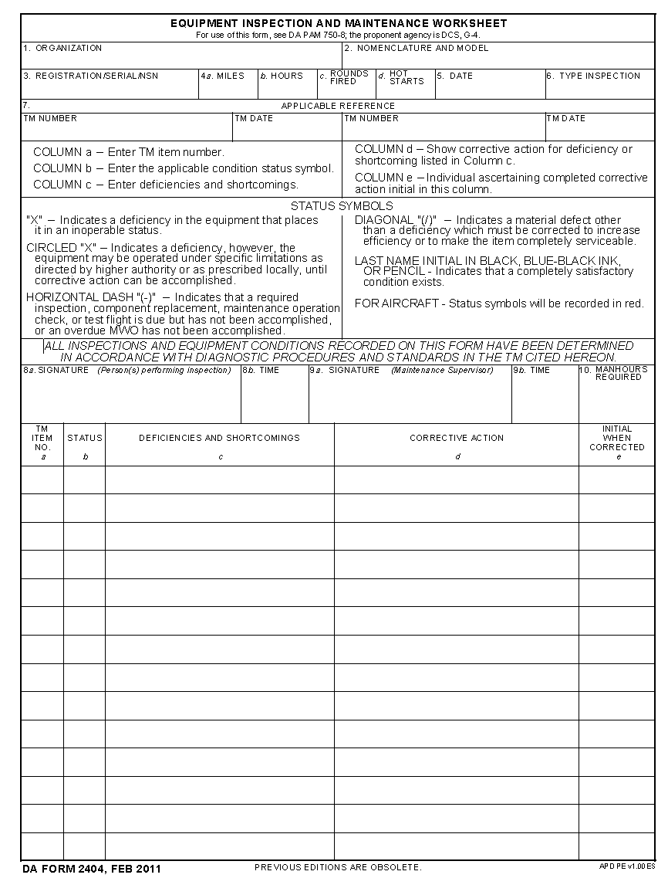
5 X Cracked Receiver Rail DA Form 2407 (Direct Support)
25 Oct XX Quarterly
D Co 13th Military Police Battalion Pistol Semiautomatic, 9mm, M9
4 X Recoil Spring Bent 5360-01-206-0934
SN 168246
SN 167938
Student Signature
TM 9-1005-317-23&P 28 Feb 07
Figure 1

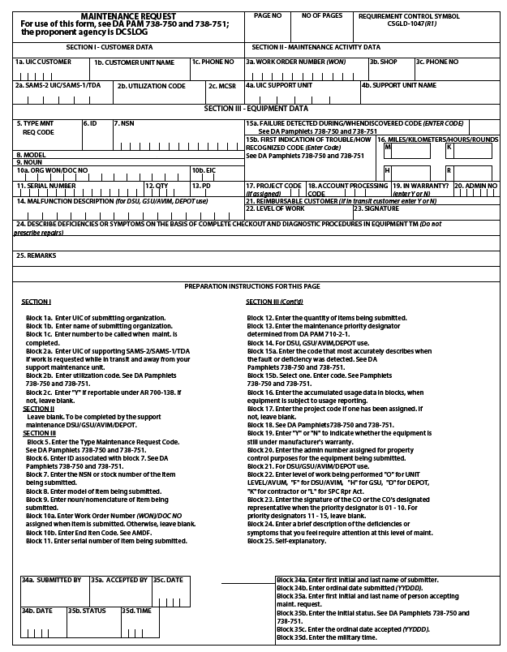
Cracked Receiver Rail
F
1 6 8 2 4 6 0 0 0 0 1 1 2 N 2
4MN
M9
1 A 1005-01-118-2640
Pistol, Semiautomatic, 9mm
0
W K 4 C 3 0 D Co 13th MP BN 765-9185
1 1
Figure 2

