SPECIAL INSTRUCTIONS

- This is a hands-on practical exercise. You will use only the reference publications shown. You may use notes. Do not talk to other students at any time. Speak only to the instructor.

- Be sure to read the “SITUATION”. If you have any questions, ask the instructor now.

- The soldier will score a GO (G) if all steps are passed. The soldier will score a NO-GO (NG) if any steps are failed. If the soldier scores a NG on any step, the soldier will be shown what was done incorrectly, how to do it properly, and then will be re-tested.

- During this practical exercise you will need:

  - Safety Goggles
  - M110 Semi-Automatic Sniper System
  - 10 Ea A159 – Cartridge 7.62mm Dummy M172
  - Tool Kit Small Arms Repairman
  - AR 25-400-2
  - TM 9-1005-342-10
  - TM 9-1005-342-23&P
  - DA Pam 750-8
  - Pencil or Pen

GENERAL INFORMATION

Your unit of assignment | D Co, 13th MP BN  Fort Lee, VA 23801
Unit DODAAC | WK4C30
Unit UIC | WBAKD0
Company Commander | Paul J. Sfransky  CPT, MP
Supply Clerk/Assistant Armorer | You are the Supply Clerk/Assistant Armorer
Unit Phone Number | 765-9185
Maintenance Supervisor | SFC Mike McGuire
Direct Support Unit (DSU) | 581st Maintenance Company
M110 National Stock Number | 1005-01-534-2841
M110 Serial Number | Use the serial number from the weapon.
M110 EIC | 4FZ

GENERAL SITUATION 1
You are the armorer for D Co 13th MP BN. The Commander has informed you that the M110 Semi-Automatic Sniper System is scheduled for their quarterly service. You have been tasked with performing organizational maintenance on the M110 Semi-automatic Sniper System.

Requirement 1
Using TM 9-1005-342-10, TM 9-1005-342-23&P, and the performance sheet listed below, clear the M110 Semi-Automatic Sniper System.

UNLOAD AND CLEAR THE WEAPON | GO | NO GO
NOTE: If weapon is not cocked, ambidextrous safety selector lever cannot be placed toward SAFE.
- Point weapon in a SAFE direction.
- Place ambidextrous safety selector lever on SAFE.
- Remove cartridge magazine by depressing ambidextrous magazine catch and releasing cartridge magazine.
- To lock bolt open, pull charging handle rearward. Press ambidextrous bolt catch and allow bolt to move forward until it engages bolt catch.
- Return charging handle to full forward position.
- If you haven’t before, place ambidextrous safety selector lever on SAFE.
- Check receiver and chamber to ensure these areas contain no ammunition or other obstructions.
- With ambidextrous safety selector lever pointing toward SAFE, allow bolt to go forward by pressing ambidextrous bolt catch.

Requirement 2
Using TM 9-1005-342-10, TM 9-1005-342-23&P and performance sheet listed below, field strip the M110 Semi-Automatic Sniper System and locate and describe the major components.

DISASSEMBLY OF THE WEAPON | GO | NO GO
- Ensure weapon has been cleared.
- Remove the sling.
UPPER RECEIVER AND BARREL ASSEMBLY AND LOWER RECEIVER AND ADJUSTABLE BUTTSTOCK ASSEMBLY
CAUTION: Only use hand pressure to disengage the front pivot pin and rear takedown pin. Force other than hand pressure may cause damage to the weapon and replacement of the weapon would be required.
NOTE: Ensure that the bolt and carrier assembly are in the forward position prior to disassembly.
- Push rear takedown pin (left to right) until flush and pull pin as far as it will go.
- Pivot upper receiver and barrel assembly from lower receiver and adjustable buttstock assembly.
- Push lower receiver front pivot pin flush. Pull front pivot pin (left to right) as far as it will go; separate upper receiver and barrel assembly from lower receiver and adjustable buttstock assembly.
BOLT AND CARRIER ASSEMBLY
- Pull back on charging handle to extract bolt and carrier assembly
- Remove bolt and carrier assembly from upper receiver and barrel assembly.
- Remove charging handle.
- Retract firing pin retaining pin from bolt and carrier assembly.
- Drop firing pin out of rear of bolt and carrier assembly.
- Push bolt assembly inward to rear locked position.
- Remove bolt cam pin.
- Remove bolt assembly from bolt and carrier assembly.
LOWER RECEIVER AND ADJUSTABLE BUTTSTOCK ASSEMBLY
- Depress buffer, press in buffer detent and release buffer and action spring.
- Remove buffer and action spring.
- Separate action spring from buffer.
DAY OPTIC SCOPE
- DOES NOT remove Day Optic Scope.
BIPOD – DO NOT REMOVE BIPOD To receive go, the student will tell instructor how to remove the bipod
- Loosen bipod thumbscrew counterclockwise. If unable to loosen with finger pressure, it may be necessary to use a 5/32” allen wrench.
- Squeeze side plates together to remove the bipod assembly.
- Lift bipod assembly away from lower rail.
SOUND SUPPRESSOR
- Pull quick detatch locking latch upward from rear of weapon.
- Turn sound suppressor clockwise quarter of a turn, and pull away from barrel.
MAGAZINE
- Push up on the rear of bottom of the magazine and slide left to right on the magazine bottom plate.
- Remove magazine bottom plate.
- Remove magazine spring and follower.
This completes disassembly field stripping.
- Proper protective /safety gear used during disassembly.

Requirement 3
Using TM 9-1005-342-23&P, DA Pam 750-8, and a computer with the Army form program or blank DA Form 2404 (Figure 1), and DA Form 2407 (Figure 2). Complete the DA Form 2404 for the required quarterly service and prepare the DA Form 2407 on the M110 SASS. Annotate all corrective actions as required. Today’s date is 30 October 20XX. The following deficiencies were found on the rifle.

DEFICIENCIES FOUND
Bolt Gas Ring Warped

Requirement 4
Using TM 9-1005-342-10, TM 9-1005-342-23&P, and the performance sheet listed below, student will reassemble the M110 Semi-Automatic Sniper System.

REASSEMBLY OF THE WEAPON | GO | NO GO
MAGAZINE
- Place follower and spring in magazine.
- Depress spring and reinsert magazine bottom plate.
SOUND SUPPRESSOR
- Fully extend the quick detatch (QD) locking latch on the sound suppressor.
- Slide sound suppressor on barrel holding the QD locking latch up.
- Align QD locking latch with slots in gas block by turning sound suppressor counter-clockwise until it stops.
- Push down on QD locking latch and lock sound suppressor on to the gas block.
BIPOD – To receive go the student will tell the instructor how to reassemble the bipod.
- On the bipod assembly, squeeze side plates together.
- While squeezing side plates together, engage side plates with mounting adapter swivel stud on the bottom of the upper receiver and barrel assembly.
- Release side plates.
- Hand tighten bipod thumbscrew clockwise to secure side plates onto mounting adapter.
- Using a 5/32” Allen wrench from the deployment kit, tighten bipod thumbscrew firmly, but no more than ¼ turn -1/3 turn past “finger tight”.
DAY OPTIC SCOPE
- Day Optic Scope was not disassembled.
LOWER RECEIVER AND ADJUSTABLE BUTTSTOCK ASSEMBLY
- Assemble action spring and buffer.
- Make sure hammer is cocked. Insert assembled action spring and buffer into lower receiver and adjustable buttstock assembly extension. Buffer detent may need to be depressed as buffer is fully inserted.
BOLT AND CARRIER ASSEMBLY
- Reinsert the bolt assembly into the bolt carrier assembly.
- Rotate bolt assembly to align cam pin hole at rear of cam slot of bolt carrier assembly. Ensure extractor is facing to the right.
- Insert cam pin with firing pin hole aligned front to rear.
- Hold firing pin retaining pin to its full open stop. Hold bolt carrier assembly downwards in palm of hand and drop firing pin into bolt carrier assembly.
- With firing pin fully forward, push in on firing pin retaining pin. Firing pin retaining pin should be flush or below the surface of the bolt carrier assembly body.
- Pull bolt assembly to its extended (unlocked) position. Hold rear of bolt carrier assembly down against open palm, place thumb over the firing pin retaining pin, and shake bolt carrier assembly. Firing pin should not fall out if firing pin retaining pin and firing pin are properly installed (you should also be able to hear firing pin moving back and forth).
- Insert charging handle into upper receiver and barrel assembly. Ensure charging handle lugs enter their grooves in the rear of upper receiver and barrel assembly through the clearance slots near the rear of the upper receiver and barrel assembly. Position the charging handle by sliding it in approximately three inches from its full forward position.
- Position the carrier key of the bolt and carrier assembly in groove of charging handle. Push forward on bolt carrier assembly and charging handle until they are fully forward. You should hear a click as charging handle locks in position.
- Make sure hammer is cocked and ambidextrous safety selector lever is on SAFE.
- Position upper receiver and barrel assembly and lower receiver and adjustable buttstock assembly so that the front pivot pin holes are aligned.
- Push in front pivot pin.
- Rotate lower receiver upward and push in rear take down pin.
- Reattach sling.

Requirement 5
Using TM 9-1005-342-10, TM 9-1005-342-23&P and the performance sheet listed below, student will conduct a safety/function check on the M110 SASS to ensure weapon has been reassembled correctly.

SAFETY/FUNCTION CHECK | GO | NO GO
CHECKING SAFE POSITION
- Remove magazine and check chamber.
- Place ambidextrous safety selector lever on SAFE position.
- Pull charging handle fully to the rear and lock bolt to the rear.
- Returns charging handle to its forward position.
- Visually check receiver and chamber area for ammunition or foreign objects.
- Release bolt catch and allow bolt to lock into battery.
- Squeeze trigger fully to the rear. You should not hear anything as the hammer should not fall. Release the trigger.
CHECKING SEMI POSITION AND DISCONNECTOR
- Place ambidextrous safety selector lever on FIRE position.
- Squeeze trigger fully to the rear while listening for the hammer to snap forward.
- You should hear hammer snap forward with a distinct click. Continue holding the trigger fully to the rear.
- While holding trigger to the rear, pull the charging handle fully to the rear. Ride the charging handle forward slowly and listen for the hammer to fall. You should hear nothing as the hammer should be held to the rear by the disconnector.
- Slowly release the trigger. You should hear a light click as the hammer is released from the disconnector and engages the sear.
- Squeeze the trigger fully to the rear. You should hear the hammer fall forward with a distinct click.
- Close the ejection port cover.

PERFORMANCE MEASURE | RESULTS
Clear the rifle before disassembly | P | F
Disassemble the rifle. | P | F
Prepare DA Form 2404 and DA Form 2407 | P | F
Assemble the rifle. | P | F
Perform a function check | P | F
Weapon functions as mission-ready | P | F
Verified By Signature:

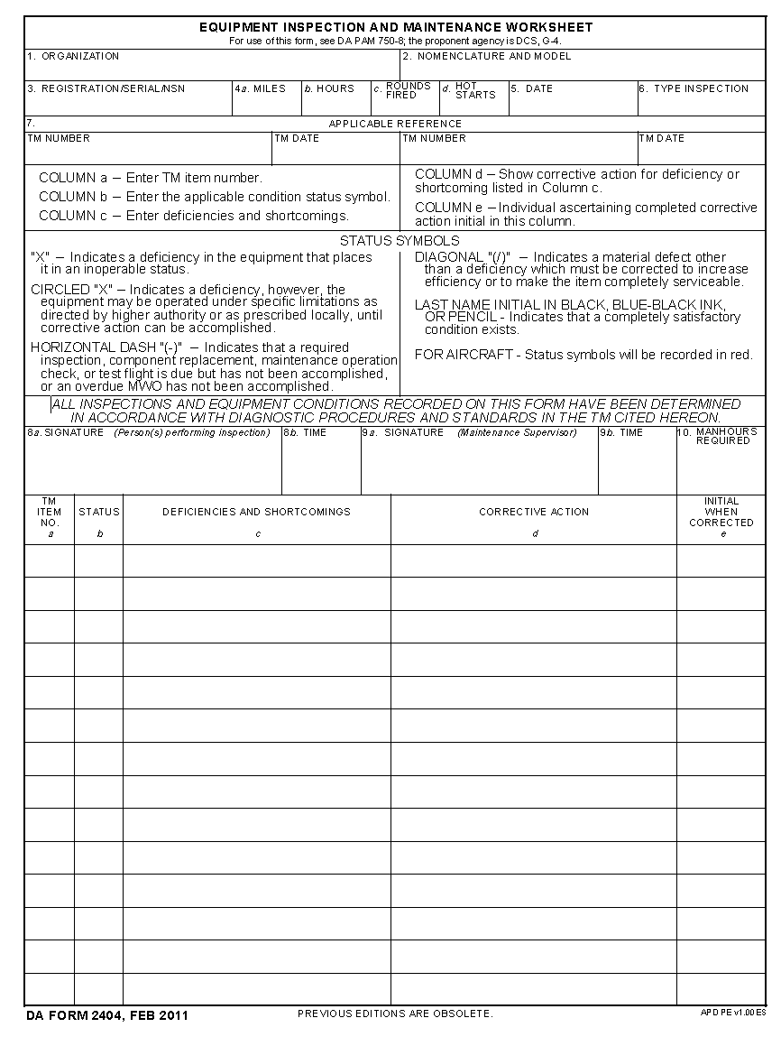
Figure 1
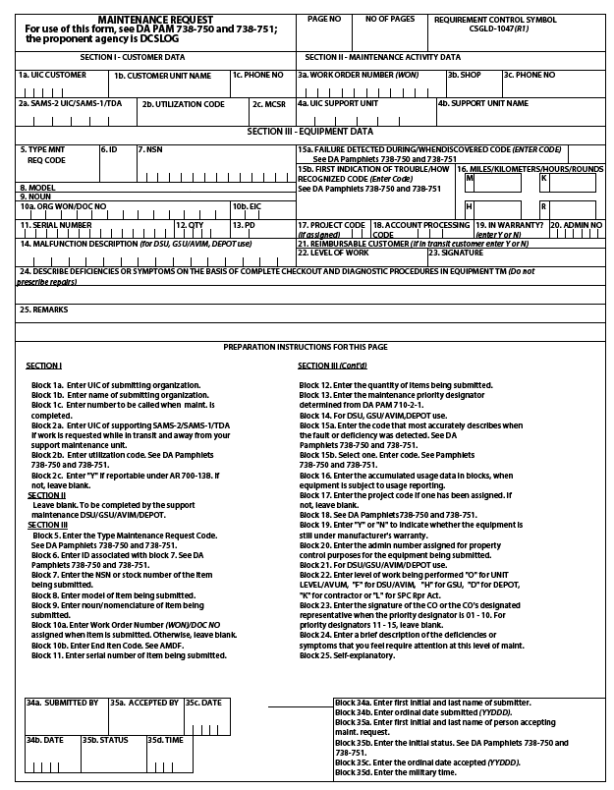
Figure 2

