SPECIAL INSTRUCTIONS

- This is a hands-on practical exercise. You will use only the reference publications shown. You may use notes. Do not talk to other students at any time. Speak only to the instructor.

- Be sure to read the “SITUATION”. If you have any questions, ask the instructor now.

- The soldier will score a GO (G) if all steps are passed. The soldier will score a NO-GO (NG) if any steps are failed. If the soldier scores a NG on any step, the soldier will be shown what was done incorrectly, how to do it properly, and then will be re-tested.

- During this practical exercise you will need:

  - Safety Goggles
  - MK19 Mod 3 Machine Gun
  - Linked Dummy Rounds
  - Tool Kit Small Arms Repairman
  - AR 25-400-2
  - TM 9-1010-230-10
  - TM 9-1010-230-23&P
  - DA Pam 750-8
  - Computer with forms program or blank forms.
  - Pencil or Pen

GENERAL INFORMATION

Your unit of assignment | D Co, 13th MP BN  Fort Lee, VA 23801
Unit DODAAC | WK4C30
Unit UIC | WBAKD0
Company Commander | Paul J. Sfransky  CPT, MP
Armorer/Supply Clerk | You are the Armorer/Supply Clerk
Unit Phone Number | 765-9185
Maintenance Supervisor | SFC Mike McGuire
Direct Support Unit (DSU) | 581st Maintenance Company
MK19 National Stock Number | 1010-01-126-9063
MK19 Serial Number | Use SN from weapon you are working on
MK19 EIC | 4AE

GENERAL SITUATION
You are the unit armorer for D Co 13th MP BN. The Supply Sergeant has informed you that the MK19 Machine Guns are scheduled for their quarterly service. You have been tasked to perform field maintenance on the Machine Gun 40mm, MK19 Mod 3.

Requirement 1
Using TM 9-1010-230-10, TM 9-1010-230-23&P, and the performance sheet listed below, unload and clear the MK19 Machine Gun.

UNLOAD AND CLEAR THE WEAPON | GO | NO GO
- Point in a safe direction.
- Unload the Machine gun 40mm, MK19 Mod 3.
  - Remove live round or spent case from bolt
    - Put the weapon on ‘S’ and keep it pointed in a safe direction.
    - Remove case catch bag (if applicable). Charge the weapon.
    - Return the charger handles to the forward position and rotate only one charger handle up.
    - Insert the tip of a cleaning rod through the receiver rail as close to the bolt face as possible.
    - Raise up on the cleaning rod to force the live round or case off the bolt face and out the bottom of the gun. Catch the live round as it falls out/
    - Turn in live round as required
  - Remove linked rounds from feeder. Open top cover and see if any linked rounds are in the feeder. If rounds are present:
    - With one hand, reach beneath the feeder. Press the primary and secondary positioning pawls simultaneously.
    - At the same time, slide the linked rounds out of the feeder and out of the feed throat.
    - Return the linked rounds to the ammunition can.
- Clear the MK 19 Machine Gun
  - Keep weapon pointed in safe direction.
  - Raise top cover assembly
  - Verify that no ammo is present in the bolt face and feeder.
  - Put bolt in forward position.

Requirement 2
Using TM 9-1010-230-10, TM 9-1010-230-23&P and performance sheet listed below, disassemble the MK19 Machine Gun.

DISASSEMBLY OF THE WEAPON | GO | NO GO
- Remove Feed Throat Assembly
  - Squeeze plungers to ensure proper functioning. If not functioning properly, return to direct support maintenance.
- Remove bolt and backplate assembly.
WARNING: Be sure bolt is FORWARD before removing backplate. Serious injury could result.
- Put the safety on ‘F’
- Open top cover
- Observing the WARNING, pull straight out on backplate pin. Use rim of spent case.
- Lift up slightly on backplate assembly. Slowly pull the bolt and backplate assembly out of the receiver
- Support the bolt with one hand and a control grip with the other. (While pressing down on the sear receiver catch release, lift the bolt up slightly and pull back to remove it).
- Remove Primary Drive Lever and Vertical Cam Assembly.
  - Reach under top of receiver to locate the drive lever lock on the vertical cam assembly. Slide the lock rearward about ¼ inch.
CAUTION: Do not rest vertical cam assembly on its chromed surface.
  - Press down on the primary drive lever’s pivot post. This releases the primary drive lever and vertical cam.
  - Pull out the vertical cam (to the rear) and the primary drive lever from the receiver.
- Remove secondary drive lever.
- Raise top cover.
- Push down on pivot post (from outside top cover). This releases the secondary drive lever.
- Lift out the secondary drive lever from inside the top cover.
- Remove feed slide assembly.
- Pivot the tray with feed slide assembly out of the top cover.
- Move feed slide assembly to line up tabs with slots in tray.
- Lift upward on feed slide assembly.
- Remove top cover assembly.
- Hold top cover straight up to align crosspin end.
- Pull straight out on pins.
- Lift off top cover.
- Remove feed tray.
NOTE: Feed tray must be down to remove top cover pins.
- Lift tray out of feeder.
- Remove alignment guide assembly.
- Depress the flat leaf spring by using a cartridge link or small tool.
- Slide alignment guide toward feeder mouth.
- Pull rearward on alignment guide, and lift it out.
- Remove ogive plunger assembly.
- Ensure alignment guide has been removed first.
- Pull out ogive plunger.
- Remove round positioning block.
- Ensure alignment guide has been removed.
- Push in and slide round positioning block toward muzzle-end of gun.
- Pull round positioning block away from wall or receiver.
- Remove charger assemblies (LH and RH).
- Rotate charger handle up.
- Using either your fingers or a spent case pry out on the lip of the lock plunder
- Lift up on the lock plunger to retract it, and slide charger assembly all the way rearward.
- Pull charger assembly away from receiver.
- Remove sear assembly.
- Turn receiver on its top. Put safety in ‘F’ (FIRE) position.
- Lift up slightly on lock pin with fingers or female end of cartridge link.
- Squeeze sear (underneath safety) and simultaneously rotate sear housing assembly approximately 15 degrees in either direction.
- Press down on sear housing assembly and continue rotation until it stops (90 degrees from original position).
- Press sear and safety together while you put safety on ‘S’ (SAFE). This locks the sear in the ‘down’ position and prevents accidental loss of the sear spring.
- Lift out sear housing assembly

STUDENT: You must stop at this time and have an instructor verify that you have correctly completed requirements 1 and 2.

Requirement 3
Using TM 9-1010-230-23&P, DA Pam 750-8, and a computer with an Army form program or blank DA Form 2404 (Figure 1), and DA Form 2407 (Figure 2). Prepare a DA Form 2404 and DA Form 2407 on the MK19 Machine Gun. Annotate all corrective actions as required. The following deficiencies were found on the weapon. Today’s date is 30 March 20XX. (Instructor can add additional faults)

DEFICIENCY
Feed Pawl Spring is weak.

Requirement 4
Using TM 9-1010-230-10, TM 9-1010-230-23&P, and the performance sheet listed below, student will reassemble the MK19 Machine Gun.

REASSEMBLY OF THE WEAPON | GO | NO GO
- Install charger assemblies (LH and RH).
- Rotate charger handle to straight-up position.
- Line up lugs on charger with slots in receiver rail. Insert charger lugs into slots.
- Hold charger tightly against rail. Slide charger forward until it locks in place.
- Attach round positioning block.
- Insert block into slots, with the tang end forward.
- Push against block and slide it toward the rear until block locks in place.
- Insert ogive plunger assembly.
  - Insert ogive plunger.
- Install alignment guide assembly.
- Position the alignment guide assembly so that the pin is lined up with slot in feeder wall.
- Hold the alignment guide against the front wall and slide the alignment guide into the receiver until it ‘clicks.’’
- Install feed tray and feed slide assembly.
- Place tray into top of feeder, recessed side up.
- Pinholes on tray should line up with lugs on receiver.
- Position feed slide assembly so that tabs are lined up with slots on tray
- Insert tabs into slots. Drop feed slide assembly into tray and move it slightly to ensure engagement.
- Install top cover assembly.
CAUTION: To avoid breaking the crosspin, be sure it is fully inserted into the receiver before closing the top cover.
  - Feed tray should be in place resting in the receiver.
  - Place the top cover on the receiver with the pinholes in line with the receiver lug end feed tray pinholes.
  - Hold top cover straight up. Insert top cover pins on both sides. Ensure the crosspin is fully inserted then rotate the top cover fully open.
- Engage secondary drive lever.
WARNING: If secondary drive lever is not properly engaged with the feed slide pin, gun will not fire.
  - Rotate the feed slide assembly and tray upward.
  - Engage forked end of secondary drive lever with the feed slide pin.
  - Press raised pivot post through hole in top cover.
  - Press secondary drive lever against cover until it locks in place.
- Install vertical cam assembly.
- Slide vertical cam assembly through the rear of the receiver. Raised portion should slide over the top of the receiver. Drive lever lock should be underneath.
- Engage forked end in the notch.
- Engage primary drive lever.
  - Hold vertical cam assembly in place and slide primary drive lever into receiver.
  - Slide drive lever lock rearward and engage pivot post of lever through holes in receiver and vertical cam
  - Slide drive lever lock (on vertical cam just beneath top of receiver) forward.
- Install bolt and backplate assembly.
CAUTION: Before inserting assembly, put cocking lever in forward position.
Assemble bolt and backplate using one of the following procedures.
  - Procedure 1 – With sear assembly on gun:
    - Place safety in ‘F’ (FIRE) position.
    - Press sear using thumbs or rim of cartridge case.
    - Make sure cocking lever is cocked and forward.
    - Slide bolt and backplate assembly all the way forward.
    - Insert backplate pin to lock assembly in place.
  - Procedure 2 – With sear off gun:
    - Make sure cocking lever is cocked forward.
    - Insert bolt and backplate assembly into receiver
    - Insert backplate pin to lock assembly in place.
    - Close cover
- Install sear assembly.
- Turn receiver over on its top.
- Place sear housing on the receiver and line up sear housing assembly at a right angle to the barrel centerline.
- Put safety on ‘F’ (FIRE) position.
- Press down and rotate housing assembly until it stops.
- Press up on sear and continue rotation until it locks in position.
12. Install feed throat assembly
  - Squeeze plungers; align pins with holes in receiver. Release plunger to reattach feed throat.

Requirement 5
Using TM 9-1010-230-10, TM 9-1010-230-23&P, and the performance sheet listed below, perform a functions check on the MK19 Machine Gun.

FUNCTION CHECK | GO | NO GO
WARNING: Ensure that the machine gun is clear before performing a function check.
- Check functioning with safety on ‘S’ (SAFE) then on ‘F’ (FIRE)
  - With top cover closed, put safety in ‘S’ (SAFE) position (push left)
  - Pull bolt to the rear.
  - Push charger handles back to forward position. Rotate charger handles up.
  - Observe previously mentioned WARNING.
  - Press trigger. Bolt should not go forward.
  - Put safety in ‘F’ (FIRE) position (push right)
  - Press trigger. Bolt should spring forward.
  - Put safety in ‘S’ (SAFE) position.
  - Leave bolt in forward position and continue
- Open top cover; inspect interior of receiver for missing/damaged parts.
  - Touch firing pin.
  - Touch bolt face to ensure it is lubricated and not dry, pitted, or corroded.
- Check feed slide assembly and feeder.
  - Move secondary drive lever back and forth. Feed slide assembly should move freely.
  - Press the pawls to check spring tension.
  - Inspect link guide for roughness and galling.
  - Perform feed slide adjustment inspection
- Close top cover.

STUDENT: You must stop at this time and have an instructor verify that you have correctly completed requirements 4 and 5.

PERFORMANCE MEASURE | RESULTS
- Clear the weapon before disassembly | P | F
- Disassemble the weapon. | P | F
- Prepare DA Form 2404 and DA Form 2407 | P | F
- Assemble the weapon. | P | F
- Performs a function check | P | F
- Weapon functions as mission-ready | P | F
Verified By Signature:
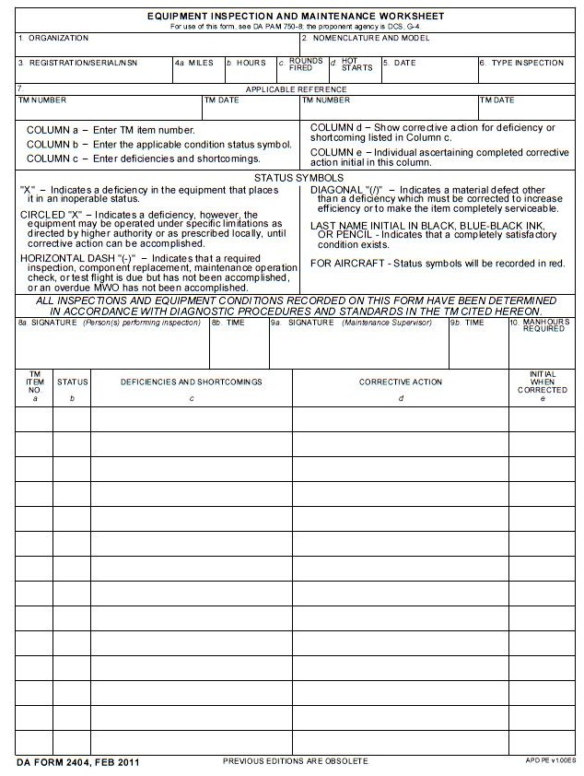
XXXXXXX 30 March 20XX Quarterly
TM 9-1010-230-23&P 30 Nov 2005
Student Signature
6 X Feed Pawl Spring is Weak DA Form 2407 (SPT MNT)
D Co, 13th MP BN Machine Gun 40mm, MK19 Mod 3
Figure 1
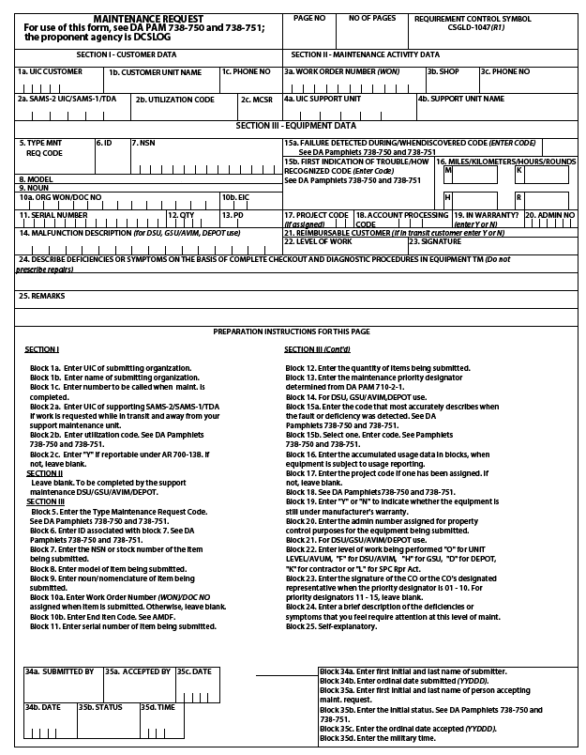
Machine Gun 40mm
MK19, Mod 3
1 A 1 0 1 0 – 0 1 – 1 2 6 – 9 0 6 3
0
WBAKD0 D Co, 13th MP BN 765-9185
4 A E
X X X X X X 00 0 0 1 1 2 N DX
F
Feed Pawl Spring is Weak
1 1
1 1
1 1
Figure 2

