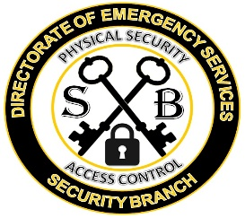
ICE COMMENT/SURVEY
Thank you for taking the time to leave us your feedback. Please be sure to complete the suggestion box so we can make certain we are meeting your needs.
What is your rank? (Circle One)
PVT/CPL SGT/SSG SFC/CSM W0 LT/CPT MAJ/LTC COL or above N/A

Customer Service:

Facility Appearance Excellent Good OK Poor Awful N/A

Employee/Staff Attitude Excellent Good OK Poor Awful N/A

Timeliness of Service Excellent Good OK Poor Awful N/A

Hours of Service Excellent Good OK Poor Awful N/A

Product or service meet your needs? Excellent Good OK Poor Awful N/A

Trainer was well prepared? Excellent Good OK Poor Awful N/A

Knowledge of instructor? Excellent Good OK Poor Awful N/A

Materials distributed were helpful? Excellent Good OK Poor Awful N/A

Overall experience Excellent Good OK Poor Awful N/A

What is your status? (Circle One)
Active Duty Retired Civilian Employee Reserve/National Guard Family Member
Veteran Contractor N/A Non Affiliated Civilian

Satisfaction:
Would you recommend this service to others? Yes No N/A

Response Requested? Yes or No
Customer Information:
Name: Phone:
Email: Unit:
Comments about your experience:
__________________________________________________________________________________________________________________________________________________________________________________________________________________________________________________________________________________________________________________________________________________________________________________________

