Block Callers YeaLink Phones

- Go to your History
  - 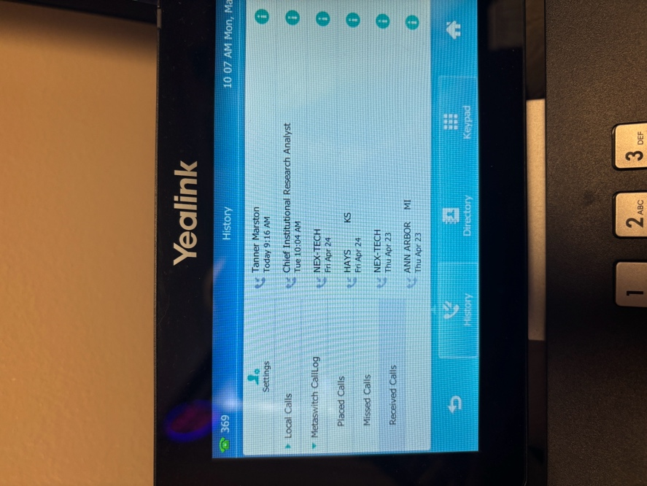
- Press the i icon next to the contact
  - 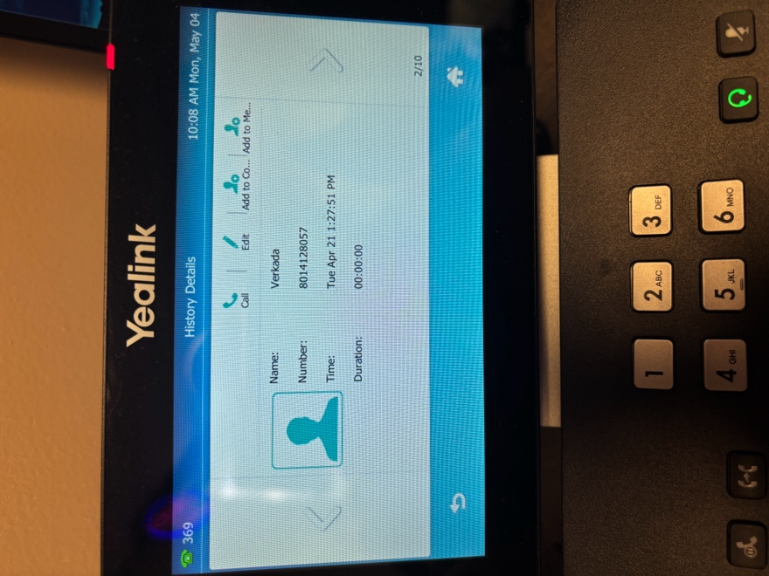
- Press add to Contact List
  - 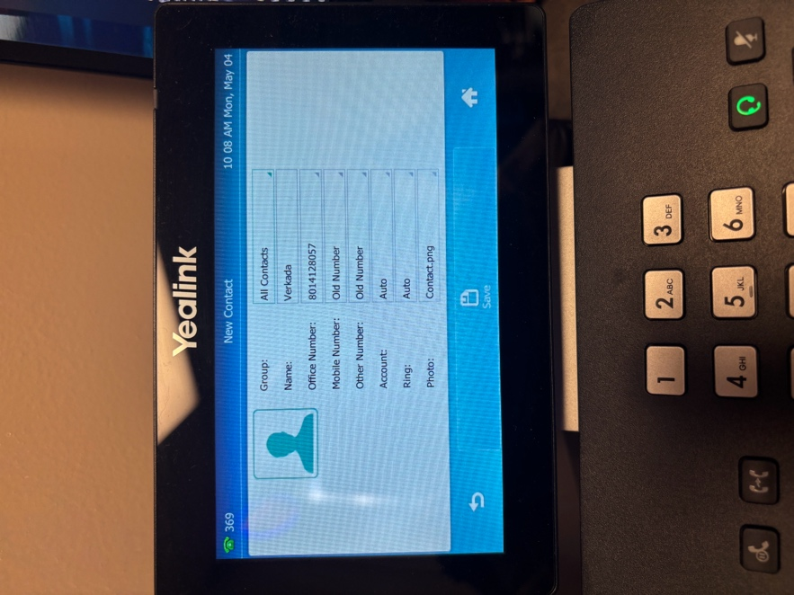
- Press All Contacts
  - 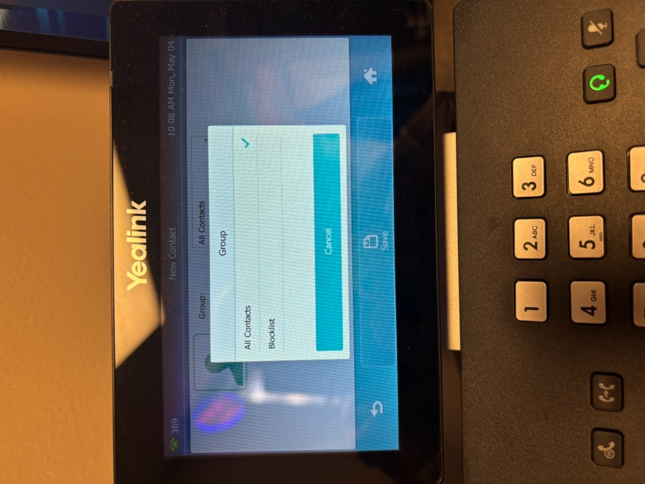
- Select Blocklist
  - 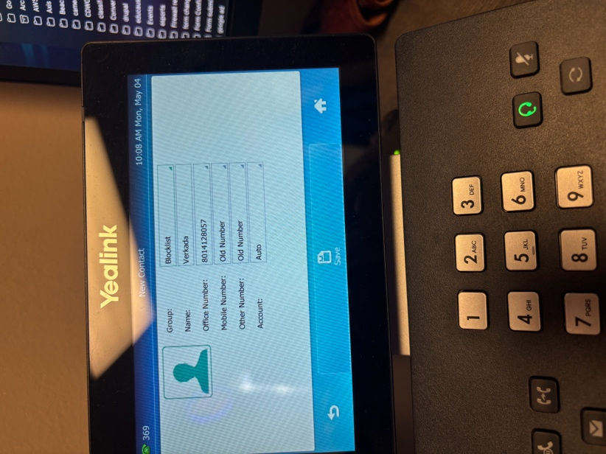
- Click Save

