Please select in the image what is highlighted in yellow.

- Select Next

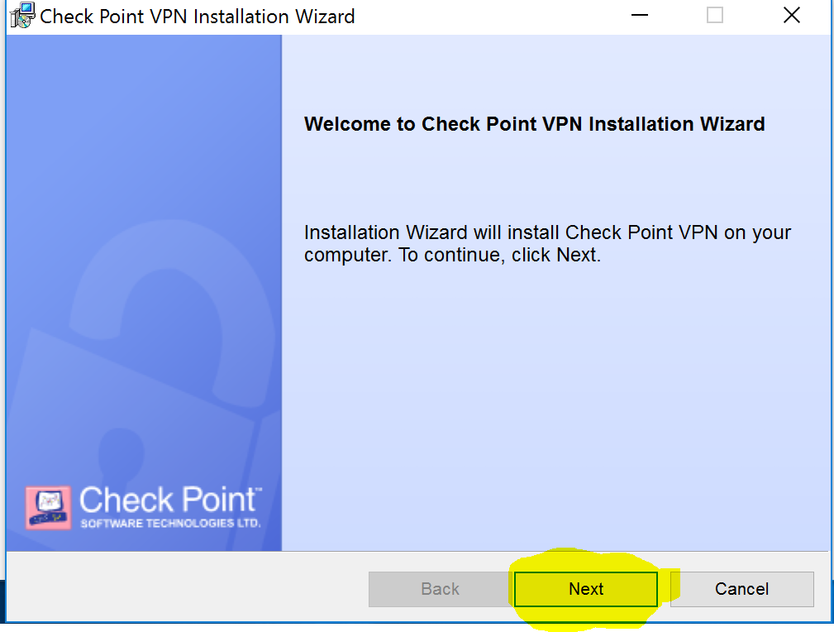

- Select Endpoint Security VPN
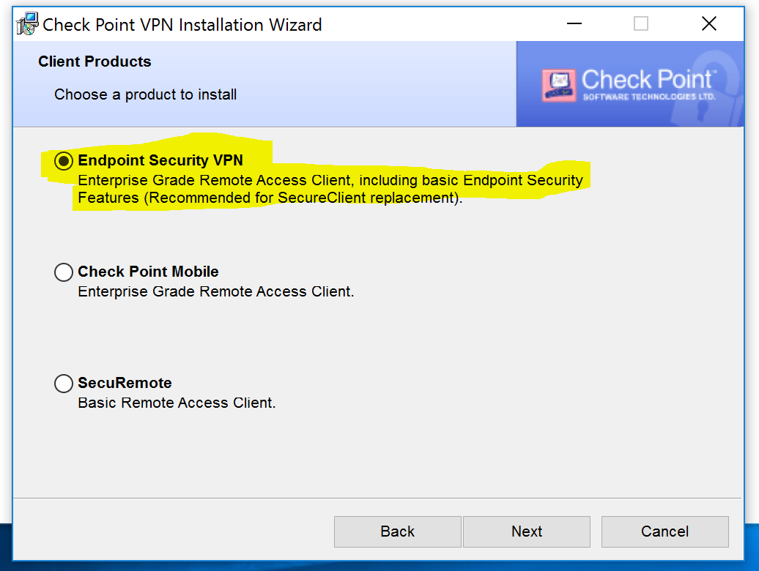

- Accept Terms
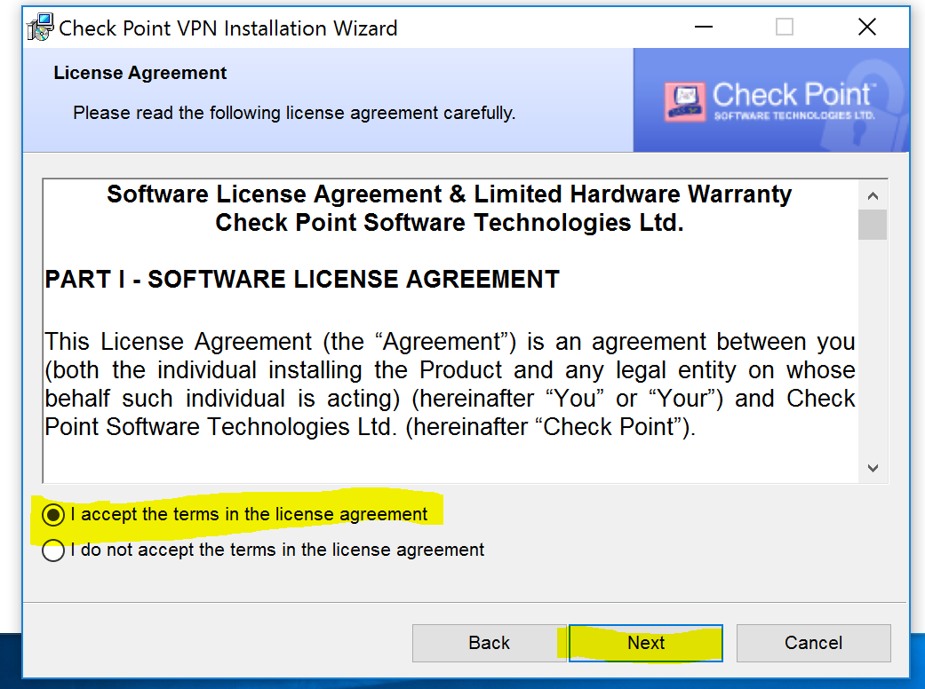
- Install
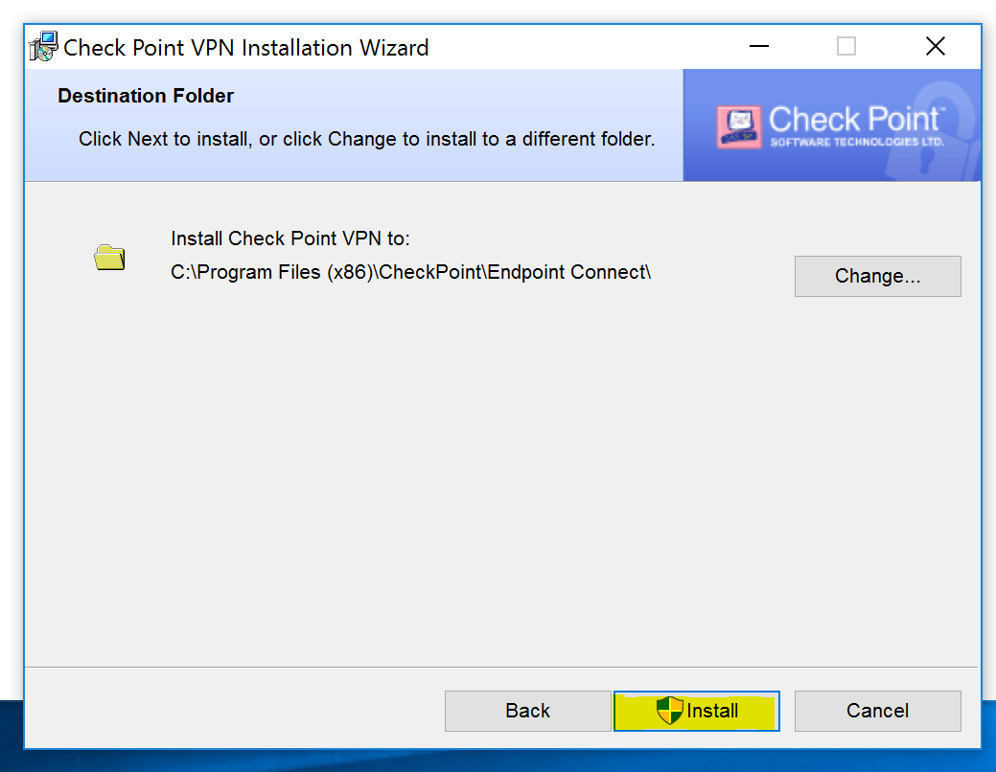

- Finish the installation
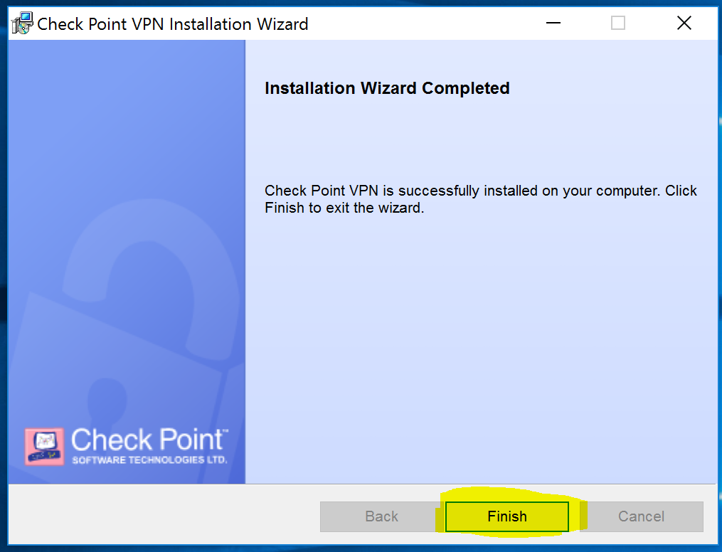

- Please restart your computer at this time selecting Yes and
save any documents you may have open
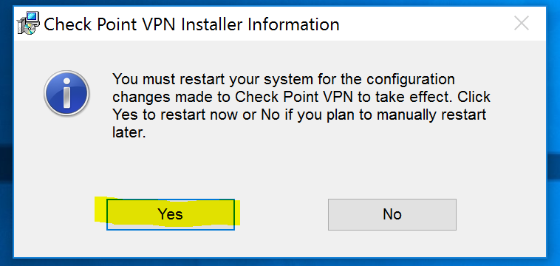

- In your notifications icon area, you will see a LOCK. This is your VPN application and shows your current status of connection. Double-Click your icon

VPN can also be found in All programs.
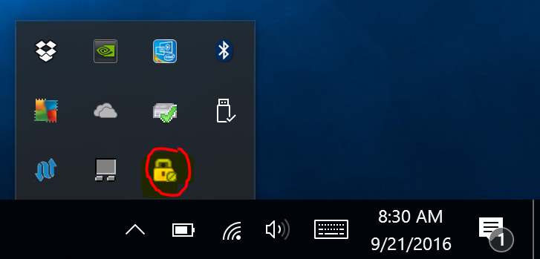

- You will be prompted to configure
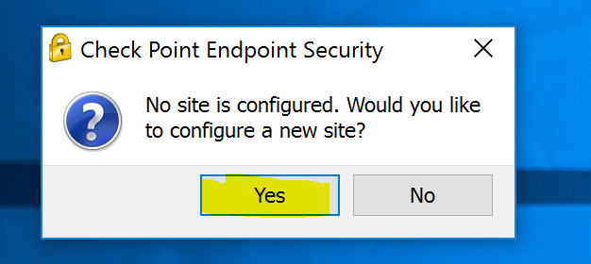

- Installation wizard will load and you will select Next

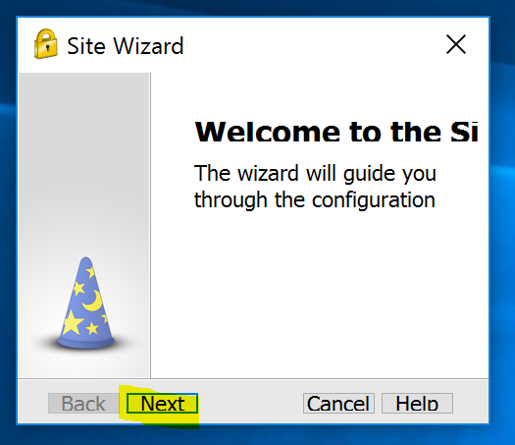

- When typing in the server address the display name should fill itself showing in the image below
Address: 198.248.192.90
Select Next when complete

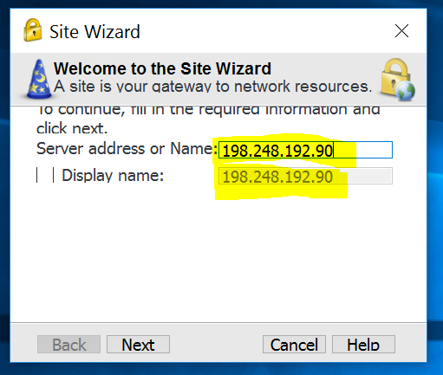

- Trust and Continue to verify the sites Certificate

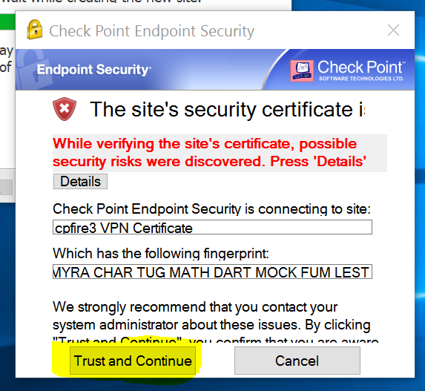

- Here you will select the type of Authentication Method: Certificate
then select next.

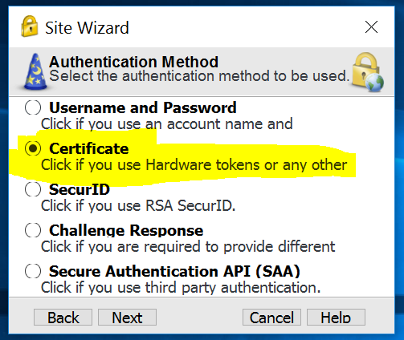

- You will select Use Certificate from Public-Key and select Next

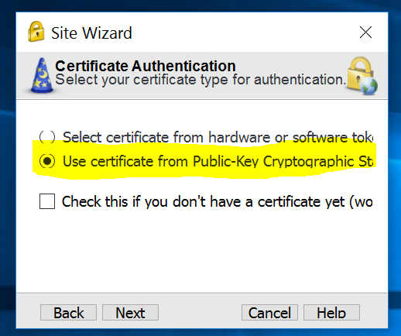

- The wizard will prompt you that the VPN Site was successfully created.
Select Finish 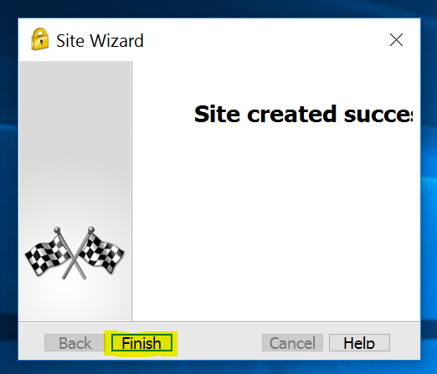

- If you are not prompted to connect please double click your VPN icon on the bottom right in your notifications menu or find in “all programs” (“all apps” for windows 10 users)

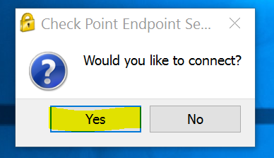

- We will need to Browse to find your Certificate.p12 type of file to load.
Note: this will take care of your username and you will only have to type in the password privided by your network administrator
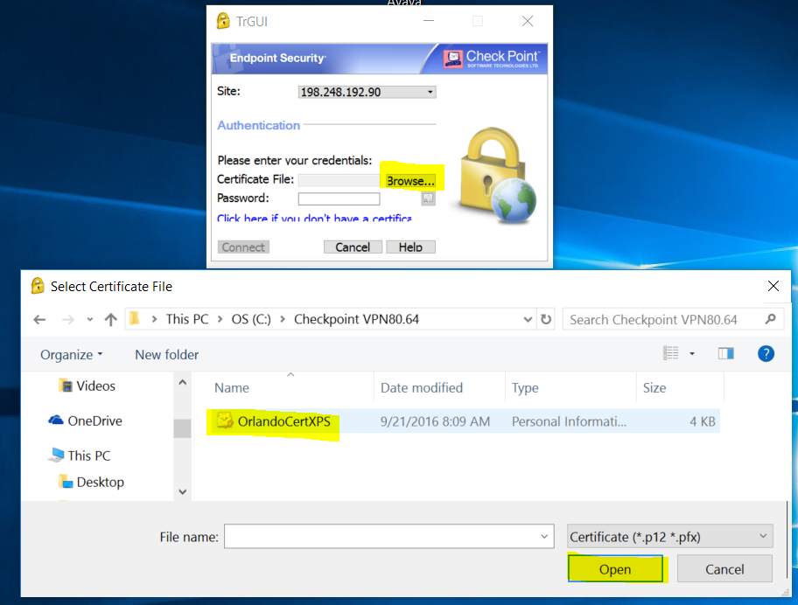
- Type password and select Connect
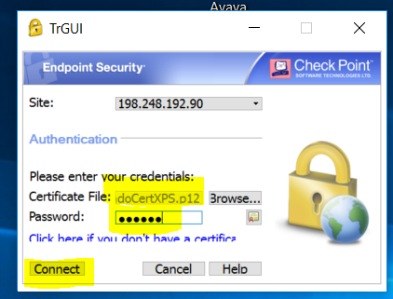

- In your notifications menu it will display a green circle next the VPN icon showing it is connected

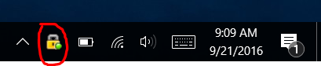
You are now ready to set up your Avaya Communicator.

If you are not able to connect please right-click on the VPN icon and Disconnect and try to connect again.

Still having Problems? Please Contact me: hernandezo@bartonccc.edu
Orlando Hernandez
Coordinator of Enterprise Technology
Barton Community College
245 NE 30 Rd
Great Bend, KS 67530
Office: (620) 792-9346
Extension: 346

