- Double Click to install this package file containing VPN
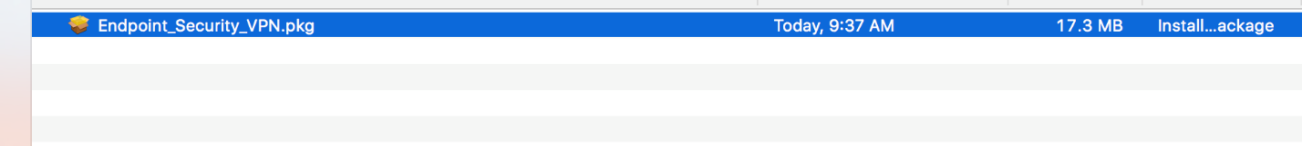

- Step 2: Click Continue

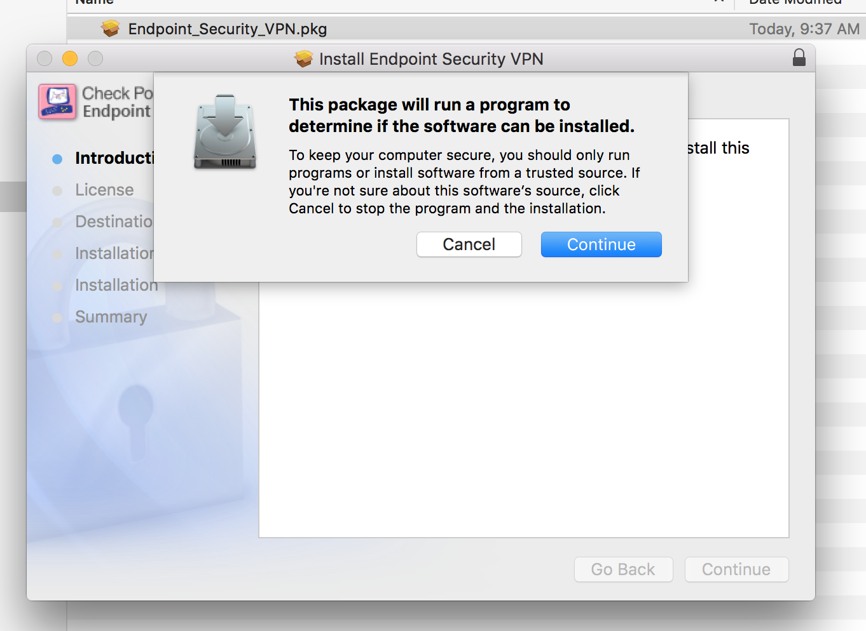

- Step 3: Click Continue

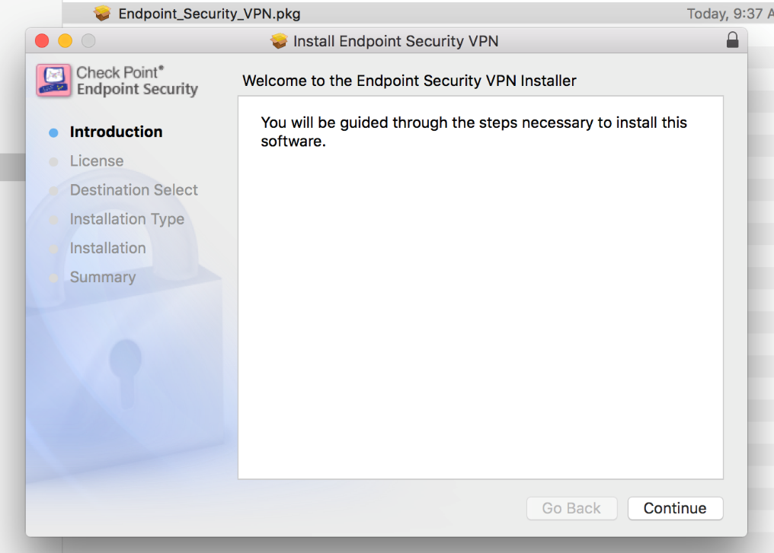

- Step 4: Agree to the Terms and conditions
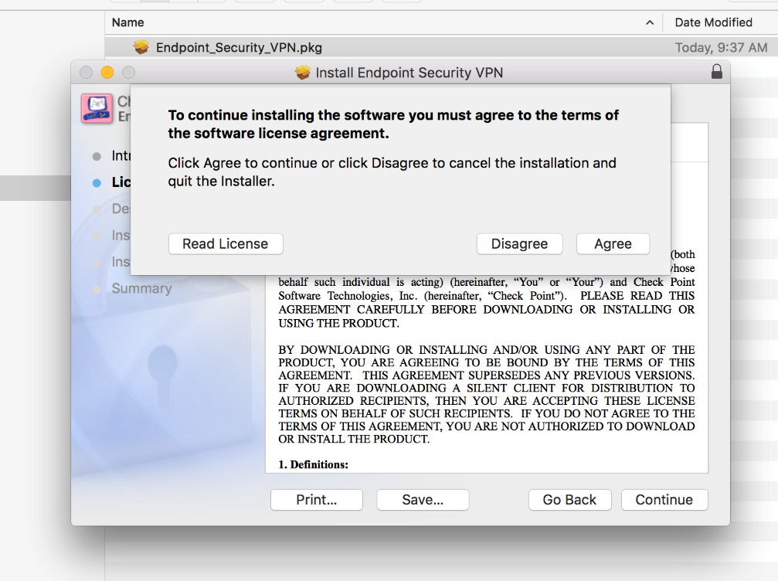

- Step 5: Choose to Continue selecting your Mac Hard drive
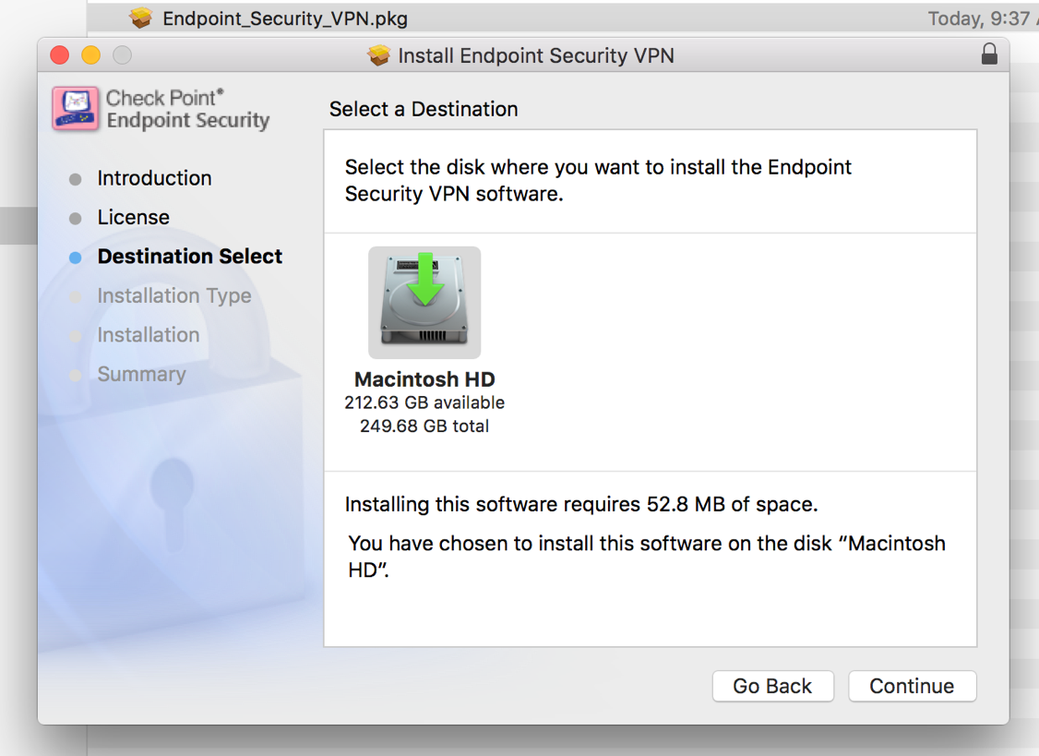

- Step 6: Click Install or If you wish to choose your location to save please do so here
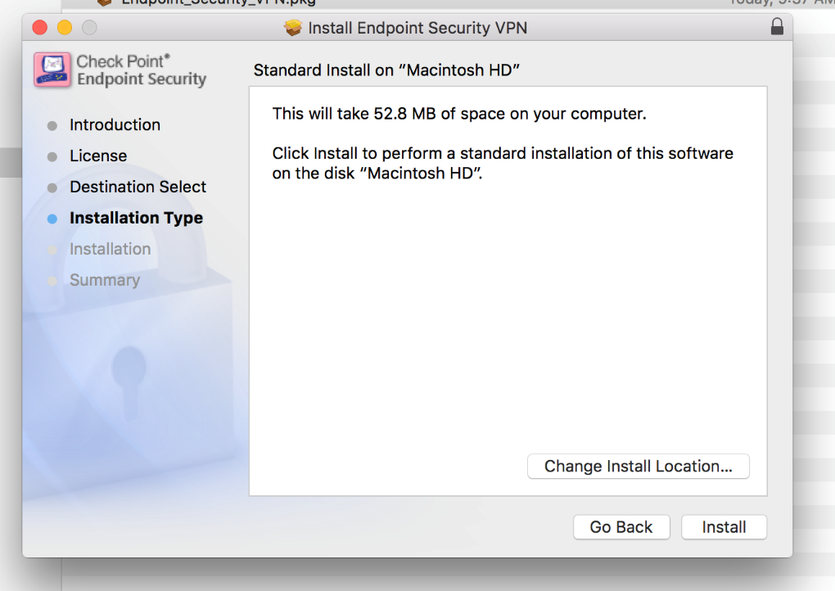

- Step 7: Use your Mac Credentials to give permission for software to install
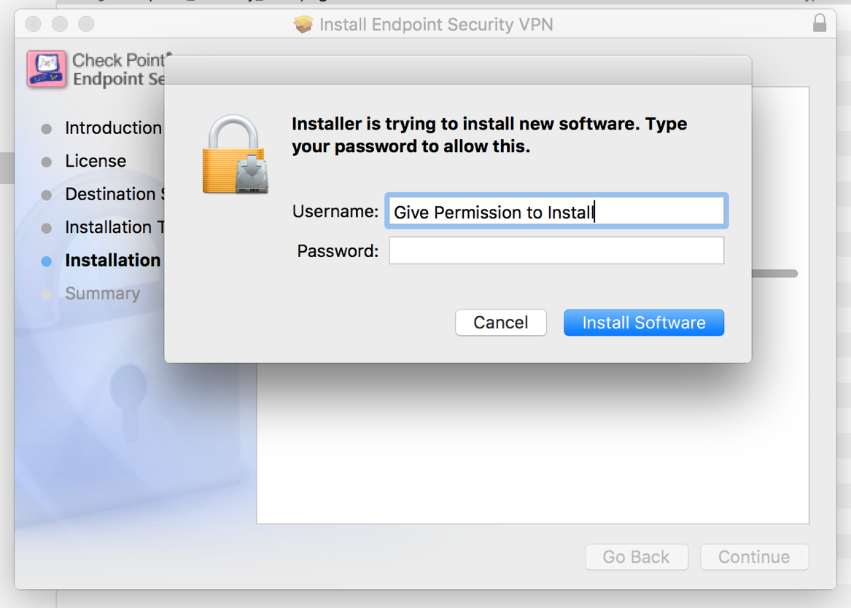
- If all goes well your installation will prompt it was successful click Close
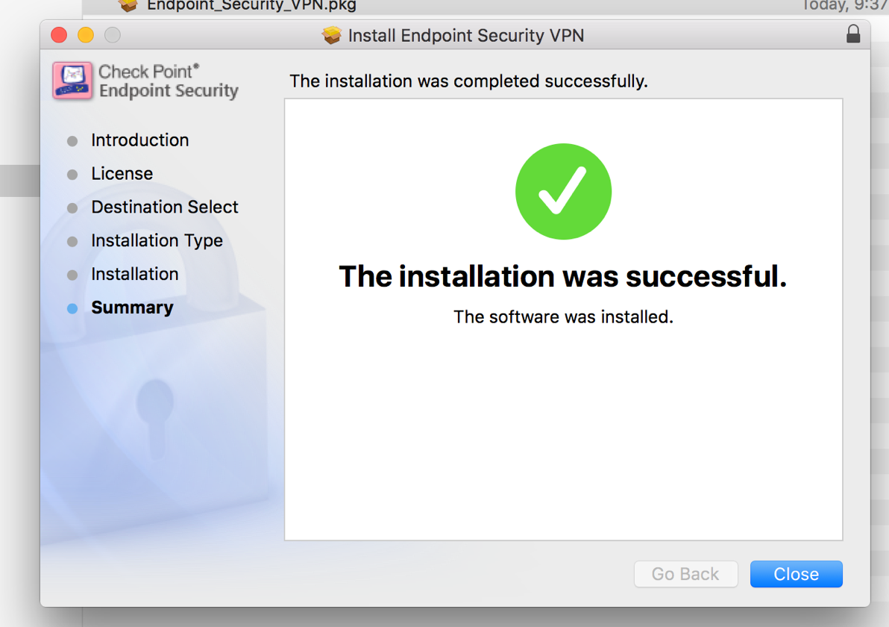

- On the top right of your Mac in your notifications icons you will how a new lock icon please double-click or click then select Connect
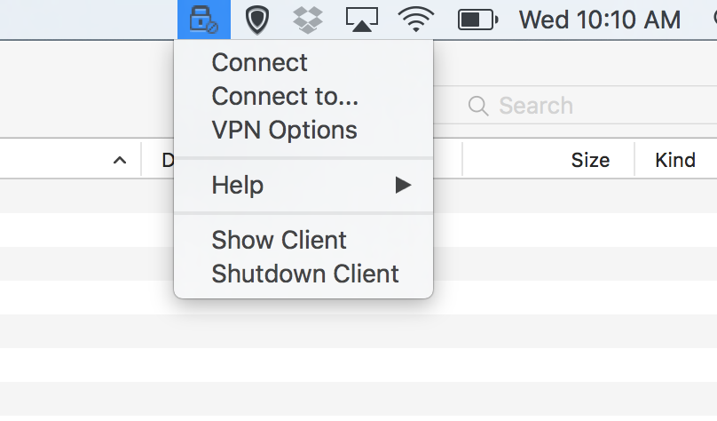

- Select Yes to Configure a new site
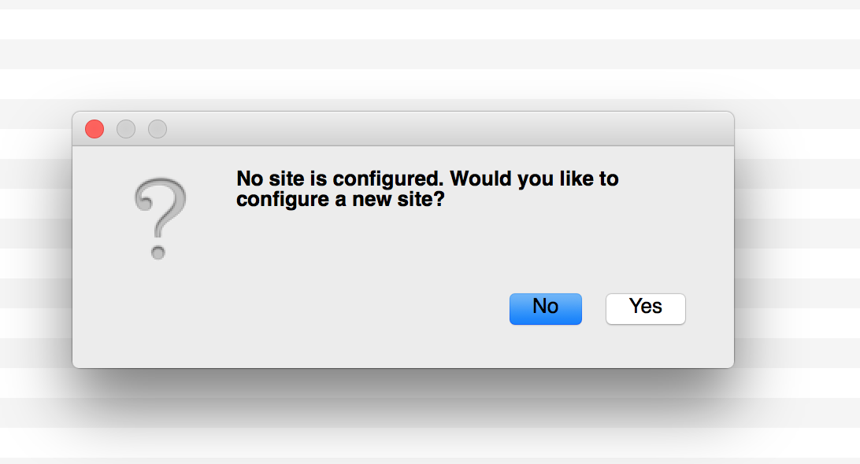

- Click Next
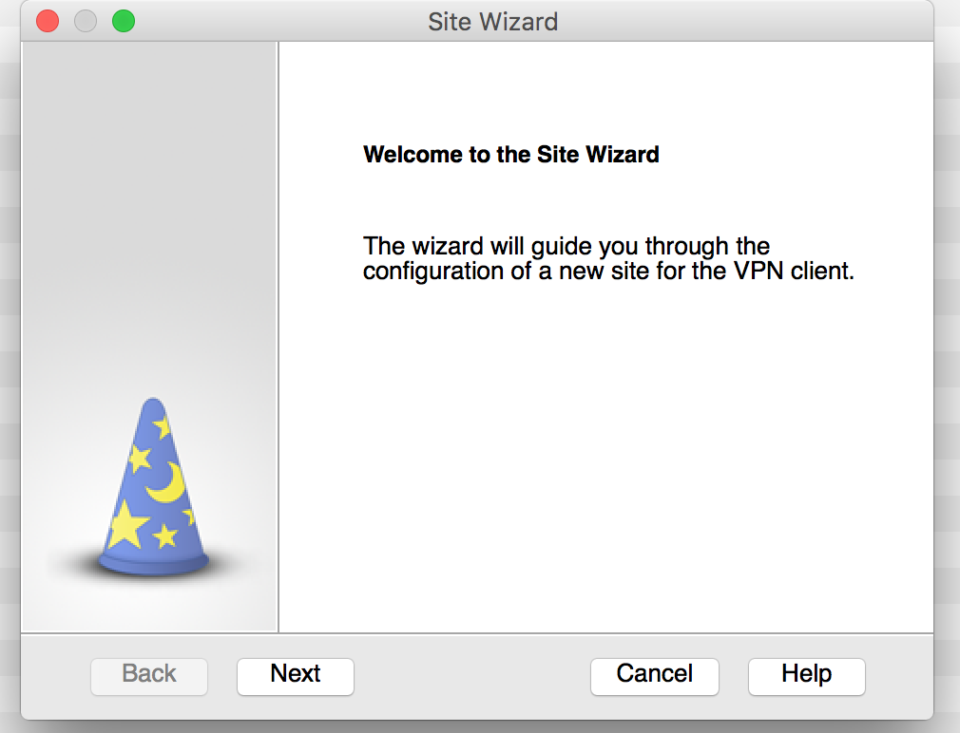

- Your Server address you will type in will be 198.248.192.90 and click Next
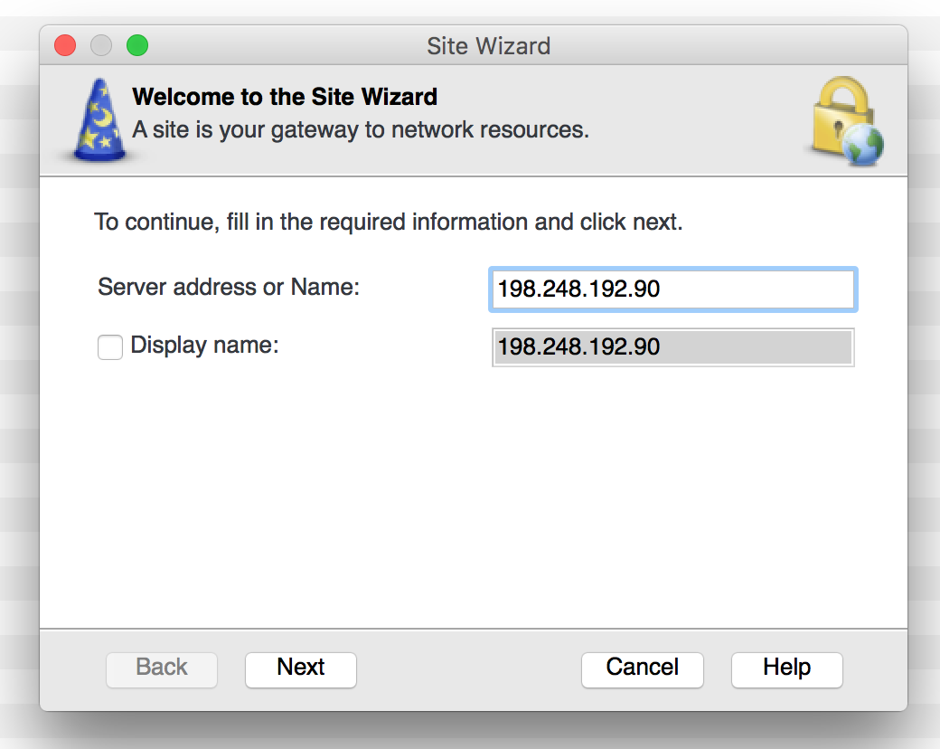

- A certificate dialog box will prompt you and we will select to Trust and Continue
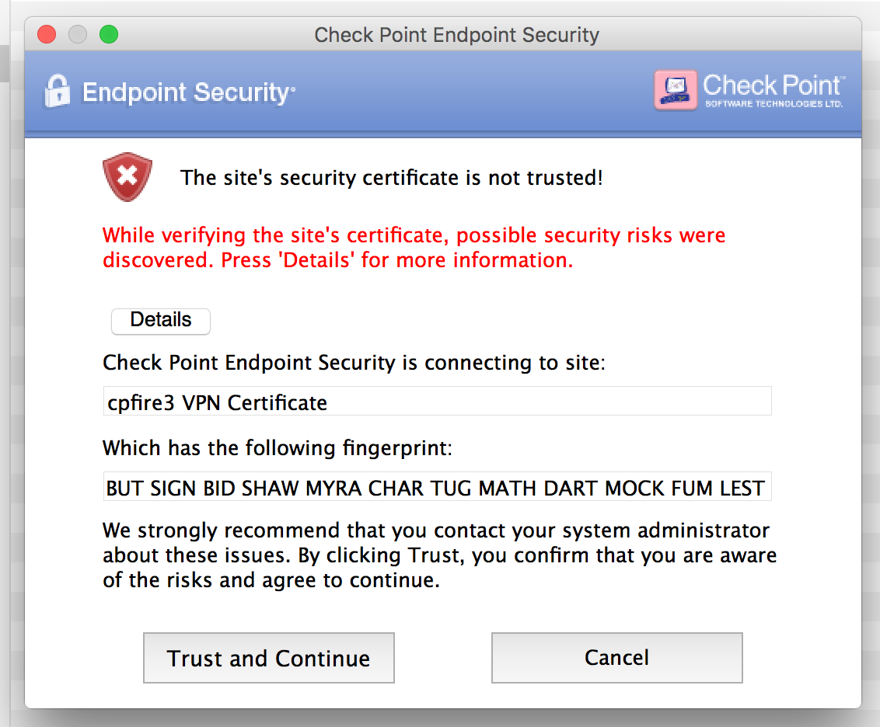

- The authentication method we will then select is Certificate (provided by your network admin)
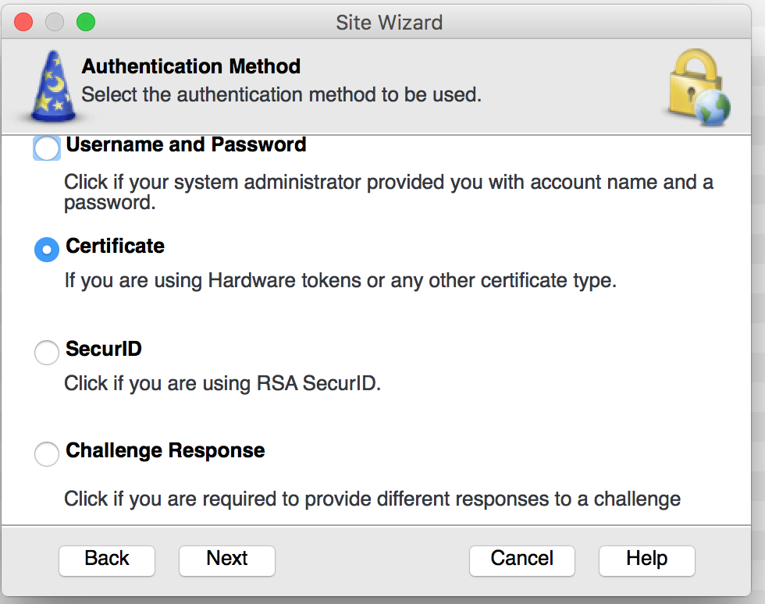

- Certificate Authentication we will select Use certificate from Public Key
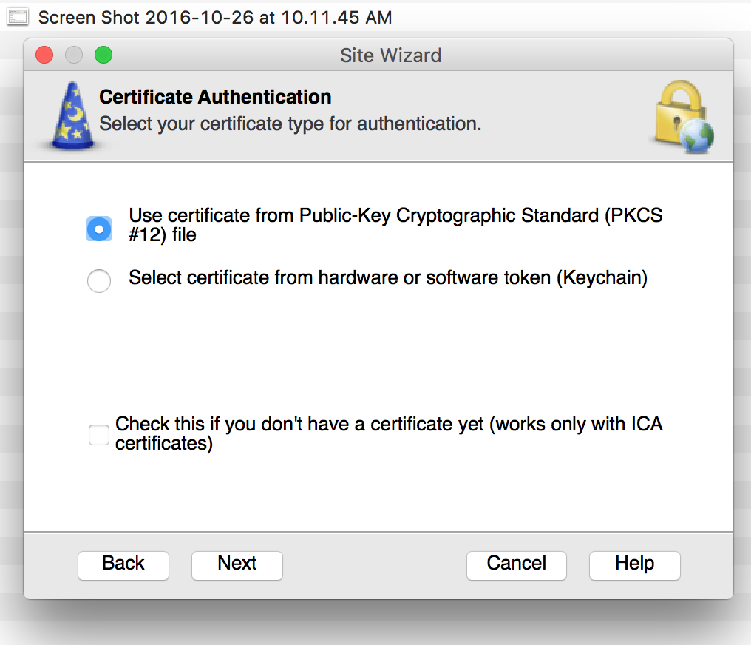

- Our site has now been created please click Finish
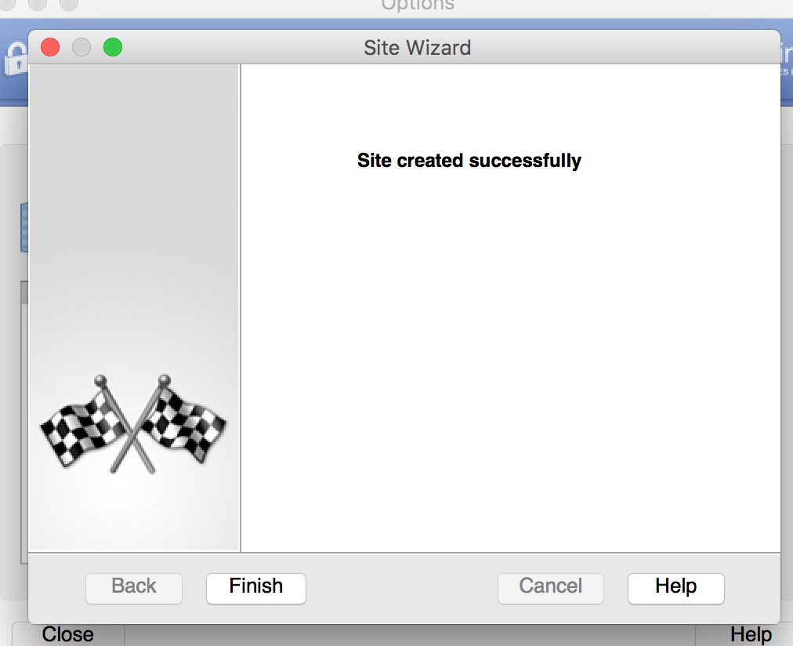
- If not prompted by this screen please double click the VPN lock icon in Notifications Bar
And select Yes
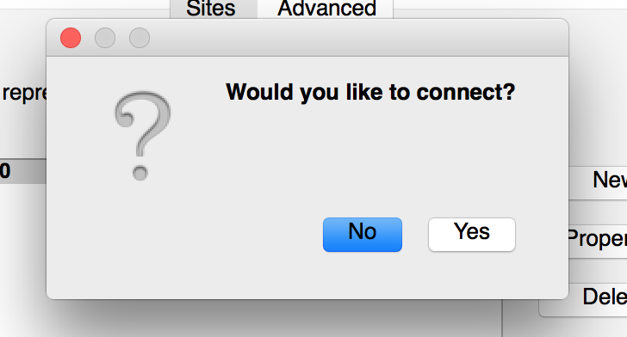

- Select your Certificate file from the location on your Computer.
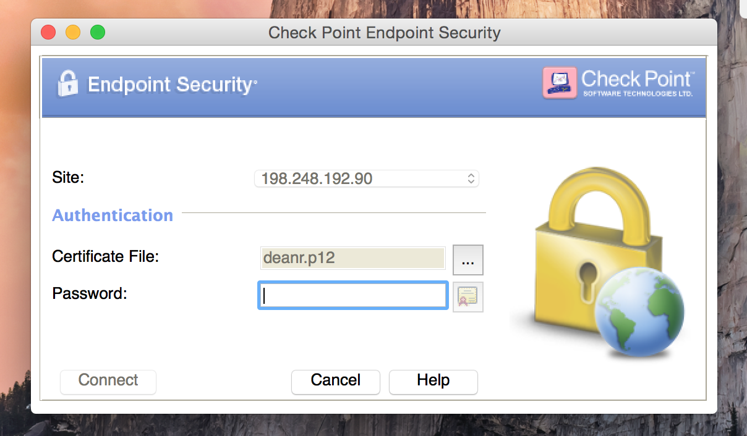

- Choose the Certificate file with the .p12 type of extension and select Open
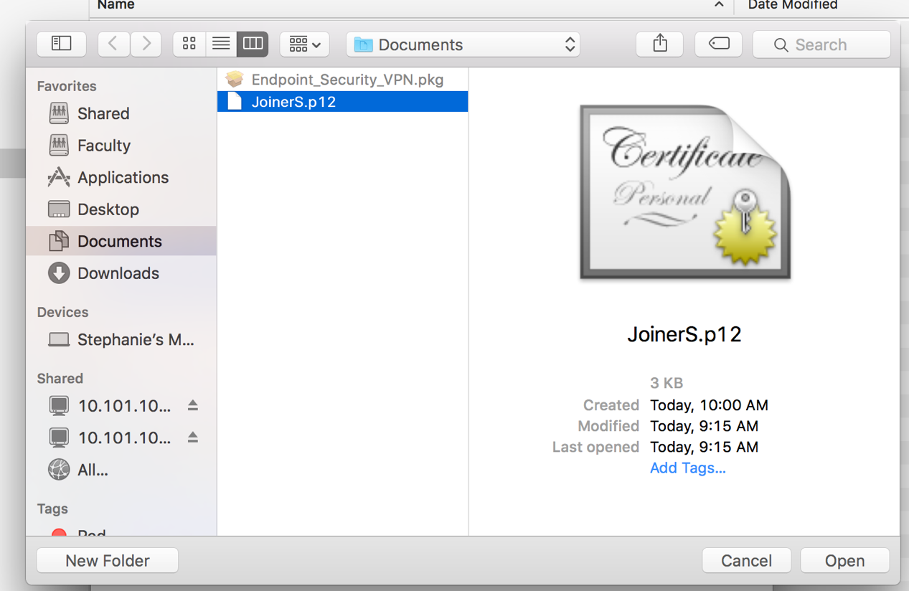

- Type your password in provided by your Network Administrator. And Connect

- The VPN icon should show a green dot showing you are connected to the Barton Campus Network.
