AGENDA/MINUTES
Team Name | Accreditation Committee
Date | 7/25/2019
Time | 4:00 – 5:00 p.m.
Location | A-113 / Join Zoom Meeting  https://zoom.us/j/419028667  One tap mobile  +16699006833,,419028667# US (San Jose)  +19294362866,,419028667# US (New York)  Dial by your location  +1 669 900 6833 US (San Jose)  +1 929 436 2866 US (New York)  Meeting ID: 419 028 667

Facilitator |  | Myrna Perkins |  |  |  |  | Recorder | Sarah Riegel
Team members |  |  |  |  |  |  |  |  | Present X  Absent O
x | Myrna Perkins |  | o | Cathie Oshiro | x | Randy Thode |  |  | x | Jo Harrington
x | Elaine Simmons |  | x | Angie Maddy | o | Mark Dean |  |  | o | Charles Perkins
x | Sarah Riegel |  | o | Dr. Heilman
Topics/Notes
Discuss Student Success Academy Team Participants – Myrna Perkins
- Select 5 individuals for the traveling team
- Recommendation will go to Dr. Heilman, he will approve
- Traveling team will need to get acclimated, HLC orientation webinar on 7/31
- These folks will travel to the F2F in October and March
- Student success academy does not count for the quality initiative

Myrna will send these to Dr Heilman for his feedback:
- Angie Maddy
- Judy Jacobs
- Matt Connell
- Stephanie Joiner
- Lindsay Holmes
- Erin Eggers
- Danika Bielek
- Emily Cowles

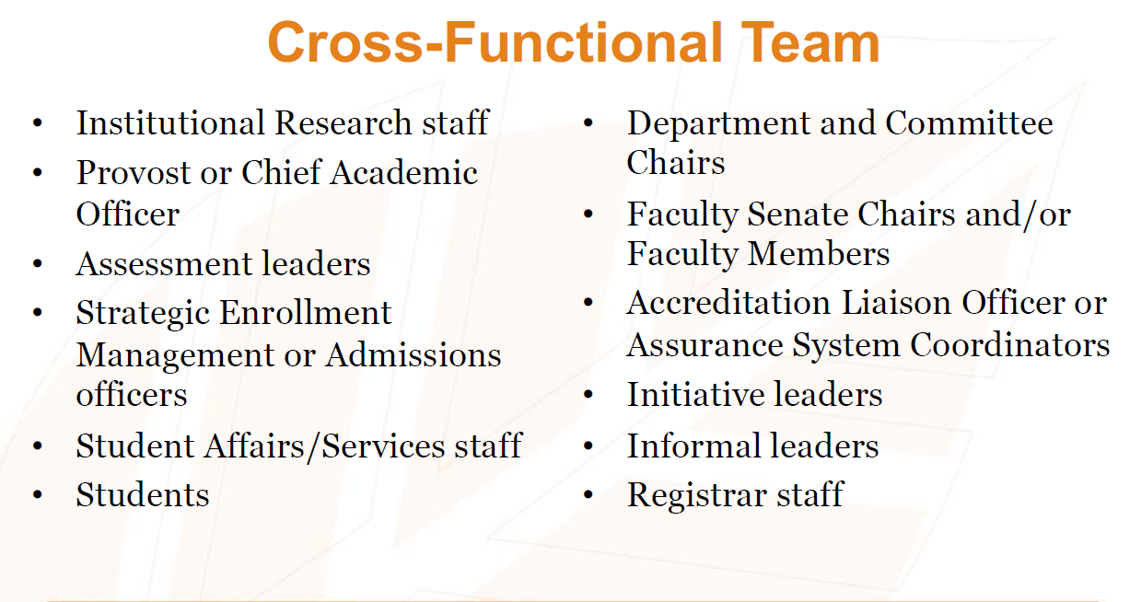

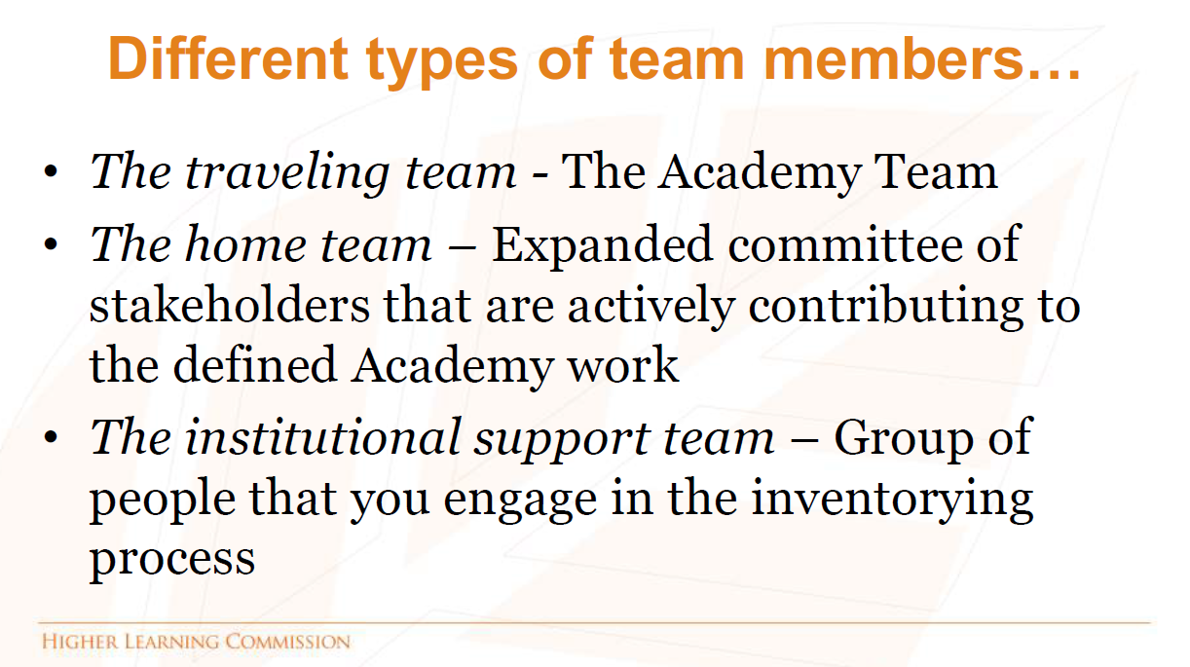

Assessment Academy | Quality Initiative Update – Jo Harrington

Team members:
- Jo Harrington
- Elaine Simmons (can’t attend)
- Vic Martin
- Ange Davied
- Randy Thode (can’t attend)
- Charlotte Cates to go to Chicago
- Kurt Konda to go to Chicago

Update on Theme Conversations – Myrna Perkins

Need to still have small conversations with these:
- Board of Trustees
- Budget Process
- Faculty/Staff
- Infrastructure
- Process Management
- Retention, Persistence, Completion
- Strategic Planning
- Teaching & Learning

Follow-up Process – Myrna has documentation of all conversations on T: drive – need to determine how we circle back on these conversations
Accreditation Map on the T: drive – Myrna Perkins

Review revised criterion (effective fall 2020) – core components slightly changed and subcomponents changed – they are focusing more on outcomes

Criterion 1: Mission
The institution’s mission is clear and articulated publicly; it guides the institution’s operations.
Core Components
1.A. The institution’s mission is articulated publicly and operationalized throughout the institution.
1. The mission statement is developed through a process suited to the nature and culture of the institution and is adopted by the governing board.
2. The mission and related statements are current and reference the institution’s emphasis on the various aspects of its mission, such as instruction, scholarship, research, application of research, creative works, clinical service, public service, economic development and religious or cultural purpose.
3. The mission and related statements identify the nature, scope and intended constituents of the higher education offerings and services the institution provides.
4. The institution’s academic offerings, student support services and enrollment profile are consistent with its stated mission.
5. The institution clearly articulates its mission through public information, such as statements of purpose, vision, values, goals, plans or institutional priorities.
1.B. The institution’s mission demonstrates commitment to the public good.
2. The institution’s educational responsibilities take primacy over other purposes, such as generating financial returns for investors, contributing to a related or parent organization, or supporting external interests.
3. The institution engages with its external constituencies and responds to their needs as its mission and capacity allow.
1.C. The institution provides opportunities for civic engagement in a diverse, multicultural society and globally-connected world, as appropriate within its mission and for the constituencies it serves.
1. The institution encourages curricular or cocurricular activities that prepare students for informed citizenship and workplace success.
2. The institution’s processes and activities demonstrate inclusive and equitable treatment of diverse populations.
3. The institution fosters a climate of respect among all students, faculty, staff and administrators from a range of diverse backgrounds, ideas and perspectives.

Action Items |  |  |  |  |  |  |  |  |  | Responsibility

ALWAYS KEEPING IN MIND:
Barton Core Priorities (Values)/Strategic Plan Goals
Drive Student Success
Cultivate Community Engagement
Emphasize Institutional Effectiveness
Optimize Employee Experience

