AGENDA/MINUTES
Team Name | Accreditation Committee
Date | 19-Jan-2021
Time | 2:00 pm
Location | Zoom  Myrna Perkins is inviting you to a scheduled Zoom meeting.  Join Zoom Meeting  https://zoom.us/j/96228386115  Meeting ID: 962 2838 6115  One tap mobile  +12532158782,,96228386115# US (Tacoma)  +13462487799,,96228386115# US (Houston)

Facilitator |  | Myrna Perkins |  |  |  |  | Recorder | Sarah Riegel
Team members |  |  |  |  |  |  |  |  | Present X  Absent O
x | Elaine Simmons |  | x | Angie Maddy | x | Mark Dean |  |  | x | Cathie Oshiro
x | Randy Thode |  | x | Jo Harrington | x | Sarah Riegel |  |  | x | Myrna Perkins
Guests
Informational Items
Topics/Notes |  |  |  |  |  |  |  |  |  | Reporter
- Accreditation Timeline | Year 8
  - Located on the T drive under Accreditation

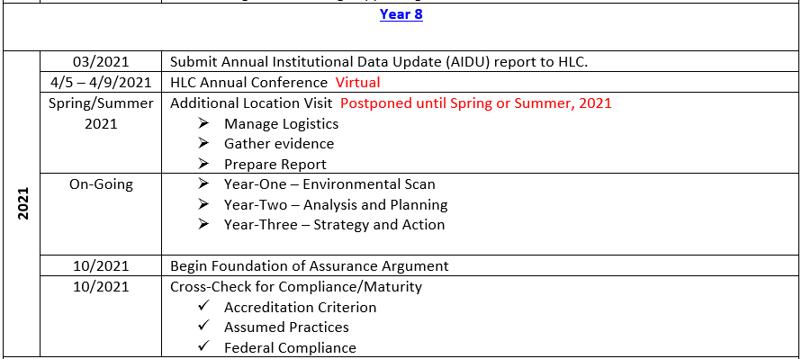
- Additional Location Visit | Spring 2021
  - Peer Reviewer is associated with McPherson College – Coleen Tyler
  - Myrna sent her a welcome email and asked for dates that work for her
  - Must have report to her 30 days prior to visit date
  - Myrna will get Cathie a list of items we need to write to
  - HLC just wants to see that we offer the same service and resources to the other locations

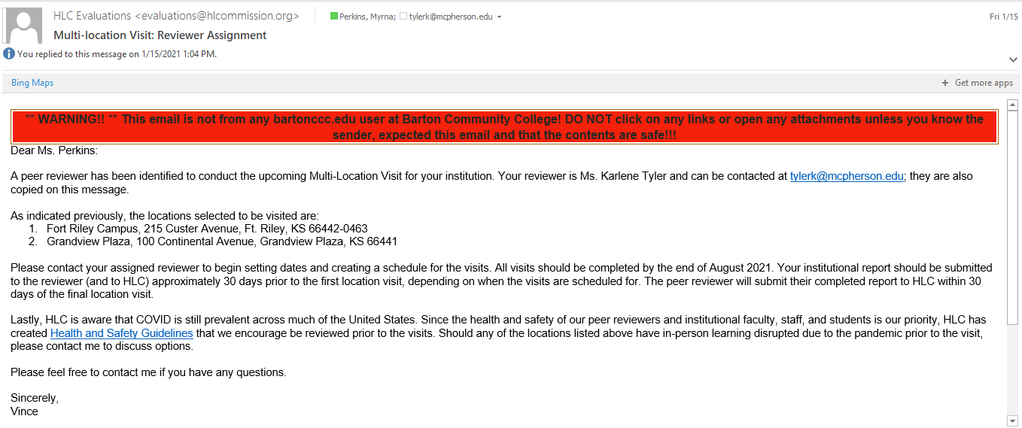
- HLC Annual Conference | April 5 – 9th, 2021 | Virtual Conference

Attendee | Date | Program
Dr. Heilman | Monday, April 5, 2021 | Presidents Program
Elaine Simmons  Angie Maddy  Stephanie Joiner  Cathie Oshiro  Jo Harrington  Randy Thode | Monday, April 5, 2021 | Accreditation Program
Myrna Perkins | Monday, April 5, 2021 | Peer Corps
Elaine Simmons  Angie Maddy  Stephanie Joiner  Cathie Oshiro  Jo Harrington  Randy Thode  Charles Perkins  Myrna Perkins | Tuesday, April 6 – Friday, April 9, 2021 | General

- Deeper Dive | Criterion 1: Mission
  - Started looking at the final report form our last assurance argument
  - Peer review feedback on 1.D.3. – the next peer review team will note the comments from the prior peer review and see how we’ve responded to the comments – we need to be clear why we are sending out these surveys to our constituents and what are we doing with the data we collect
  - Charles was collecting information on who was sending out surveys
  - Gap: we don’t survey our partners
  - The advisory boards will start meeting in about month so we could start there
  - Could we develop a survey to use this spring to capture some feedback
  - WTCE division used to survey – Elaine will see what we have documented
  - Does the Foundation do any surveys? Myrna will check
  - See if PR does any surveys – Mark will check with Brandon
  - Dr. Heilman was interested in using a 3rd party to review our mission statement – Myrna will visit with Dr. Heilman about utilizing the college employees to do this instead of a 3rd party
  - We need to solicit input from all constituents even the community when reviewing the mission statement
  - Student Success Academy is surveying the college for one word the best described Barton – we could use this towards the mission statement work – Angie
  - Elaine is taking the 29 graduates of the Leadership Institute and dividing them into work groups – Myrna would like a group for Accreditation – they could work on the mission statement

Discussion document provided.
Action Items |  |  |  |  |  |  |  |  |  | Responsibility

ALWAYS KEEPING IN MIND:
Barton Core Priorities/Strategic Plan Goals
Drive Student Success
- Increase student retention and completion
- Enhance the Quality of Teaching and Learning
Cultivate Community Engagement
- Enhance Internal Communication
- Enhance External Communication
Emphasize Institutional Effectiveness
- Initiate periodic review of the Mission Statement and Vision Statement.
- Through professional development, identify and create a training for understanding and use of process improvement methodologies.
Optimize Employee Experience
- Develop more consistent & robust employee orientation.
- Enhance professional development system.

