AGENDA/MINUTES
Team Name | Accreditation Committee
Date | 19-May-2021
Time | 2:00 pm
Location | A-113  Please note A-113 is the physical location for this meeting. Zoom is available for those who are joining remotely.  Myrna Perkins is inviting you to a scheduled Zoom meeting.  Join Zoom Meeting  https://zoom.us/j/94242957863  Meeting ID: 942 4295 7863  One tap mobile  +13462487799,,94242957863# US (Houston)  +16699006833,,94242957863# US (San Jose)

Facilitator |  | Myrna Perkins |  |  |  |  | Recorder | Sarah Riegel
Team members |  |  |  |  |  |  |  |  | Present X  Absent O
o | Elaine Simmons |  | x | Angie Maddy | o | Mark Dean |  |  | x | Cathie Oshiro
x | Randy Thode |  | x | Jo Harrington | x | Sarah Riegel |  |  | x | Myrna Perkins
x | Stephanie Joiner |  | x | Lindsay Holmes | x | Janet Balk |  |  | x | Abby Kujath
x | Matt Connell |  | x | Lee Miller | x | Karly Little |  |  | x | Kurt Teal
x | Brian Howe |  | x | Claudia Mather | x | Kathy Kottas |  |  | o | Todd Mobray
Guests
“Doing Accreditation”
Topics/Notes |  |  |  |  |  |  |  |  |  | Reporter
Additional Location Visit | Summer, 2021  “Institutions with three or more off-campus additional locations are required to undergo a Multi-Location Visit every five years. The visit is conducted by an HLC peer reviewer and involves a representative sample of the institution’s additional locations. The purpose of the Multi-Location Visit is to confirm the continuing effective oversight by the institution of its additional locations.” -- From HLC website.  Report due to HLC: May 24, 2021  Virtual Visit with Ms. Tyler: TBD  Mock Visit: TBD  Date of Visit: June 24, 2021  HLC Peer Review: Ms. Karlene Tyler  We need to decide:  - Who will be present for the visit? FR – Kurt, Janet, Abby; GVP – Kurt, Lindsay, Kathy, Karyl White, Dean Dexter  - What date to hold the mock visit? 2 weeks prior via zoom – Kurt will look at dates  - What date/time to visit via Zoom or by phone with Ms. Tyler regarding logistics? Consider doing this shortly after the mock visit – Kurt will look at dates  Participants:  - Location Operational Administrator  - Home Campus Oversight Administrator  - Location Individual(s) Responsible for Academic Quality  - Location Individual(s) Responsible for Student Services  - Individual(s) Responsible for Library or Other Academic Support Services  - Faculty  - Students  Locations:  - Fort Riley Campus, 211 Custer Avenue, Ft. Riley, KS  - Grandview Plaza, 100 Continental Avenue, Grandview Plaza, KS |  |  |  |  |  |  |  |  |  | Myrna Perkins  Cathie Oshiro
Mission Review Process  https://internal.bartonccc.edu/policy/college-operations  https://docs.bartonccc.edu/procedures/2102-strategicguide.pdf  Mission Review Project Timeline  Step 1 Late May The first step will be an introductory message sent to a selected survey population. The message is meant to serve as preparation and a learning opportunity. Following up, an online survey would be sent out to a diverse pre-selected group of constituents (TBD). Todd’s team already has the online form completed.  Step 2 Early June The second step will be a Zoom meeting for those who would want to participate in this second step of discussion.  Step 3 Late June The results of the survey and Zoom meeting feedback will then be reviewed and distilled at the early Executive Leadership Retreat (which includes student involvement) to formulate a Mission revision or non-revision.  Step 4 Early July The output from the retreat will go to President’s Staff as an agenda item for final review.  Step 5 Late July The final product would go before the Board of Trustees.  Link to survey: https://forms.office.com/r/m2MnNCQ5G4  - Todd will pull the Student Success focus group data and the Barton Identity survey data into this process |  |  |  |  |  |  |  |  |  | Myrna Perkins  Document Provided:  Mission Review Message
HLC Spotlight: Obligations of Membership (Formerly Obligations of Affiliation)  - HLC’s Obligations of Membership  https://www.hlcommission.org/Policies/obligations-of-membership.html  15. The institution submits timely payment of dues and fees in accordance with the published Dues and Fees Schedule and accepts the fact of surcharges for late payment.  https://www.hlcommission.org/Accreditation/dues-and-fees-schedule.html?highlight=WyJmZWVzIiwyMDIxXQ==  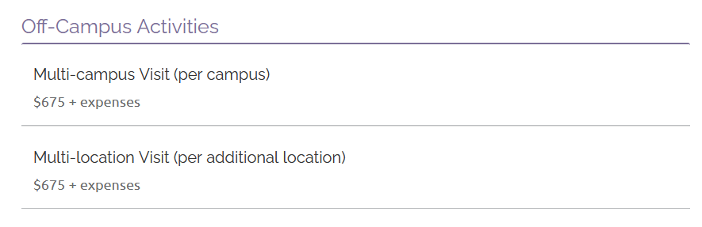 |  |  |  |  |  |  |  |  |  | Myrna Perkins
HLC’s Criterion Spotlight | Assumed Practices  A. Integrity: Ethical and Responsible Conduct  - The institution establishes and publicizes clear procedures for receiving complaints from students and other constituencies, responding to complaints in a timely manner, and analyzing complaints to improve its processes. The institution does not retaliate against those who raise complaints.  https://docs.bartonccc.edu/community/boardoftrustees/bot-student-complaint-process.pdf |  |  |  |  |  |  |  |  |  | Myrna Perkins
Public Disclosure Spotlight  - Bethel College  - Colby Community College  - Dodge City Community College  - Garden City Community College  - Highland Community College  - Kansas City Kanas Community College  CRITERION THREE, CORE COMPONENT 3.D  1 (3.3.D)  • Criterion Three, Core Component 3.D, “the institution provides support for student learning and effective teaching.”  Independence Community College – Removal of Sanction  Met Without Concerns  - The Technology Committee has created a technology plan that addresses key infrastructure issues and is viewed as a multi-year project.  - The Institution has addressed security issues related to access to sensitive data in the administrative systems. New policies are in place regarding such access.  - The Institution recently hired a new chief financial officer who has revamped the budget and budgeting process and has identified ways to address some of the prioritized needs. |  |  |  |  |  |  |  |  |  | Myrna Perkins  Document Provided
Accreditation Liaison Officer Report  Three changes were submitted and approved for the Ft. Riley Location:  - Ft Riley address updated from 215 Custer Ave to 211 Custer Ave  - Grandview Plaza address update from Avenue to Drive  - 24.0102 (AGS) removed from Ft. Riley. AGS now falls under CIP 24.0101 |  |  |  |  |  |  |  |  |  | Myrna Perkins
HLC Peer Reviewer Report & Insights  - Federal Compliance Panel Review – September, 2021 |  |  |  |  |  |  |  |  |  | Myrna Perkins
Student Success Academy Report  - June 2 is their next meeting with the mentor to review inventories and map next steps |  |  |  |  |  |  |  |  |  | Angie Maddy  Stephanie Joiner
Report Writer Report  - Halted until we get clarification on the mission project  Evidence Collection Assignment Progress – no update |  |  |  |  |  |  |  |  |  | Cathie Oshiro  Stephanie Joiner
Evidence Collection Report – no update |  |  |  |  |  |  |  |  |  | Randy Thode
Action Items |  |  |  |  |  |  |  |  |  | Responsibility

ALWAYS KEEPING IN MIND:
Barton Core Priorities/Strategic Plan Goals
Drive Student Success
1. Advance student entry, reentry, retention and completion strategies.
2. Commit to excellence in teaching and learning.
Cultivate Community Engagement
3. Expand partnerships across the institution.
4. Reinforce public recognition of Barton Community College.
5. Foster a climate of inclusivity so students, employees, and communities are welcomed, supported, and valued for their contributions.
Emphasize Institutional Effectiveness
6. Develop, enhance, and align business processes.
7. Manifest an environment that supports the mission of the college.
Optimize Employee Experience
8. Promote an environment that recognizes and supports employee engagement, innovation, collaboration, and growth.
9. Develop, enhance, and align business human resource processes.

