AGENDA/MINUTES
Team Name | Accreditation Committee
Date | 15-Sep-2021
Time | 2:00 pm – 3:30 pm
Location | A-113 | Zoom (A-113)

Facilitator |  | Myrna Perkins |  |  |  |  | Recorder | Sarah Riegel
Team members |  |  |  |  |  |  |  |  | Present X  Absent O
x | Elaine Simmons |  | o | Angie Maddy | o | Mark Dean |  |  | x | Cathie Oshiro
x | Randy Thode |  | x | Jo Harrington | x | Sarah Riegel |  |  | x | Myrna Perkins
x | Stephanie Joiner |  | x | Lindsay Holmes | x | Janet Balk |  |  | x | Abby Kujath
x | Matt Connell |  | x | Lee Miller | x | Karly Little |  |  | x | Kurt Teal
x | Brian Howe |  | x | Claudia Mather | x | Kathy Kottas |  |  | x | Todd Mobray
o | Dr. Heilman (Optional) |  | x | Renae Skelton
Guests
“Doing Accreditation”
Topics/Notes |  |  |  |  |  |  |  |  |  | Reporter
Mission Review Project  Mission Review Project Timeline  Step 1 Late May The first step will be an introductory message sent to a selected survey population. The message is meant to serve as preparation and a learning opportunity. Following up, an online survey would be sent out to a diverse pre-selected group of constituents (TBD). Todd’s team already has the online form completed. COMPLETED  Step 2 Early June The second step will be a Zoom meeting for those who would want to participate in this second step of discussion. COMPLETED  Step 3 Late June The results of the survey and Zoom meeting feedback will then be reviewed and distilled at the early Executive Leadership Retreat (which includes student involvement) to formulate a Mission revision or non-revision. COMPLETED  Step 4 Early July The output from the retreat will go to President’s Staff as an agenda item for final review. COMPLETED  Step 5 Late July The final product would go before the Board of Trustees. The Board of Trustees approves the proposed revision. COMPLETED  Step 6 4-Sep-2021 Barton’s revised mission statement is announced to the public. COMPLETED https://www.gbtribune.com/opinion/bartons-new-fresh-mission-statement/  Step 7 September, 2021 Barton Policy 2102 is revised to reflect the new Mission Review Process  - 02-Aug-2021: Meeting w/ Dr. George, Dr. Heilman, Todd Mobray, Myrna Perkins  Notes of Dr. George’s Comments: The mission is the DNA of the Institution. The framework of the Institution is the Mission which should flow into Action and then Effect (Outcome). It is often the middle piece—“Action”—that institutions miss. Evidence of action is critical in demonstrating the Institution has met the Criteria for Accreditation. Sometimes institutions work so organically, specific examples of the actions are missed and must be teased out. Submerged actions need to be more explicit. Great work on the project! Overall, Barton is a high-functioning institution – just need to work towards further refinement of all operational aspects in regard to accreditation. Sometimes the challenge is continuing to refine and sophisticate. |  |  |  |  |  |  |  |  |  | Myrna Perkins
To-Do List  A list has been started identifying actions/projects which are in progress to address some gaps or missing information for the Assurance Argument.  Document is located on the T drive. |  |  |  |  |  |  |  |  |  | Cathie Oshiro  Document
HLC Criterion Spotlight: Federal Compliance Report  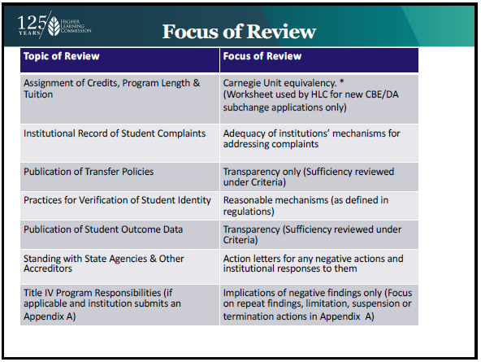  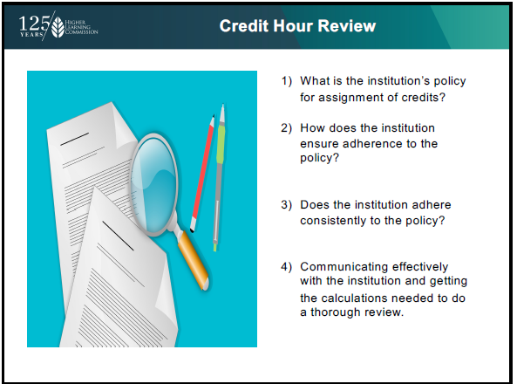  Credit Hour Review  - Need further conversation/awareness  - Create a process map  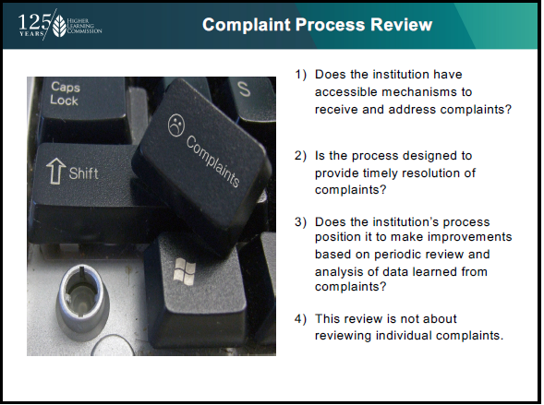  Compliant Process Review  - VP of Instruction captures student complaints from the instructional areas  - Need to determine how the VP’s of Administration and Student Services are capturing their student complaints  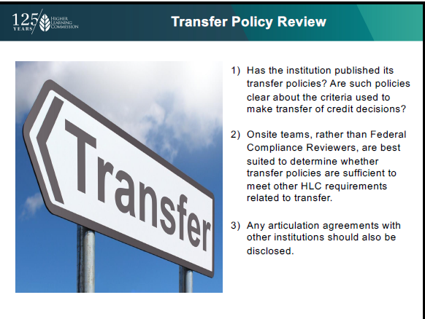  Transfer Policy Review  - We currently keep a spreadsheet of our 2+2 agreements  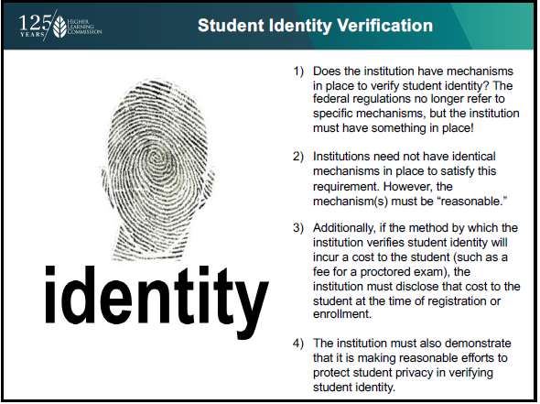  Student Identity Verification  - When we start using Banner 9 we will be able to capture photos of students  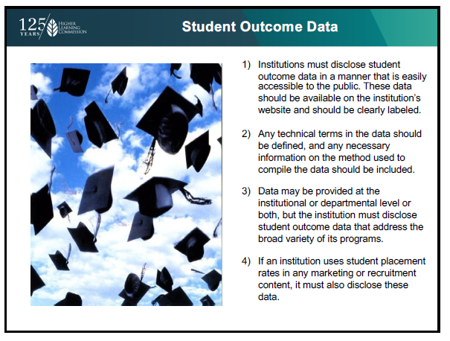  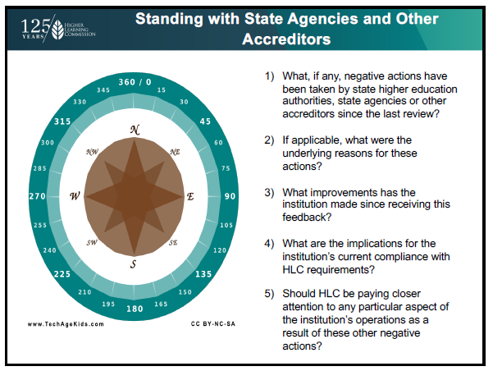  Standing with State Agencies and Other Accreditors  - Programs with outside accreditation: nursing, MLT, dietary, paramedic, pharmacy tech, phlebotomy  - Kurt will check on OSHA  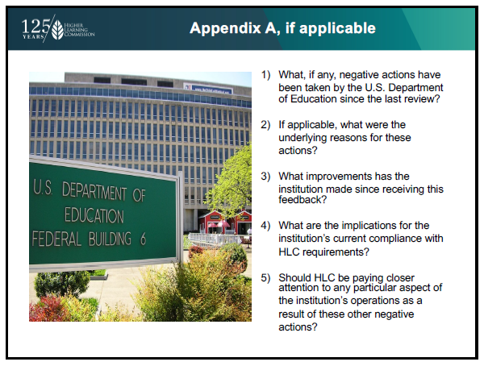  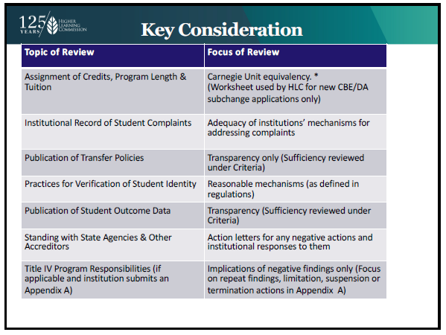 |  |  |  |  |  |  |  |  |  | Myrna Perkins
Public Disclosure Spotlight  The link below contains detailed information on Cloud and HLC’s reasoning for the Probationary status.  https://www.hlcommission.org/component/directory/?Itemid=&Action=ShowBasic&instid=1776  - Lack of evidence for assessment  - Lots of turnover with President’s and Vice-President’s  - Lack of evidence for consistency |  |  |  |  |  |  |  |  |  | Myrna Perkins  Karly Little
Accreditation Liaison Officer Report  No actions to report |  |  |  |  |  |  |  |  |  | Myrna Perkins
HLC Peer Reviewer Report & Insights  - Federal Compliance Training  - Federal Compliance Panel Review | Private, Religious-Affiliated Institution– September, 2021  - Financial Indicator Panel | 2 Private, Not-For-Profit Institutions and 1 Public U. – September, 2021  - Comprehensive Evaluation | Community & Technical College – November, 2021 |  |  |  |  |  |  |  |  |  | Myrna Perkins
Student Success Academy Report  - Currently in a holding pattern – meeting in 2 weeks with HLC to discuss what to expect in year 3  - Data collection completed  - Upcoming items: communication plan and final findings report |  |  |  |  |  |  |  |  |  | Angie Maddy  Stephanie Joiner
Action Items |  |  |  |  |  |  |  |  |  | Responsibility
None

ALWAYS KEEPING IN MIND:
Barton Core Priorities/Strategic Plan Goals
Drive Student Success
1. Advance student entry, reentry, retention and completion strategies.
2. Commit to excellence in teaching and learning.
Cultivate Community Engagement
3. Expand partnerships across the institution.
4. Reinforce public recognition of Barton Community College.
5. Foster a climate of inclusivity so students, employees, and communities are welcomed, supported, and valued for their contributions.
Emphasize Institutional Effectiveness
6. Develop, enhance, and align business processes.
7. Manifest an environment that supports the mission of the college.
Optimize Employee Experience
8. Promote an environment that recognizes and supports employee engagement, innovation, collaboration, and growth.
9. Develop, enhance, and align business human resource processes.

