AGENDA | MINUTES
Team Name | Accreditation Committee
Date | 1/18/2023
Time | 4:00-5:00 pm
Location | Zoom  https://bartonccc-edu.zoom.us/j/92788057833

Facilitator |  | Myrna Perkins |  |  |  |  | Recorder | Sarah Riegel
Team members |  |  |  |  |  |  |  |  | Present X  Absent O
x | Elaine Simmons |  | x | Angie Maddy | x | Mark Dean |  |  | x | Cathie Oshiro
x | Randy Thode |  | x | Jo Harrington | x | Sarah Riegel |  |  | x | Myrna Perkins
x | Stephanie Joiner |  | o | Lindsay Holmes | x | Janet Balk |  |  | x | Abby Kujath
o | Matt Connell |  | x | Lee Miller | o | Karly Little |  |  | x | Kurt Teal
x | Brian Howe |  | x | Claudia Mather | x | Kathy Kottas |  |  | x | Todd Mobray
o | Dr. Heilman (Optional)
Guests
“Doing Accreditation”
Topics/Notes |  |  |  |  |  |  |  |  |  | Reporter
Accreditation Pathway: Standard or Open
https://www.hlcommission.org/Accreditation/standard-and-open-pathways.html
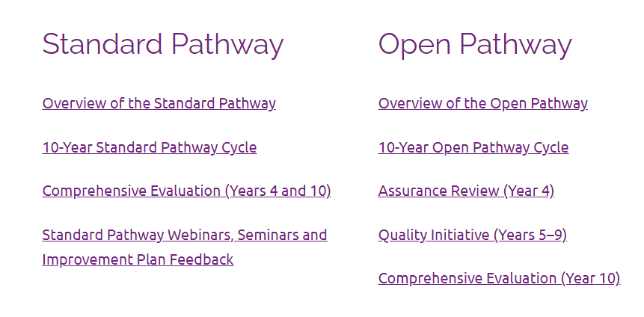
- Peer review team lead suggested we consider going to Standard Pathway due to the additional touch point mid-way through
- Value in having a team here on campus mid-cycle and it keeps us focused on accreditation
- Face-to-face interactions with a team is more valuable that exchanging reports
- Standard votes: Myrna, Brian, Kurt, Janet, Stephanie, Lee, Abby, Mark, Angie, Todd
- Open votes: Randy, Jo, Elaine, Kathy
- Myrna will put together a recommendation for the board

Action Items |  |  |  |  |  |  |  |  |  | Responsibility
n/a

ENDS:

1. Fundamental Skills
2. Work Preparedness
3. Academic Advancement
4. Barton Experience
5. Regional Workforce Needs
6. Barton Services and Regional Locations
7. Strategic Planning
8. Contingency Planning

Barton Core Priorities/Strategic Goals

Drive Student Success
1. Advance student entry, reentry, retention, and completion strategies.
2. Foster excellence in teaching and learning.
Cultivate Community Engagement
3. Expand partnerships & public recognition of Barton Community College.
Optimize the Barton Experience
4. Promote a welcoming environment that recognizes and supports student and employee engagement, integrity,
inclusivity, value, and growth.
Emphasize Institutional Effectiveness
5. Develop, enhance, and align business processes.

