AGENDA/MINUTES
Team Name | Accreditation Committee
Date | 13-Nov-2024
Time | 2:00 – 3:00 pm
Location | Join Zoom Meeting  https://bartonccc-edu.zoom.us/j/93397664252  Meeting ID: 933 9766 4252

Facilitator |  | Myrna Perkins |  |  |  |  | Recorder |  | Sarah Riegel
Team members |  |  |  |  |  |  |  | Present X  Absent O
x | Janet Balk |  | x | Mark Dean | x | Renee Demel |  | x | Jo Harrington
o | Maggie Harris |  | o | Dr. Marcus Garstecki | x | Jenna Hoffman |  | x | Lindsay Holmes
x | Brian Howe |  | x | Darren Ivey | x | Dr. Stephanie Joiner |  | o | Dr. Kathy Kottas
o | Abby Kujath |  | x | Karly Little | x | Angie Maddy |  | x | Claudia Mather
x | Lee Miller |  | x | Todd Mobray | x | Myrna Perkins |  | x | Sarah Riegel
o | Amye Schneider |  | x | Elaine Simmons | x | Kurtis Teal |  | x | Dr. Jenn Bernatis
Guests
“Doing Accreditation”
Topics/Notes |  |  |  |  |  |  |  |  | Reporter
Writing War Room  - Room is located near F-30  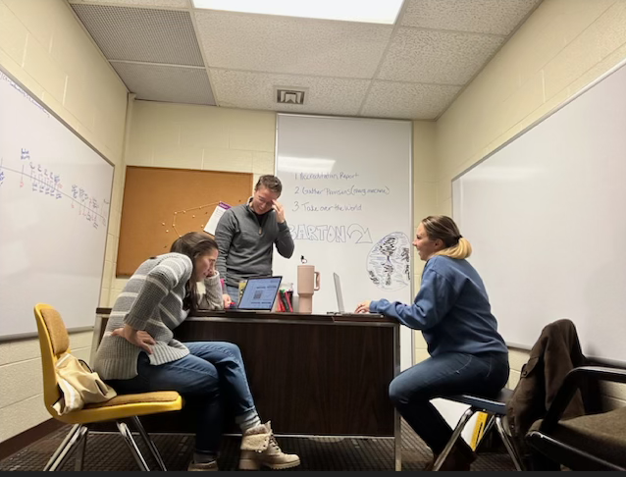 |  |  |  |  |  |  |  |  | Stephanie, Lee, and Karly
PEP Application Review  - Draft PEP application sent as an attachment  - Application will be sent to HLC for their review |  |  |  |  |  |  |  |  | Stephanie, Lee, Karly, Jenn
Review of Previous Visit Comments and Preparation for Writing Next AA  - Comment from reviewer in Criteria 3A regarding faculty membership in LICC. The recommendation is for majority representation by faculty. Currently only 2.5 faculty members are on the committee (I have counted EDs as the .5 as they may also be teaching a class or two…) – we will ask for a faculty member from faculty council to join LICC  - Student engagement/involvement in decision making processes – consider having a regular forum for all students to gather feedback  - Diversity plan – how is this shifting into HLC’s definitions of citizenship and how are we planning for either, particularly recognizing state limitations  - Timeline of mission review/strategic plan review in regard to timeline for writing report and planning for visit |  |  |  |  |  |  |  |  | Stephanie
HLC Academy Mentor/Facilitator Report*  - In October at the Q Center, helped facilitate several schools as the wrapped up their assessment academy  - Just assigned second school to work with  *These reports are not specific information due to confidentiality but allow for a time to report actions occurring that strengthen Barton’s partnership with HLC. |  |  |  |  |  |  |  |  | Jo
ALO Report  - Mid-Cycle Visit Scheduled | November 2-3, 2026, Assurance Argument must be submitted by October 5, 2026  - Accreditation Timeline  - Prison Education Program (PEP) |  |  |  |  |  |  |  |  | Myrna
HLC Peer Reviewer Report*  - Mid-Cycle Comprehensive Visit – October  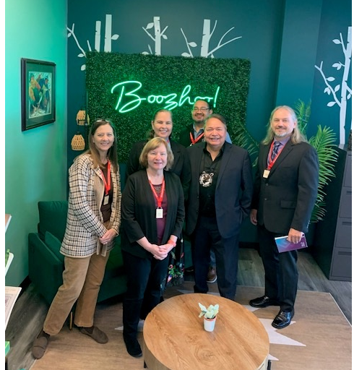  - https://www.hlcommission.org/get-involved/service-opportunities/become-a-peer-reviewer/  *These reports are not specific information due to confidentiality but allow for a time to report actions occurring that strengthen Barton’s partnership with HLC. |  |  |  |  |  |  |  |  | Myrna
Accreditation Action Items

Develop an action plan from HLC Report feedback plus things identified during the preparation for the Comprehensive Visit, development of the Assurance Argument, etc.

- “The Team acknowledges these efforts and suggests that the College continue to work actively on the diversity plan that they have established.” (3.C)

- “Ongoing communication and coordination of retention efforts are essential to sustain the objectives of the Student Success Plan recommendations.” (4.C) Student Success Alliance

- “The College appears committed to further developing its capability to collect and use student data to improve student retention and success across its many programs and campuses. (4.C) Student Success Alliance

- “With the College’s focus on improving student success data, further analysis of this data will support academic and student success initiatives across the College.” (4.S) Student Success Alliance/Institutional Effectiveness

- “The Team recommends a more deliberate documentation of the role of students in decision-making processes for future accreditation arguments.” (5.A)

- “While the success of Workforce programs is evident, the Team recommends a more deliberate documentation of Workforce Training outcomes.” (5.A)

- "Barton told the Team that they are moving to a more permanent membership. The Team recommends that careful consideration of the committee composition includes a majority of faculty.” (3.A)

- Update of the Data Dictionary (Federal Compliance Report) Institutional Effectiveness/PTP/Student Success Alliance

- Update of the Programs of Study Webpage (Federal Compliance Report) PTP Sub-Group

- Code of Conduct Training (Federal Compliance Report)

- Assignment of Credit Hours Process (Federal Compliance Report) Elaine

- Accreditation Continuity Planning | Cultivate Barton HLC Peer Reviewers

Action Items |  |  |  |  |  |  |  |  | Responsibility
n/a

Mission

Barton offers exceptional and affordable learning opportunities supporting student, community, and employee needs.

ENDS:

- Fundamental Skills
- Workplace Preparedness
- Academic Advancement
- Barton Experience
- Regional Workforce Needs
- Barton Services & Regional Locations
- Strategic Planning
- Contingency Planning

Barton Core Priorities

- Drive Student Success
- Cultivate Community Engagement
- Optimize the Barton Experience
- Emphasize Institutional Effectiveness

Strategic Plan Goals

- Advance student entry, reentry, retention and completion strategies.
- Foster excellence in teaching and learning.
- Expand partnerships & public recognition of Barton Community College.
- Promote a welcoming environment that recognizes and supports student and employee engagement, integrity, inclusivity, value, and growth.
- Develop, enhance, and align business processes.

