AGENDA/MINUTES
Team Name | Accreditation Committee
Date | 17-Apr-2025
Time | 2:00 – 3:00 pm
Location | Join Zoom Meeting  https://bartonccc-edu.zoom.us/j/93660672419  Meeting ID: 936 6067 2419

Facilitator |  | Myrna Perkins |  |  |  |  | Recorder |  | Sarah Riegel
Team members |  |  |  |  |  |  |  | Present X  Absent O
x | Janet Balk |  | x | Dr. Jenn Bernatis | x | Mark Dean |  | x | Renee Demel
x | Dr. Marcus Garstecki |  | x | Jo Harrington | o | Maggie Harris |  | x | Jenna Hoffman
o | Lindsay Holmes |  | x | Brian Howe | x | Darren Ivey |  | o | Dr. Stephanie Joiner
x | Dr. Kathy Kottas |  | x | Abby Kujath | x | Karly Little |  | x | Angie Maddy
x | Claudia Mather |  | x | Lee Miller | x | Myrna Perkins |  | x | Sarah Riegel
x | Amye Schneider |  | x | Elaine Simmons | x | Kurt Teal
Guests
x | Nick Larmer
“Doing Accreditation”
Topics/Notes |  |  |  |  |  |  |  |  | Reporter
2025 HLC Conference Highlights  Conference attendees will share highlights of the conference.  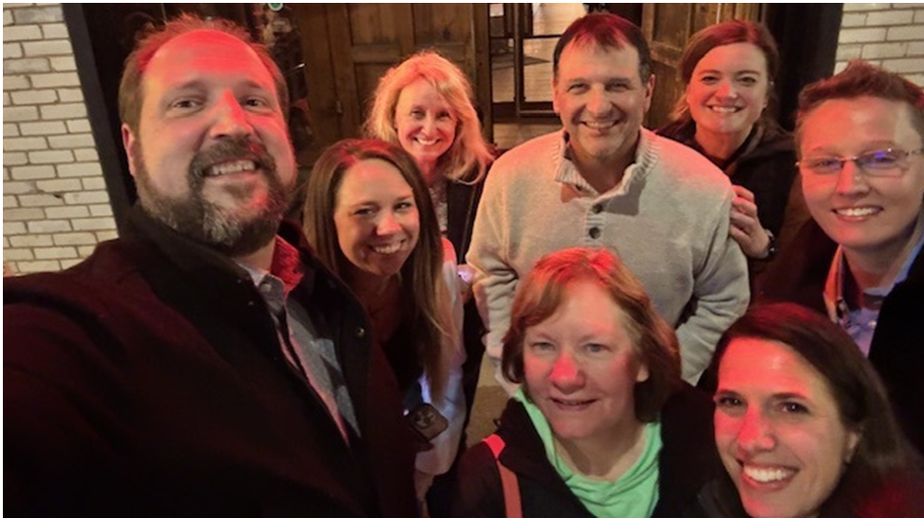  Conference attendees:  - Dr. Jenn Bernatis, Barton’s Evidence Collection Facilitator, attending general sessions  - Dr. Marcus Garstecki, President, attending the presential track and general sessions  - Jo Harrington, Instructor and HLC Assessment Academy Facilitator, attending general sessions  - Dr. Stephanie Joiner, Barton’s Accreditation Writing Team, attending general sessions  - Karly Little, Barton’s Accreditation Writing Team, attending general sessions  - Lee Miller, Barton’s Accreditation Writing Team, attending general sessions  - Myrna Perkins, Barton’s ALO and HLC Peer Reviewer, attending team chair peer review training and general sessions  Data Points to Share:  - 3800 attendees at the 2025 HLC Conference  - In 2022 (the year of Barton’s last Reaffirmation Visit), 44% of associate-granting institutions were in good standing. Currently, 58% of associate-granting institutions are in good standing. 4% of associate-granting institutions are on probation for 2024.  - Barton is one of 354 institutions that have been moved from the Assurance System platform for the Assurance Report to the new Canopy platform. These institutions were moved first due to having a visit in 25-26 or 26-27.  - HLC has approximately 1500 peer reviewers. Of those, there are 120-130 team chairs.  - HLC’s Institutional Actions Council (IAC) turns over (reverses) an estimated 20% of the recommendations made by a peer review team.  Additional Items to Share:  Simple Evaluative Technique  - Existence – Does it exist?  - Usage – Is it used?  - Effectiveness – Is it effective?  AI  - Spectrum of AI use – from need to use/implement to keep it away from me  - Overlaps with Megan and Curtis’s experience from their FL conference  - Conversations about private AIs and security  - Impact on higher education and more industries dissolving AI initiatives  - Surprising lack of some general awareness  Highlights  - Addressing change (leadership, management, identifying/addressing SWOT, new landscape)  - Value of H.E. and ROI for students / benefit for workforce  - Data driven (dashboards) – (turning data into information we can use) |  |  |  |  |  |  |  |  | Conference Attendees:  Jo, Stephanie, Lee, Karly, Dr. Bernatis,  Dr. Garstecki, Myrna  
2025-2026 AC Meetings  - Planning for the 2026 Mid-Cycle visit will begin.  - The 2025-2026 AC meetings will revolve around the Assurance Argument writing.  - The AC will be updated via email messages. |  |  |  |  |  |  |  |  | Myrna
ALO Report  - Annual report submitted to HLC (AIDU) on 4/3/2025.  - Prison Education Program (PEP) approved by IAC. Location visit is the final accreditation step. Brief update report will be required. |  |  |  |  |  |  |  |  | Myrna
HLC Peer Reviewer Report*  - Completed PEP Location Visit—March 4, 2025  - Completed Comprehensive Visit – April 14 – 16, 2025  - Completed Team Chair Training at 2025 HLC Conference (29)  - Received 15-year recognition for HLC Peer Review service at HLC Conference  - Appointment to the Institutional Actions Council (IAC) 117 + 16 = 123 members  From: Kerry Lofton <klofton@hlcommission.org>  Sent: Friday, April 4, 2025 8:58 AM  To: Perkins, Myrna <PerkinsM@bartonccc.edu>  Cc: Sharon Ulmer <sulmer@hlcommission.org>  Subject: Response to IAC Appointment  Dear Myrna,  Thank you for accepting the appointment to the Institutional Actions Council (IAC). This email confirms that you have been appointed to the IAC with the Higher Learning Commission. . .  *These reports are not specific information due to confidentiality but allow for time to report actions occurring that strengthen Barton’s partnership with HLC. |  |  |  |  |  |  |  |  | Myrna    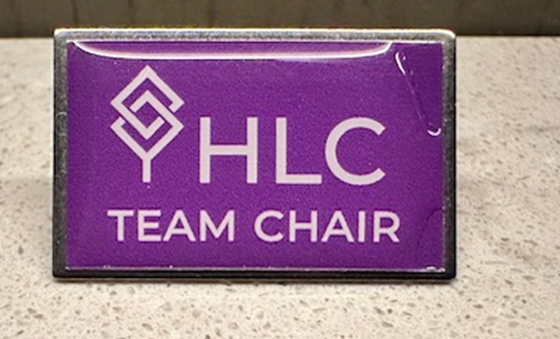  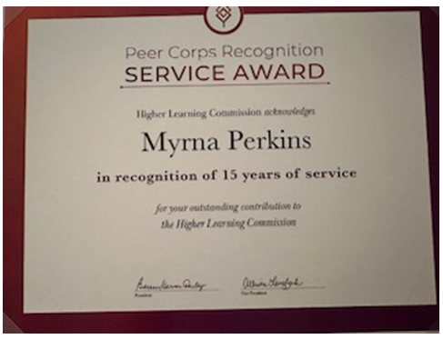
HLC Assessment Mentor | Academy Facilitator Report*  *These reports are not specific information due to confidentiality but allow for time to report actions occurring that strengthen Barton’s partnership with HLC. |  |  |  |  |  |  |  |  | Jo
HLC Credential Lab  Microcredentials  - Noting/explaining ROI for microcredentials – demonstrating value  - Data driven (why are they offered)  - HLC aligned with direction for microcredentials (value emphasis)  - Questions/Concerns for Credential Lab |  |  |  |  |  |  |  |  | Lee
Sub-Group Work | Writing Team

Report Writing Guiding Principles

- Transparency: Draft documents will be located at an identified and accessible location.
- Layered Writing Process: The writing process should include stages.

Phase 1. Discovery: Research for content, visit with key individuals.
Phase 2. Draft: Writing of the initial narrative.
Phase 3. Collaborative Conversation: Discuss sections/get feedback on draft from individuals key to the topic.
Phase 4. Editorial Review: Write the final draft with one voice.

- Develop a Project Timeline: Reports have a due date. Work back from this to create a timeline for the project to incorporate all writing phases.
- Develop a Repository of Narratives for Common Topics: There are common topics which most HLC reports require (e.g. Oversight of Instruction, Student Assessment, Budgeting Process) which should be standard narratives available for use in any report where needed.

Sub-Group Work | Evidence Repository

- Evidence Gathering Guiding Principles
- Transparency: Evidence documents should be located at an identified and accessible location.
- Foundational Evidence: HLC’s Providing Evidence document should guide collection of foundational documentation.
- Additional Level of Supporting Documentation: The evidence collection should also archive other supporting documentation.
- Collection Inclusive of Human Interest/Human Connection Anecdotes: The evidence collections should also archive anecdotal evidence of human interaction.
- Periodic Data Inventory Audit: At least annually the evidence inventory should be reviewed for accuracy and relevancy.

Breadcrumbs from 2022 Comprehensive Visit

Develop an action plan from HLC Report feedback plus things identified during the preparation for the Comprehensive Visit, development of the Assurance Argument, etc.

- “The Team acknowledges these efforts and suggests that the College continue to work actively on the diversity plan that they have established.” (3.C)

- “Ongoing communication and coordination of retention efforts are essential to sustain the objectives of the Student Success Plan recommendations.” (4.C) Student Success Alliance

- “The College appears committed to further developing its capability to collect and use student data to improve student retention and success across its many programs and campuses. (4.C) Student Success Alliance

- “With the College’s focus on improving student success data, further analysis of this data will support academic and student success initiatives across the College.” (4.S) Student Success Alliance/Institutional Effectiveness

- “The Team recommends a more deliberate documentation of the role of students in decision-making processes for future accreditation arguments.” (5.A)

- “While the success of Workforce programs is evident, the Team recommends a more deliberate documentation of Workforce Training outcomes.” (5.A)

- "Barton told the Team that they are moving to a more permanent membership. The Team recommends that careful consideration of the committee composition includes a majority of faculty.” (3.A)

- Update of the Data Dictionary (Federal Compliance Report) Institutional Effectiveness/PTP/Student Success Alliance

- Update of the Programs of Study Webpage (Federal Compliance Report) PTP Sub-Group

- Code of Conduct Training (Federal Compliance Report)

- Assignment of Credit Hours Process (Federal Compliance Report) Elaine

- Accreditation Continuity Planning | Cultivate Barton HLC Peer Reviewers

Action Items |  |  |  |  |  |  |  |  | Responsibility
n/a

Mission
Barton offers exceptional and affordable learning opportunities supporting student, community, and employee needs.

ENDS:

- Fundamental Skills
- Workplace Preparedness
- Academic Advancement
- Barton Experience
- Regional Workforce Needs
- Barton Services & Regional Locations
- Strategic Planning
- Contingency Planning

Barton Core Priorities

- Drive Student Success
- Cultivate Community Engagement
- Optimize the Barton Experience
- Emphasize Institutional Effectiveness

Strategic Plan Goals

- Advance student entry, reentry, retention and completion strategies.
- Foster excellence in teaching and learning.
- Expand partnerships & public recognition of Barton Community College.
- Promote a welcoming environment that recognizes and supports student and employee engagement, integrity, inclusivity, value, and growth.
- Develop, enhance, and align business processes.

