AGENDA/MINUTES
Team Name | Accreditation Committee
Date | 09-Jan-2026
Time | 9:30 am – 10:30 am
Location | https://bartonccc-edu.zoom.us/j/84980987848  Meeting ID: 849 8098 7848

Facilitator |  | Myrna Perkins |  |  |  |  | Recorder |  | Sarah Riegel
Team members |  |  |  |  |  |  |  | Present X  Absent O
x | Janet Balk |  | x | Narren Brown | x | Mark Dean |  | x | Renee Demel
x | Dr. Marcus Garstecki |  | x | Jenna Hoffman | x | Lindsay Holmes |  | x | Darren Ivey
x | Dr. Stephanie Joiner |  | x | Dr. Kathy Kottas | x | Abby Kujath |  | o | Karly Little
x | Angie Maddy |  | x | Claudia Mather | x | Lee Miller |  | x | Myrna Perkins
x | Sarah Riegel |  | o | Amye Schneider | x | Elaine Simmons |  | x | Kurt Teal
x | Brian Howe |  | x | Jo Harrington
Guests
“Doing Accreditation”
Topics/Notes |  |  |  |  |  |  |  |  | Reporter
Accreditation Timeline  - Multi-Location Visit March 11 & 12, 2026  - AIDU Report March 2026  - Mid-Cycle Visit November 2 & 3, 2026 |  |  |  |  |  |  |  |  | Myrna
Multi-Location Visit  - Pratt Location March 11, 2026, Afternoon  - Ft Riley Military & American Medical Response March 12, 2026  - January 30, 2026, Report Due  - February 2026 Preparation for Visit |  |  |  |  |  |  |  |  | Myrna
Assurance Argument for 2026 Mid-Cycle Visit  - Starting to get writing process organized  - Will start micro meeting to gather information |  |  |  |  |  |  |  |  | Lee
HLC Credential Lab  - Two sessions so far – change leadership and skill validation  - Another session this month over employer and workforce connected credentials |  |  |  |  |  |  |  |  | Claudia
HLC Academy Mentor/Facilitator Report*  - Revising Assessment Academy structure to align with new criteria, Jo is working with a pilot group  - Will be attending winter workshops on general education assessment and program assessment  - Jo is mentoring four schools now  *These reports are not specific information due to confidentiality but allow for time to report actions occurring that strengthen Barton’s partnership with HLC. |  |  |  |  |  |  |  |  | Jo
ALO Report  - Prison Education Program (PEP) approved with KDOC, HLC, and ED |  |  |  |  |  |  |  |  | Myrna
HLC Peer Reviewer Report*  - October 2025 Team Chair | Comprehensive Visit  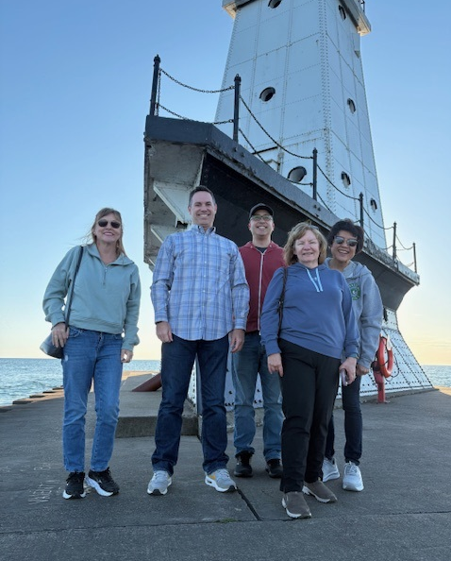  - January 2026 | Federal Compliance Report  *These reports are not specific information due to confidentiality but allow for time to report actions occurring that strengthen Barton’s partnership with HLC. |  |  |  |  |  |  |  |  | Myrna
Accreditation Action Items
Develop an action plan from HLC Report feedback plus things identified during the preparation for the Comprehensive Visit, development of the Assurance Argument, etc.

- “The Team acknowledges these efforts and suggests that the College continue to work actively on the diversity plan that they have established.” (3.C)

- “Ongoing communication and coordination of retention efforts are essential to sustain the objectives of the Student Success Plan recommendations.” (4.C) Student Success Alliance

- “The College appears committed to further developing its capability to collect and use student data to improve student retention and success across its many programs and campuses. (4.C) Student Success Alliance

- “With the College’s focus on improving student success data, further analysis of this data will support academic and student success initiatives across the College.” (4.S) Student Success Alliance/Institutional Effectiveness

- “The Team recommends a more deliberate documentation of the role of students in decision-making processes for future accreditation arguments.” (5.A)

- “While the success of Workforce programs is evident, the Team recommends a more deliberate documentation of Workforce Training outcomes.” (5.A)

- "Barton told the Team that they are moving to a more permanent membership. The Team recommends that careful consideration of the committee composition includes a majority of faculty.” (3.A)

- Update of the Data Dictionary (Federal Compliance Report) Institutional Effectiveness/PTP/Student Success Alliance

- Update of the Programs of Study Webpage (Federal Compliance Report) PTP Sub-Group

- Code of Conduct Training (Federal Compliance Report)

- Assignment of Credit Hours Process (Federal Compliance Report) Elaine

- Accreditation Continuity Planning | Cultivate Barton HLC Peer Reviewers

Action Items |  |  |  |  |  |  |  |  | Responsibility
n/a

Mission
Barton offers exceptional and affordable learning opportunities supporting student, community, and employee needs.

ENDS:

- Fundamental Skills
- Workplace Preparedness
- Academic Advancement
- Barton Experience
- Regional Workforce Needs
- Barton Services & Regional Locations
- Strategic Planning
- Contingency Planning

Barton Core Priorities

- Drive Student Success
- Cultivate Community Engagement
- Optimize the Barton Experience
- Emphasize Institutional Effectiveness

Strategic Plan Goals

- Advance student entry, reentry, retention and completion strategies.
- Foster excellence in teaching and learning.
- Expand partnerships & public recognition of Barton Community College.
- Promote a welcoming environment that recognizes and supports student and employee engagement, integrity, inclusivity, value, and growth.
- Develop, enhance, and align business processes.

