AGENDA/MINUTES
Team Name | Academic Integrity Council
Date | 4/19/2022
Time | 3:30 – 4:30 pm
Location | Zoom https://zoom.us/my/elainesimmons

Facilitator |  | Elaine Simmons |  |  |  |  | Recorder | Sarah Riegel
Team members |  |  |  |  |  |  |  |  |  | Present X  Absent O
x | Carla Alford |  | o | Angela Campbell | x | Stephanie Joiner |  |  | x |  | Claudia Mather
x | Amanda Alliband |  | x | Deanna Heier | o | Kathy Kottas |  |  | x |  | Lee Miller
x | Paulia Bailey |  | x | Darren Ivey | x | Karly Little |  |  | x |  | Andrea Thompson
o | Janet Balk |  | x | Erika Jenkins-Moss | o | Angie Maddy
Guests
x | Matt Connell |  | x | Megan Schiffelbein
Topics/Notes |  |  |  |  |  |  |  |  |  |  | Reporter
Academic Integrity Procedure  https://docs.bartonccc.edu/procedures/2502-academicintegrity.pdf  Discussion Points:  Page Four – Faculty Rights and Responsibilities Section (grading and Student Code of Conduct)  - Statement on grades not being altered without the consent of the instructor  - Consider changing this because the college no longer offers the grade appeal procedure, it’s handled through the student problem resolution  - Does the problem resolution address grade changes? – Elaine will discuss with Dean’s Council  - There are situations that come up through the problem resolution where the grade given by the instructor might be overridden  - Consider changing the first paragraph to: As an academic matter, faculty retain all rights of grade assignment and related academic sanctions as it correlates with our policies and procedures. Course grades assigned may not be altered without the consent of the appropriate faculty member.  - Need to add language on Student Code of Conduct to the last paragraph  - Once a violation is considered a Capital Violation, all procedural steps and student communication will be completed by Barton administration in alignment with the Student Code of Conduct.  - Language on taking the XF course again  - Student can take the XF course over again  - XF grade will remain on the transcript  - The grade from retaking the course will be used for GPA  - Should we put this information with the definition of XF in the college catalog?  - XF Form – include a box for the instructor to mark whether or not the student could retake their course  - XF Form – do we need to indicate a grade on the XF form since the form is giving the student an XF grade (remove the grade line item from the XF form)  - No refunds for coursework taken in term of expulsion |  |  |  |  |  |  |  |  |  |  | Elaine
Institutional Policy for Student Agreement on College Use of Student Data
- Do we need student agreement/acknowledgment that the college will use their student data?
- Turn-It-In and Canvas collects our student’s data

International Center for Academic Integrity National Conference  - Faculty buy-in and communication with students  - Consider having an option for faculty to submit an anonymous report to track types of behavior  - AI process  - Some students still don’t realize their actions are an AI violation – need to educate them early on  - Student-centered course redesign  - Making sure your pedagogy is matching what you want your students to learn  - Educational sanctions should be the norm  - Canvas course instructors could assign to the whole class or certain students  - Students can earn badges for completing the AI course  - This could be for all students and/or students in violation of the AI policy  - What students don’t know when they arrive on campus  - Culture of integrity and developing student ownership and engagement  - Start the semester/school year off talking to students as emerging scholars/professionals  - The Center is redoing Barton Online student orientation (summer pilot) – they can add a piece on AI – let Matt know if there’s anything to add  - Have a round table for all faculty to get together and talk about AI; Lee’s 3/22 email |  |  |  |  |  |  |  |  |  |  | Stephanie/Erika
AI Wheel  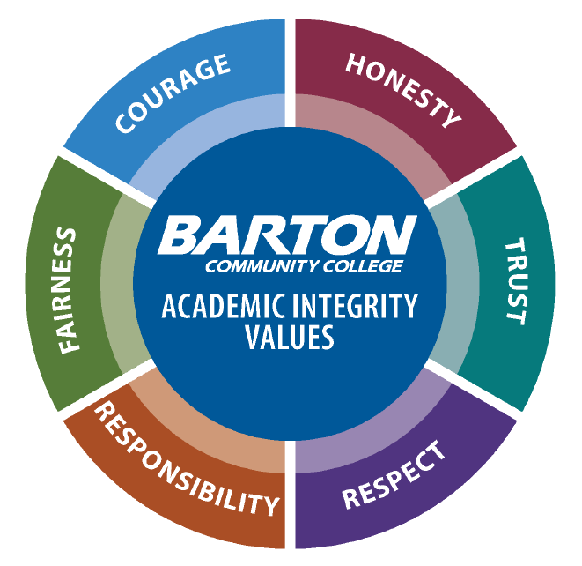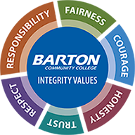  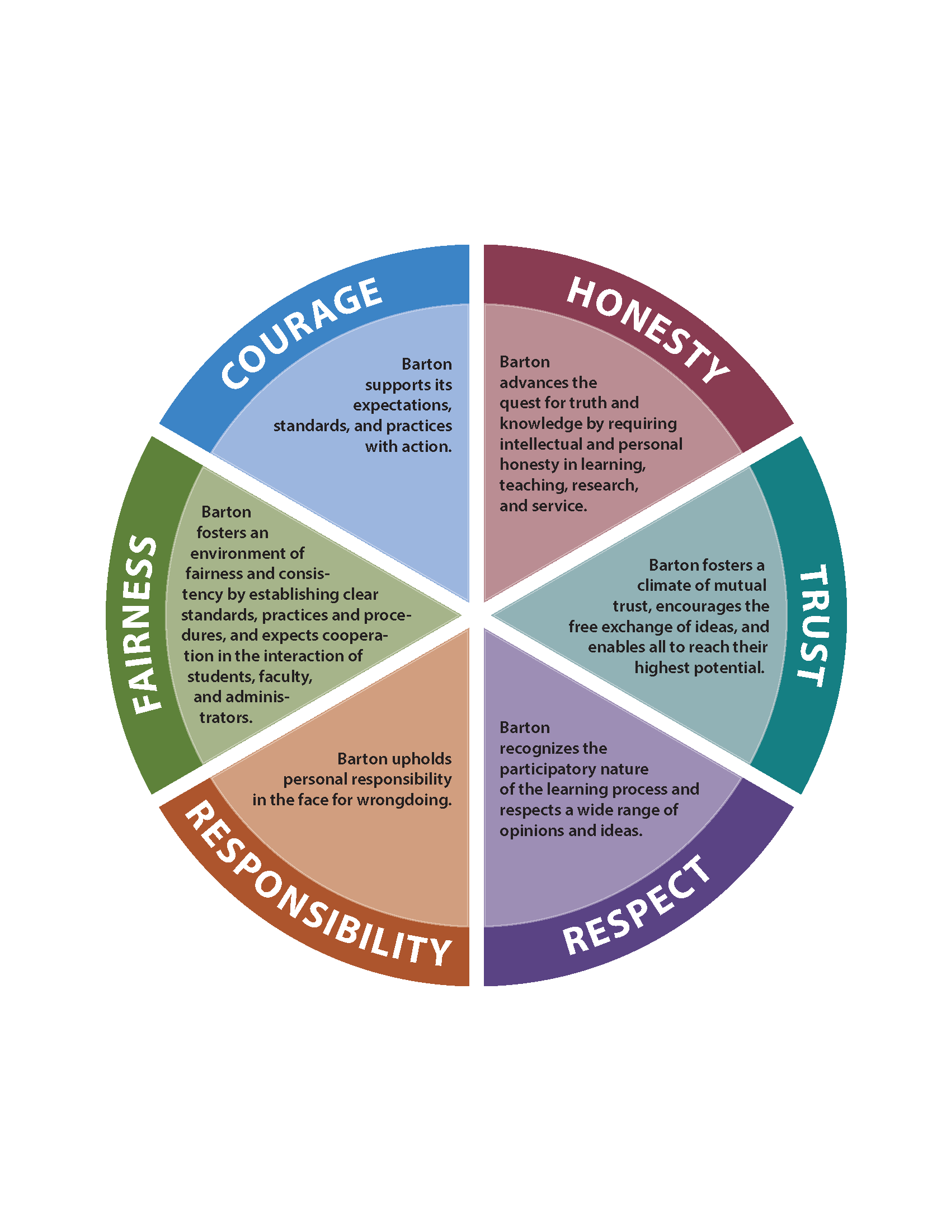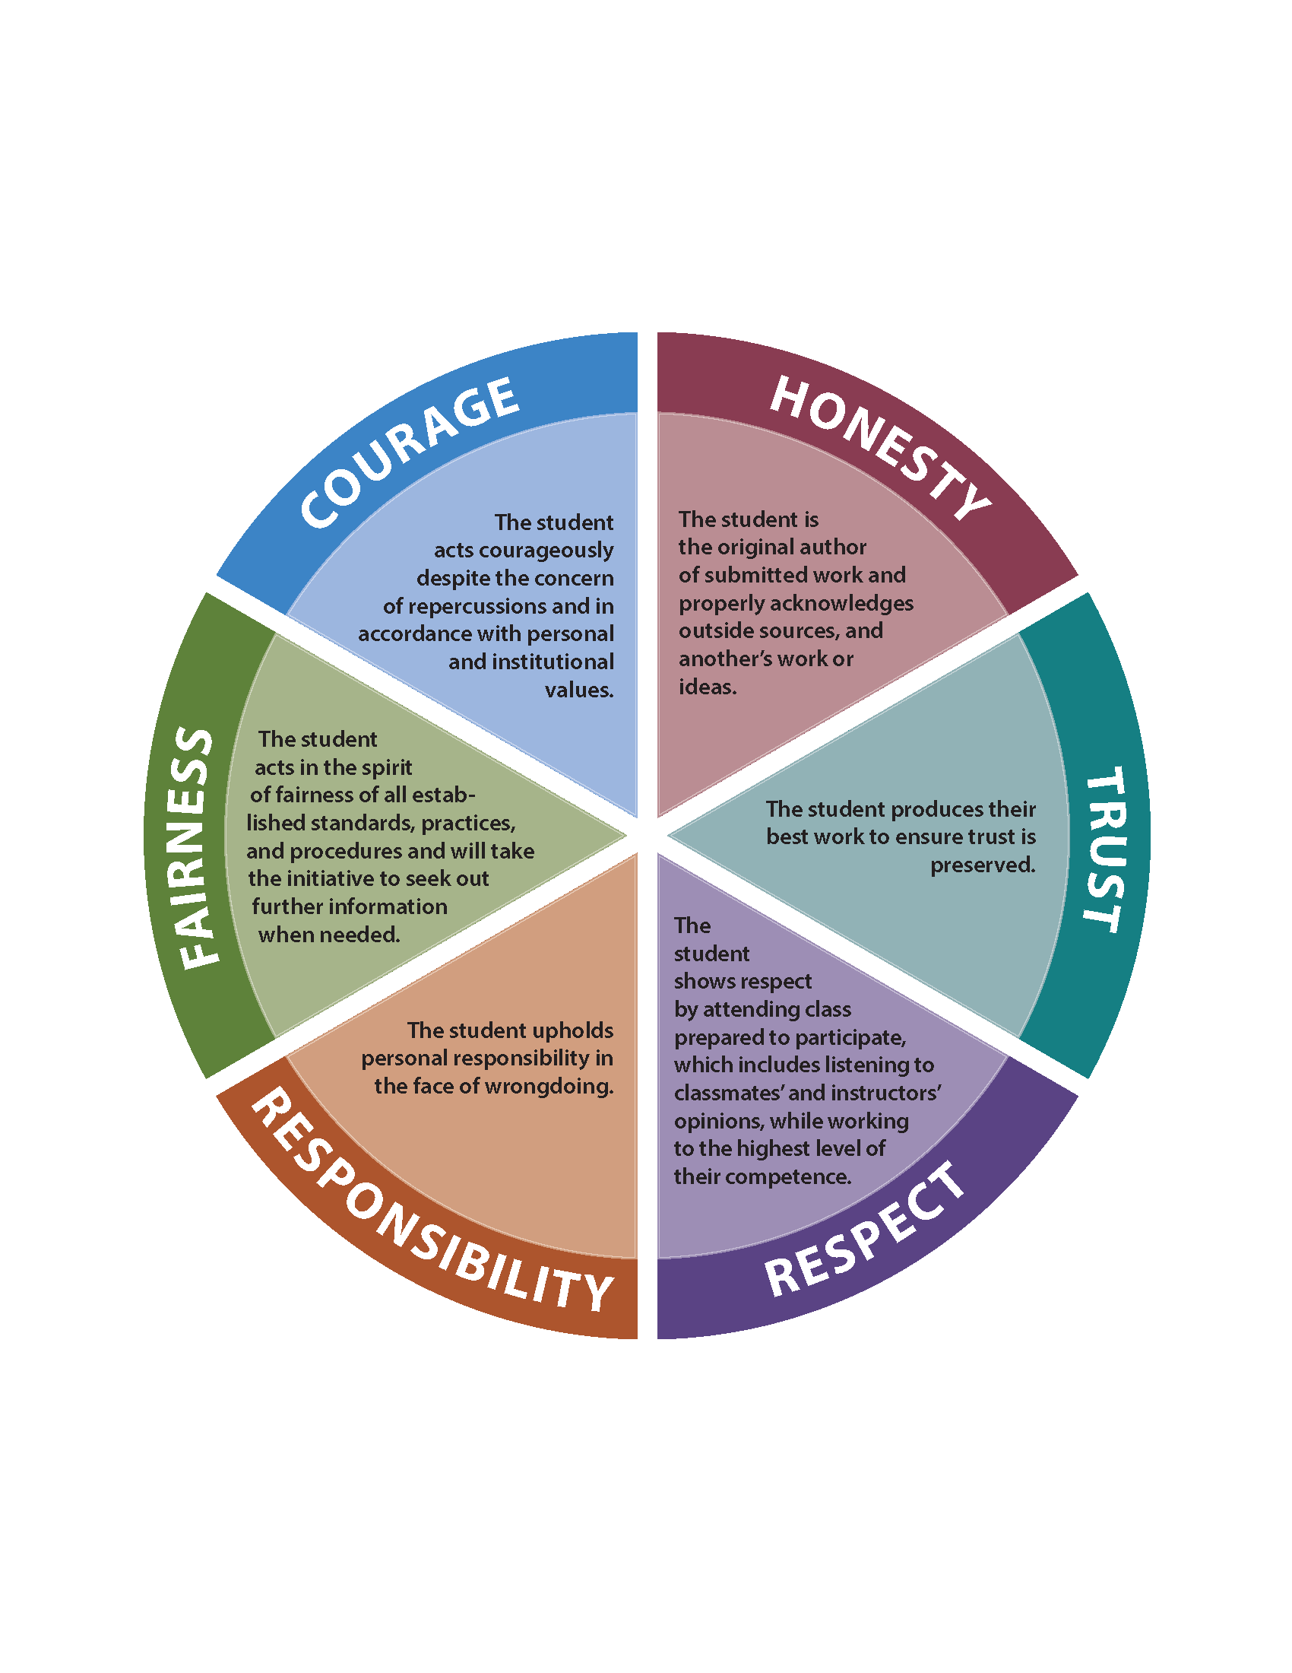  - New Design – Integrity Values  - College and student obligation wheels  - Portal  - Identification of areas to change – signature block, SAD shell, Academic Development Center, program handbooks, CEP faculty shell, classroom posters, light pole banners on GB campus, banners at FR/FL/GVP, etc.  - College Announcement |  |  |  |  |  |  |  |  |  |  | Claudia/Deanna/All
Academic Integrity Best Practices/Website  - Faculty Best Practices: Academic Integrity and Communication (still a work in progress)  - AI Website – Deanna is working with Samantha  - House under About Barton  - There’s already AI information under Admissions, these can be linked together  - Anything from the SAD shell can be linked  - Have the AI wheel on the web page, make interactive and auditory |  |  |  |  |  |  |  |  |  |  | Deanna
Continued AI Awareness/PD Activities  - New Faculty Boot Camp  - The Center is reaching out to all new faculty during onboarding process to talk about course design, OER, compliance and AI procedure/process  - AI and Center Webpages – have resources available on the webpage (e.g. poster or swag requests)  - SAD Shell – open to all Barton students  - Course Binder Project – AI Overview & Resources – include AI procedure  - Swag  - Include integrity related quotes from recognizable people  - If we produce the items internally we could personalize the items for students  - Possible items: lanyards, click pens with highlighter, t-shirts, water bottles, notebooks, stickers of the AI wheel, pins of the AI wheel, magnets  - Student success packets – could we collaborate with Student Services, Academic Development Center (Stephanie)  - Include swag with a textbook purchase (both in-person and online)  - Send swag to anyone nominated for AI ambassadors  - Cougar Tales – at least once a year have an AI presentation  - Continued Integrity Campaign Plans  - Is there a nomination process for new AI ambassadors? New ambassadors will be selected every 2 years (Fall 2022)  - Orientation Day – include AI ambassadors at academic integrity presentations |  |  |  |  |  |  |  |  |  |  | All
Updated Academic Integrity Statement – Effective in Course Syllabi Spring 2022  Academic Integrity is scholarship based on honesty, trust, respect, responsibility, fairness, and courage. Barton Community College pledges to uphold these core values of integrity in all aspects of teaching and learning. Students are the authors of submitted work and shall give credit to outside sources and other’s work or ideas. In all aspects undertaken by students, faculty, staff, and all other stakeholders of Barton Community College, the following pledge applies: On my honor as a Cougar, I am acting with integrity in academics. I am acting per personal and institutional values and refraining from any form of academic dishonesty, and I will not tolerate the academic dishonesty of others. Acts of academic dishonesty, intended or unintended, are subject to Procedure 2502 Academic Integrity and may result in the grade of XF. Barton defines an XF grade as failure as a result of a violation of Academic Integrity.  - AI Council Approvals (Full Statement) – have all this done by January 1, 2022:  - Concourse – done  - Enrollment Form (Lori) – done  - Enrollment Self-Serve (Lori) – done  - Portal (Claudia/Samantha) – working on  - BOL Orientation (Claudia) – done  - Student Handbook (Angie) – done  - Student Orientation (Angie) – done  - Admissions App (Tana) – done |  |  |  |  |  |  |  |  |  |  | All
Plagiarism Academy and Contract Cheating Academy – wait until Fall 2022  - These could be an optional sanction to prevent students from violating the AI policy again  - These would be offered online to include all student groups  - Need to consider budget  - This is two separate events/sanctions  - This is not a credit course, more if the student wants to continue they need to do this |  |  |  |  |  |  |  |  |  |  | Lee
Review Data from AI Violation Reports  - Look for trends |  |  |  |  |  |  |  |  |  |  | Stephanie
AI Story/Feedback  - How specific should faculty be in their course syllabus in regards to AI  - Could the AI language or lack of AI language lead to assumption by the students  - Faculty should consider stating what they want the student to do versus the language of don’t do this  - There needs to be a balance between the students knowing the expectations and the instructor having the discretion to address the violation (don’t be so specific in your syllabus that it boxes you in)  - We need to consider how we, in the workforce, use resources and examples so we don’t have to reinvent the wheel |  |  |  |  |  |  |  |  |  |  | Elaine
2021-2022 Council Themes & Goals  Themes  - Understanding Why Students Cheat  - Contract Cheating  - Policy Considerations  - Impacting the Culture  - Professional Development  Goals  - Promote a culture of respect, responsible conduct and integrity  - Support the institution’s positive reputation of academic integrity  - Identify ways to educate students on integrity values and academic expectations  - Provide professional development across the institution including faculty, staff and students  - Identify course design, teaching practices, and assessment systems to deter cheating  - Utilize collaborative strategies to create awareness, exchange information and identify best practices across the instructional system  - Develop an academic integrity orientation module for students (F2F and online) |  |  |  |  |  |  |  |  |  |  | Elaine/Team
Next Meeting: May 9, 2022

ENDS:
FUNDAMENTAL SKILLS | REGIONAL WORKFORCE NEEDS
WORK PREPAREDNESS | BARTON SERVICES & REGIONAL LOCATIONS
ACADEMIC ADVANCEMENT | STRATEGIC PLANNING
“BARTON EXPERIENCE” | CONTINGENCY PLANNING

Barton Core Priorities/Strategic Plan Goals

Drive Student Success
1. Advance student entry, reentry, retention and completion strategies.
2. Commit to excellence in teaching and learning.

Cultivate Community Engagement
3. Expand partnerships across the institution.
4. Reinforce public recognition of Barton Community College.
5. Foster a climate of inclusivity so students, employees, and communities are welcomed, supported, and valued for their contributions.

Emphasize Institutional Effectiveness
6. Develop, enhance, and align business processes.
7. Manifest an environment that supports the mission of the college.

Optimize Employee Experience
8. Promote an environment that recognizes and supports employee engagement, innovation, collaboration, and growth.
9. Develop, enhance, and align business human resource processes.

