AGENDA/MINUTES
Team Name | Academic Integrity Council
Date | 7/27/2022
Time | 1:30 – 2:30 pm
Location | Zoom https://zoom.us/my/elainesimmons

Facilitator |  | Elaine Simmons |  |  |  |  | Recorder | Sarah Riegel
Team members |  |  |  |  |  |  |  |  |  | Present X  Absent O
x | Amanda Alliband |  | x | Matt Connell | x | Stephanie Joiner |  |  | o |  | Claudia Mather
x | Paulia Bailey |  | o | Deanna Heier | x | Kathy Kottas |  |  | x |  | Lee Miller
x | Janet Balk |  | x | Darren Ivey | x | Karly Little |  |  | x |  | Megan Schiffelbein
o | Angela Campbell |  | x | Erika Jenkins-Moss | o | Angie Maddy |  |  | o |  | Andrea Thompson
Guests
Topics/Notes |  |  |  |  |  |  |  |  |  |  | Reporter
Discuss 2022-2023 Council Themes & Goals  Themes  - Understanding Why Students Cheat  - Contract Cheating  - Policy Considerations  - Impacting the Culture  - Professional Development  Goals  - Promote a culture of respect, responsible conduct and integrity  - Support the institution’s positive reputation of academic integrity  - Identify ways to educate students on integrity values and academic expectations  - Provide professional development across the institution including faculty, staff and students  - Identify course design, teaching practices, and assessment systems to deter cheating  - Utilize collaborative strategies to create awareness, exchange information and identify best practices across the instructional system  - Develop an academic integrity orientation module for students (F2F and online)  Discussion items:  - Consider shifting our focus towards faculty development  - Consider removing contract cheating from the themes since the other themes are big picture and this is a very specific type of cheating |  |  |  |  |  |  |  |  |  |  | All
Academic Integrity Best Practices/Website  - Faculty Best Practices: Academic Integrity and Communication (still a work in progress)  - AI Website – Deanna is working with Samantha  - House under About Barton  - There’s already AI information under Admissions, these can be linked together  - Anything from the SAD shell can be linked  - Have the AI wheel on the web page, make interactive and auditory  - Title the page Barton Integrity  - Subpages: Policies & Procedures, AI Fair, Forms, Resources, AI Features  - Portal Integrity Card – Description & Linkage to Website |  |  |  |  |  |  |  |  |  |  | Deanna
Professional Development Opportunities  - Faculty Council PD Session – August 24th; 3:30p.m. – Integrity Tools  - Presenter(s) – Matt Connell, Megan Schiffelbein, Angie Reed  - Academic Integrity Council/Center for Innovation & Excellence PD Session – Turnitin  - Date/Time?  - Panelists: Karly Little, Paulia Bailey, ??  - Academic Development Center Turnitin Session  - AI is presented as part of student orientation  - Cougar Conversation – 2 sessions scheduled in October for AI (in-person and zoom) |  |  |  |  |  |  |  |  |  |  | Amanda, Claudia, Matt & Stephanie
AI Resource for International Students
- Academic Development Center could offer general sessions and/or one-on-one’s for students as faculty request
- Could we have a pamphlet or video or animated series for students to view
- AI canvas shell for faculty for resource sharing

Academic Integrity Procedures & Processes  Procedure Discussion Points:  Page Four – Faculty Rights and Responsibilities Section  As an academic matter, faculty retain all rights of grade assignment and related academic sanctions as it correlates with our policies and procedures. Grades and academic sanctions called into question in response to Basic or Capital violations will be discussed with Course grades assigned may not be altered without the consent of Adjustments to grade and academic sanctions will be discussed with the appropriate faculty member.  Process Discussion Points:  - Language on retaking the course in which they received the XF  - Student can take the XF course over again  - XF grade will remain on the transcript  - The grade from retaking the course will be used for GPA  - Should we put this information with the definition of XF in the college catalog?  - Should this information be included in procedure #2511 grade & attendance  - Should it be in procedure #2502 (this one)  - XF Form – include a box for the instructor to mark whether or not the student could retake their course – still up for discussion – what about the courses that are taught by only one instructor  - XF Form – do we need to indicate a grade on the XF form since the form is giving the student an XF grade (remove the grade line item from the XF form) |  |  |  |  |  |  |  |  |  |  | Elaine
Examity Security Concerns  - There’s some concern from students on the terms and conditions of Examity (maybe a half-dozen student comments)  - The same comments are coming from high schools where they do not allow students to use Examity on their school computers  - This is a discussion for faculty, not just the AI Council  - Talk to Dean’s Council about putting something in the course syllabi  - Maybe have as a topic at Faculty Council  - Reach out to Camille Roberts (K-State ICAI rep) – do they have any research/recommendations on this topic |  |  |  |  |  |  |  |  |  |  | Matt
International Center for Academic Integrity National Conference  - Faculty buy-in and communication with students  - Consider having an option for faculty to submit an anonymous report to track types of behavior  - AI process  - Some students still don’t realize their actions are an AI violation – need to educate them early on  - Student-centered course redesign  - Making sure your pedagogy is matching what you want your students to learn  - Educational sanctions should be the norm  - Canvas course instructors could assign to the whole class or certain students  - Students can earn badges for completing the AI course  - This could be for all students and/or students in violation of the AI policy  - What students don’t know when they arrive on campus  - Culture of integrity and developing student ownership and engagement  - Start the semester/school year off talking to students as emerging scholars/professionals  - The Center is redoing Barton Online student orientation (summer pilot) – they can add a piece on AI – let Matt know if there’s anything to add  - Have a round table for all faculty to get together and talk about AI; Lee’s 3/22 email |  |  |  |  |  |  |  |  |  |  | Stephanie/Erika
AI Wheel  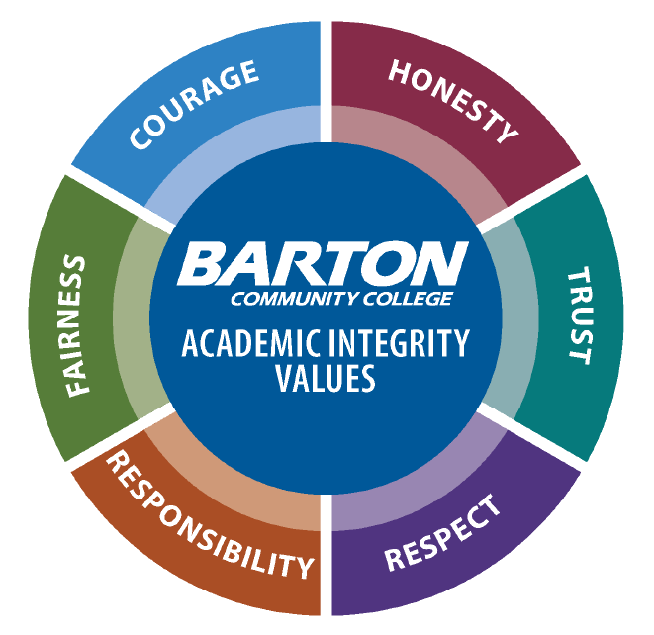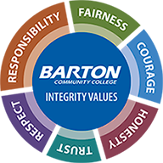  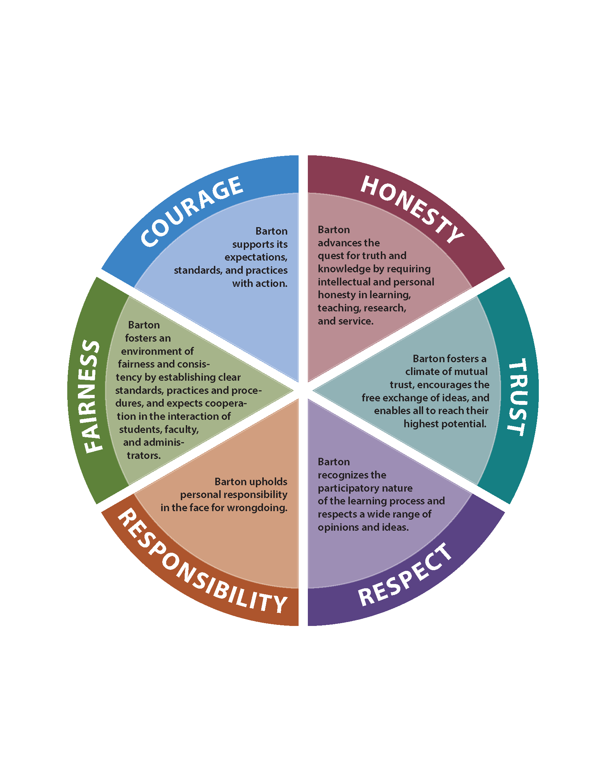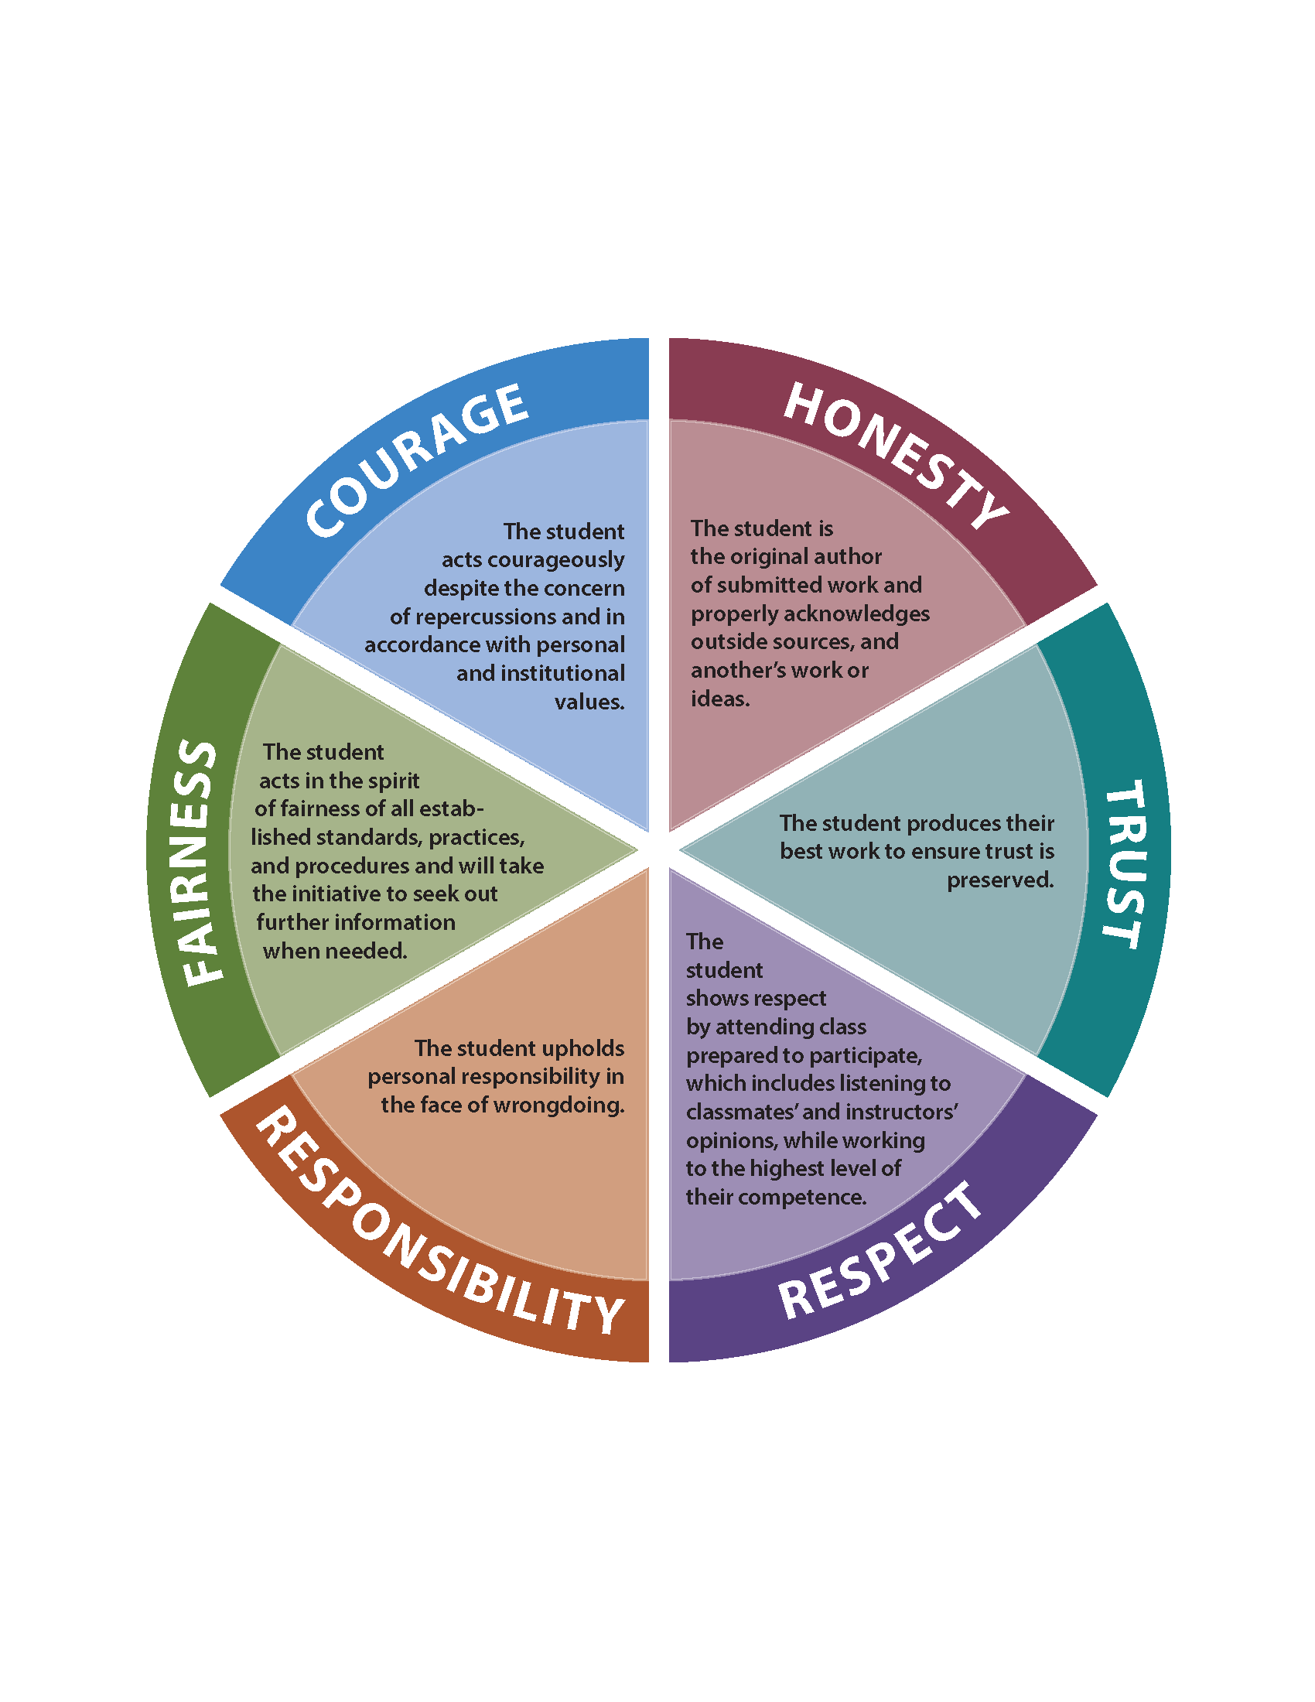  - New Design – Integrity Values  - College and student obligation wheels  - Identification of areas to change – signature block, SAD shell, Academic Development Center, program handbooks, CEP faculty shell, classroom posters, light pole banners on GB campus, banners at FR/FL/GVP, etc.  - College Announcement |  |  |  |  |  |  |  |  |  |  | Claudia/Deanna/All
Continued AI Awareness/PD Activities  - New Faculty Boot Camp  - The Center is reaching out to all new faculty during onboarding process to talk about course design, OER, compliance and AI procedure/process  - AI and Center Webpages – have resources available on the webpage (e.g. poster or swag requests)  - SAD Shell – open to all Barton students  - Course Binder Project – AI Overview & Resources – include AI procedure  - Swag  - Include integrity related quotes from recognizable people  - If we produce the items internally we could personalize the items for students  - Possible items: lanyards, click pens with highlighter, t-shirts, water bottles, notebooks, stickers of the AI wheel, pins of the AI wheel, magnets  - Student success packets – could we collaborate with Student Services, Academic Development Center (Stephanie)  - Include swag with a textbook purchase (both in-person and online)  - Send swag to anyone nominated for AI ambassadors  - Cougar Tales – at least once a year have an AI presentation  - Continued Integrity Campaign Plans  - Is there a nomination process for new AI ambassadors? New ambassadors will be selected every 2 years (Fall 2022)  - Orientation Day – include AI ambassadors at academic integrity presentations |  |  |  |  |  |  |  |  |  |  | All
Updated Academic Integrity Statement – Effective in Course Syllabi Spring 2022  Academic Integrity is scholarship based on honesty, trust, respect, responsibility, fairness, and courage. Barton Community College pledges to uphold these core values of integrity in all aspects of teaching and learning. Students are the authors of submitted work and shall give credit to outside sources and other’s work or ideas. In all aspects undertaken by students, faculty, staff, and all other stakeholders of Barton Community College, the following pledge applies: On my honor as a Cougar, I am acting with integrity in academics. I am acting per personal and institutional values and refraining from any form of academic dishonesty, and I will not tolerate the academic dishonesty of others. Acts of academic dishonesty, intended or unintended, are subject to Procedure 2502 Academic Integrity and may result in the grade of XF. Barton defines an XF grade as failure as a result of a violation of Academic Integrity.  - AI Council Approvals (Full Statement) – have all this done by January 1, 2022:  - Concourse – done  - Enrollment Form (Lori) – done  - Enrollment Self-Serve (Lori) – done  - Portal (Claudia/Samantha) – created a Barton Integrity card  - When you click on the card it will take you to the AI web page  - Include language on the card: Integrity is important at Barton. Begin your journey here.  - BOL Orientation (Claudia) – done  - Student Handbook (Angie) – done  - Student Orientation (Angie) – done  - Admissions App (Tana) – done |  |  |  |  |  |  |  |  |  |  | All
Review Data from AI Violation Reports  - Look for trends |  |  |  |  |  |  |  |  |  |  | Stephanie
AI Story/Feedback  - How specific should faculty be in their course syllabus in regards to AI  - Could the AI language or lack of AI language lead to assumption by the students  - Faculty should consider stating what they want the student to do versus the language of don’t do this  - There needs to be a balance between the students knowing the expectations and the instructor having the discretion to address the violation (don’t be so specific in your syllabus that it boxes you in)  - We need to consider how we, in the workforce, use resources and examples so we don’t have to reinvent the wheel |  |  |  |  |  |  |  |  |  |  | Elaine
Next Meeting: September 7, 2022

ENDS:

1. Fundamental Skills
2. Work Preparedness
3. Academic Advancement
4. Barton Experience
5. Regional Workforce Needs
6. Barton Services and Regional Locations
7. Strategic Planning
8. Contingency Planning

Barton Core Priorities/Strategic Goals

Drive Student Success
1. Advance student entry, reentry, retention, and completion strategies.
2. Foster excellence in teaching and learning.
Cultivate Community Engagement
3. Expand partnerships & public recognition of Barton Community College.
Optimize the Barton Experience
4. Promote a welcoming environment that recognizes and supports student and employee engagement, integrity,
inclusivity, value, and growth.
Emphasize Institutional Effectiveness
5. Develop, enhance, and align business processes.

