AGENDA/MINUTES
Team Name | Academic Integrity Council
Date | Monday, August 31, 2026
Time | 2:00-3:00 p.m.
Location | Zoom https://bartonccc-edu.zoom.us/my/riegelsbcc

Facilitator |  | Elaine Simmons |  |  |  |  | Recorder | Sarah Riegel
Team members |  |  |  |  |  |  |  |  |  | Present X  Absent O
x | Paulia Bailey |  | x | Nicole Frank | x | Kathy Kottas |  |  | x |  | Andrea Thompson
x | Janet Balk |  | x | Darren Ivey | o | Karly Little |  |  | x |  | Jenna Wornkey
x | Deanna Brown |  | o | Erika Jenkins-Moss | x | Angie Maddy
x | Angela Campbell |  | x | Stephanie Joiner | x | Lee Miller
x | Nolan Esfeld |  | x | Sam Kline-Martin | x | Megan Schiffelbein
Topics/Notes |  |  |  |  |  |  |  |  |  |  | Reporter
2026-2027 Council Goals  - Promote an institutional culture and reputation of respect, responsible conduct, and integrity  - Sponsor professional development activities to support faculty, staff, and students  - Identify course design, teaching practices, and assessment systems to support academic integrity  - Maintain and communicate a college-wide Artificial Intelligence standard  - Address policy/procedures considerations and develop and/or modify as applicable |  |  |  |  |  |  |  |  |  |  | All
Strategic Planning Update  Initiative 2.1: Define articial intelligence (AI) in the instructional setting, sponsor professional development for faculty, and identify methods for communicating AI use to students.  Champions: Claudia, Megan  Projects: Create AI co-horts for faculty and staff for training and at some point for students  - 10 participants have signed up for the AI sandbox cohort  - First cohort meeting is Wednesday |  |  |  |  |  |  |  |  |  |  | Lee
AI for All: Community Colleges Lead the Way Update  - Group will continue meeting semi-annually to serve as an advisory group and provide feedback on AI implementation  - There’s development of a college-wide AI procedure that will list approved AI software and include guidelines for their use. The procedure will be reviewed by HR and include information about PII and personal information protection, with an expected release for college feedback within the month. The Center for Learning Excellence will serve as a partner to help instructional designers understand the products. |  |  |  |  |  |  |  |  |  |  | Kathy
AI Fundamentals Course  - F2F – 4 students  - Online – 13 students |  |  |  |  |  |  |  |  |  |  | Stephanie
Midwest Alliance  - Hosted by Camilla Roberts – KSU; Meets Once a Month  - 8/28/26 - JCCC, WSUTech, Oklahoma State University, University of Oklahoma, Barton  - KSU – Not Grading Assignments Any More/Grading Occurs with Exams  - WSUTech & JCCC – Don’t Use College Academic Integrity Procedure with High School Students; Use High School Policies  - Majority of Group Isn’t Using Turnitin; Once is Considering Not Renewing Contract  - Talked About Copyright Issues; Disabled AI Feature; Use for Plagarism Only  - No Reliance on Percentages  - Using These Tools  - https://processfeedback.org/  - https://www.trinka.ai/  - https://inktrail.co/  - KSU November Symposium (Live & Remote)  - https://www.k-state.edu/ai-symposium/2026-symposium/  - WSU Assessment Tool: https://claude.ai/public/artifacts/5017836c-8a16-40c4-b9cf-5197f54d01c2  - Claudia’s Notes (May 2026)  - Claudia’s notes: https://docs.bartonccc.edu/iss/documents/ai%20council/AI%20Midwest%20Consortium%20Notes.msg  - https://docs.bartonccc.edu/iss/documents/ai%20council/QM%20Conference%20April.pdf |  |  |  |  |  |  |  |  |  |  | Elaine
Turnitin Clarity  - Elaine shared feedback from a recent meeting with other institutions about their use of Turnitin, noting that some schools view it only as a plagiarism tool and others have concerns about its effectiveness. The group discussed the importance of proper faculty training and implementation, with Paulia emphasizing that the tool's effectiveness depends on how it's used and Stephanie highlighting challenges in online courses. |  |  |  |  |  |  |  |  |  |  | All
Faculty Feedback on Academic Integrity  https://docs.bartonccc.edu/iss/documents/ai%20council/Faculty%20Feedback%20on%20Academic%20Integrity.docx |  |  |  |  |  |  |  |  |  |  | Elaine
Assessment Institute Graduates – Feedback on Assessment & AI  https://docs.bartonccc.edu/iss/documents/ai%20council/AI%20&%20Assessment%20Feedback.docx |  |  |  |  |  |  |  |  |  |  | Elaine
Cowley CC – Student AI Use Chart  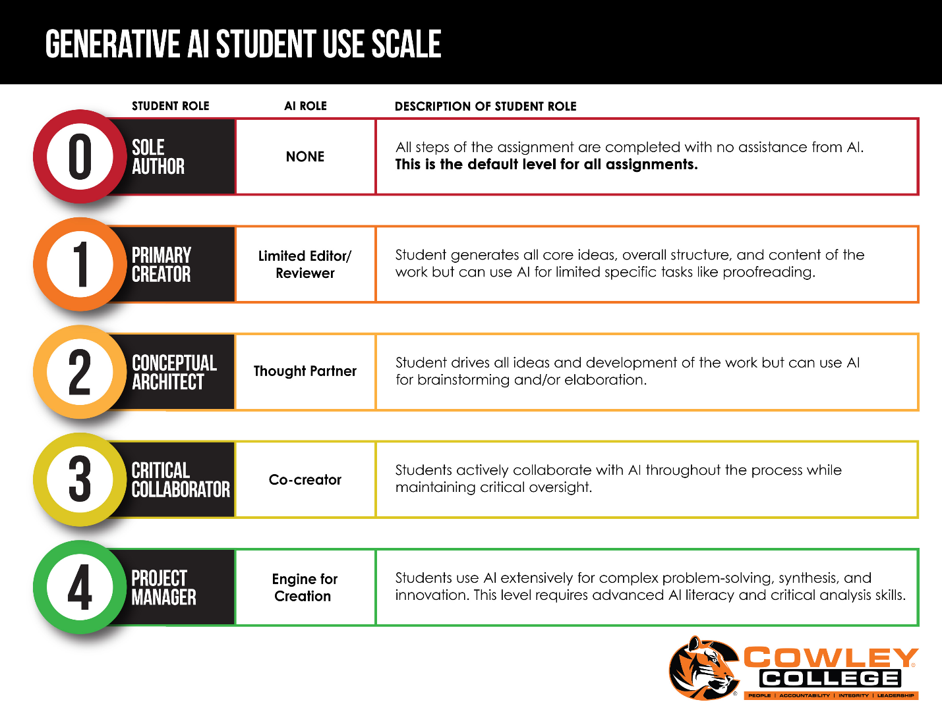 |  |  |  |  |  |  |  |  |  |  | Elaine
Orientations & Integrity  - BOL – academic integrity section included  - College (Online) – academic integrity section included  - Academic Development Center – academic integrity section included in the in-person orientation  - Janet and Claudia are working on a video to include in the Canvas course shells |  |  |  |  |  |  |  |  |  |  | Claudia, Angie, and Nolan
Academic Integrity Series  #1 – Teaching ethical use of AI as part of academic integrity training - May 28  This session will share value-based strategies for teaching ethical use of AI to all students as part of academic integrity training and provide opportunities for discussion to apply these strategies to ethical scenarios.  #2 – Re-designing assessment for ethical use of AI - June 11  This session will present an Assessment Re(Design Toolkit) to help reframe GenAI as a design challenge for learning and assessment. The session will encourage a shift away from detection to making student thinking and decision-making visible in assessment approaches that prioritize ethical GenAI use and learner agency.  #3 – Investigating misuse of AI - June 25  This session will examine approaches to investigating student misuse of AI by  academic conduct officers, and include advice about procedures, detection,  evidence, and outcomes.  #4 – Co-owning integrity work with students in the age of AI - July 9  This session will focus on the value of collaborating with students in work about ethical use of GenAI, so that academic integrity becomes a shared responsibility between students, faculty, and staff.  #5 – Going forward with integrity, staying human - July 23  This session will consider the current AI-based challenges in academic integrity  work and focus on the human durable skills to navigate these challenges. |  |  |  |  |  |  |  |  |  |  | Elaine
Integrity Website  - Barton Website – https://www.bartonccc.edu/integrity  - Artificial Intelligence Website – https://www.bartonccc.edu/AI (page is not live yet)  - Students and faculty  President’s Staff Feedback  - Website features an academic viewpoint – not a college-wide context  - Value definitions are only present in the Academic Integrity procedure; thus, we are missing the college-wide context |  |  |  |  |  |  |  |  |  |  | Nolan, Erika, Darren, and Deanna
Action Items
- All Council Members: Review the link for the K-State Symposium (November 10-12) and email Elaine by Thursday, September 3rd with interest in attending.
- All Council Members: Read the three embedded documents (faculty feedback, assessment institute feedback, student AI use chart) and be prepared to discuss at the September 22nd meeting.
- All Council Members: Review the council goals (25-26) and be prepared to discuss modifications at the September 22nd meeting.
- Subcommittee (Nolan, Erika, Darren, Deanna): Start over with the AI website and provide an update at the September 22nd meeting.

Next Meeting: September 22, 2026; December 1, 2026

