AGENDA/MINUTES
Team Name | Academic Integrity Council
Date | 9/22/2026
Time | 2:00-3:00 pm
Location | Zoom https://bartonccc-edu.zoom.us/my/riegelsbcc

Facilitator |  | Elaine Simmons |  |  |  |  | Recorder | Sarah Riegel
Team members |  |  |  |  |  |  |  |  |  | Present X  Absent O
x | Paulia Bailey |  | o | Nicole Frank | x | Kathy Kottas |  |  | x |  | Andrea Thompson
x | Janet Balk |  | x | Darren Ivey | x | Karly Little |  |  | x |  | Jenna Wornkey
x | Deanna Brown |  | x | Erika Jenkins-Moss | x | Angie Maddy
x | Angela Campbell |  | x | Stephanie Joiner | x | Lee Miller
x | Nolan Esfeld |  | x | Sam Kline-Martin | o | Megan Schiffelbein
Topics/Notes |  |  |  |  |  |  |  |  |  |  | Reporter
2026-2027 Council Goals  - Promote an institutional culture and reputation of respect, responsible conduct, and integrity  - Sponsor professional development activities to support faculty, staff, and students  - Identify course design, teaching practices, and assessment systems to support academic integrity  - Maintain and communicate a college-wide Artificial Intelligence standard  - Address policy/procedures considerations and develop and/or modify as applicable  - Add student integrity and AI literacy components to their professional development initiatives  - Include information about the long-term impact of AI decisions on students' critical thinking skills and future readiness |  |  |  |  |  |  |  |  |  |  | All
Strategic Planning Update  - Initiative 2.1: Define articial intelligence (AI) in the instructional setting, sponsor professional development for faculty, and identify methods for communicating AI use to students.  - Champions: Claudia, Megan  - Projects: Create AI co-horts for faculty and staff for training and at some point for students  - 10 participants have signed up for the AI sandbox cohort |  |  |  |  |  |  |  |  |  |  | Lee/Megan
AI for All: Community Colleges Lead the Way Update  - Meet again in a couple weeks—nothing new today |  |  |  |  |  |  |  |  |  |  | Kathy
Midwest Alliance  - Hosted by Camilla Roberts – KSU; Meets Once a Month  - 8/28/26 - JCCC, WSUTech, Oklahoma State University, University of Oklahoma, Barton  - KSU – Not Grading Assignments Any More/Grading Occurs with Exams  - WSUTech & JCCC – Don’t Use College Academic Integrity Procedure with High School Students; Use High School Policies  - Majority of Group Isn’t Using Turnitin; Once is Considering Not Renewing Contract  - Talked About Copyright Issues; Disabled AI Feature; Use for Plagarism Only  - No Reliance on Percentages  - Using These Tools  - https://processfeedback.org/  - https://www.trinka.ai/  - https://inktrail.co/  - KSU November Symposium (Live & Remote)  - https://www.k-state.edu/ai-symposium/2026-symposium/  - WSU Assessment Tool: https://claude.ai/public/artifacts/5017836c-8a16-40c4-b9cf-5197f54d01c2  - Claudia’s Notes (May 2026)  - Claudia’s notes: https://docs.bartonccc.edu/iss/documents/ai%20council/AI%20Midwest%20Consortium%20Notes.msg  - https://docs.bartonccc.edu/iss/documents/ai%20council/QM%20Conference%20April.pdf |  |  |  |  |  |  |  |  |  |  | Elaine
Turnitin Clarity  - Stephanie is gathering feedback—how Turnitin clarity interacts with rubrics  Turnitin – Threshold Percentages  - There’s concerns about the varying thresholds for handling potential plagiarism cases and sought feedback on whether more evidence beyond percentage scores should be required for violation reports |  |  |  |  |  |  |  |  |  |  | All
Faculty Feedback on Academic Integrity  https://docs.bartonccc.edu/iss/documents/ai%20council/Faculty%20Feedback%20on%20Academic%20Integrity.docx |  |  |  |  |  |  |  |  |  |  | Elaine
Assessment Institute Graduates – Feedback on Assessment & AI  https://docs.bartonccc.edu/iss/documents/ai%20council/AI%20&%20Assessment%20Feedback.docx |  |  |  |  |  |  |  |  |  |  | Elaine
Cowley CC – Student AI Use Chart  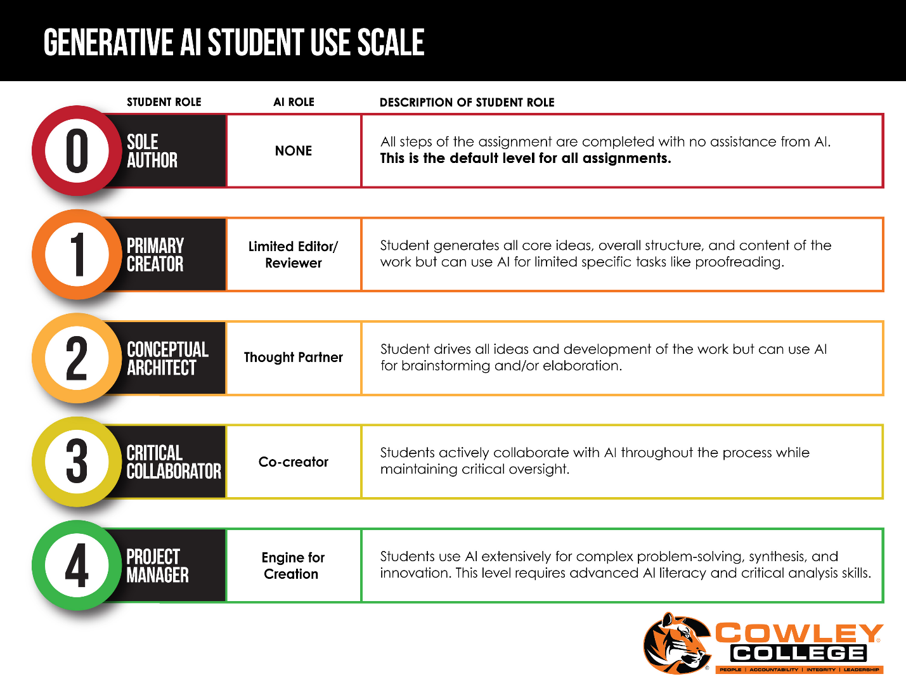  - Form a subcommittee to simplify the Cowley document and develop best practices for communicating with students about AI usage |  |  |  |  |  |  |  |  |  |  | Elaine
Courageous Conversations |  |  |  |  |  |  |  |  |  |  | All
Orientations & Integrity  - BOL – academic integrity section included; spring 2027  - College (Online) – academic integrity section included  - Academic Development Center – academic integrity section included in the in-person orientation  - Janet and Claudia are working on a video to include in the Canvas course shells |  |  |  |  |  |  |  |  |  |  | Megan, Angie, and Nolan
KSU Symposium
- Darren, Andrea and ??
- Early bird registration concludes September 30th.
- There is a remote option if travel and away time are not an option
- https://www.k-state.edu/ai-symposium/2026-symposium/registration/

Academic Integrity Series  #1 – Teaching ethical use of AI as part of academic integrity training - May 28  This session will share value-based strategies for teaching ethical use of AI to all students as part of academic integrity training and provide opportunities for discussion to apply these strategies to ethical scenarios.  #2 – Re-designing assessment for ethical use of AI - June 11  This session will present an Assessment Re(Design Toolkit) to help reframe GenAI as a design challenge for learning and assessment. The session will encourage a shift away from detection to making student thinking and decision-making visible in assessment approaches that prioritize ethical GenAI use and learner agency.  #3 – Investigating misuse of AI - June 25  This session will examine approaches to investigating student misuse of AI by  academic conduct officers, and include advice about procedures, detection,  evidence, and outcomes.  #4 – Co-owning integrity work with students in the age of AI - July 9  This session will focus on the value of collaborating with students in work about ethical use of GenAI, so that academic integrity becomes a shared responsibility between students, faculty, and staff.  #5 – Going forward with integrity, staying human - July 23  This session will consider the current AI-based challenges in academic integrity  work and focus on the human durable skills to navigate these challenges. |  |  |  |  |  |  |  |  |  |  | Elaine
Integrity Website  - Barton Website – https://www.bartonccc.edu/integrity  - Artificial Intelligence Website – https://www.bartonccc.edu/AI  - For students and faculty  - Let the group know if you have any feedback  President’s Staff Feedback  - Website features an academic viewpoint – not a college-wide context  - Value definitions are only present in the Academic Integrity procedure; thus, we are missing the college-wide context |  |  |  |  |  |  |  |  |  |  | Nolan, Erika, Darren, and Deanna
Action Items
- Elaine will send out a follow-up email to the group with two opportunities for subcommittee participation: (1) to review and simplify the Cowley AI use document, and (2) to draft best practices for Turnitin or communicating with students
  - Reach out to another group of faculty if there is not enough interest in the subcommittees
- Lee will attend the Midwest meeting on Friday at noon and pay attention to any comments about treating high school students differently
- Stephanie will attempt to get a count of faculty using Turnitin Clarity

Next Meeting: December 1, 2026

