AGENDA/MINUTES
Team Name | Programs, Topics & Processes (PTP)
Date | 9/17/2026
Time | 8:30-10:00 am
Location | Zoom https://bartonccc-edu.zoom.us/j/5354602075

Facilitator |  | Elaine Simmons |  |  |  |  | Recorder | Sarah Riegel
Team members |  |  |  |  |  |  |  |  | Present X  Absent O
x | Chris Baker |  | x | Mary Foley | x | Karly Little |  |  | o |  | Myrna Perkins
x | Janet Balk |  | x | Nicole Frank | x | Angie Maddy |  |  | x |  | Laura Pratt
x | Chris Case |  | x | Jared Hall | x | Claudia Mather |  |  | x |  | Laura Stutzman
x | Lori Crowther |  | x | Lindsay Holmes | x | Mollie McReynolds |  |  | o |  | Ben Tillman
o | Renee Demel |  | x | Erika Jenkins-Moss | x | Lee Miller |  |  | o |  | Jessica Vsetecka
x | Mary Doyle |  | x | Stephanie Joiner | x | Wendy Miller |  |  | x |  | Josh Winkler
x | Erin Eggers |  | x | Kathy Kottas | x | Joshua Nuss |  |  | x |  | Jenna Wornkey
x | Nolan Esfeld |  | x | Abby Kujath | x | Megan Phillips
Ex-Officio members
o | Nicole Berger |  | o | Dee Ann Smith | x | Amanda Staab
Topics/Notes |  |  |  |  |  |  |  |  |  | Reporter
Subject Codes/Org Changes – DONE  Subject Codes & Orgs  - Set up eight additional subject codes and orgs  - This impacts degree maps, Degree Works, Banner, KHEDS, Concourse, Instructional Reviews, FLAC this fall 2026 |  |  |  |  |  |  |  |  |  | Elaine
Fort Leonard Wood  - The MOA is signed. It is a three-year probationary Memorandum of Agreement; annual reviews will be conducted.  - Students will pay $170 for Barton Online and $153 for daytime and nighttime zoom courses  - Scheduling preference – OER certified courses  - No residential offerings  - A room is available for students to take zoom coursework on post or students may choose their own location to attend class  - FLW is not open on federal holidays, but open on training holidays  - Grand Canyon University will provide testing services  - This location was discussed with Myrna in November 2025 and again May 2026. We will not pursue location approval during the first year of course offerings. We will utilize this timeframe to gather data on whether the students are taking their coursework on post. We need to determine if students will be able to take more than 50% of their coursework on post.  - Launch – fall 2026 – CP, LSEC, and Barton Online – enrollment opens 9/21 – classes start 10/12 (CP) and 11/3 (LSEC)  - Need to add FLW to the admissions app  - Jared and Abby will work with Amanda on promotions  - Jared will meet with Chris to discuss the specific reports requested by FLW regarding enrollment and completion rates  - Jared will send out a list of programs that can be advertised at FLW per the MOA |  |  |  |  |  |  |  |  |  | Elaine/Jared/Abby
CEP Dual Credit Programming/Excel in CTE Update  - CEP Changes  - Faculty will be paid through their local district  - Faculty are limited to teaching 10 credit hours per semester  - Effective Fall 2026  - Communication Notices  - Process Changes  - CEP Program Impact Moving Forward  - Excel in CTE Changes  - Freshman & sophomore students not eligible for funding  - GPA (2.0 or higher)  - Junior/Senior status – on track for graduation  - Promise Act eligible courses for SB155 Benefits; if not, students can still take but are responsible for payment  - Fail one Excel in CTE course – student is responsible for retake payment  - Fail more than one Excel in CTE course – student no longer eligible for Excel in CTE; student can take coursework and pay  - Declaring Major  - Effective June 1, 2026; however, state funding impacts retro to 2025-2026  - Communication Notices – article on Great Bend Post  - Process Changes  - Excel in CTE Impact Moving Forward |  |  |  |  |  |  |  |  |  | Karly
eCampus Update  - Fall textbooks are live  - Spring Faculty Requests – 8/28/2026 request deadline; due back 10/19/2026 |  |  |  |  |  |  |  |  |  | Laura/Erin
Modern Campus  - Modules: Catalog, Curriculum, Scheduling, Registration (credit and non-credit), Nudges (texting) and Career (Lightcast)  - Wrap-Up with the Curriculum Module; 25-26 catalog done; build 26-27 catalog  - Curriculum module is next; the following is the team: Sarah Riegel (lead), Lori Crowther and Jessica Vsetecka (second leads), Angie Maddy, Stephanie Joiner, Kathy Kottas, Jared Hall, Brian Howe, Connie Wagner, Ronnie Dean, and Elaine Simmons – launch in October |  |  |  |  |  |  |  |  |  | Elaine/Angie
General Education – Website Discussion  https://www.bartonccc.edu/programs/generaleducation  - We will leave the “Prior to Fall 2024” section on the general education webpage for another year and revisit the decision in February 2027, before Fall 2027 enrollment. This will allow time to assess the impact on students who may be graduating in Spring 2026. |  |  |  |  |  |  |  |  |  | Elaine
Annual Degree Map Review
- August 3-September 30, 2026 – teams review degree maps and program web pages
- October 1, 2026 – degree maps due to Sarah
- October 1-30, 2026 – Sarah review degree maps
- November 2, 2026 – degree maps due to Lori
- November 2, 2026-January 29, 2027 – Lori updates Degree Works
- February 1-12, 2027 – Sarah will resave degree maps on the T: drive
- February 15-26, 2027 – Communications complete web updates; Sarah shares information with Mary Doyle and Megan Phillips
- March 1, 2027 – degree maps posted on the web
- April 6, 2027 – Fall 2027 enrollment begins

Micro-Credential – OSH – DONE  OSH Micro Credential Proposal  - Claudia has met with Dean Hall and Laura  - Working on major codes with Lori – done  - Promotion plans can begin – done |  |  |  |  |  |  |  |  |  | Jared/Laura/Claudia
Early Childhood Executive Summary (CA-1, CA-2, and CA-5)  Early Childhood Executive Summary  - KBOR paperwork sent 8/20/2026; updated in September  - Effective date – Fall 2027  - Campus location – Online  - CIP code (Sarah)  - Major code (Lori)  - Degree Map (Sarah)  - Banner/Degree Works (Lori)  - HLC/Dept of Ed (Myrna)  - Web pages/Areas of Study page (Communications/Mary)  - College catalog (Mary)  - Admissions application (Admissions)  - Change of Major form (Mary D.)  - Brochures/publications (Communications)  - Add to AI Portal for MyCCA, TA (Megan/Abby)  Program Changes:  - Amending current 24 credit hour certificate to a 28-credit hour Infant and Toddler Certificate (CA2)  - Myrna comments: Approval needed by HLC and ED. HLC approval should not take long, but ED will be a few weeks to months. We will need to try to request approvals all at once or the system will be locked until a future request can be opened.  - Adding a 28-credit hour Preschool Certificate (CA2)  - Myrna comments: Approval by HLC and ED. Since this is a new certificate, please allow a couple of months at HLC and then the same afterwards for ED approval.  - Adding an 18-credit hour Paraeducator Certificate (CA1)  - Myrna comments: Approval by HLC and ED. Since this is a new certificate, please allow a couple of months at HLC and then the same afterwards for ED approval.  - Adding an 8-credit hour Substitute SAPP  - Myrna comments: No approvals are needed by HLC or ED. This will need to be identified in Banner as ineligible for federal aid.  - Updating the 64-credit hour associate in applied science degree to include new courses (CA2)  - Myrna comments: HLC will need to be notified. No other approval action is anticipated presently.  - Updating the 60-credit hour associate in science  - Myrna comments: HLC will need to be notified. No other approval action is anticipated presently. |  |  |  |  |  |  |  |  |  | Mary
KBOR Program Reviews  - Scales Technician – forthcoming CA-2  - Ag – forthcoming CA-2  - Hazardous Materials – Student Employment Project  - Emergency Management – Student Employment Project |  |  |  |  |  |  |  |  |  | Elaine
Completers & Employment Subcommittees  - Completers workgroup: Kathy, Megan, Jared, Lori, Laura, Lindsay, Erika, Shanda, Joshua, Mary D.  - The group met and reviewed current system of collecting completer information, specific to SAPP and certificate programs.  - Need to establish consistent communication process.  - Elaine wants to meet with Lori, Jessica, and Angie to create a year schedule of reminders for reporting completers  - Employment Info workgroup: Jared, Kathy, Lindsay, Lee, Laura, Chris C., Erika, Mary D.  - The group has met once and is scheduled for additional discussions.  - Ideas presented at Cabinet  - Leaning towards instructor involvement; graduation survey; Perkins survey |  |  |  |  |  |  |  |  |  | Elaine
Program Brochures – Locations and Processes  - Several locations across campus: T building, science building, library, various department offices  - Jared will send Amanda pictures of the displays at FR, FL, GVP  - Communications will work with Kathy’s office (Dani) to ensure all areas have updated brochures  - Kathy stated they are adding a date to each brochure to help identify current versions  - Consider creating career guides for academic programs – Stephanie, Nicole, and Amanda will work on this  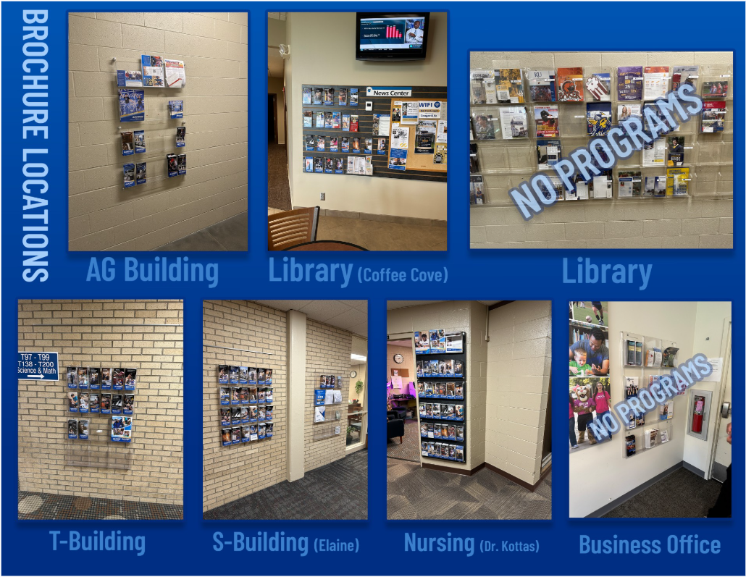 |  |  |  |  |  |  |  |  |  | Amanda
Business Management & Leadership AAS Update  - Added a few emphasis electives to accommodate prison students limited coursework options  - General accounting, payroll procedures, intro to computers, principles of macro and micro economics, word processing, general psychology  - Prevent asking for exceptions  - For fall 2027 |  |  |  |  |  |  |  |  |  | Mary
Syllabus Viewing in the Portal  - Student trying to view syllabus via concourse link in portal prior to course beginning  - Could we put the public link to all concourse syllabi so they could access syllabi prior to start of course  - Stephanie will work with Renee and bring back to the October meeting |  |  |  |  |  |  |  |  |  | Claudia/Stephanie
Student Success Metrics  - Data dictionary and metrics discussion |  |  |  |  |  |  |  |  |  | Stephanie/Angie
KBOR Performance Agreement Indicator 1 – Barton Degrees & Certificates Awarded  - Deadline to report completers to KBOR – May 31 (can be reported after 5/31 but students must finish by 5/31) |  |  |  |  |  |  |  |  |  | Chris
  Data  Reported  Date | 2024-2025 | Data  Reported  Date | 2025-2026 | Data  Reported  Date | 2025-2026  (Previous  Year) | 2026-2027
  1/10/2024 | 403 | 1/9/2025 | 372 | 1/2026 | 503 | 491
  2/7/2024 | 484 | 2/10/2025 | 402 | 2/10/2026 | 517 | 492
  3/12/2024 | 549 | 4/9/2025 | 472 | 3/9/2026 | 543 | 496
  4/10/2024 | 575 | 5/13/2025 | 505 | 4/8/2026 | 602 | 545
  5/20/2024 | 739 | 6/10/2025 | 896 | 5/21/2026 | 1046 | 840
  6/11/2024 | 10 | 7/8/2025 | 18 | 6/10/2026 | 1032 | 1067
  7/10/2024 | 19 | 8/5/2025 | 62 | 7/8/2026 | 40 | 10
  8/14/2024 | 91 | 9/9/2025 | 127 | 8/5/2026 | 102 | 54
  9/11/2024 | 131 | 10/7/2025 | 158 | 9/17/2026 | 170 | 154
  10/9/2024 | 148 | 11/11/2025 | 197
  11/13/2024 | 197 | 12/9/2025 | 206
  12/4/2024 | 197
Bulletin of Classes Swim Lane Deadlines (T:\Bulletin\Bulletin Online Dates)  - Scheduling swim lanes now have spring 27-summer 27-fall 27 |  |  |  |  |  |  |  |  |  | Lori
LICC Update  - NAID 1987: course title and subject code changes (spring 2027) |  |  |  |  |  |  |  |  |  | Sarah
Web Site Update – n/a |  |  |  |  |  |  |  |  |  | Amanda/Ben
Barton Online Update – n/a |  |  |  |  |  |  |  |  |  | Erin
Center for Learning Excellence Update  - Received positive feedback on AI cohort sessions  - Claudia announced a change to the Instructional Excellence Academy, which will now be open to all faculty as the Instructional Excellence Series starting in October |  |  |  |  |  |  |  |  |  | Claudia
Academic Development Center Update – n/a |  |  |  |  |  |  |  |  |  | Nolan
Institutional Effectiveness Update  - Worked on KBOR and IPEDS data collections |  |  |  |  |  |  |  |  |  | Chris
HLC/Department of Education Update – n/a  https://docs.bartonccc.edu/finaid/SCI%20Documents/SCI_POS.pdf  https://www.bartonccc.edu/financialaid/studentconsumerinfo |  |  |  |  |  |  |  |  |  | Myrna
Student Services Update  - 25% of switchboard calls are not forwarded—meaning advising is able to answer questions and not pass callers off to other departments |  |  |  |  |  |  |  |  |  | Angie
IT Update – n/a |  |  |  |  |  |  |  |  |  | Renee
Instruction Update  - Wheels and Squeals this Saturday  - 4-H Pathfinders camp on 10/3  - HOSA Western Regional Conference on 11/9  - ESSDACK the end of Oct  - Faculty recital today  - Autumn arts concert  - Co-requisite symposium on 10/23 – 56 registered from 16 institutions  - JKSD on 11/6  - Military Friendly survey – send Jared feedback; goal is to complete it before Thanksgiving |  |  |  |  |  |  |  |  |  | Deans/Elaine
Next Meeting: October 14, 2026

