Canvas Messaging After Course End Date

The Canvas messaging is tied to the course dates. Once the course ends, students are no longer able to communicate through the course due to this setting. This is not a setting we can change; however, there is a way to communicate afterwards.
There is only one option for you to receive and compose a message to students without tying it to a course. Be aware this will require you to communicate with your students about how to communicate after a course has ended.

A week or two prior to the end of your course, compose an email from your Barton email with your class letting them know if they need to contact you after the course closes, they can respond to “this message”.
- Go to “Course Analytics” from the home page within the course you want to message

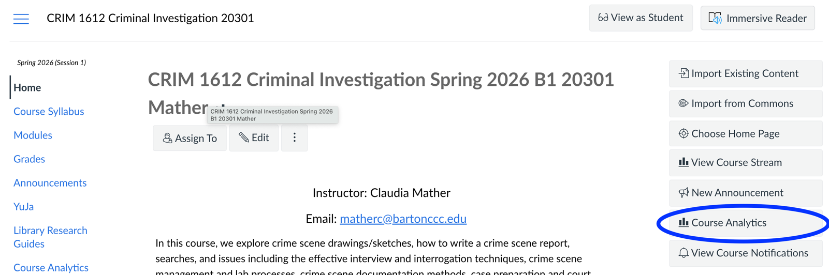

- Click on Students

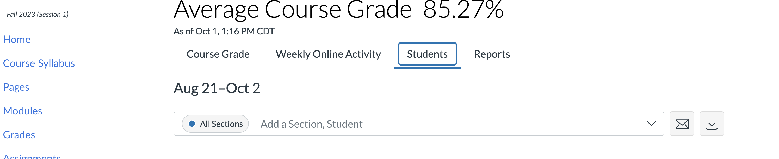

- Copy and paste each student’s email address in the composed message.
  - This is time intensive since you have to copy and paste each student’s email address into the message, but nonetheless, it will allow communication after the course ends.

