Gainful Employment (GE)
(What You Need to Know!)

- What is GE?

Basically, GE is a set of federal regulations ensuring that students do not become overly encumbered with student loan debt for education or training that does not result in lucrative employment for the student.

- Preventing Student Debt
- More Rigorous Accountability
- Greater Transparency
- Improving Outcomes

For more information:

http://www.ed.gov/news/press-releases/obama-administration-announces-final-rules-protect-students-poor-performing-career-college-programs

http://www.protectstudentsandtaxpayers.org/wp-content/uploads/2015/06/GainfulEmploymentQA_June-30-2015-_5-pages.pdf

- Who does GE affect?

For more information:
http://www.usnews.com/education/blogs/student-loan-ranger/2015/07/08/what-the-new-gainful-employment-rule-means-for-college-students
- What is a GE program?

Presently, any non-degree program falls under GE.

- What information needs to be provided to ED when requesting approval for a new GE program?

- GE Notice of Intent -- http://docs.bartonccc.edu/finaid/Wiki%20Documents/GENoticeOfIntent.docx
- Example of GE Notice of Intent –
http://docs.bartonccc.edu/research/internaldata/Forms/GE%20Notice%20of%20Intent%20Example.docx

- GE Disclosure Template -- http://ope.ed.gov/GainfulEmployment/

- What are institutional responsibilities regarding GE?

Institutional responsibilities broadly fall into one of two categories:

- Reporting—

Annually, by October 1st, institutions must report information for each student enrolled in a GE program. Each spring, institutions must also work through submitted data to let ED know of any updates or to that all data captured is correct.

For more information: http://www.ifap.ed.gov/GainfulEmploymentInfo/GEFAQV2.html#Reporting

- Disclosures—
Institutions must provide Student Consumer Information via prescribed disclosures, updating information annually by January 1st.

WTCE, IR, and PR work together to publish prescribed data on Barton website program pages--
http://bartonccc.edu/gainfulemployment

For more information: http://www.ifap.ed.gov/GainfulEmploymentInfo/GEFAQV2.html#Disclosure

- What happens after data is submitted to ED?
From data provided to ED, Debt-to-Earnings ratios for students in the GE programs are calculated. Programs must meet pre-determined thresholds or risk losing their eligibility for Title IV funding.
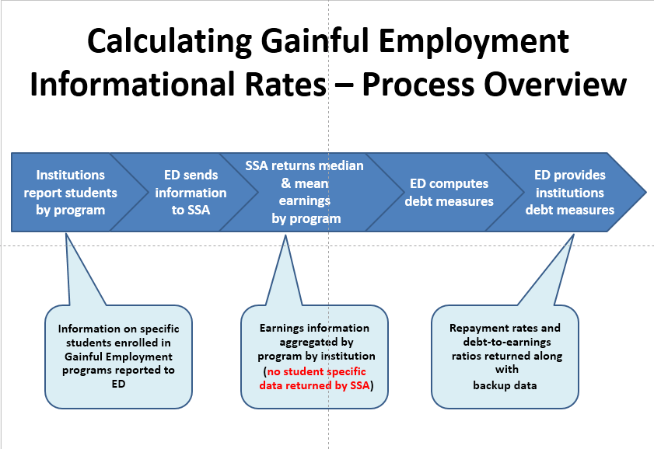

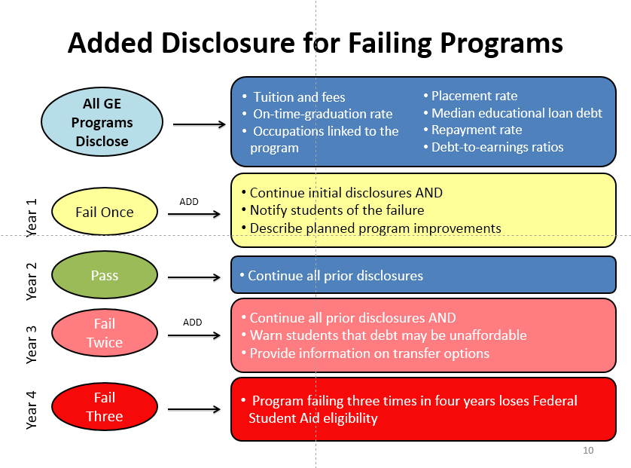

For more information:
https://www.acenet.edu/news-room/Documents/Gainful-Employment-2014-Proposed-Rule-Summary.pdf

