ASSESSMENT PROCESSES HANDBOOK

BARTON COMMUNITY COLLEGE

WHY WE ASSESS:

Guiding Principles

Assessment at Barton is not about uniform methods or rigid procedures. It is about a shared purpose. Faculty and staff work together to ensure students learn what they came here to learn. This unity of purpose shapes Barton’s culture of assessment and supports decisions that advance student learning.
Assessment strengthens the quality of Barton’s programs and services. It is comprehensive and grounded in the values expressed in the Mission. Assessment uses multiple methods, operates continuously, and provides information that confirms student learning across the College. It is part of Barton’s culture and supported through training and institutional processes.

Continuous Improvement

Faculty and staff are continuously working to improve. They want to understand how students learn and how instruction can be strengthened. What faculty learn about their students affects how future students experience the course. This cycle of improvement is supported by the Outcomes Assessment Committee (OAC).
Documentation, often completed through thoughtful reflection, helps faculty and staff analyze their evidence of learning, understand patterns, and identify adjustments that will support students. This practice is embedded in Barton’s culture, including the journal work completed during the Assessment Institute.

Mission

Barton offers exceptional and affordable learning opportunities supporting student, community, and employee needs.

Assessment ensures these learning opportunities are effective, meaningful, and aligned with Barton’s purpose. Because student learning occurs throughout the College, assessment confirms that Barton is meeting its responsibilities and providing the learning environment students deserve.

A Note on Accreditation

Assessment at its core is about improving student learning. Barton engages in assessment because it is the right thing to do for students. It is not a compliance exercise. Accreditation follows naturally from this commitment to learning. The Higher Learning Commission (HLC) values assessment and expects evidence that student learning is continuously improved. Barton’s assessment processes meet these expectations because they originate from Barton’s Mission and culture.

Barton is not committed to assessment simply because of an accreditation mandate, accreditation follows naturally due to Barton’s commitment to improving student learning.

STUDENT LEARNING OUTCOMES

Assessment at Barton focuses on student learning outcomes, the statements that describe what a student will know or be able to do when they complete a learning experience. Barton uses student learning outcomes as a generic term that refers to outcomes at every level of the College.
Student learning outcomes are expressed differently at each level of assessment. The Institutional level uses Fundamental Learning Outcomes. The General Education level uses General Education Learning Outcomes. The Program level uses Program Learning Outcomes. The Course level uses Course Outcomes, which include the Competencies listed in the syllabus. The Classroom level uses individual lesson Learning Objectives. Each level contributes evidence that supports improvement across the College and aligns with Barton’s Mission.
Student Learning Outcomes (SLOs) is the generic term used to stand for all Learning Outcomes independent of level.

Benchmark Definition

Student learning outcomes are compared to a benchmark; the minimum level of performance that indicates the outcome has been met. The specific benchmark is determined by the respective faculty, staff, or area. Barton traditionally uses a standard benchmark of 70% with an aspirational benchmark of 80%. These benchmarks align with the levels of performance used for institutional reporting. Benchmarks help faculty and staff interpret the evidence and decide whether improvements are needed. Documentation explains how benchmark data informed decisions that support student learning.

LEVELS OF ASSESSMENT

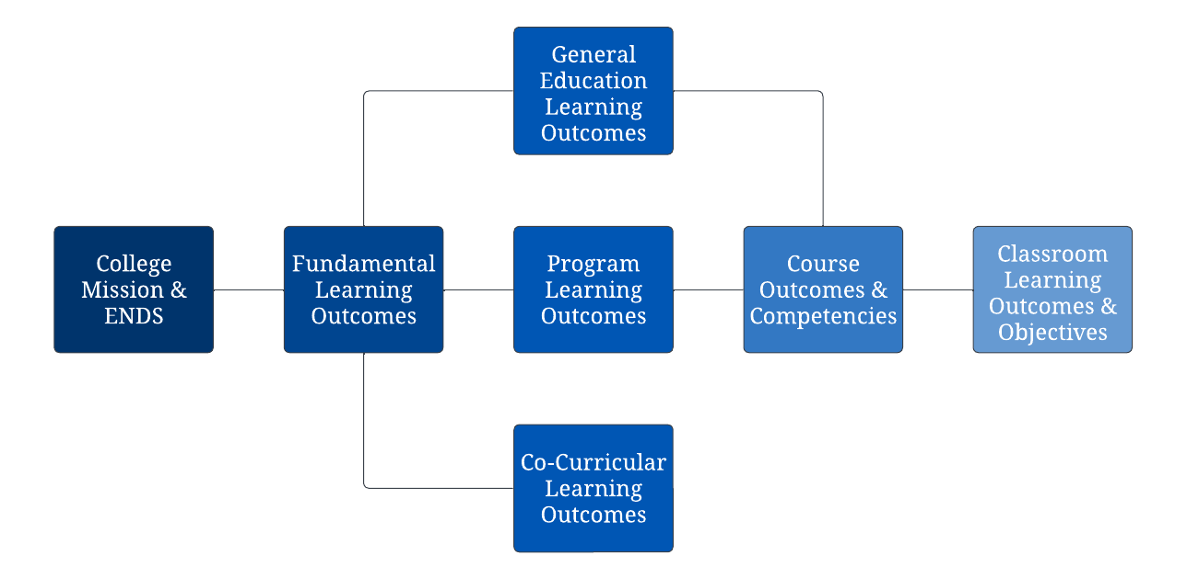
The levels of assessment begin with the Mission and follow a structure that connects each level of learning across the College. This structure ensures that Barton can understand student learning from an institutional perspective through the classroom experience.

Assessment Process Map

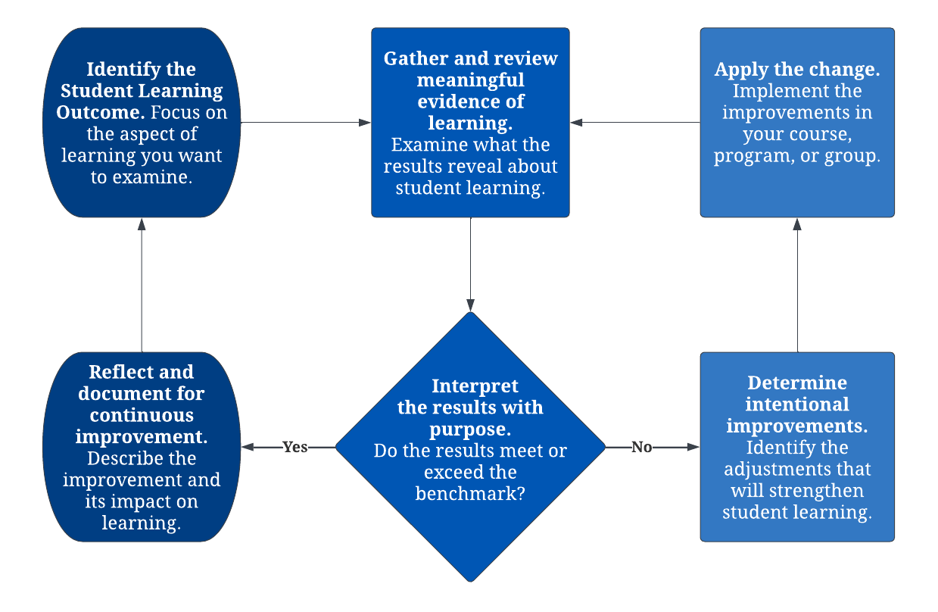
The diagram below provides a high-level view of how Barton assesses student learning outcomes at all levels of assessment. It illustrates the progression from identifying an outcome to interpreting results and determining whether improvements are needed. This map establishes the shared structure that guides assessment work across the College.

Institutional Assessment

Barton’s Board of Trustees has defined a series of END Statements (Board‑defined expectations) that express, in measurable terms, the value Barton intends to create for students and communities. Institutional assessment focuses on the Fundamental Learning Outcomes (FLOs), which support Barton’s Mission through the END for Fundamental Skills. Evidence is drawn from existing assessments at the General Education, Program, and Co-Curricular levels to understand how students demonstrate the FLOs without creating separate tools. This approach provides a collective institutional view of learning and informs continuous improvement.
Barton’s five Fundamental Learning Outcomes are:
- Critical Thinking.
- Life‑Long Learning.
- Historical Perspective.
- Technological Perspective.
- Cultural Perspective.

Use, Apply, and Document the Assessment

Evidence aligned with the Fundamental Learning Outcomes is collected and compiled for review. The Outcomes Assessment Committee examines this evidence to identify strengths, areas for improvement, and opportunities for professional development. Through this process, the Committee determines next steps that support instructional quality and continuous improvement.

Close the Loop

The Coordinator of Assessment provides an annual report on the Fundamental Learning Outcomes to the Board of Trustees in relation to the ENDs. The Board reviews the results, asks questions to deepen understanding, and affirms the College’s progress toward student learning expectations. Highlights from this review are shared publicly in the Community Report as part of an Assessment Spotlight, which ensures transparency and keeps the community informed about student learning at Barton. This review guides the Outcomes Assessment Committee as it plans next steps for continued improvement in alignment with the Mission.
Assessment results are communicated transparently through annual reports and public postings to support the broader community’s understanding of student learning at Barton.

General Education Assessment

General Education Assessment focuses on the General Education Learning Outcomes (GELOs), which describe the knowledge, skills, or abilities students should demonstrate upon completion of the general education curriculum. The General Education Learning Outcomes serve as the program level outcomes for general education and align upward to the Fundamental Learning Outcomes, ensuring that broad academic preparation supports institutional expectations.
Because general education is treated as its own program at Barton, assessment of the GELOs occurs within general education courses and is coordinated through the Program Assessment Committee.
The General Education Learning Outcomes are:
- Communication Skills.
- Quantitative Reasoning.
- Scientific Reasoning.
- Personal and Social Responsibility.
- Aesthetic Awareness.
- Cultural and Historical Understanding.
- Critical Thinking and Problem Solving.
- Technological Literacy.

Use, Apply, and Document the Assessment

Faculty use established tools to collect and compile evidence related to the General Education Learning Outcomes. Evidence is aggregated across courses so that patterns, strengths, and areas for improvement can be identified. These results support instructional decisions and strengthen the general education curriculum.

Close the Loop

The Program Assessment Committee reviews the aggregated General Education Learning Outcomes data to determine next steps and to identify areas that may benefit from additional support or professional development. The Coordinator of Assessment provides updates to internal leadership groups on general education assessment results. This review promotes continuous improvement and supports alignment with Barton’s Mission and Fundamental Learning Outcomes.

Co-Curricular Assessment

Co‑curricular Assessment examines learning that occurs through student organizations or clubs designed to support curricular or institutional outcomes. These experiences complement the curriculum and strengthen learning beyond the classroom.
Co‑Curricular groups are defined as follows:
Barton Community College’s Co‑Curricular groups are student organizations or clubs designed to support curricular outcomes and objectives. These are separate from extracurricular activities (activities solely for social engagement or entertainment and without curricular connection), performance groups (activities developed through credit‑bearing courses and assessed through course and program assessment), and Student Services activities (such as advisement, tutoring center, or career services, which are assessed through various institutional reviews).
Co‑curricular experiences involve sustained engagement over time rather than one‑time events, and they are intentionally designed to support student learning rather than solely promote participation or engagement.
Co‑curricular learning outcomes align directly to the Fundamental Learning Outcomes, which make co‑curricular contributions visible within Barton’s broader understanding of learning. The Co‑Curricular Assessment Committee oversees this work and operates within the Outcomes Assessment Committee for institutional alignment while maintaining appropriate autonomy.

Use, Apply, and Document the Assessment

Group Sponsors identify the outcomes for their group and determine how they will gather evidence of student learning. Evidence may be drawn from experiential tasks, presentations, performances, projects, reflections, or other meaningful activities. The Co-Curricular Assessment Process Handbook provides guidance for planning and documentation.
Co‑curricular participation varies from year to year, and some groups may experience limited or no student involvement. When this occurs, sponsors are encouraged to share that information accurately, so the College maintains a clear understanding of student engagement across all learning environments. The purpose of co‑curricular assessment is to support Barton’s mission by recognizing the meaningful learning opportunities sponsors create, regardless of the level of participation. This process highlights the important role co‑curricular experiences play in student development and affirms the value of the time and care sponsors invest in their areas.

Close the Loop

Each co-curricular group documents its results and any adjustments made to improve learning. The Co-Curricular Assessment Committee compiles submitted reports and prepares an annual summary that illustrates co-curricular learning across the College. This summary contributes to Barton’s understanding of learning in multiple contexts and supports continuous improvement across the institution.

Program Assessment

Program Assessment examines how well students achieve the skills and abilities defined by the Program Learning Outcomes. It provides a holistic view of learning across a curriculum rather than within a single course. This evidence helps faculty understand how program design, sequencing, and instructional practices support student learning.
Program Assessment is faculty‑driven. Programs own their Program Learning Outcomes, the courses aligned to those outcomes, and the competencies within those courses. Evidence summarized for Program Assessment is provided to assist interpretation, not to prescribe specific actions. Faculty use these summaries during Instructional Review, Barton’s biennial program review process, to determine the significance of observed patterns and to decide how best to strengthen learning within their curriculum.
Program Assessment connects the learning demonstrated in individual courses to the broader expectations of the program. Aggregated evidence helps faculty understand how course‑level competencies contribute to the Program Learning Outcomes and supports conversations about strengths, opportunities for improvement, and the effectiveness of the curriculum. This work reinforces the quality and integrity of Barton’s programs and informs strategic planning, instructional quality, and continuous improvement across the College.

Program Learning Outcomes

Program Learning Outcomes identify the core abilities students should possess upon completion of a program. Faculty determine, document, and periodically review the Program Learning Outcomes. Faculty may revise outcomes, aligned courses, or course‑level competencies when program goals or syllabi change, because programs own their curriculum and the alignment to the Program Learning Outcomes.
Programs map the Program Learning Outcomes to course‑level competencies so evidence from designated courses can be aggregated at the program level. This mapping supports meaningful evidence that is drawn across courses, locations, and modalities.
One illustration of this connection can be seen in the Fine Arts Program. A Program Learning Outcome may require students to create a body of work. Courses such as Graphic Design and Painting I support this outcome through competencies that contribute to a student’s ability to meet the stated expectation. When faculty see how course‑level competencies aggregate into a program‑level outcome, they often describe it as the moment when the broader structure of assessment becomes clear. This example shows how classroom decisions support learning across the curriculum and how individual work connects to the shared goals of the program. It reflects the shift from me to we and reinforces Barton’s commitment to ensuring student learning at every level.
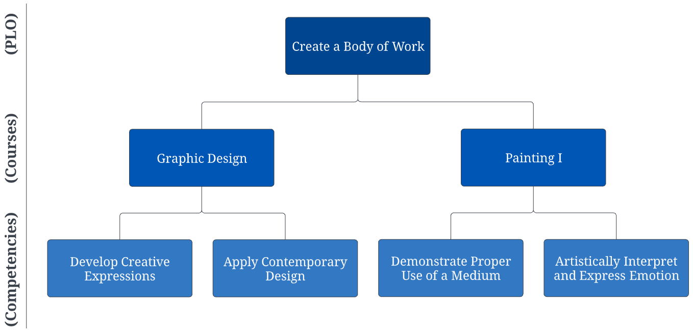

Use, Apply, and Document the Assessment

Program assessment evidence is collected each term through faculty‑submitted spreadsheets that document mapped course competencies. Evidence is aggregated across courses, locations, and modalities to provide a program‑level view of learning that is used during Instructional Review.
Analyses summarize meaningful patterns. These may include trends over time and comparisons to Barton’s benchmarks. However, these benchmarks are used to support discussion, not to prescribe specific actions.
Program Assessment summaries highlight areas of interest and statistical patterns to help content experts interpret their evidence and decide next steps appropriate to the context of the program. Faculty remain responsible for determining significance and for selecting actions that will strengthen student learning.
Two report types support this work. Individual Program Assessment Reports are provided to programs to inform Instructional Review and local decision making. In addition, Barton prepares a collegewide Program Assessment Report that aggregates program results and documents longitudinal trends across the institution.
Committees operate within the Outcomes Assessment Committee for institutional alignment while maintaining appropriate autonomy. Faculty work with the Program Assessment Committee as needed for support with mapping, tools, and report interpretation.

Close the Loop

Program Assessment results feed directly into the biennial Instructional Review cycle. Faculty review trends, identify strengths and growth opportunities, and document measurable goals. Faculty also identify curriculum, sequencing, or instructional adjustments and any related budget requests needed to support student learning.
Instructional Review aligns Program Assessment with Barton’s planning processes. Reviews follow a defined sequence of data collection, collaborative analysis, goal setting, submission, and follow‑up reporting, and they are timed to inform budgeting and strategic planning. This cycle provides institutional assurance that program‑level decisions are informed by evidence and that progress is monitored over time.

Course Assessment

Course Assessment focuses on summative, macro level evidence at the end of a course. It differs from Classroom Assessment, which examines formative, real‑time learning during instruction. Summative evidence shows how well students achieved the course outcomes and competencies after completing the full set of learning opportunities. These outcomes align upward to Program Learning Outcomes for program courses and to General Education Learning Outcomes for general education courses. Together, this evidence contributes to Barton’s understanding of learning across the curriculum.
Course Assessment is designed to help faculty strengthen their own course by identifying patterns in summative evidence and adjusting teaching, sequencing, or supports for the next offering of the course. It is not a comparison of instructors. It is a reflection tool that keeps learning at the center across all modalities and locations.
Faculty assess all competencies in the syllabus throughout the course. This remains a foundational instructional responsibility. Course Assessment does not replace that broader evaluation. It simply documents one piece of the picture.
To support continuous improvement in a manageable way, faculty complete a spot check by documenting one course competency each term.
This documentation:
- Helps faculty pause and reflect on a specific part of the course.
- Keeps improvement goals visible from term to term.
- Supports memory across long teaching cycles, especially when a course is offered only occasionally.
- Provides a consistent snapshot of instructional improvement without creating unnecessary burden.

Choose a Student Learning Outcome to Assess

The student learning outcomes can be found in the course syllabus, specifically the course competencies. For the spot check, faculty select one competency to document for the term. This documented competency provides a snapshot of macro learning without requiring identical artifacts across instructors.

Choose an Assessment Technique

Summative Course Assessment uses end-of-course evidence such as:
- A final exam or project.
- A cumulative performance, recital, or production.
- A major written or oral presentation.
- A portfolio artifact or final body of work.
These techniques are used at the end of the course after students have had sufficient learning opportunities related to the competency. Summative evidence is most useful when it clearly aligns with the competency being documented.
Although faculty select the summative assessment technique that best reflects the design of their course, collaboration with colleagues is strongly encouraged. Using shared assessments, or discussing common approaches to summative work, can help faculty interpret results more effectively and recognize the value of learning from one another. Collaborative conversations also support alignment across locations and modalities while preserving the autonomy and creativity of individual instructors

Use, Apply, and Document the Assessment

Faculty document:
- The competency selected for the term.
- A brief description of the summative assessment used.
- Quantitative evidence showing how students performed on that competency.
- A short reflection on what the evidence suggests.
- The specific change they plan to make before teaching the course again.
This documentation is concise and focused on improvement. Individual assessment reflections are gathered to illustrate how faculty use assessment to strengthen teaching and improve student learning. These narratives highlight shifts in thinking about assessment and the ways faculty work to enhance learning through their instructional decisions. Selected reflections are compiled into a report shared with faculty to illustrate effective assessment practices and support continued growth across the College.

Close the Loop

Faculty review the improvements made to their courses and collaborate with peer faculty to share strategies and learn from one another. Working together, faculty can strengthen the quality of the course across locations and modalities. The submitted course assessments are compiled annually by the Course Assessment Committee and posted on the College assessment website as evidence of course assessment at Barton.

Classroom Assessment

Classroom Assessment Techniques (CATs) measure student learning as it happens during the course. Classroom Assessment focuses on micro level, formative evidence gathered during individual lessons or activities. It differs from Course Assessment, which examines summative evidence at the end of a course. Formative evidence shows how students are learning in the moment and supports real time instructional adjustments designed to help the same group of students who provided the evidence. Classroom Assessment helps faculty think from one lesson to the next rather than only from one course offering to the next.
Faculty use Classroom Assessment to understand how students are progressing toward the lesson level objectives that support the course competencies. Classroom Assessment does not replace Course Assessment. Instead, it provides ongoing insight that strengthens instruction and supports student learning throughout the course. Documentation is not required.
Classroom Assessment Techniques are considered an Assumed Practice at Barton.
Classroom Assessment Techniques are considered an Assumed Practice at Barton. Participation rates have exceeded ninety percent since 2019, reflecting a significant cultural shift from earlier years. Although documentation is no longer required, faculty are expected to use Classroom Assessment Techniques consistently as part of high‑quality instruction. These techniques support real time adjustments that strengthen learning and are embedded in Barton’s culture of continuous improvement.

Choose a Student Learning Outcome to Assess

Faculty decide the learning goal for a given lesson or activity. This includes identifying the purpose of the lesson and what students should learn, as this information guides how material is presented. Individual lesson learning objectives support the course competencies and help shape how formative evidence will be interpreted.

Choose an Assessment Technique

Faculty select a technique suited to the learning goal. Classroom Assessment Techniques may include quick checks, brief written responses, performance tasks, or other strategies. Resources in the Learning Resource Center also provide examples from recognized authors in classroom assessment.

Use and Apply the Assessment

Information gathered from Classroom Assessment Techniques is used to make immediate instructional adjustments designed to improve student learning. These adjustments are made as soon as possible so students receive timely support.

Close the Loop

Faculty review their Classroom Assessment results from the lens of their course. Discussing these results with colleagues is an effective way to learn from one another and collaborate on potential issues. Faculty then apply the insights gained to future lessons and future course offerings. Classroom Assessment remains a consistent practice that supports high‑quality instruction across all contexts.

ASSESSMENT COMMITTEE STRUCTURE

Oversight of the various levels of assessment is provided by faculty‑led committees consistent with Barton’s assessment framework. The committees organize assessment work across the College and ensure that evidence from each level contributes to continuous improvement. Committees operate within the Outcomes Assessment Committee for institutional alignment while maintaining appropriate autonomy.
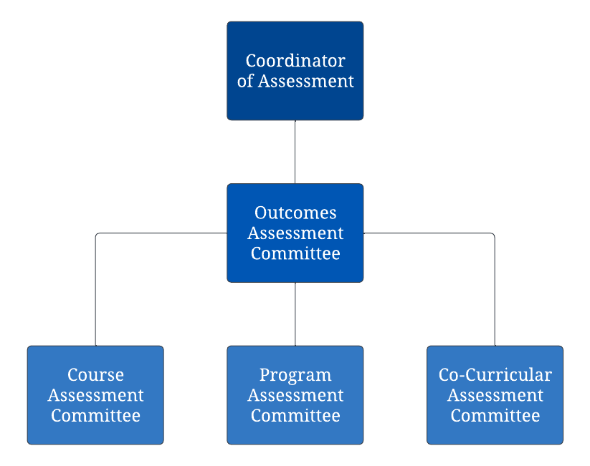
The Outcomes Assessment Committee provides coordination and alignment across Program Assessment, Course Assessment, and Co‑Curricular Assessment. These committees guide assessment processes at their respective levels, review submitted materials, and support faculty and staff in using assessment evidence to strengthen learning.

