[DATE]
Dear [EMPLOYEE NAME]
Welcome to Barton Community College. I am glad you are here!
My name is Jo Harrington. I serve as Barton’s Coordinator of Assessment in addition to teaching mathematics. I have spent many years helping students make sense of mathematics, and over time that experience grew into supporting faculty as they navigate assessment. My goal is to give you a clear and encouraging starting point as you settle in and to introduce the way we approach the assessment of student learning at Barton.
Assessment at Barton is a practical way to understand what students are learning and to use that insight to strengthen our teaching over time. It is grounded in the idea that purpose should guide the process, so the work helps you and your students without adding stress.
To assist you in your first year, you will find our printed Assessment of Student Learning brochure included with this letter. The brochure provides an overview of the layers we use, classroom, course, program, co-curricular, and institutional. It also highlights the resources available to you. Keep it somewhere accessible so you can refer to it whenever you want a reminder of the overall structure or need to locate a specific support area.
If you have questions or need help, email is the easiest way to reach me.
Welcome again to Barton. I look forward to working with you and am glad you joined our instructional team.
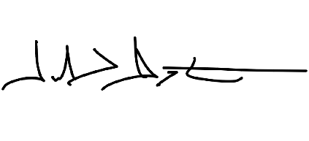
Sincerely,

Jo Harrington
Coordinator of Assessment
Mathematics Instructor
Barton Community College
harringtonj@bartonccc.edu

