**GoTo Meeting Class Connection Instructions**

**For the (class name) Class (day/s of week)**

**October 21, 2014 – November 13, 2014**

**Instructor – Instructor Name**

**ID CODE – 123-456-789**

1. **Turn on computer, power button is located on right side of computer monitor.**
2. **If another user has used machine, click on the “Switch User” button.**
3. **Log in as instructor:**
   1. **In Top Line type: machine name of room\instructor then press the “Enter” key. (there is not a password for instructor account)**
4. **In the lower right hand corner of the desktop screen, there is a block arrow.** 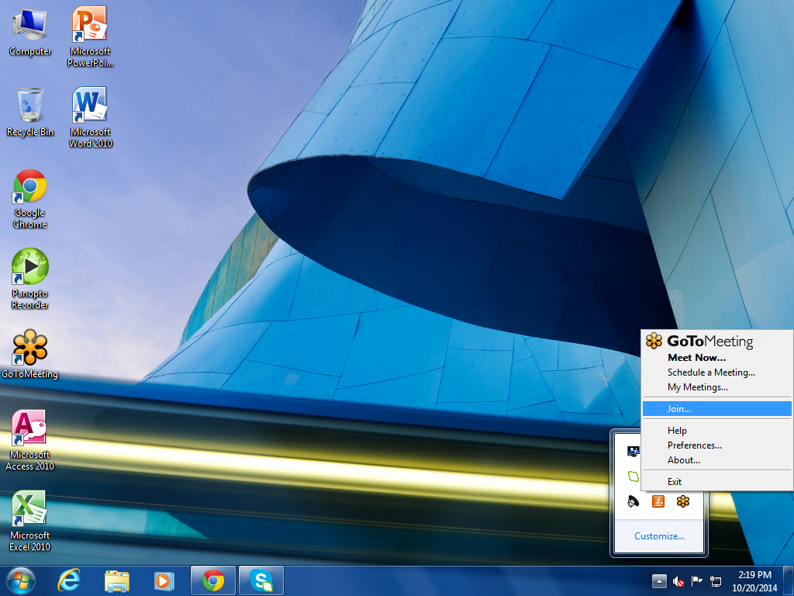
   1. **LEFT click on the block arrow.**
      1. **A box will pop up**

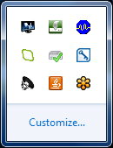

* + 1. **RIGHT Click on the Orange Flower Icon.** 
  1. **A box list will pop up, LEFT Click on Join…**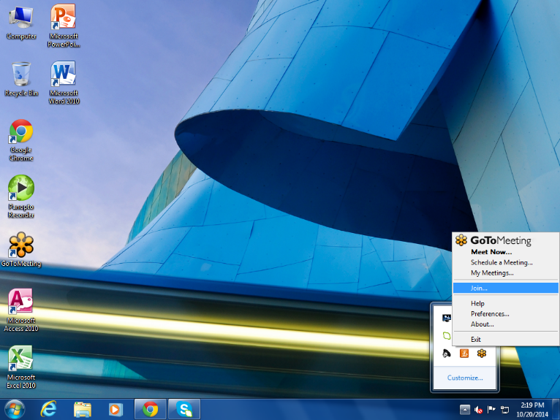
  2. **A Join Session box will pop up, enter the meeting ID number and press the “Enter” key. 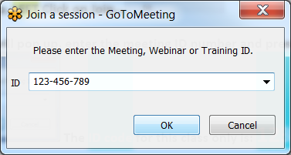 The ID code for this class only is: 123-456-789**
  3. **When the meeting window appears, click on the camera icon on the slim bar.** 



1. **Be sure that the speakers are set apart and the camera is set to view the students in the class room.**