**GoTo Meeting Class Connection Instructions**

**HOW TO *HOST* AN Impromptu MEETING**

1. **Turn on computer, power button is located on right side of computer monitor.**
2. **If another user has used machine, click on the “Switch User” button.**
3. **Log in as NON-BCC account:**
   1. **Log in as Instructor, the username is instructor: Password (leave blank and hit Enter)**

**Username: machine name of classroom\instructor**

**Password: Hit Enter**

1. **In the lower right hand corner of the desktop screen, there is a block arrow.** 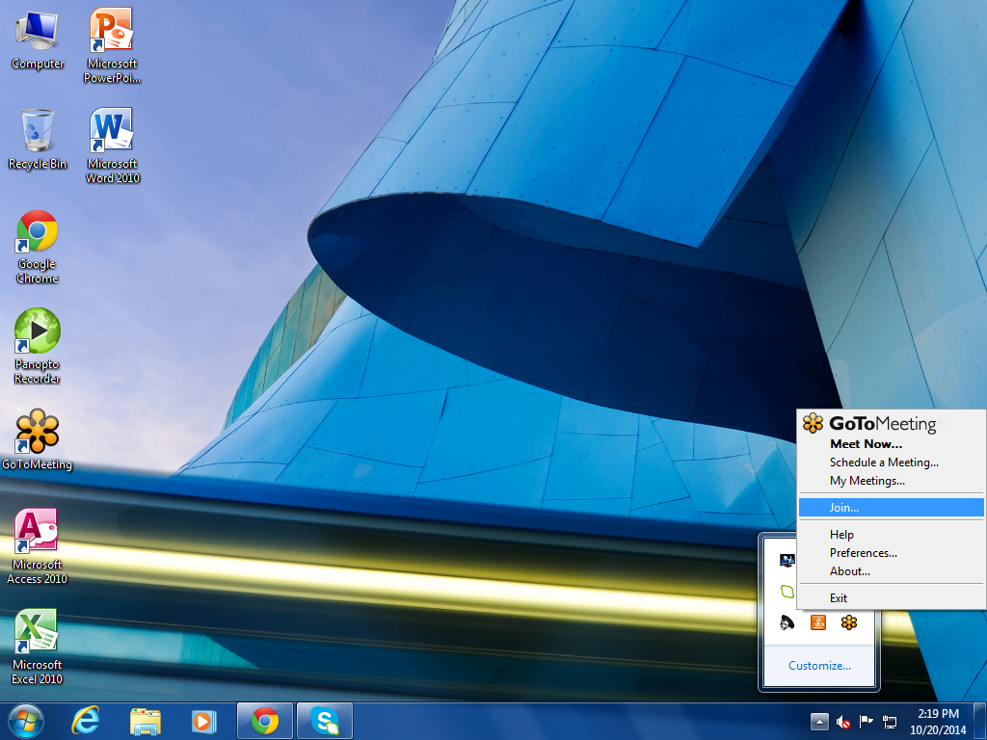
   1. **LEFT click on the block arrow.**
      1. **A box will pop up**

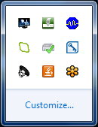

* + 1. **RIGHT Click on the Orange Flower Icon.** 
  1. **A box list will pop up, LEFT Click on Meet Now…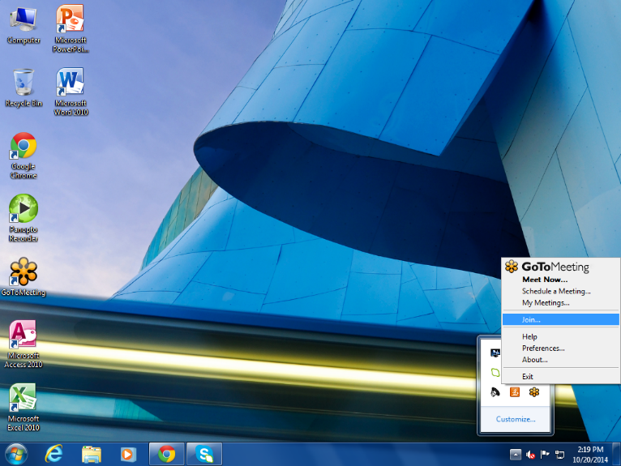 for impromptu.**
  2. **A GoToMeeting Control box will pop up.**

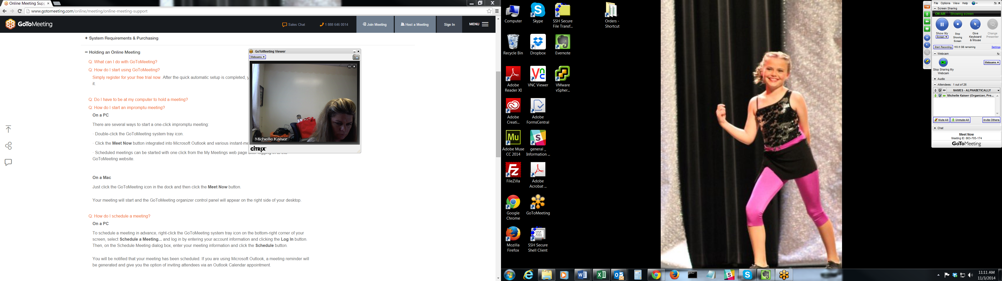

**-Click on the Camera Icon to share the camera**

**-Click on the Screen Icon to share your screen**

**-Click on “*Invite Others*” under the “*Attendee*” section to send out the meeting**

**ID to other attendees to join.**

**To share the invite with other Attendees, click on the** **“*Invite Others*” under the “*Attendee*” section and open up your webmail to send out the meeting ID code. When you click on Invite Others you receive two choices, click on copy to clip board and log in to your Barton web mail account and paste the invitation information in a new email to attendees.**

**Barton Web Mail Access:** [**http://internal.bartonccc.edu/it/employee-email.html**](http://internal.bartonccc.edu/it/employee-email.html)

1. **Be sure that the speakers are set apart and the camera is set to view the you/students in the class room.**
2. **For further assistance with GoToMeeting please Call HELP DESK at ext. 100**